Wireshark – Lab 2 – FTP

Note: If no FTP server is available, you may open the packet capture file ftp2.pcapng located in T:\Andrew Errity\Wireshark and answer questions 1-6 under task 2 below.

Using an FTP client

Let’s begin our exploration of FTP by downloading some FTP client software that will enable us to connect to a FTP server.
- Go to https://filezilla-project.org/ and download the FileZilla Client software.
- Once the download has completed, run the setup file and follow the installation wizard.
- When the client has installed open the FileZilla Client.
- Enter the following details and click ‘Quickconnect’:
  - Host: IP address provided by your lecturer
  - Username: student
  - Password: iadtstudent

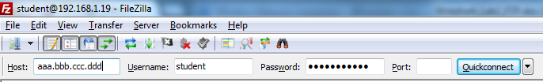
Figure 1: FileZilla connection fields.

- If the connection was successful you should see the following on the right hand side of the FileZilla:

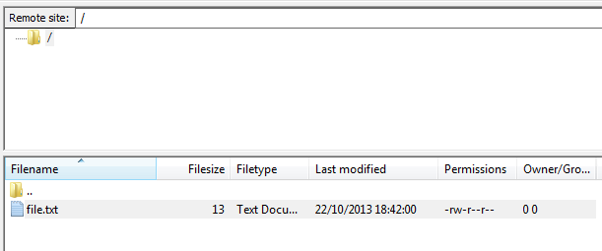
Figure 2: FileZilla remote client view.

This is the directory structure on the ftp server.
- Right click on file.txt and click View/Edit. The text file will open.

Tracing FTP using Wireshark

Once you have completed part 1 and confirmed that you can connect to the FTP server, do the following:
- Open the FileZilla client and ensure you have disconnected from the ftp server (select Server->Disconnect).
- Launch Wireshark and start a capture.
- Complete steps 4-6 from part 1.
- Stop the Wireshark capture
- Enter “ftp or ftp-data” in the filter window in Wireshark.

Answer the following questions:
- Is FTP transported over TCP or UDP?
TCP
- When the ‘Welcome to the FTP service.” response is sent by the FTP server, what is the source port? What is the destination port?
Source port:50587
Destination port: 21

- What is the FTP response code number for a successful login?
230
- What does the FTP request LIST mean? Hint: look at the FTP response to this request.
List remote files
- When the FTP-DATA (file.txt) is transmitted, what is the source port? What is the destination port? Are these the same ports as in 2. above? Why?
Source Port:50587
Destination Port:21
- How many bytes of FTP-DATA are transmitted when the file is retrieved?
24 bytes

Hint: A description of FTP commands can be found at http://www.nsftools.com/tips/RawFTP.htm

