Web Design and Development CA1

2nd year | 09/01/2017

N00150623

Emily Meagher

[Year]

Contents

Project Overview 2

Design 2

Implementation 3

Testing 4

Conclusion 5

Resources 5

# Project Overview

As a part of the web design and development module we were required to implement a HTML/ CSS/ JavaScript/ PHP application that allowed a user to input data into a form which would then be uploaded to a database table. The forms needed to be validated using JavaScript which would display appropriate error messages if there was a problem. The form would also then be validated and sanitised using PHP. The PHP would check the submitted data and see if it contains sanitisation or validation errors then the form would be resubmitted to the user with the appropriate error messages so they could change the data so it could then be submitted to the database.

# Design

The form is constructed using Bootstrap 3 Framework. Using the components from Bootstrap, the form was created using panels which made the overall form look more professional and easier for users to use.

Buttons were also a major part of the form as it helped connect the different web pages together and allowed for the PHP and JavaScript validation and sanitisation to take place. The buttons used classes exclusive to Bootstrap to make the buttons larger or smaller or give them a colour.

A basic layout given by Bootstrap was used to create the layout of the form which helped with making the form more structured i.e. placing the password input field after the email input field.

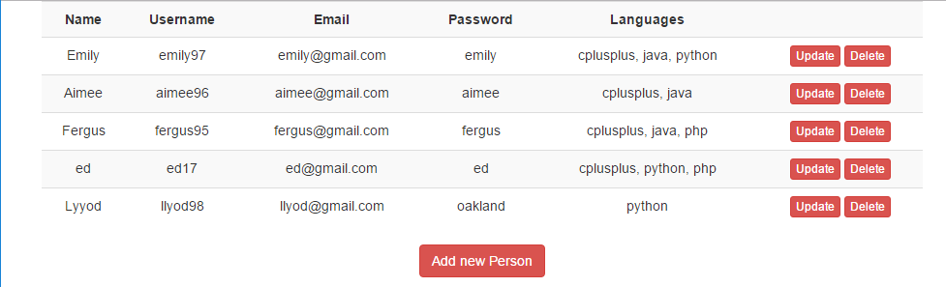

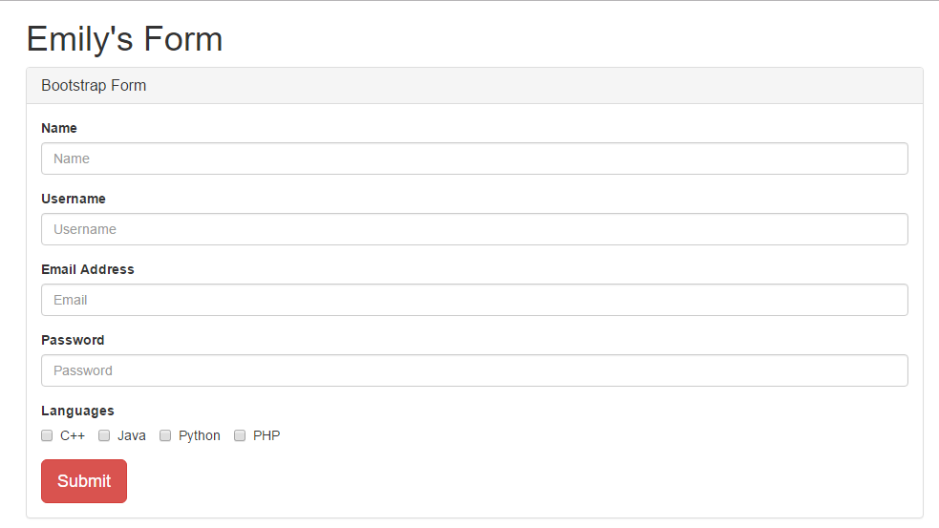

# Implementation

By using phpmyadmin, a database corresponding to the form was created in order for all the information to be stored within as well as it displaying in the index.php. The database required very little effort to create as long as the corresponding column names in the code were found in the database otherwise an error would occur.

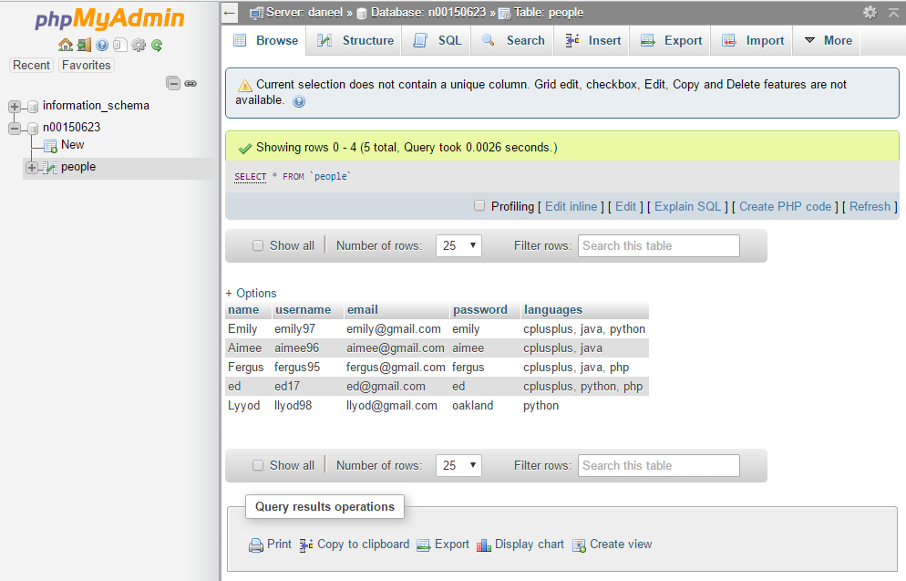

Another interesting part of the code was the use of classes. Classes were used so that they could be referenced whenever needed instead of being written out many times which takes up too much time and requires a lot of work when finding errors in the code. PeopleTable.php and DB.php were the classes used in this assignment. DB.php was used to connect to the database which required the username, password, database and host name to connect successfully. The PeopleTable.php file was where the magic happened. At the beginning of the file, variables are initialised so they can be used by the functions and editing can be made easier. The classes were a lot easier to manage as it was simpler to find the errors and it reduced the amount of work. It also reduced redundancy within the application.

# Testing

Currently the application cannot be deleted and updated by the user. Evidence of this can be found in the code.

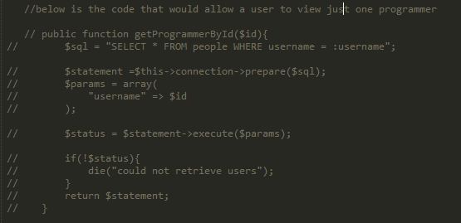

Testing took a vigorous amount of time as the Avaya server was down multiple times since the beginning of the project but the application was able to be completed using xampp. Testing was carried out by myself, classmates or by lecturers. This mainly involved looking at the application to see what was wrong with a feature and to search in the code to find the error which was generally a syntax error. The application was then tested on a regular student from the college who suggested that the application contained the button to create new people. They also thought adding buttons to update and delete information in case anything required modification. However, I was unable to complete this during the allocated time.

Validation required a lot of work as the form was being validated by both JavaScript and PHP. JavaScript validation was a lot easier to do as JavaScript was being taught in this module at the time. PHP required more research and the use of John Dempsey’s programming tutorials to gain an understanding of how the code should be structured but also how to reference back to the HTML. With the help of these resources, validation was achieved.

# Conclusion

In conclusion, I feel I have created an application which required many programming languages to be used to make a form that could be used commercially. From this project, I have learned how to use HTML, CSS, JavaScript and PHP in a Bootstrap framework to allow for data to be submitted to a database.

If I had an extra week to do this project, I feel I would’ve had a better chance at the updating and deleting functions as they are quite important to this sort of application as it is useful to change user information as well as delete unnecessary data.

I hope to use what I have learned from this project to expand my understanding of all the languages and to use the form in webpages I create in the future.

# Resources

Mark Otto, and Bootstrap contributors. "Bootstrap · The World's Most Popular Mobile-First And Responsive Front-End Framework.". *Getbootstrap.com*. N.p., 2017. Web. 9 Jan. 2017.

"PHP: Hypertext Preprocessor". *Php.net*. N.p., 2017. Web. 9 Jan. 2017.

"John Dempsey". *Vimeo*. N.p., 2017. Web. 9 Jan. 2017.

“Web_Design_and_Development_CA1_Overview.pdf”. iadt.ie. N.p. 2017. Web. 9 Jan. 2017.