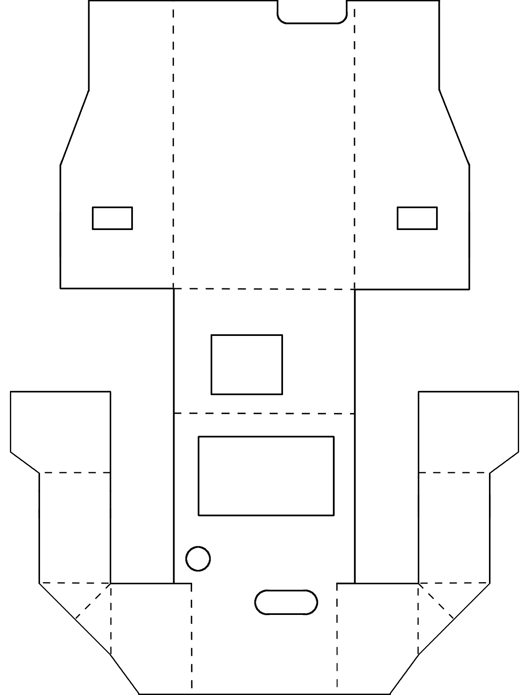

Cut along solid lines

Fold along dashed lines