6.2.1a Box Plot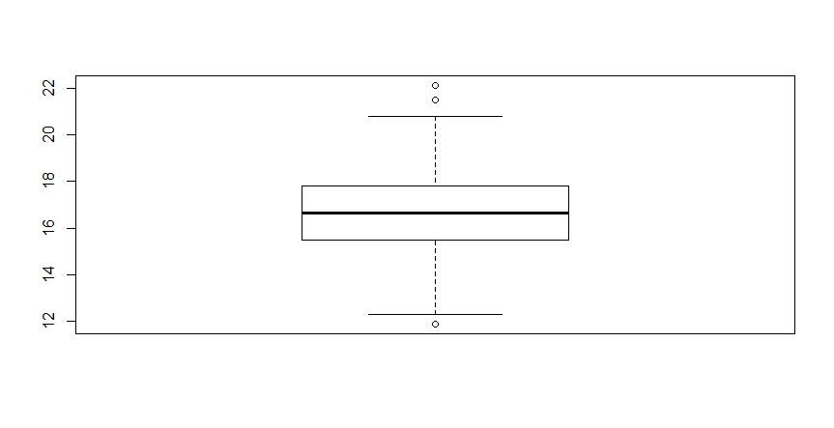

6.2.2 Baby Carrots Box Plot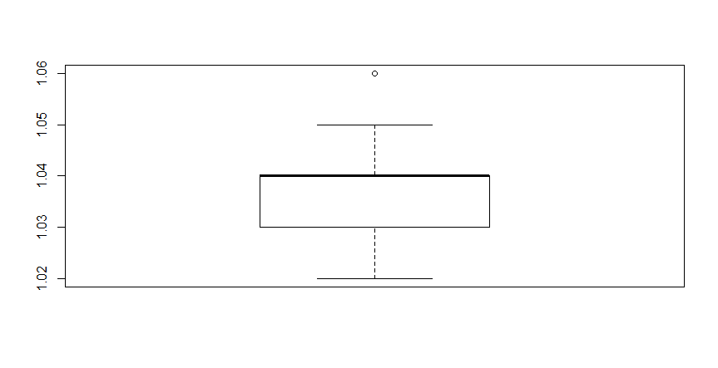

6.2.2 Regular Carrots Box Plot

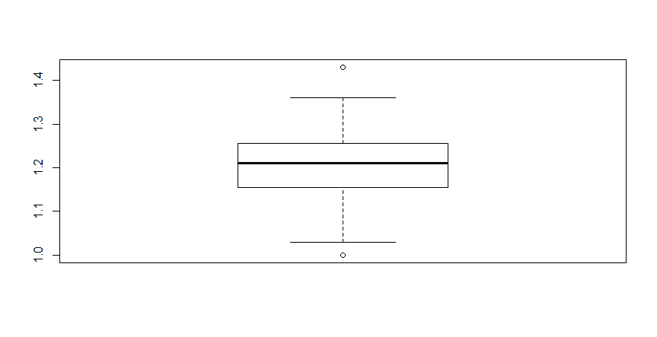

6.2.6 Box Plot

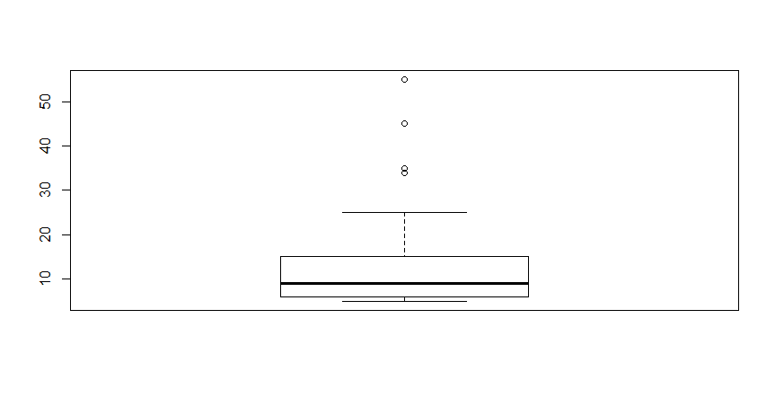

6.3.13 Female Spiders Q-Q Plot

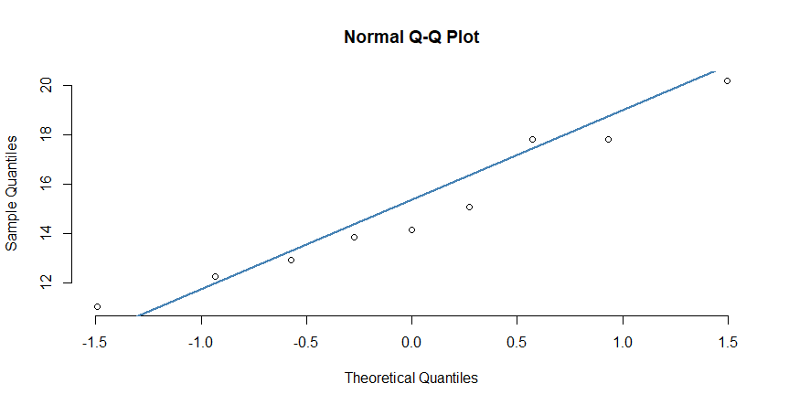

6.3.13 Male Spiders Q-Q Plot

