Research Proposal: The Effect of Lifestyle Choices on Overcoming the Flu

Stats 101B

Spring 2020

Emily Allendorf

Jieyi Wang

**Introduction**

Given the current global health crisis from COVID-19, it has become increasingly interesting to investigate what factors influence the human body’s healing process. Specifically, are there non-biological factors--and by extension lifestyle choices--that can influence the healing process. Diet and exercise are common examples of lifestyle choices which can affect healing. In light of the growing scholarship in the benefits of mindfulness on the body, we thought it would be interesting to investigate the impact of mindfulness on healing. Furthermore, we wanted to investigate its effects in comparison to prevailing lifestyle choices such as exercise. We have not considered diet because within the constraints of the Island, we are limited in our ability to affect the day-to-day lifestyle choices of our participants. Therefore, we are focusing on once-daily actions such as going for a run, or briefly meditating.

**Specific Aims.**

Our specific aims are as follows:

* To identify which lifestyle activities correspond to the largest improvement in the healing process (whether that is purely psychological or actually physical) compared to no additional lifestyle activities
* To determine if physical activity or mental activity corresponds to a greater improvement in healing
* To control for the potential effects of biological sex on healing process by blocking by sex

**Previous Scholarship**

The background of this paper is based on a study from the National Institute of Health titled “Advantage of meditation over exercise in reducing cold and flu illness is related to improved function and quality of life”. The paper found that exercise or meditation were both connected to improved quality of life but not necessarily any lessening of flu symptoms or quicker recovery. The authors used self-reported measures of happiness which we cannot mimic, so we will use the biological indicator Serotonin as a proxy to happiness.

This decision is based on another NIH paper titled “Happiness & Health: The Biological Factors- Systematic Review Article” which linked hormones from the brain like dopamine and serotonin to happiness. The paper also cites a link between physical activity and happiness which primes us to consider the relationship between running and test subjects’ serotonin levels.

**Preliminary Data.**

**White Blood Cell Levels:**

Our preliminary sampling of 6 individuals between 20 and 40 (3 males and 3 females) over the course about 3 days shows a relationship between white blood cell count and days since injection.

Additionally there appears to be a relationship between sex and white blood cell count and activity and white blood cell count.

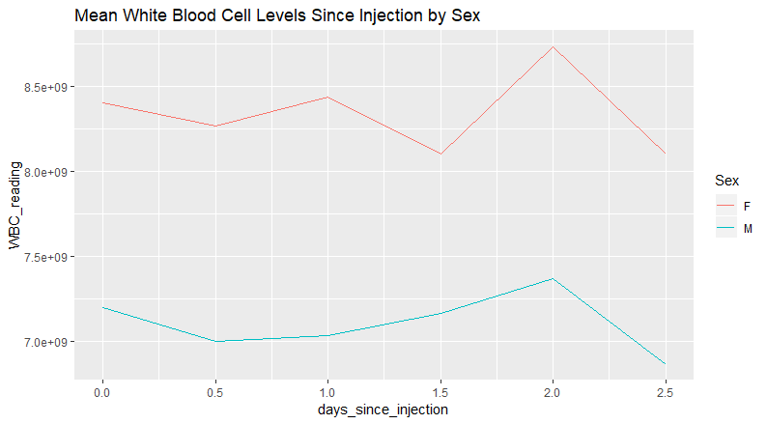

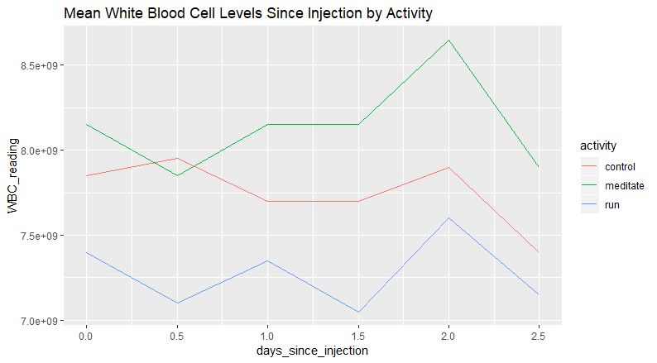

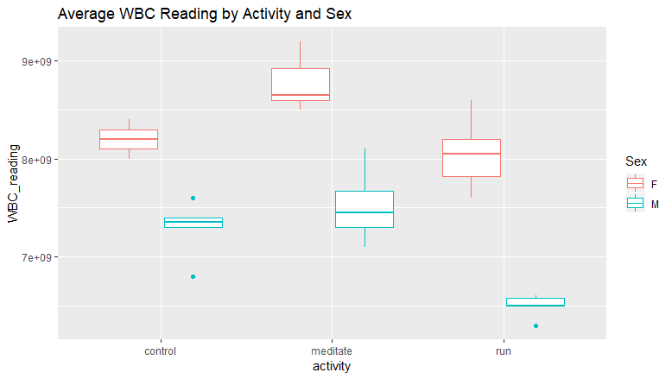

However, looking at the graph above, there doesn’t appear to be an interaction between activity and sex in regards to WBC readings.

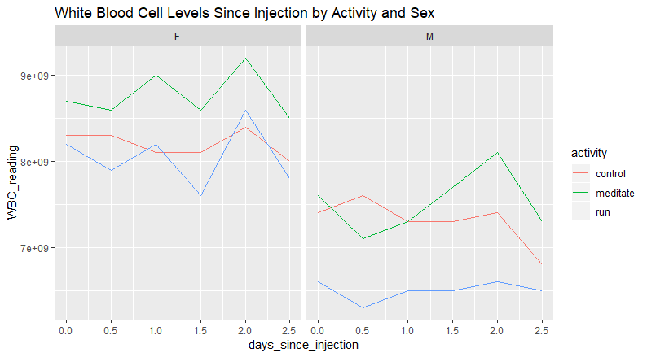

**Serotonin Levels**

We also found a similar relationship between serotonin levels, days since injection, activity, and sex. That is, activity sex, and days since injection are all realted to serotonin levels but there is no interaction between activity and sex.

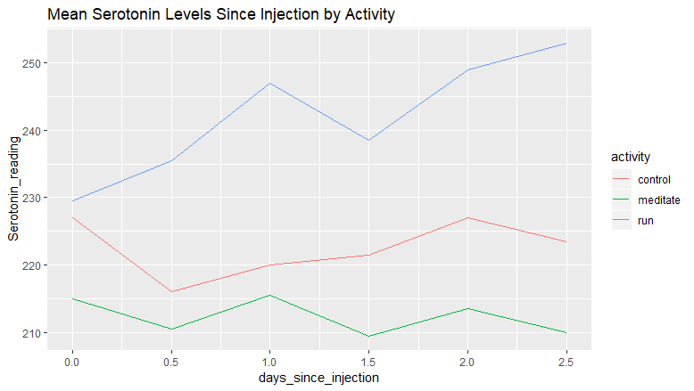

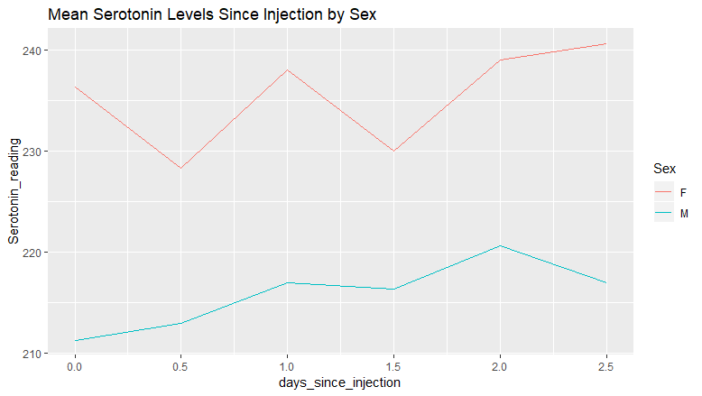

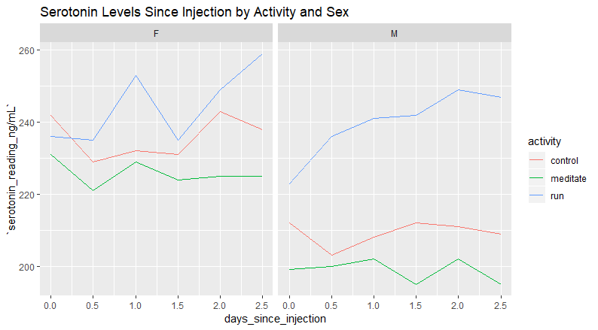

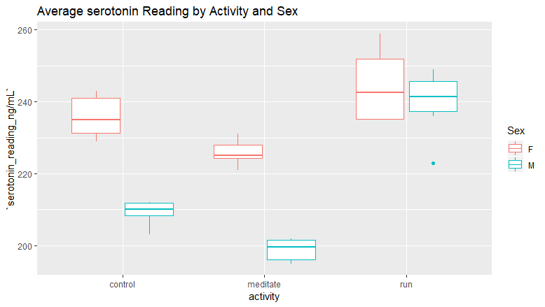

**Temperature:**

Our preliminary research did not find a clear relationship between temperature and days since injection, sex, and activity. In fact, the mean temperature across all activities was 37℃.

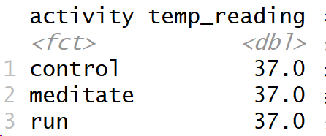

For this reason and the fact that fever is only one possible symptom of the flu and is therefore not guaranteed to result in any extreme body temperature changes, we will likely drop this response variable from our data collection.

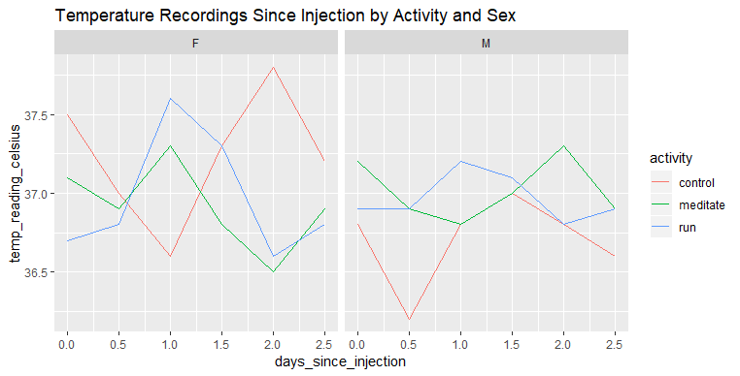

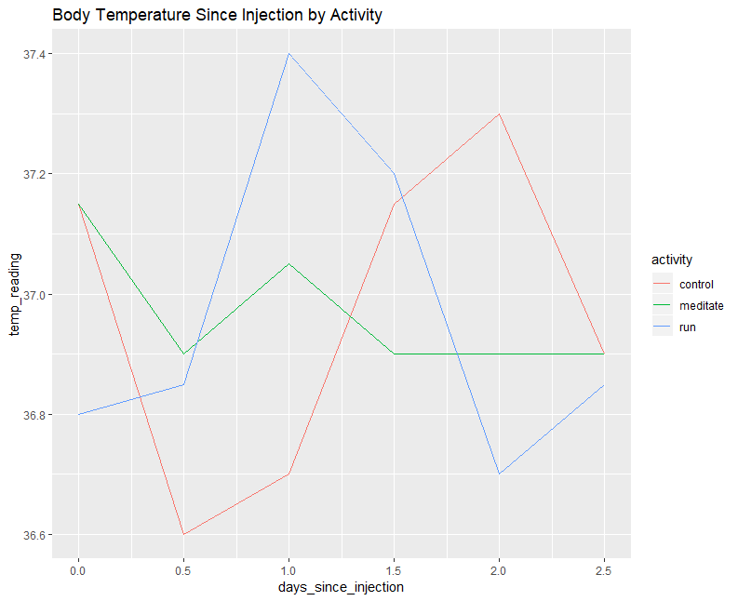

**Experimental Design and Methods.**

**Variables**:

Response: White Blood Cell Count, Serotonin, and Dopamine Levels

White blood cell count is intended as a proxy for the progress of the immune system in battling the virus. Serotonin and Dopamine are two hormones that have been linked to happiness and are used in lieu of asking subjects directly how happy they feel--as that is impossible on the island.

Treatment Factor: Lifestyle Choice (Control, Run 5 km, Happy Memories,Pet dog?)

Blocking: Sex

Held Constant: Age (20 - 40)

**Procedure**:

1. Select simple random sample for a Balanced Complete Block design blocking on sex and potentially considering Randomized Effects Model for within-subject variability.

The Obasi et. al. paper reports an effect size as large in magnitude as -.33 for quality of life and -.22 for symptom improvement. Based on our early research, we will use an overall effect size of .30 (?) Using G Power for an a priori ANOVA with fixed effects, we get a total sample size of 126, with 21 per group (16 if 4 levels) .

1. (DON'T THINK WE NEED THIS STEP) Take initial white blood cell count (WBC), serotonin levels, and dopamine levels
2. Inject subjects with the flu virus immediately.
3. Wait until beginning of the 4th day then repeat wellness diagnostics (temp, WBC, serotonin, dopamine levels)

Four days is the average time after exposure it takes for symptoms to appear, according to Harvard Medical School.

1. Immediately perform treatment on individuals:
   1. Run 1 km then drink 250 mL water (to account for dehydration effects on serotonin levels cited in Zimmer)
   2. Think of happy memories
   3. Pet Dog
   4. Control
2. Wait the following lengths of time before gathering wellness diagnostics:
3. 35 min after running 1 km (Zimmer) (need to further research this)
4. 20 min after happy memories (Ramirez) (also needs further research)
5. 10 min after petting dog (Beetz)
6. 0 min for control group
7. Repeat treatment and diagnostics every 24 hours for 6 days (the average duration of symptoms according to Harvard Medical School)

**References**

Obasi, Chidi N, et al. “Advantage of Meditation over Exercise in Reducing Cold and Flu Illness Is Related to Improved Function and Quality of Life.” *US National Library of Medicine: National Institute of Health*, Blackwell Publishing Ltd, Nov. 2013, [www.ncbi.nlm.nih.gov/pmc/articles/PMC3582749/](http://www.ncbi.nlm.nih.gov/pmc/articles/PMC3582749/).

Dfarhud, Dariush, et al. “Happiness & Health: The Biological Factors- Systematic Review Article.” *US National Library of Medicine: National Institute of Health*, Tehran University of Medical Sciences, Nov. 2014, [www.ncbi.nlm.nih.gov/pmc/articles/PMC4449495/](http://www.ncbi.nlm.nih.gov/pmc/articles/PMC4449495/).

Godman, Heidi. “How Long Does the Flu Last?” Harvard Health, Harvard Health Publishing, Dec. 2016, [www.health.harvard.edu/staying-healthy/how-long-does-the-flu-last](http://www.health.harvard.edu/staying-healthy/how-long-does-the-flu-last).

Ramirez, S., Liu, X., MacDonald, C. et al. Activating positive memory engrams suppresses depression-like behaviour. Nature 522, 335–339 (2015). <https://doi.org/10.1038/nature14514>

Zimmer, P., Stritt, C., Bloch, W. et al. The effects of different aerobic exercise intensities on serum serotonin concentrations and their association with Stroop task performance: a randomized controlled trial. Eur J Appl Physiol 116, 2025–2034 (2016). <https://doi.org/10.1007/s00421-016-3456-1>

<https://www.nature.com/articles/nature14514#citeas>