XMOD 2.1 Documentation

Welcome to XMOD 2.1!

Start XMOD by double clicking on Xmod-2.1.jar
If it will not open, open the terminal, navigate to where there .jar file is located and run the following command:
java -jar Xmod-2.1.jar
If you do not have java installed, please follow the directions in INSTALL.txt

FUNCTIONALITY
- Run an Experiment
On the Experiment pane, click LOAD TMS FILE
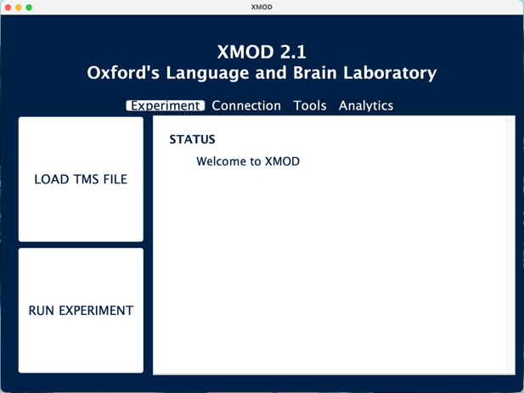

Select your .tms file
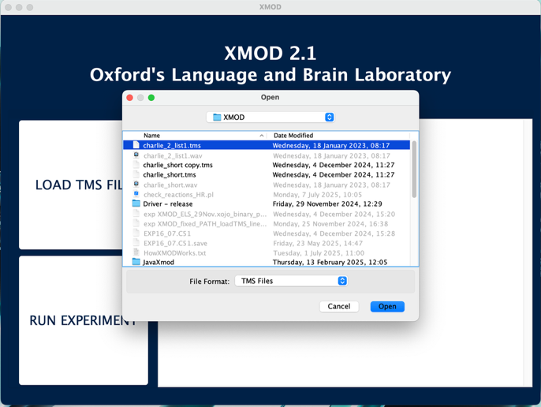

If everything is good to go, you will see this:

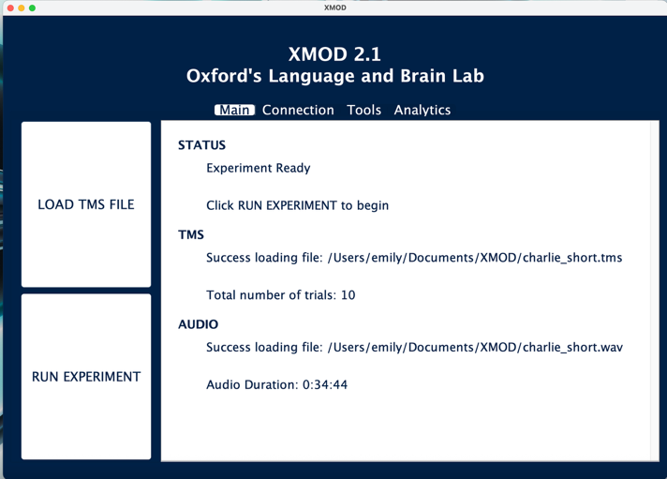

On the Experiment pane, click RUN EXPERIMENT
A pop-up with reminders will appear – make sure you are happy

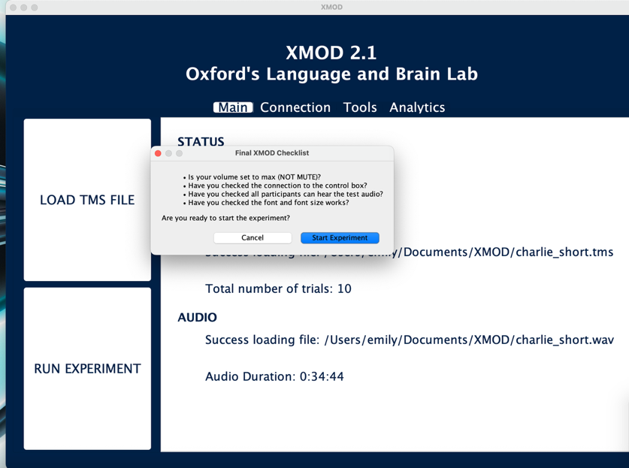

Click Start Experiment and it will begin.

Note that you do NOT need to do the following:
- Play audio independently
- Turn off participant monitors before the experiment begins

The experiment results will be saved to file in a directory called ‘results/’ in the same directory as your .tms file
Note results for a given participant will only be saved as long as they respond to at least one trial.

- Abort an Experiment
Press ESC
Your results to date will be saved to file in a directory called ‘results/’ in the same directory as your .tms file
Note results for a given participant will only be saved as long as they respond to at least one trial.
This is what you should see on the screen:

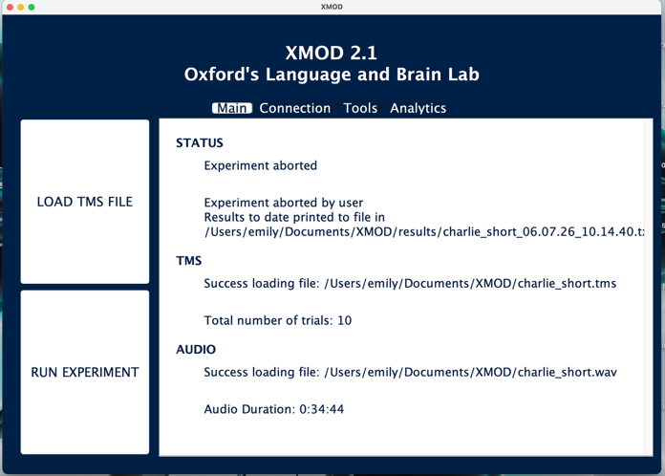

- Change the Font
On the Tools pane, click CHANGE FONT
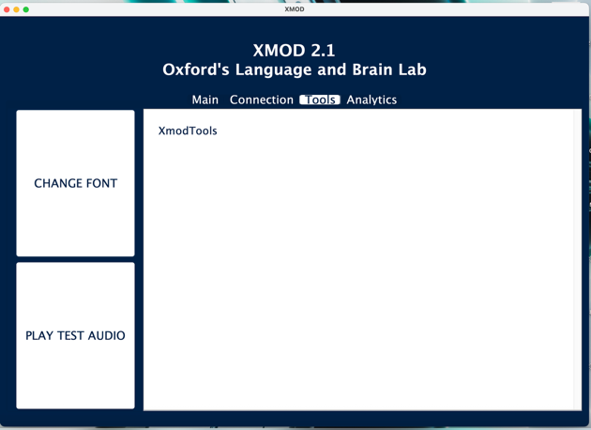

You can alter the font and the font size in the drop down menus at the top of the window.
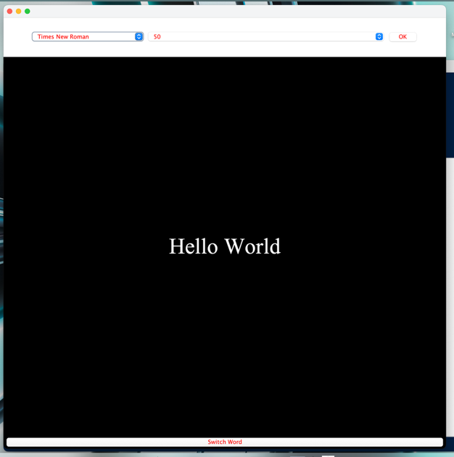

To change the word displayed on screen, click the ‘Switch Word’ button at the bottom to cycle through the options. These include words in different scripts as well particularly challenging digraphs in Bengali.
If you are happy with your changes, click OK
If you are not happy, click the red cross in the corner to close the window.
Your changes will be summarised on screen

- Play Test Audio
On the Tools plane, click PLAY TEST AUDIO

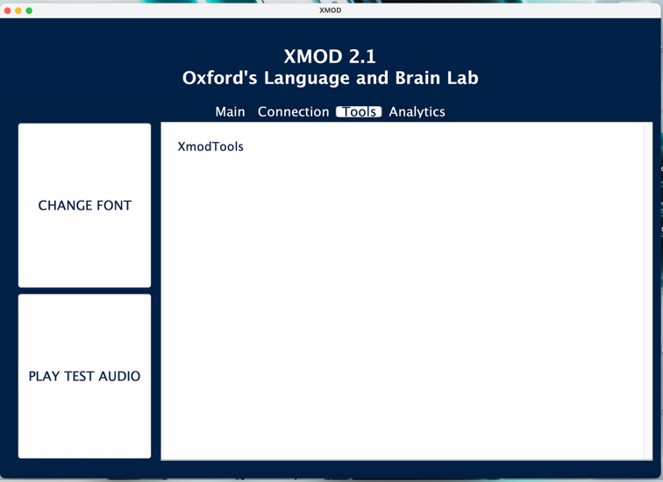

It will play an arpeggio audio file on loop until you click STOP TEST AUDIO
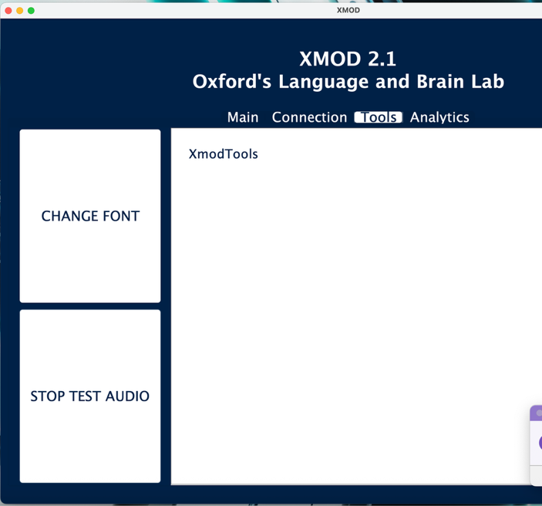
- Test the control box
On the Connection pane, click the buttons for different outcomes:
- CHECK CONNECTION: flashes lights on box; attempts reconnection to box
- CONTROLLER INFO: prints control box info to screen
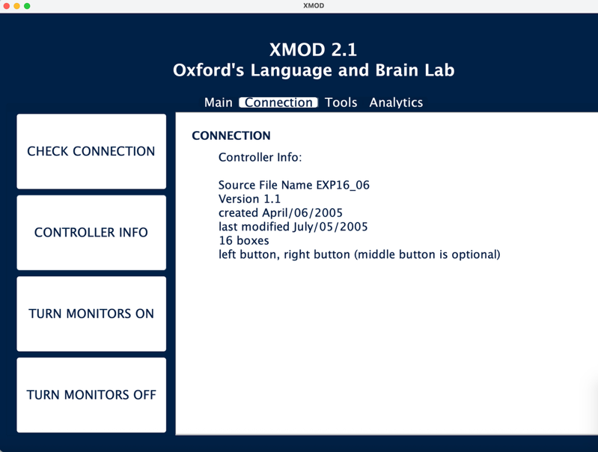

- TURN MONITORS ON/OFF: turns participant monitors on/off

If not connected to the control box you will see:
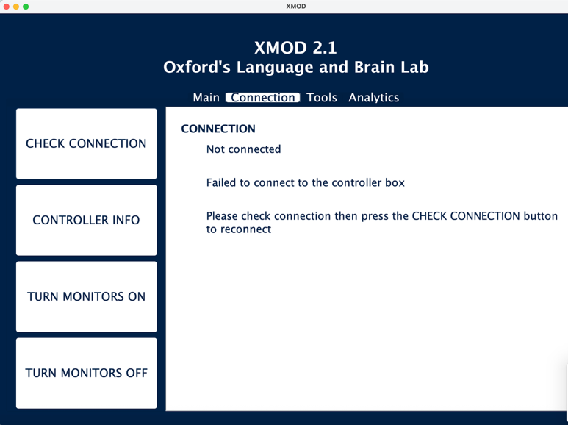
Once connected, you will see:
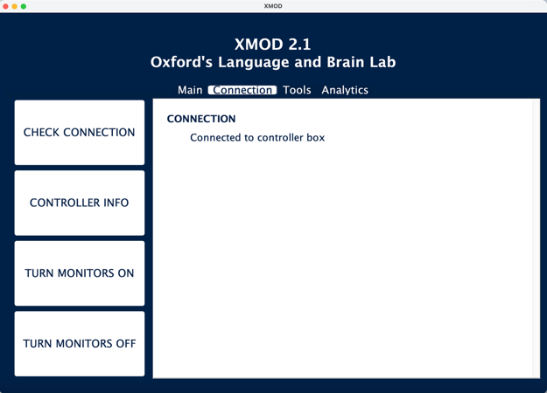
[ELS: Note 6/7/2026 – if the main experiment page says controller box not connected, then you reconnect, the main experiment page does not update this info but the experiment will run]

DESCRIPTION OF ALL THE BUTTONS
There are 4 panes on Xmod 2.1
EXPERIMENT:

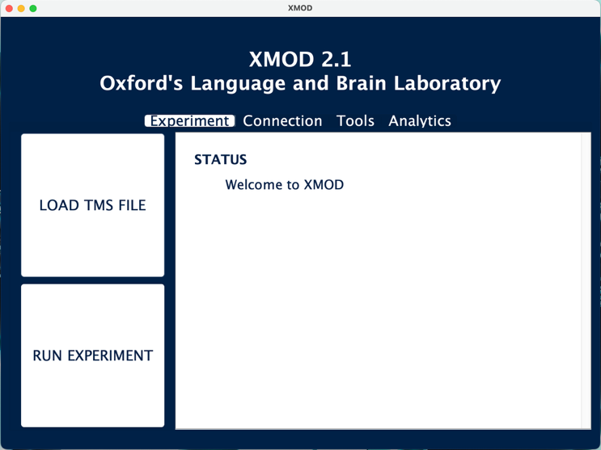
LOAD TMS FILE:
Click on this button to launch a file chooser. Select your .tms file
It will load your .tms file and the .wav with the same name.
If there is a problem with either, an error message will appear on screen
RUN EXPERIMENT:
If the experiment is not ready to run, an error message with details will appear on screen
This will open a MessageBox with reminders.
Click Run to start the experiment
Note you do not need to start the audio yourself OR turn off participant monitors

CONNECTION
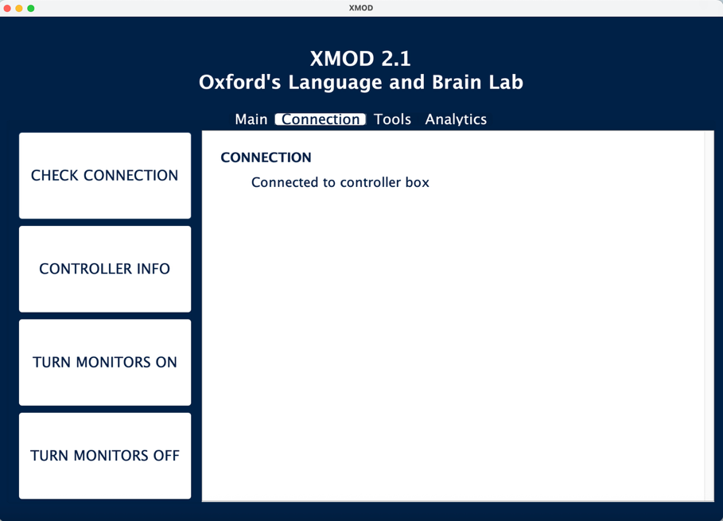

CHECK CONNECTION:
Click to reconnect to the box
3 lights should flash on the box
CONTROLLER INFO:
This will display information about the control box on screen
TURN MONITORS ON:
This will turn participant monitors on
TURN MONITORS OFF
This will turn participant monitors on

TOOLS

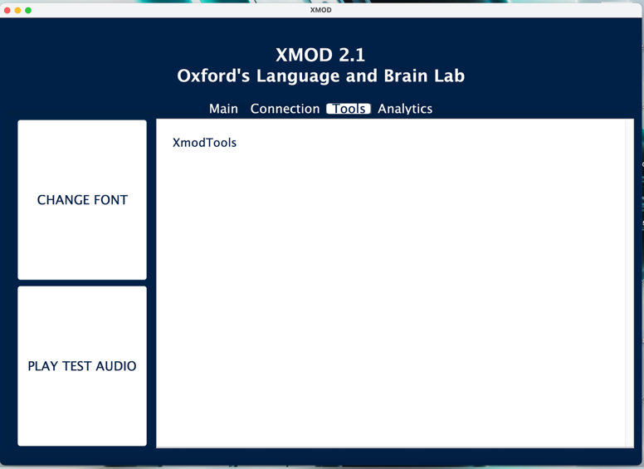
CHANGE FONT:
This will display the Change Font Window
PLAY TEST AUDIO:
This will play an audio file of an Arpeggio in C Major on loop until the button is pressed again

ANALYTICS
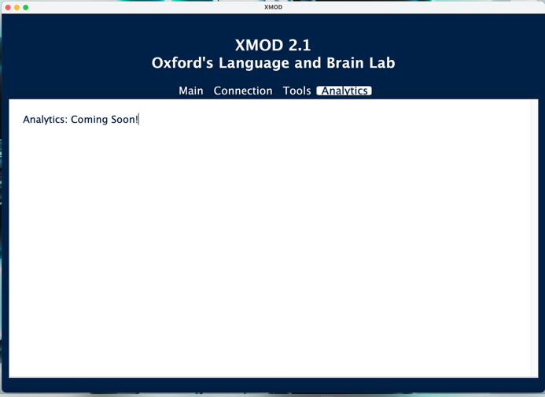
<nothing here currently>

If you have any feedback, please contact Dr Emily Lindsay-Smith on Emily.lindsay-smith@ling-phil.ox.ac.uk

