Results of the 2022 eastern and northern Bering Sea continental shelf bottom trawl survey of groundfish and invertebrate fauna

DRAFT: December 10, 2022

# H1 Results and Discussion

## H2 Ocean Temperatures and the Cold Pool

### H3 Selected Invertebrates Estimates

#### H4: test test

##### H5: test test

###### H6: test test

In 2022, the Resource Assessment and Conservation Engineering (RACE) division of the National Marine Fisheries Service’s (NMFS) Alaska Fisheries Science Center (AFSC) conducted the 40th Eastern Bering Sea Crab/Groundfish Bottom Trawl Survey (EBS) from May to July 2022, as well as the 5th Northern Bering Sea Crab/Groundfish Survey - Eastern Bering Sea Shelf Survey Extension (NBS) from July to August 2022. The addition of the NBS survey expanded the study area to also cover the Bering Sea continental shelf (bottom depths between approximately 20 and 200 m) from the Alaska coastline to the U.S.-Russia Maritime Boundary between the Alaska Peninsula and the Bering Strait, including Norton Sound. Two stern trawlers, the 43.9-m FV *Alaska Knight* and 37.8-m FV *Vesteraalen*, were chartered for these surveys. Demersal populations of fishes and invertebrates were sampled by trawling for 30 minutes at stations arranged on a systematic grid, which consisted of 376 total stations in the EBS and 144 total stations in the NBS. At each station, species composition, length distribution, and age structure samples were collected from ecologically and commercially important species. All survey stations in the EBS and NBS were sampled successfully.

The recent trend of higher-than-average temperatures continued on the EBS shelf for the eighth consecutive year. In 2022, both the mean surface (7.5°C) and bottom (2.6°C) water temperatures were warmer than the survey long-term average of surface (6.8°C) and bottom (2.5°C). The 2022 mean bottom temperatures were the nineteenth warmest observed since the beginning of the EBS shelf bottom trawl survey time series in 1982. Effective management of fisheries resources and healthy ecosystems are especially important to Alaska Native communities and to the tens of thousands of people who are employed by the Alaska fishing industry. The commercial fishing industry in Alaska generates billions of dollars for the U.S. economy annually (<https://www.fisheries.noaa.gov/alaska/socioeconomics/alaska-economic-and-social-sciences-research>; <https://www.fisheries.noaa.gov/national/sustainable-fisheries/fisheries-economics-united-states>).

Table 1.-- Special projects and collections undertaken during the 2022 eastern Bering Sea and northern Bering Sea shelf bottom trawl survey, sorted by principal investigator and agency.

| **Project title** | **Principal investigator** | **Agency1** |
| --- | --- | --- |
| **EBS** | | |
| Observer Collection | Sarah Friedman | AFSC-FMA |
| Blood collection for stress physiology | Bianca Prohaska | AFSC-RACE |
| Tanner and snow OA collections | Chris Long | AFSC-RACE |
| Bitter crab live collections | Erin Fedewa | AFSC-RACE |
| Crab Tagging | Leah Zacher | AFSC-RACE |
| 15/30 Bottom trawl tow duration comparison | Lukas DeFilippo | AFSC-RACE |
| **EBS & NBS** | | |
| Shark population genetics and age structure sampling | Cindy Tribuzio | AFSC-ABL |
| Use of EBS bottom trawl survey acoustic data to augment the MACE acoustic-trawl survey time series of walleye pollock abundance (“AVO”; Acoustic vessels of opportunity) | MACE | AFSC-MACE |
| MML Food Habits Reference Collection | Katie Luxa | AFSC-MML |
| Shellfish Photo Documentation Refresh | Allie Conrad | AFSC-RACE |
| Fish Condition Index-Pollock/Cod | Bianca Prohaska | AFSC-RACE |
| Bitter Crab Syndrome Monitoring | Erin Fedewa | AFSC-RACE |
| Snow Crab Condition | Erin Fedewa | AFSC-RACE |
| Length and weight collection for Arctic cod, saffron cod, rex sole, and starry flounder | Liz Dawson | AFSC-RACE |
| Specimen Collection for Outreach Events | Liz Dawson | AFSC-RACE |
| Morphological and genetic identification of larval stages of sandlance species, Ammodytes hexapterus and A. personatus | Melanie Paquin | AFSC-RACE |
| Light meter calibration | Ned Laman | AFSC-RACE |
| CTD data collection | RACE | AFSC-RACE |
| Pacific cod tagging | Susanne McDermott | AFSC-RACE |
| Flatfish genomics | Ingrid Spies | AFSC-REFM |
| Arctic and saffron cod growth | Tom Helser | AFSC-REFM |
| Black eye syndrome: eyestalk collection | Maya Groner | Bigelow Laboratory for Ocean Sciences |
| Black eye syndrome: live collection | Maya Groner | Bigelow Laboratory for Ocean Sciences |
| IPHC Pacific halibut data collection on NOAA Fisheries groundfish trawl surveys | Kayla Ualesi | IPHC |
| Harmful Algal Bloom (HAB) toxins in Alaskan food webs | Kathi Lefebvre | NWFSC |
| Forensic and eDNA Voucher Collection | Abigail Wells | NWFSC + University of Washington Ichthyology Collection |
| Marine Ecology of Arctic and Pacific Lampreys | Trent Sutton | UAF |
| Population genetics of herring in the Bering Sea | Andrés López | University of Alaska Fairbanks |
| **NBS** | | |
| Ongoing mollusk collection (gastropods/chitons) | Roger Clark | SBMNH & LACMNH |
| Investigation the foraging habits of beluga in the Bering Sea | Mi-Ling Li | University of Delaware |
| 1AFSC-ABL - Auke Bay Laboratories; AFSC-FMA - Fisheries Monitoring & Assessment Division; AFSC-MACE - Midwater Assessment & Conservation Engineering Division; AFSC-MML - Marine Mammal Laboratory; AFSC-RACE - Resource Assessment & Conservation Engineering Division; AFSC-REFM - Resource Ecology & Fisheries Management Division; IPHC - International Pacific Halibut Commission; NWFSC - Northwest Fisheries Science Center; SBMNH & LACMNH - Santa Barbara Museum of Natural History & Natural History Museum of Los Angeles County; UAF - University of Alaska Fairbanks | | |

The size of the cold pool each summer is defined by the extent of bottom temperatures below 2°C and depends on sea ice coverage from the previous winter, the timing of sea ice retreat during the spring and early summer, as well as other oceanographic and meteorological conditions (Wyllie-Echeverria and Wooster, 1998). During the coldest years, sea ice extended farther south and lasted later into spring resulting in cold pools that extended farther south through the middle domain into Bristol Bay and near the Alaska Peninsula (Figs. **Error! Reference source not found.** and **Error! Reference source not found.**). Interannual variability in the dynamics of seasonal ice is a major environmental driver on the Bering Sea shelf (Stabeno et al., 2001; Stabeno, Farley Jr., et al., 2012; Stabeno, Kachel, et al., 2012) that can change recruitment and migration patterns, as well as cause major distributional shifts in groundfish and crab species (Kotwicki and Lauth, 2013; Nichol et al., 2019; Stevenson and Lauth, 2019). abundance-at-length), the high-density strata were grouped, resulting in eight subareas: 10, 20, 30 (31+32), 40 (41+42+43), 50, 60 (61+62), 82, and 90 (Fig. **1**; Table **1**).

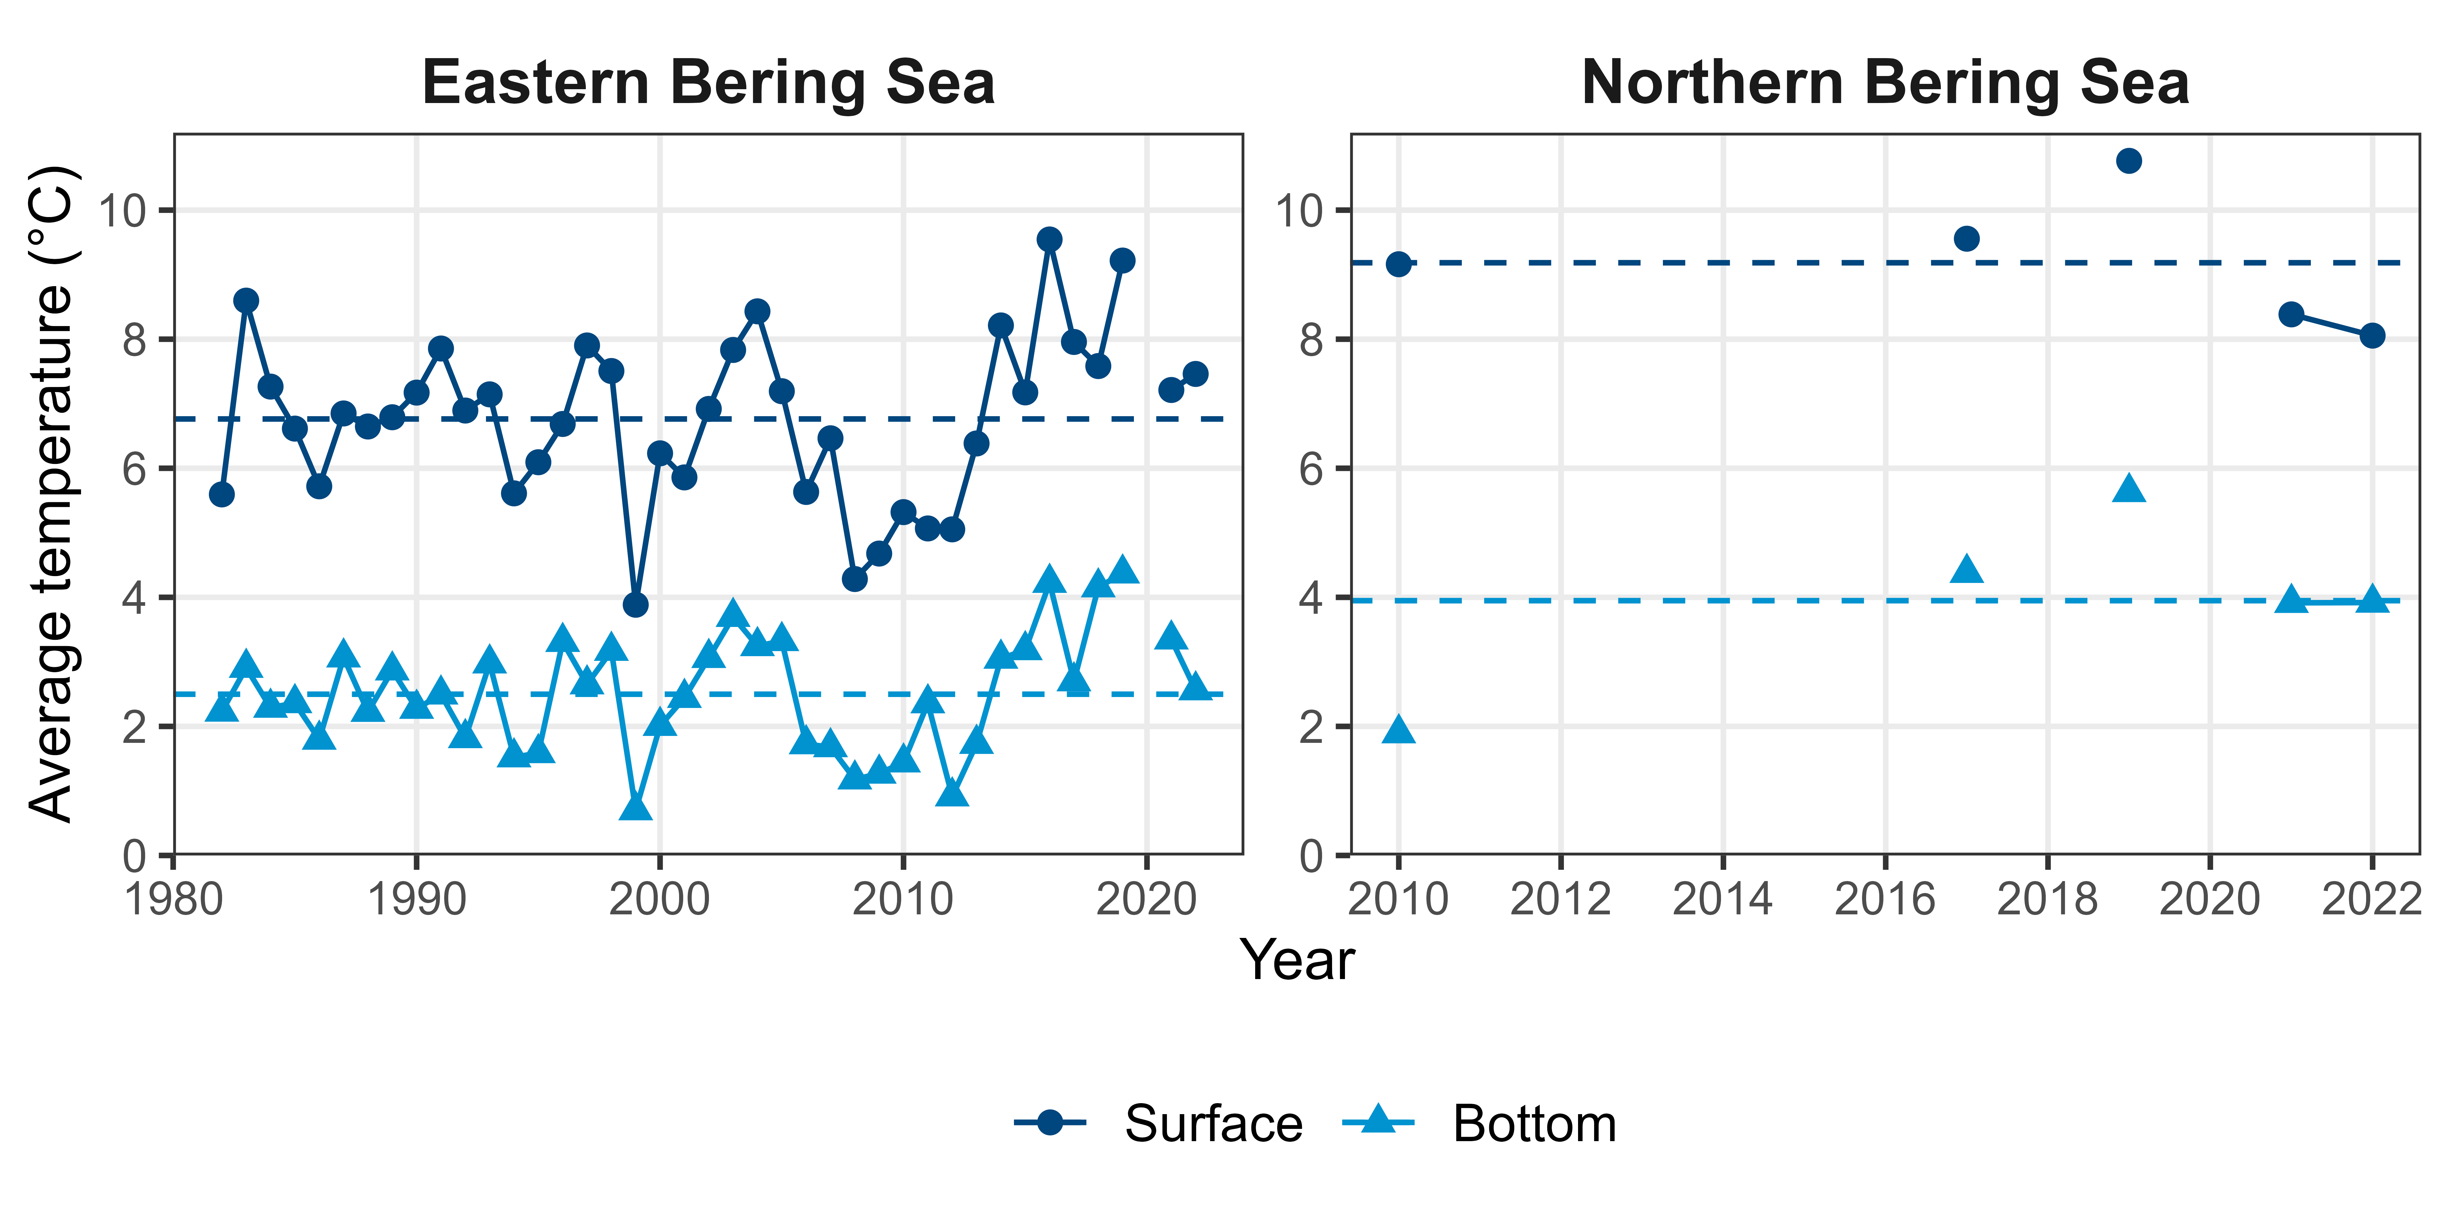

**Fig.** **5.--** Average summer surface (light blue triangles) and bottom (dark blue circles) and time-series average surface (dark blue dashed line) and bottom (light blue dashed line) temperatures (°C) on the EBS shelf, based on data collected during standardized summer bottom trawl surveys from 1982–2022 (left), and northern Bering Sea shelf based on data collected during standardized summer bottom trawl surveys (right).

Table 17.-- Mean Number CPUE (no./ha) with standard deviation, and estimated population (millions) with standard deviation (millions) and 95% lower (LCL; millions) and upper (UCL; millions) confidence limits for walleye pollock (*Gadus chalcogrammus*) by stratum observed during the 2022 EBS and NBS shelf bottom trawl survey.

| **Stratum** | **Mean CPUE  (no./ha)** | **SD CPUE** | **Estimated population  (millions)** | **SD population  (millions)** | **95% LCL  (millions)** | **95% UCL  (millions)** | **Hauls with weights** | **Hauls with counts** | **Hauls with lengths** |
| --- | --- | --- | --- | --- | --- | --- | --- | --- | --- |
| **EBS** | | | | | | | | | |
| 10 | 51.11 | 13.65 | 402.25 | 107.44 | 185.12 | 619.39 | 58 | 58 | 58 |
| 20 | 19.55 | 3.61 | 80.52 | 14.85 | 50.20 | 110.85 | 31 | 31 | 31 |
| 31 | 121.64 | 32.98 | 1,155.27 | 313.22 | 528.84 | 1,781.71 | 69 | 69 | 69 |
| 32 | 329.74 | 142.10 | 291.72 | 125.71 | 0.00 | 589.02 | 8 | 8 | 8 |
| 41 | 173.26 | 44.13 | 1,079.58 | 274.97 | 523.87 | 1,635.29 | 44 | 44 | 44 |
| 42 | 526.97 | 85.15 | 1,271.16 | 205.39 | 851.75 | 1,690.56 | 30 | 30 | 30 |
| 43 | 127.19 | 22.81 | 267.91 | 48.05 | 167.97 | 367.85 | 22 | 22 | 22 |
| 50 | 43.29 | 17.56 | 164.68 | 66.80 | 27.06 | 302.30 | 25 | 25 | 25 |
| 61 | 271.83 | 38.04 | 2,386.04 | 333.90 | 1,711.23 | 3,060.86 | 60 | 60 | 60 |
| 62 | 140.86 | 22.91 | 91.02 | 14.80 | 54.79 | 127.24 | 7 | 7 | 7 |
| 82 | 56.87 | 14.84 | 102.11 | 26.64 | 43.48 | 160.74 | 12 | 12 | 12 |
| 90 | 234.93 | 59.20 | 271.09 | 68.31 | 109.53 | 432.64 | 8 | 8 | 8 |
| **Total** | **153.42** | **12.29** | **7,563.35** | **606.07** | **6,363.33** | **8,763.37** | **374** | **374** | **374** |
| **NBS** | | | | | | | | | |
| 70 | 51.46 | 7.18 | 407.85 | 56.88 | 292.90 | 522.80 | 58 | 58 | 58 |
| 71 | 20.38 | 5.92 | 165.60 | 48.09 | 68.41 | 262.80 | 50 | 50 | 50 |
| 81 | 31.55 | 6.67 | 121.00 | 25.58 | 68.51 | 173.49 | 28 | 28 | 28 |
| **Total** | **34.92** | **3.96** | **694.46** | **78.75** | **536.95** | **851.96** | **136** | **136** | **136** |

**Table** **18.--** Mean weight CPUE (kg/ha) with standard deviation, and estimated biomass (thousand mt) with standard deviation (thousands) and 95% lower (LCL; thousand mt) and upper (UCL; thousand mt) confidence limits for walleye pollock (*Gadus chalcogrammus*) by stratum observed during the 2022 EBS and NBS shelf bottom trawl survey.

| **Stratum** | **Mean CPUE  (kg/ha)** | **SD CPUE** | **Estimated biomass  (thousand mt)** | **SD biomass  (thousands)** | **95% LCL  (thousand mt)** | **95% UCL  (thousand mt)** | **Hauls with weights** | **Hauls with counts** | **Hauls with lengths** |
| --- | --- | --- | --- | --- | --- | --- | --- | --- | --- |
| **EBS** | | | | | | | | | |
| 10 | 25.66 | 4.24 | 201.95 | 33.40 | 134.46 | 269.44 | 58 | 58 | 58 |
| 20 | 13.41 | 2.49 | 55.24 | 10.24 | 34.32 | 76.16 | 31 | 31 | 31 |
| 31 | 72.11 | 20.24 | 684.88 | 192.28 | 300.31 | 1,069.44 | 69 | 69 | 69 |
| 32 | 166.10 | 50.55 | 146.94 | 44.72 | 41.18 | 252.70 | 8 | 8 | 8 |
| 41 | 100.82 | 23.07 | 628.20 | 143.78 | 337.62 | 918.78 | 44 | 44 | 44 |
| 42 | 320.99 | 48.88 | 774.30 | 117.91 | 533.52 | 1,015.08 | 30 | 30 | 30 |
| 43 | 47.24 | 8.40 | 99.50 | 17.70 | 62.69 | 136.31 | 22 | 22 | 22 |
| 50 | 36.61 | 14.35 | 139.28 | 54.60 | 26.79 | 251.76 | 25 | 25 | 25 |
| 61 | 141.05 | 19.95 | 1,238.06 | 175.12 | 884.14 | 1,591.98 | 60 | 60 | 60 |
| 62 | 58.51 | 4.20 | 37.80 | 2.72 | 31.16 | 44.45 | 7 | 7 | 7 |
| 82 | 26.39 | 5.81 | 47.37 | 10.43 | 24.41 | 70.33 | 12 | 12 | 12 |
| 90 | 87.05 | 24.24 | 100.45 | 27.97 | 34.30 | 166.60 | 8 | 8 | 8 |
| **Total** | **84.26** | **6.72** | **4,153.97** | **331.10** | **3,498.39** | **4,809.56** | **374** | **374** | **374** |
| **NBS** | | | | | | | | | |
| 70 | 21.35 | 3.81 | 169.22 | 30.18 | 108.23 | 230.21 | 58 | 58 | 58 |
| 71 | 16.70 | 6.74 | 135.69 | 54.73 | 25.07 | 246.31 | 50 | 50 | 50 |
| 81 | 23.38 | 5.23 | 89.68 | 20.05 | 48.54 | 130.82 | 28 | 28 | 28 |
| **Total** | **19.84** | **3.30** | **394.58** | **65.64** | **263.31** | **525.86** | **136** | **136** | **136** |

Pacific