[Title]

[Subtitle]

[authors]



U.S. Department of Commerce

National Oceanic and Atmospheric Administration

National Marine Fisheries Service

NOAA Technical Memorandum NMFS-[F/SPO, OHC, OPR or OSF]-###

[Month] 2019

[Title]

[Authors]

NOAA Technical Memorandum NMFS-[F/SPO, OHC, OPR or OSF]-###

[month] [year]



U.S. Department of Commerce

Wilbur L. Ross, Jr., Secretary

National Oceanic and Atmospheric Administration

Neil A. Jacobs, Ph.D., Acting NOAA Administrator

National Marine Fisheries Service

Chris Oliver, Assistant Administrator for Fisheries **Recommended citation:**

[Authors]. [Year]. [Title] NOAA Tech. Memo. NMFS-[F/SPO, OHC, OPR or OSF]-###, ## p.

Copies of this report may be obtained from:

[office name]

National Oceanic and Atmospheric Administration

1315 East-West Highway [bldg./room]

Silver Spring, MD 20910

[or alternate address]

Or online at:

<http://spo.nmfs.noaa.gov/tech-memos/>

[or alternate URL for OHC, OSF or OPR pages]

# [H1]

## [H2]

### [H3]

#### [H4]

##### [H5]

###### [H6]

Contents

[H1] 4

[H2] 4

[H3] 4

Seafood Sales and Processing 4

United States | Commercial Fisheries 5

## Seafood Sales and Processing

Authors economic contributions or impacts of recreational fishing activities in the United States is based on spending by recreational anglers.[1] Total annual trip expenditures were estimated at the state level by multiplying mean trip expenditures by the estimated number of adult trips in each trip mode (for-hire, private boat, and shore) and adjusting by the CPI (consumer price index) to the current year. Total annual durable expenditures were estimated by multiplying mean durable expenditures by the estimated annual number of adult participants in the United States and adjusting by the CPI (consumer price index) to the current year.

Authors economic contributions or impacts of recreational fishing activities in the United States is based on spending by recreational anglers. Total annual trip expenditures were estimated at the state level by multiplying mean trip expenditures by the estimated number of adult trips in each trip mode (for-hire, private boat, and shore) and adjusting by the CPI (consumer price index) to the current year. Total annual durable expenditures were estimated by multiplying mean durable expenditures by the estimated annual number of adult participants in the United States and adjusting by the CPI (consumer price index) to the current year.

* Drum (Atlantic croaker and spot) (Atlantic regions)
* **Drum (seatrouts) (Atlantic regions)**: sand seatrout, seatrout genus, silver seatrout, spotted seatrout, and weakfish
* Pacific halibut (North Pacific)

## United States | Commercial Fisheries

#### Harvest (H) & Release (R) of Key Species/Species Groups (thousands of fish)[2], [3]

|  |  |  |  |  |
| --- | --- | --- | --- | --- |
| Fishing Mode | #Jobs | Sales | Income | Value Added |
| For-Hire | 1,097 | 121,965 | 41,158 | 73,447 |
| Private Boat | 1,876 | 254,812 | 79,074 | 154,631 |
| Shore | NA | NA | NA | NA |
| Total Durable Expenditures | 10,610 | 1,343,395 | 522,431 | 851,616 |
| Total State Economic Impacts | 13,583 | 1,720,172 | 642,663 | 1,079,694 |

I may be using the wrong trips value?

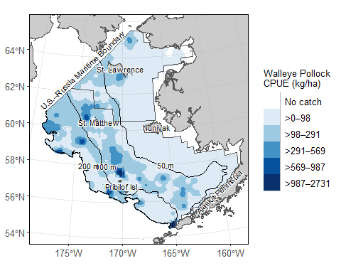

Figure 5. Cpue of walleye pollock (gadus chalcogrammus) across the northern and eastern bering sea.s

1. Trip expenditure estimates were generated from the 2016/2017 National Marine Recreational Fishing Expenditure Survey. Durable goods expenditures were generated from the 2014 National Marine Recreational Fishing Expenditure Survey [Available at <http://www.st.nmfs.noaa.gov/economics/fisheries/recreational/Marine-Angler-Durable-Expenditures/2014-durable-expenditures-survey>].
2. Data on the number of fish released in Texas are not collected by the Texas Parks and Wildlife Department (TPWD) and therefore not reported in this table.
3. ‘NA’ = not available.