# Example of how to use this R Markdown document

Here is the report content!

## Citations

My example dataset has 41,079 rows in it and 17 columns in it.[1] That is an 100% decrease[2]. This work has nothing to do with (Sverdrup, 1953), but I’ll cite it here anyway. I am sure that Arrhenius (1889) would like to have something to say about that!

Note that references will appear at the bottom of this document (and any document that you put references in) but when you combine this document with all of the other documents that you create, it will shift to the bottom of the report.

## Equations

Here is some equation you’ll need to have in this report, of which produces the variable $X$.

Eq. 1

$$X=Y+Z$$

## Example Figure

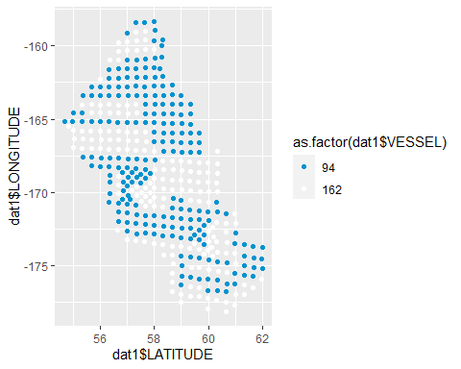

Figure 1. Here’s a plot[3]

## Example Table

### Table 1. Here’s a table[4]

|  |  |  |
| --- | --- | --- |
| Latitude | Longitude | Vessel ID Number |
| 58.3 | -168.5 | 162 |
| 58.3 | -168.5 | 162 |
| 58.3 | -168.5 | 162 |
| 58.3 | -168.5 | 162 |
| 58.3 | -168.5 | 162 |
| 58.3 | -168.5 | 162 |

# References

Arrhenius, S. (1889). Über die reaktionsgeschwindigkeit bei der inversion von rohrzucker durch säuren. *Zeitschrift Für Physikalische Chemie*, *4*(1), 226–248. Journal Article.

Sverdrup, H. (1953). On conditions for the vernal blooming of phytoplankton. *Journal Du Conseil*, *18*(3), 287–295. Journal Article.

1. Wow, this project is so cool!
2. Here’s another, free-written footnote!
3. A footnote for this figure!
4. Here is a Footnote for this table