SAP Production Data Documentation

Shellfish Assessment Program Survey Team

Table of contents

# 1. Survey Background

## 1.1 What we do

## 1.2 Who is conducting the research?

Scientists from the Alaska Fisheries Science Center’s Groundfish Assessment Program (GAP) conduct these bottom trawl surveys with participation from the Alaska Department of Fish & Game (ADF&G), the International Pacific Halibut Commission (IPHC), universities, and other organizations. This research is conducted primarily on chartered fishing vessels.

## 1.3 What is the research objective?

Learn more about the [program](https://www.fisheries.noaa.gov/alaska/science-data/groundfish-assessment-program-bottom-trawl-surveys). The objectives of these surveys are to:

* monitor the population and environmental trends in the marine ecosystem of the Bering Sea, Aleutian Islands, and Gulf of Alaska,
* produce fishery-independent biomass (weight) and abundance (number) estimates for commercially important fish and crab species, and
* collect other biological and environmental data for use in ecosystem-based fishery management.

## 1.4 Who is conducting the research?

Scientists from the Alaska Fisheries Science Center conduct these bottom trawl surveys with participation from the Alaska Department of Fish & Game (ADF&G), the International Pacific Halibut Commission (IPHC), and universities. This research is conducted on chartered fishing vessels.

## 1.5 Bottom trawl surveys and regions

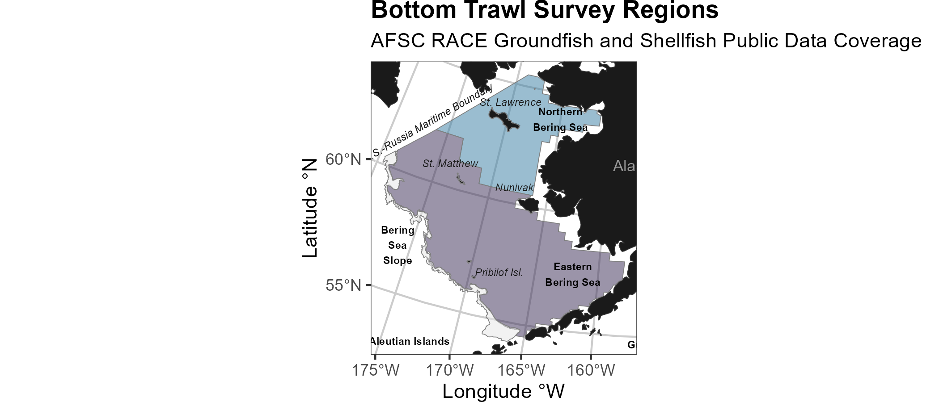

Strata used in the all surveys.

Each survey conducted by the [Groundfish Assessment Program](https://www.fisheries.noaa.gov/alaska/population-assessments/north-pacific-groundfish-stock-assessments-and-fishery-evaluation) are multispecies bottom trawl surveys. We collect environmental and biological data to assess how climate variability and [loss of sea](https://www.fisheries.noaa.gov/alaska/ecosystems/habitat-and-ecological-processes-research-regarding-loss-sea-ice) ice are affecting bottom-dwelling marine life on the Bering Sea shelf. We monitor trends in the distribution (location and movement patterns) and abundance of groundfish and crab species as well as oceanographic data (e.g., water temperature, depth). We collect biological information such as organism weight, length, stomachs to learn about diets, and [otoliths](https://www.fisheries.noaa.gov/alaska/science-data/alaska-age-and-growth-procedures-otolith-examination) to [determine fish ages](https://www.fisheries.noaa.gov/alaska/science-data/fish-otolith-chronologies). We use this information in [annual stock assessments](https://www.fisheries.noaa.gov/alaska/population-assessments/north-pacific-groundfish-stock-assessments-and-fishery-evaluation) and to assess the state of the ecosystem. This research is conducted on fishing industry contract vessels.

| **Survey** | **Survey Definition ID** | **Years** | **Depth (m)** | **Area (km2)** | **# Statistical Areas** | **# Possible Stations** |
| --- | --- | --- | --- | --- | --- | --- |
| Aleutian Islands Bottom Trawl Survey | 52 | 2024 - 1991 (14) | 1 - 500 | 64,415.0 | 80 | 1,312 |
| Eastern Bering Sea Slope Bottom Trawl Survey | 78 | 2016 - 2002 (6) | 201 - 1,200 | 32,861.3 | 37 |  |
| Eastern Bering Sea Crab/Groundfish Bottom Trawl Survey | 98 | 2024 - 1982 (42) | 1 - 200 | 492,989.9 | 28 | 515 |
| Gulf of Alaska Bottom Trawl Survey | 47 | 2023 - 1990 (16) | 1 - 1,000 | 313,784.9 | 37 | 6,939 |
| Northern Bering Sea Crab/Groundfish Survey - Eastern Bering Sea Shelf Survey Extension | 143 | 2023 - 2010 (6) | 1 - 100 | 198,866.8 | 4 | 144 |

### 1.5.1 **Aleutian Islands**

Most recent data report: (Von Szalay et al., 2023)

* Upper Continental Slope of the Aleutian Islands from Unimak Pass to Stalemate Bank
* Triennial (1990s)/Biennial since 2000 in even years, since 1992
* Modified Index-Stratified Random of Successful Stations Survey Design
* Important commercial fish species include Atka mackerel, [Pacific ocean perch](https://www.fisheries.noaa.gov/species/pacific-ocean-perch), [walleye pollock](https://www.fisheries.noaa.gov/species/alaska-pollock), [Pacific cod](https://www.fisheries.noaa.gov/species/pacific-cod), [sablefish](https://www.fisheries.noaa.gov/species/sablefish), and other rockfish species.

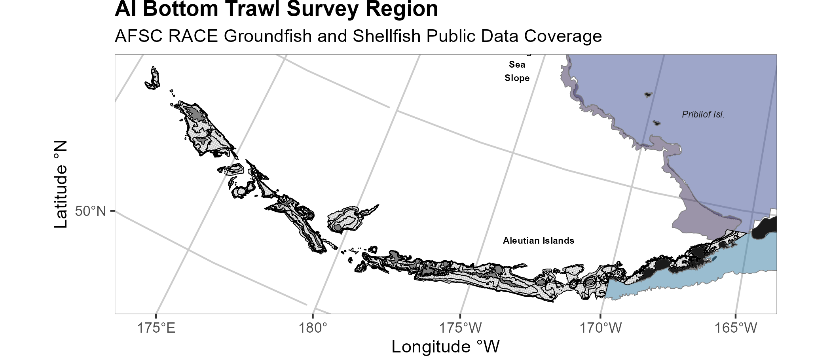

Strata used in the Aleutian Islands bottom trawl survey.

### 1.5.2 **Gulf of Alaska**

Most recent data report: (Siple et al., 2024)

* Continental Shelf and Upper Slope of the Gulf of Alaska extending from the Islands of Four Mountains 2,300 km east to Dixon Entrance
* Triennial (1990s)/Biennial since 2001 in odd years, since 1991
* Stratified Random Survey Design
* Important commercial species in the Gulf of Alaska include [Pacific ocean perch](https://www.fisheries.noaa.gov/species/pacific-ocean-perch), [walleye pollock](https://www.fisheries.noaa.gov/species/alaska-pollock), [Pacific cod](https://www.fisheries.noaa.gov/species/pacific-cod), flatfish, and other rockfish species.

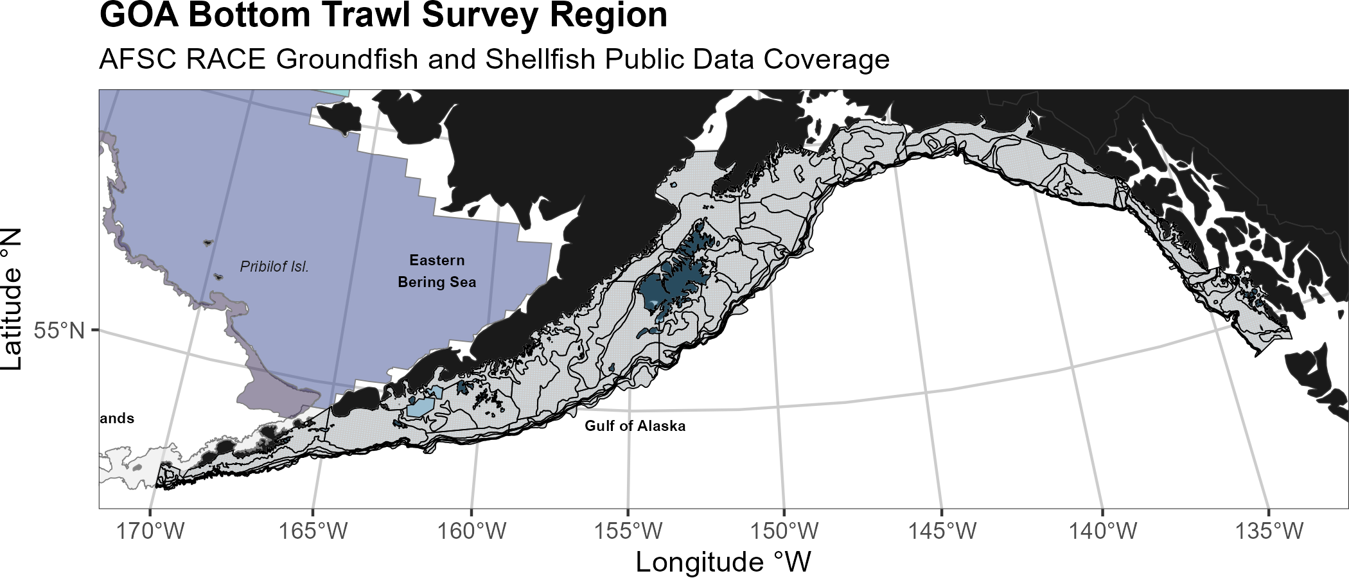

Strata used in the Gulf of Alaska bottom trawl survey.

### 1.5.3 **Eastern Bering Sea Shelf**

Most recent data report: (Markowitz et al., 2024)

* The continental shelf of the eastern Bering Sea from the Aleutian Islands to the Bering Strait
* Conducted annually since 1982.
* Uses a stratified systematic sampling survey design with fixed stations at center of 20 x 20 nm grid.
* Similar in design to the northern Bering Sea shelf bottom trawl survey.
* Focus species for the Bering Sea include [walleye pollock](https://www.fisheries.noaa.gov/species/alaska-pollock), [Pacific cod](https://www.fisheries.noaa.gov/species/pacific-cod), [Greenland turbot](https://www.fisheries.noaa.gov/species/greenland-turbot), [yellowfin sole](https://www.fisheries.noaa.gov/species/yellowfin-sole), [northern rock sole](https://www.fisheries.noaa.gov/species/rock-sole), [red king crab](https://www.fisheries.noaa.gov/species/red-king-crab), and [snow](https://www.fisheries.noaa.gov/species/alaska-snow-crab) and Tanner crabs.

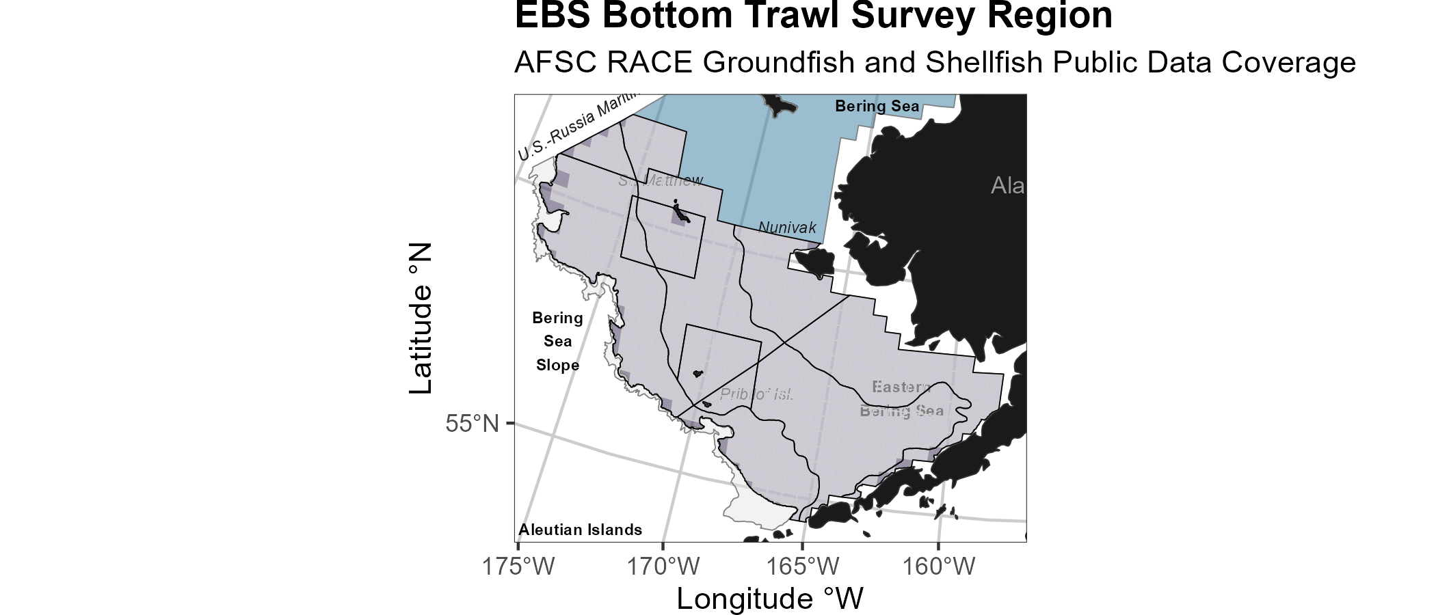

Strata used in the Eastern Bering Sea bottom trawl survey.

### 1.5.4 **Northern Bering Sea**

Most recent data report: (Markowitz et al., 2024)

* The continental shelf of the northern Bering Sea, including the area north of St. Lawrence Island and Norton Sound
* Biennial/Annual; conducted intermittently since 2010
* Uses a stratified systematic sampling survey design with fixed stations at center of 20 x 20 nm grid.
* Similar in design to the eastern Bering Sea shelf bottom trawl survey.

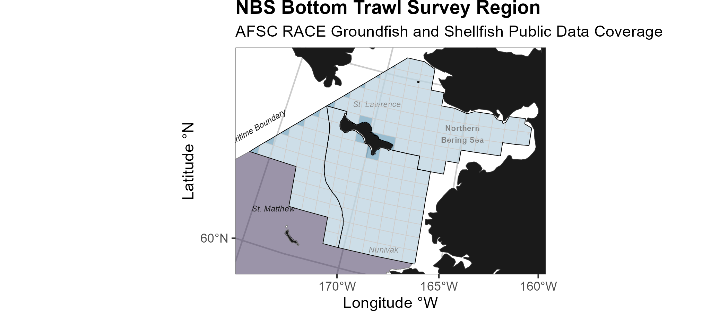

Strata used in the Northern Bering Sea bottom trawl survey.

### 1.5.5 **Eastern Bering Sea Upper Continental Slope**

Most recent data report: (Hoff, 2016)

* The eastern Bering Sea upper continental slope survey area extends from Unalaska and Akutan Islands to the U.S.-Russian Maritime Boundary at 61° N near the International Date Line (166° E to 180° W) at depths from 200 to 1,200 m
* Conducted intermittently since 2002 (funding dependent)
* Modified Index-Stratified Random of Successful Stations Survey Design
* Focus species for the Bering Sea slope include giant grenadier, [Pacific ocean perch](https://www.fisheries.noaa.gov/species/pacific-ocean-perch), popeye grenadier, [walleye pollock](https://www.fisheries.noaa.gov/species/alaska-pollock), and [arrowtooth flounder](https://www.fisheries.noaa.gov/species/arrowtooth-flounder).

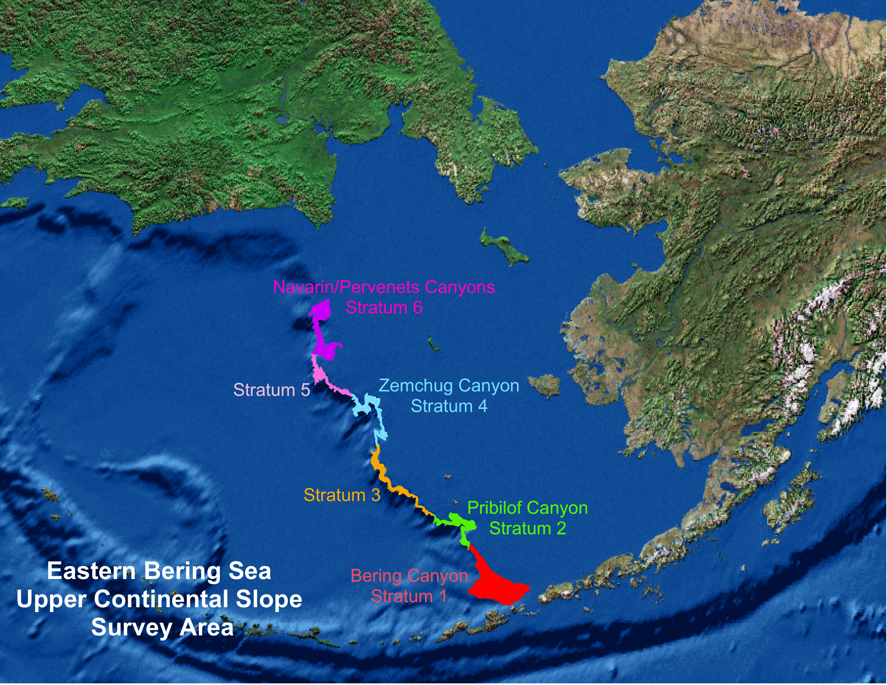

Strata used in the Bering Sea Slope bottom trawl survey.

# 2. Workflow

## 2.1 Operational Product Development Timeline

Over the course of the year, the survey team is developing a variety of different data products. Planning and preparation for surveys happens in the late winter and spring, surveys occur in the summer, data validation takes place over the course of the survey and after the survey, and data products are produced through fall and late winter.

|  | January | February | March | April | May | June | July | August | September | October | November | December |
| --- | --- | --- | --- | --- | --- | --- | --- | --- | --- | --- | --- | --- |
| Surveys |  |  |  |  | 1 | 1 | 1 | 1 |  |  |  |  |
| Planning | 1 | 1 | 1 |  |  |  |  |  | 1 | 1 | 1 | 1 |
| Development | 1 | 1 | 1 | 1 | 1 |  |  |  |  | 1 | 1 | 1 |
| Deployment (survey deliverables) |  |  |  |  |  |  |  |  | 1 | 1 | 1 | 1 |
| Deployment (survey operations) |  |  |  |  | 1 | 1 | 1 | 1 |  |  |  |  |
| Triage (fixing bugs and errors) | 1 | 1 | 1 | 1 | 1 | 1 | 1 | 1 | 1 | 1 | 1 | 1 |
| User feedback and brainstorming | 1 | 1 | 1 | 1 | 1 | 1 | 1 | 1 | 1 | 1 | 1 | 1 |

## 2.2 Data workflow from boat to production

Organisms first need to be collected aboard the vessel before data can be entered into tablets.

The objective of this process is to take raw data, QA/QC and clean these data, curate standard data products for these survey. Please note, through this process we are not providing “data” (what we consider lower level data material; see the data levels section below) but “data products”, which is intended to facilitate the most fool-proof standard interpretation of the data. These data products only use data from standard and validated hauls, and has undergone careful review.

**Once survey data collected on the vessel has been checked and validated**, the [gap_products/code/run.R](https://github.com/afsc-gap-products/gap_products/blob/main/code/run.R) script is used to orchestrate a sequence of programs that calculate the standard data products resulting from the NOAA AFSC GAP bottom trawl surveys. Standard data products are the CPUE, BIOMASS, SIZECOMP, and AGECOMP tables in the GAP_PRODUCTS Oracle schema. The tables are slated to be updated twice a year: once after the survey season following finalization of that summer’s bottom trawl survey data to incorporate the new catch, size, and effort data and once prior to an upcoming survey to incorporate new age data that were processed after the prior summer’s survey season ended. This second pre-survey production run will also incorporate changes in the data due to the specimen voucher process as well as other post-hoc changes in the survey data.

The data from these surveys constitute a **living data set** so we can continue to **provide the best available data to all partners, stakeholders, and fellow scientists**.

During each data product run cycle:

1. Versions of the tables in GAP_PRODUCTS are locally imported within the gap_products repository to compare with the updated production tables. Any changes to a production table will be compared and checked to make sure those changes are intentional and documented.
2. Use the gapindex R package to calculate the four major standard data products: CPUE, BIOMASS, SIZECOMP, AGECOMP. These tables are compared and checked to their respective locally saved copies and any changes to the tables are vetted and documented. These tables are then uploaded to the GAP_PRODUCTS Oracle schema.
3. Calculate the various materialized views for AKFIN and FOSS purposes. Since these are derivative of the tables in GAP_PRODUCTS as well as other base tables in RACEBASE and RACE_DATA, it is not necessary to check these views in addition to the data checks done in the previous steps.

# 3. News

## 3.1 News/change logs

– [SAP_PRODUCTS ChangeLog (last produced on 2024-10-15), initial development & template](https://raw.githubusercontent.com/afsc-gap-products/gap_products/main/content/intro-news/2024-10-15.txt): Run completed by: Emily Markowitz (GAP)

# 4. Code of Conduct

## 4.1 What are Codes of Conduct?

Codes of Conduct are voluntary sets of rules that assist creators, developers, and users of code and data with data protection compliance and accountability in specific sectors or relating to particular processing operations.

Codes can help organizations to ensure all participants follow best practices and rules designed specifically for their sector or processing operations, thus enhancing compliance and collaboration. They are developed and managed by an association or other body (the ‘Code Owner’) which is representative of a sector (or category of data controllers or processors), with the expert and sectoral knowledge of how to enhance data protection in their area.

### 4.1.1 [Code of Conduct](https://github.com/nmfs-opensci/.github/blob/main/CODE_OF_CONDUCT.md) from the [nmfs-opensci GitHub](https://nmfs-opensci.github.io/).

# 5. NOAA Fisheries Open Science Code of Conduct

This code of conduct was developed and adapted from the Atom code of conduct in October 2021.

## 5.1 Our Pledge

In the interest of fostering an open and welcoming environment, we as contributors and maintainers pledge to making participation in our project and our community a harassment-free experience for everyone, regardless of age, body size, disability, ethnicity, gender identity and expression, level of experience, nationality, personal appearance, race, religion, or sexual identity and orientation.

## 5.2 Our Standards

Examples of behavior that contributes to creating a positive environment include:

* Using welcoming and inclusive language
* Being respectful of differing viewpoints and experiences
* Gracefully accepting constructive criticism
* Focusing on what is best for the community
* Showing empathy towards other community members

Examples of unacceptable behavior by participants include:

* The use of sexualized language or imagery and unwelcome sexual attention or advances
* Trolling, insulting/derogatory comments, and personal or political attacks
* Public or private harassment
* Publishing others’ private information, such as a physical or electronic address, without explicit permission
* Other conduct which could reasonably be considered inappropriate in a professional setting

## 5.3 Our Responsibilities

Project maintainers are responsible for clarifying the standards of acceptable behavior and are expected to take appropriate and fair corrective action in response to any instances of unacceptable behavior.

Project maintainers have the right and responsibility to remove, edit, or reject comments, commits, code, wiki edits, issues, and other contributions that are not aligned to this Code of Conduct, or to ban temporarily or permanently any contributor for other behaviors that they deem inappropriate, threatening, offensive, or harmful.

## 5.4 Scope

This Code of Conduct applies both within project spaces and in public spaces when an individual is representing the project or its community. Examples of representing a project or community include using an official project e-mail address, posting via an official social media account, or acting as an appointed representative at an online or offline event. Representation of a project may be further defined and clarified by project maintainers.

## 5.5 Enforcement

Instances of abusive, harassing, or otherwise unacceptable behavior may be reported by contacting the project team. All complaints will be reviewed and investigated and will result in a response that is deemed necessary and appropriate to the circumstances. Further details of specific enforcement policies may be posted separately.

## 5.6 Attribution

This Code of Conduct is adapted from the [Contributor Covenant](https://contributor-covenant.org), version 1.4, available at [https://contributor-covenant.org/version/1/4](https://contributor-covenant.org/version/1/4/)

# 6. Data description

## 6.1 Data tables

### 6.1.1 AREA

Lookup table for which area are contained within a given AREA_ID for each DESIGN_YEAR. This table can be used in tandom with the GAP_PRODCUTS.STARTUM_GROUPS or AKFIN_STARTUM_GROUPS tables. Tables are provided by the Resource Assessment and Conservation Engineering Division (RACE) Shellfish Assessment Program (SAP) of the Alaska Fisheries Science Center (AFSC).There are legal restrictions on access to the data. These data are not intended for public dissemination and should not be shared without the explicit written consent of the data managers and owners (NOAA Fisheries).The GitHub repository for the scripts that created this code can be found at (https://github.com/EmilyMarkowitz-NOAA/sap_products).

Number of columns: 12

Column name from data

Descriptive column Name

Units

Oracle data type

Column description

SPECIES_CODE

Taxon code

ID key code

NUMBER(38,0)

The species code of the organism associated with the common_name and scientific_name columns. For a complete species list, review the [code books](https://www.fisheries.noaa.gov/resource/document/groundfish-survey-species-code-manual-and-data-codes-manual).

AREA_NAME

Area ID name

text

VARCHAR2(4000 BYTE)

Descriptive name of each AREA_ID. These names often identify the region, depth ranges, or other regional information for the area ID.

SURVEY_DEFINITION_ID

Survey ID

ID key code

NUMBER(38,0)

The survey definition ID key code is an integer that uniquely identifies a survey region/survey design. The column survey_definition_id is associated with the srvy and survey columns. Full list of survey definition IDs are in RACE_DATA.SURVEY_DEFINITIONS and in the [code books](https://www.fisheries.noaa.gov/resource/document/groundfish-survey-species-code-manual-and-data-codes-manual).

AREA_ID

Area ID

ID key code

NUMBER(38,0)

Area ID key code for each statistical area used to produce production estimates (e.g., biomass, population, age comps, length comps). Each area ID is unique within each survey.

N_COUNT

Hauls with taxon counts

numeric

NUMBER(38,0)

Total number of hauls with positive count data.

DESIGN_YEAR

Design year

year

NUMBER(10,0)

Year ID associated with a given value AREA_ID. This field describes the changes in the survey design over time.

AREA_TYPE

Area ID type description

category

VARCHAR2(255 BYTE)

The type of stratum that AREA_ID represents. Types include: STRATUM (the smallest building-block unit of area in these surveys), REGION, DEPTH, SUBAREA, INPFC BY DEPTH, INPFC, SUBAREA BY DEPTH, REGULATORY AREA, NMFS STATISTICAL AREA.

DESCRIPTION

Description

text

VARCHAR2(4000 BYTE)

Description of row observation.

AREA_KM2

Area (km2)

kilometers squared

NUMBER(38,3)

Area in square kilometers.

DEPTH_MIN_M

Area ID minimum depth (m)

meters

NUMBER(38,3)

Minimum depth (meters).

DEPTH_MAX_M

Area ID maximum depth (m)

meters

NUMBER(38,3)

Maximum depth (meters).

### 6.1.2 HAUL

Modifed of GAP_PRODUCTS.HAUL OR AKFIN_HAUL. Tables are provided by the Resource Assessment and Conservation Engineering Division (RACE) Shellfish Assessment Program (SAP) of the Alaska Fisheries Science Center (AFSC).There are legal restrictions on access to the data. These data are not intended for public dissemination and should not be shared without the explicit written consent of the data managers and owners (NOAA Fisheries).The GitHub repository for the scripts that created this code can be found at (https://github.com/EmilyMarkowitz-NOAA/sap_products).

Number of columns: 26

Column name from data

Descriptive column Name

Units

Oracle data type

Column description

STRATUM

Stratum ID

ID key code

NUMBER(10,0)

RACE database statistical area for analyzing data. Strata were designed using bathymetry and other geographic and habitat-related elements. The strata are unique to each survey region. Stratum of value 0 indicates experimental tows.

LATITUDE_DD_START

Start latitude (decimal degrees)

decimal degrees

NUMBER(38,6)

Latitude (one hundred thousandth of a decimal degree) of the start of the haul.

LATITUDE_DD_END

End latitude (decimal degrees)

decimal degrees

NUMBER(38,6)

Latitude (one hundred thousandth of a decimal degree) of the end of the haul.

LONGITUDE_DD_START

Start longitude (decimal degrees)

decimal degrees

NUMBER(38,6)

Longitude (one hundred thousandth of a decimal degree) of the start of the haul.

LONGITUDE_DD_END

End longitude (decimal degrees)

decimal degrees

NUMBER(38,6)

Longitude (one hundred thousandth of a decimal degree) of the end of the haul.

STATION

Station ID

ID key code

VARCHAR2(255 BYTE)

Alpha-numeric designation for the station established in the design of a survey.

DEPTH_GEAR_M

Depth of gear (m)

degrees Celsius

NUMBER(38,1)

Depth of gear (meters).

DEPTH_M

Depth (m)

degrees Celsius

NUMBER(38,1)

Bottom depth (meters).

BOTTOM_TYPE

Seafloor bottom type code

ID key code

NUMBER(38,0)

Bottom type on sea floor at haul location. For a complete list of bottom type ID key codes, review the [code books](https://www.fisheries.noaa.gov/resource/document/groundfish-survey-species-code-manual-and-data-codes-manual).

SURFACE_TEMPERATURE_C

Surface temperature (degrees Celsius)

degrees Celsius

NUMBER(38,1)

Surface temperature (tenths of a degree Celsius); NA indicates removed or missing values.

GEAR_TEMPERATURE_C

Gear temperature (degrees Celsius)

degrees Celsius

NUMBER(38,1)

Temperature recorded by net gear (tenths of a degree Celsius); NA indicates removed or missing values.

WIRE_LENGTH_M

Trawl wire length

meters

NUMBER(38,0)

Length of wire deployed during a given haul in meters.

GEAR

Type of gear used on the net

ID key code

NUMBER(38,0)

Type of gear used on net. For a complete list of gear ID key codes, review the [code books](https://www.fisheries.noaa.gov/resource/document/groundfish-survey-species-code-manual-and-data-codes-manual).

ACCESSORIES

Type of gear accessories used on the net

ID key code

NUMBER(38,0)

Type of accessories used on net. For a complete list of accessories ID key codes, review the [code books](https://www.fisheries.noaa.gov/resource/document/groundfish-survey-species-code-manual-and-data-codes-manual).

CRUISEJOIN

Cruise ID

ID key code

NUMBER(38,0)

Unique integer ID assigned to each survey, vessel, and year combination.

HAULJOIN

Haul ID

ID key code

NUMBER(38,0)

This is a unique numeric identifier assigned to each (vessel, cruise, and haul) combination.

HAUL

Haul number

ID key code

NUMBER(38,0)

This number uniquely identifies a sampling event (haul) within a cruise. It is a sequential number, in chronological order of occurrence.

HAUL_TYPE

Haul sampling type

ID key code

NUMBER(38,0)

Type of haul sampling method. For a complete list of haul type ID key codes, review the [code books](https://www.fisheries.noaa.gov/resource/document/groundfish-survey-species-code-manual-and-data-codes-manual).

VESSEL_ID

Vessel ID

ID key code

NUMBER(38,0)

ID number of the vessel used to collect data for that haul. The column vessel_id is associated with the vessel_name column. Note that it is possible for a vessel to have a new name but the same vessel id number. For a complete list of vessel ID key codes, review the [code books](https://www.fisheries.noaa.gov/resource/document/groundfish-survey-species-code-manual-and-data-codes-manual).

PERFORMANCE

Haul performance code

category

NUMBER(38,0)

This denotes what, if any, issues arose during the haul. For more information, review the [code books](https://www.fisheries.noaa.gov/resource/document/groundfish-survey-species-code-manual-and-data-codes-manual).

DATE_TIME_START

Start date and time

MM/DD/YYYY HH::MM

TIMESTAMP

The date (MM/DD/YYYY) and time (HH:MM) of the beginning of the haul. All dates and times are in Alaska time (AKDT) of Anchorage, AK, USA (UTC/GMT -8 hours).

DURATION_HR

Tow duration (decimal hr)

hours

NUMBER(38,1)

This is the elapsed time between start and end of a haul (decimal hours).

DISTANCE_FISHED_KM

Distance fished (km)

degrees Celsius

NUMBER(38,3)

Distance the net fished (thousands of kilometers).

NET_WIDTH_M

Net width (m)

meters

NUMBER(38,1)

Measured or estimated distance (meters) between wingtips of the trawl.

NET_MEASURED

Net measured during haul

logical

BINARY_DOUBLE

Logical, describing if the net was measured (TRUE) or not (FALSE) by wheelhouse and marport programs during the haul.

NET_HEIGHT_M

Net height (m)

meters

NUMBER(38,1)

Measured or estimated distance (meters) between footrope and headrope of the trawl.

### 6.1.3 SPECIMEN

Modifed of GAP_PRODUCTS.SPECIMEN OR AKFIN_SPECIMEN. Tables are provided by the Resource Assessment and Conservation Engineering Division (RACE) Shellfish Assessment Program (SAP) of the Alaska Fisheries Science Center (AFSC).There are legal restrictions on access to the data. These data are not intended for public dissemination and should not be shared without the explicit written consent of the data managers and owners (NOAA Fisheries).The GitHub repository for the scripts that created this code can be found at (https://github.com/EmilyMarkowitz-NOAA/sap_products).

Number of columns: 18

Column name from data

Descriptive column Name

Units

Oracle data type

Column description

HAULJOIN

Haul ID

ID key code

NUMBER(38,0)

This is a unique numeric identifier assigned to each (vessel, cruise, and haul) combination.

SPECIMEN_ID

Specimen unique ID

ID key code

NUMBER(38,0)

Each individual examined must have a number assigned to it that is unique within each haul (0001 to 9999), though specimen numbers may be repeated between hauls

SPECIES_CODE

Taxon code

ID key code

NUMBER(38,0)

The species code of the organism associated with the common_name and scientific_name columns. For a complete species list, review the [code books](https://www.fisheries.noaa.gov/resource/document/groundfish-survey-species-code-manual-and-data-codes-manual).

SEX

Sex of a specimen

ID key code

NUMBER(38,0)

Sex of a specimen where “1” = “Male”, “2” = “Female”, “3” = Unsexed.

WEIGHT_G

Specimen weight (g)

grams

NUMBER(38,1)

Weight of specimen (grams).

LENGTH_MM

Length of a specimen

millimeters

NUMBER(10,0)

Length bin in millimeters. A length of -9 indicates cases where no lengths were collected within a stratum for a species/year, even though catch numbers were recorded.

LENGTH_TYPE

Length type

ID key code

NUMBER(38,0)

How the taxon was measured (e.g., fork length, carapace width). For a complete list of length_type ID key codes, review the [code books](https://www.fisheries.noaa.gov/resource/document/groundfish-survey-species-code-manual-and-data-codes-manual).

### 6.1.4 STATION

Lookup table of stations. Tables are provided by the Resource Assessment and Conservation Engineering Division (RACE) Shellfish Assessment Program (SAP) of the Alaska Fisheries Science Center (AFSC).There are legal restrictions on access to the data. These data are not intended for public dissemination and should not be shared without the explicit written consent of the data managers and owners (NOAA Fisheries).The GitHub repository for the scripts that created this code can be found at (https://github.com/EmilyMarkowitz-NOAA/sap_products).

Number of columns: 8

Column name from data

Descriptive column Name

Units

Oracle data type

Column description

SURVEY_DEFINITION_ID

Survey ID

ID key code

NUMBER(38,0)

The survey definition ID key code is an integer that uniquely identifies a survey region/survey design. The column survey_definition_id is associated with the srvy and survey columns. Full list of survey definition IDs are in RACE_DATA.SURVEY_DEFINITIONS and in the [code books](https://www.fisheries.noaa.gov/resource/document/groundfish-survey-species-code-manual-and-data-codes-manual).

AREA_ID

Area ID

ID key code

NUMBER(38,0)

Area ID key code for each statistical area used to produce production estimates (e.g., biomass, population, age comps, length comps). Each area ID is unique within each survey.

STRATUM

Stratum ID

ID key code

NUMBER(10,0)

RACE database statistical area for analyzing data. Strata were designed using bathymetry and other geographic and habitat-related elements. The strata are unique to each survey region. Stratum of value 0 indicates experimental tows.

STATION

Station ID

ID key code

VARCHAR2(255 BYTE)

Alpha-numeric designation for the station established in the design of a survey.

LONGITUDE_DD

Longitude (decimal degrees)

decimal degrees

NUMBER(38,6)

Longitude (one hundred thousandth of a decimal degree).

LATITUDE_DD

Latitude (decimal degrees)

decimal degrees

NUMBER(38,6)

Latitude (one hundred thousandth of a decimal degree).

DESIGN_YEAR

Design year

year

NUMBER(10,0)

Year ID associated with a given value AREA_ID. This field describes the changes in the survey design over time.

### 6.1.5 STOCK_MATURITY_CUTOFF

MALE cutlines lookup tableTables are provided by the Resource Assessment and Conservation Engineering Division (RACE) Shellfish Assessment Program (SAP) of the Alaska Fisheries Science Center (AFSC).There are legal restrictions on access to the data. These data are not intended for public dissemination and should not be shared without the explicit written consent of the data managers and owners (NOAA Fisheries).The GitHub repository for the scripts that created this code can be found at (https://github.com/EmilyMarkowitz-NOAA/sap_products).

Number of columns: 10

Column name from data

Descriptive column Name

Units

Oracle data type

Column description

SPECIES_CODE

Taxon code

ID key code

NUMBER(38,0)

The species code of the organism associated with the common_name and scientific_name columns. For a complete species list, review the [code books](https://www.fisheries.noaa.gov/resource/document/groundfish-survey-species-code-manual-and-data-codes-manual).

DESCRIPTION

Description

text

VARCHAR2(4000 BYTE)

Description of row observation.

### 6.1.6 STRATUM_GROUP

Lookup table for which strata are contained within a given AREA_ID. This table can be used in tandom with the GAP_PRODCUTS.AREA or AKFIN_AREA tables. Tables are provided by the Resource Assessment and Conservation Engineering Division (RACE) Shellfish Assessment Program (SAP) of the Alaska Fisheries Science Center (AFSC).There are legal restrictions on access to the data. These data are not intended for public dissemination and should not be shared without the explicit written consent of the data managers and owners (NOAA Fisheries).The GitHub repository for the scripts that created this code can be found at (https://github.com/EmilyMarkowitz-NOAA/sap_products).

Number of columns: 4

Column name from data

Descriptive column Name

Units

Oracle data type

Column description

SPECIES_CODE

Taxon code

ID key code

NUMBER(38,0)

The species code of the organism associated with the common_name and scientific_name columns. For a complete species list, review the [code books](https://www.fisheries.noaa.gov/resource/document/groundfish-survey-species-code-manual-and-data-codes-manual).

AREA_ID

Area ID

ID key code

NUMBER(38,0)

Area ID key code for each statistical area used to produce production estimates (e.g., biomass, population, age comps, length comps). Each area ID is unique within each survey.

STRATUM

Stratum ID

ID key code

NUMBER(10,0)

RACE database statistical area for analyzing data. Strata were designed using bathymetry and other geographic and habitat-related elements. The strata are unique to each survey region. Stratum of value 0 indicates experimental tows.

DESIGN_YEAR

Design year

year

NUMBER(10,0)

Year ID associated with a given value AREA_ID. This field describes the changes in the survey design over time.

### 6.1.7 SURVEY_YEAR

Lookup table for DESIGN_YEAR should be used for which survey YEAR. This table can be used in tandom with the GAP_PRODCUTS.SURVEY_YEAR or AKFIN_SURVEY_YEAR tables. Tables are provided by the Resource Assessment and Conservation Engineering Division (RACE) Shellfish Assessment Program (SAP) of the Alaska Fisheries Science Center (AFSC).There are legal restrictions on access to the data. These data are not intended for public dissemination and should not be shared without the explicit written consent of the data managers and owners (NOAA Fisheries).The GitHub repository for the scripts that created this code can be found at (https://github.com/EmilyMarkowitz-NOAA/sap_products).

Number of columns: 3

Column name from data

Descriptive column Name

Units

Oracle data type

Column description

SURVEY_DEFINITION_ID

Survey ID

ID key code

NUMBER(38,0)

The survey definition ID key code is an integer that uniquely identifies a survey region/survey design. The column survey_definition_id is associated with the srvy and survey columns. Full list of survey definition IDs are in RACE_DATA.SURVEY_DEFINITIONS and in the [code books](https://www.fisheries.noaa.gov/resource/document/groundfish-survey-species-code-manual-and-data-codes-manual).

DESIGN_YEAR

Design year

year

NUMBER(10,0)

Year ID associated with a given value AREA_ID. This field describes the changes in the survey design over time.

YEAR

Survey year

year

NUMBER(10,0)

Year the observation (survey) was collected.

### 6.1.8 TEST

NA

Number of columns: 1

Column name from data

Descriptive column Name

Units

Oracle data type

Column description

YEAR

Survey year

year

NUMBER(10,0)

Year the observation (survey) was collected.

### 6.1.9 XCRAB_SPECIES

Crab specific SPECIES_ID for crab ids. Tables are provided by the Resource Assessment and Conservation Engineering Division (RACE) Shellfish Assessment Program (SAP) of the Alaska Fisheries Science Center (AFSC).There are legal restrictions on access to the data. These data are not intended for public dissemination and should not be shared without the explicit written consent of the data managers and owners (NOAA Fisheries).The GitHub repository for the scripts that created this code can be found at (https://github.com/EmilyMarkowitz-NOAA/sap_products).

Number of columns: 3

Column name from data

Descriptive column Name

Units

Oracle data type

Column description

SPECIES_CODE

Taxon code

ID key code

NUMBER(38,0)

The species code of the organism associated with the common_name and scientific_name columns. For a complete species list, review the [code books](https://www.fisheries.noaa.gov/resource/document/groundfish-survey-species-code-manual-and-data-codes-manual).

COMMON_NAME

Taxon common name

text

VARCHAR2(255 BYTE)

The common name of the marine organism associated with the scientific_name and species_code columns. For a complete species list, review the [code books](https://www.fisheries.noaa.gov/resource/document/groundfish-survey-species-code-manual-and-data-codes-manual).

### 6.1.10 XSTOCK

Stock district lookup table. Tables are provided by the Resource Assessment and Conservation Engineering Division (RACE) Shellfish Assessment Program (SAP) of the Alaska Fisheries Science Center (AFSC).There are legal restrictions on access to the data. These data are not intended for public dissemination and should not be shared without the explicit written consent of the data managers and owners (NOAA Fisheries).The GitHub repository for the scripts that created this code can be found at (https://github.com/EmilyMarkowitz-NOAA/sap_products).

Number of columns: 2

Column name from data

Descriptive column Name

Units

Oracle data type

Column description

SPECIES_CODE

Taxon code

ID key code

NUMBER(38,0)

The species code of the organism associated with the common_name and scientific_name columns. For a complete species list, review the [code books](https://www.fisheries.noaa.gov/resource/document/groundfish-survey-species-code-manual-and-data-codes-manual).

# 7. Universal Column Metadata

This table is used to string together the various field comments for the tables in GAP_PRODUCTS. This table was created by the Resource Assessment and Conservation Engineering Division (RACE) Groundfish Assessment Program (GAP) of the Alaska Fisheries Science Center (AFSC). The GitHub repository for the scripts that created this code can be found at (https://github.com/afsc-gap-products/gap_products). There are no legal restrictions on access to the data. Last updated on 12 September 2024.

| **Column name from data** | **Descriptive column Name** | **Units** | **Oracle data type** | **Column description** |
| --- | --- | --- | --- | --- |
| ABUNDANCE_HAUL | Design-based index approved haul | logical | VARCHAR2(255 BYTE) | Logical, describing if this haul was conducted in a standard manner and thus used for design-based index estimates (TRUE) or not (FALSE). |
| ACCESSORIES | Type of gear accessories used on the net | ID key code | NUMBER(38,0) | Type of accessories used on net. For a complete list of accessories ID key codes, review the [code books](https://www.fisheries.noaa.gov/resource/document/groundfish-survey-species-code-manual-and-data-codes-manual). |
| ACTION | Database action | text | VARCHAR2(255 BYTE) | Standard action taken to alter current database record |
| ACTIVE | Vessel active/inactive | logical | VARCHAR2(255 BYTE) | Logical, describing if a vessel is active (TRUE) or not (FALSE). |
| AGE | Taxon age bin (yrs) | integer | NUMBER(38,0) | Age bin of taxon. Age bin of a taxon in years estimated by the age comp estimate. Age -9 indicates unaged lengths for a particular sex because no otoliths were collected for that sex/length combination. Age -99 indicates a case where no lengths were collected within a stratum for a species/year even though catch numbers were recorded. |
| AGENCY_ACRONYM | Acronym of listed Agency | text abbreviated | VARCHAR2(255 BYTE) | Abbreviated agencies that are affiliated with the Alaska bottom trawl survey. The column agency_acronym is associated with the agency_short and agency_long columns. |
| AGENCY_JOIN | Agency ID | ID key code | NUMBER(38,0) | Affiliated agency ID key code. |
| AGENCY_LONG | Official name of agency | text | VARCHAR2(255 BYTE) | Full official name of affiliated agencies to the Alaska bottom trawl survey. The column agency_long is associated with the agency_acronym and agency_short columns. |
| AGENCY_SHORT | Agency shorthand name | text | VARCHAR2(255 BYTE) | A sort version of the full official name of affiliated agencies to the Alaska bottom trawl survey. The column agency_short is associated with the agency_acronym and agency_long columns. |
| AGE_DETERMINATION_METHOD | Aging method | ID key code | NUMBER(10,0) | Numeric code corresponding to the method of age determination. For a complete list of age determination codes, review the [code books](https://www.fisheries.noaa.gov/resource/document/groundfish-survey-species-code-manual-and-data-codes-manual). |
| AGE_DETERMINATION_METHODS | Age determination method | ID key code | NUMBER(38,0) | A unique ID used to identify this age determination method. |
| AGE_YEAR | Age bin of taxon | year | NUMBER(38,0) | Age bin of a taxon in years estimated by the age comp estimate. |
| AREAJOIN | Area polygon ID | ID key code | NUMBER(38,0) | A call sign is a designated sequence of letters and numbers that are assigned when a vessel, whether it be a sailing yacht, motor yacht, rib or commercial vessel, receives its Ship Radio Licence. The vessel also receives its MMSI number, so that each vessel is uniquely identified. |
| AREA_ID | Area ID | ID key code | NUMBER(38,0) | Area ID key code for each statistical area used to produce production estimates (e.g., biomass, population, age comps, length comps). Each area ID is unique within each survey. |
| AREA_ID_FOOTPRINT | Survey Footprint | text | VARCHAR2(4000 BYTE) | Survey footprint, usually equivalent to the SURVEY_DEFINITION_ID with the exception of the Standard and Standard +NW survey footprints in the Eastern Bering Sea shelf bottom trawl survey |
| AREA_KM2 | Area (km2) | kilometers squared | NUMBER(38,3) | Area in square kilometers. |
| AREA_NAME | Area ID name | text | VARCHAR2(4000 BYTE) | Descriptive name of each AREA_ID. These names often identify the region, depth ranges, or other regional information for the area ID. |
| AREA_SWEPT_KM2 | Area swept (km) | kilometers | NUMBER(38,6) | The area the net covered while the net was fishing (kilometers squared), defined as the distance fished times the net width. |
| AREA_TYPE | Area ID type description | category | VARCHAR2(255 BYTE) | The type of stratum that AREA_ID represents. Types include: STRATUM (the smallest building-block unit of area in these surveys), REGION, DEPTH, SUBAREA, INPFC BY DEPTH, INPFC, SUBAREA BY DEPTH, REGULATORY AREA, NMFS STATISTICAL AREA. |
| BIOMASS_MT | Estimated biomass | numeric | NUMBER(38,6) | The estimated total biomass. |
| BIOMASS_VAR | Estimated biomass variance | numeric | NUMBER(38,6) | The estimated variance associated with the total biomass. |
| BOTTOM_TEMPERATURE_C | Bottom temperature (degrees Celsius) | degrees Celsius | NUMBER(38,1) | Bottom temperature (tenths of a degree Celsius); NA indicates removed or missing values. |
| BOTTOM_TYPE | Seafloor bottom type code | ID key code | NUMBER(38,0) | Bottom type on sea floor at haul location. For a complete list of bottom type ID key codes, review the [code books](https://www.fisheries.noaa.gov/resource/document/groundfish-survey-species-code-manual-and-data-codes-manual). |
| CATALOG_NUM | Catalog number | text | VARCHAR2(255 BYTE) | Museum catalog number associated with record |
| CATCHJOIN | Catch observation ID | ID key code | NUMBER(38,0) | Unique integer ID assigned to each survey, vessel, year, and catch observation combination. |
| CLASSIFICATION | Taxonomic classification rank group | category | VARCHAR2(255 BYTE) | Phylogenetic classification group rank for a given species. |
| CLASS_TAXON | Class phylogenetic rank | category | VARCHAR2(255 BYTE) | Phylogenetic latin rank of class of a given species. |
| COLLECTED_BY | Person who collected specimen | text | VARCHAR2(255 BYTE) | Initials of person who collected specimen in the field |
| COMMENTS | Comments | text | VARCHAR2(4000 BYTE) | Comments regarding row observation. |
| COMMON_NAME | Taxon common name | text | VARCHAR2(255 BYTE) | The common name of the marine organism associated with the scientific_name and species_code columns. For a complete species list, review the [code books](https://www.fisheries.noaa.gov/resource/document/groundfish-survey-species-code-manual-and-data-codes-manual). |
| COUNT | Taxon count | count, whole number resolution | NUMBER(38,0) | Total whole number of individuals caught in haul or samples collected. |
| COUNTRY_ID | Country code | ID key code | NUMBER(38,0) | Country ID key code of where a vessel, for example, may be from. For a complete list of country ID key codes, review the [code books](https://www.fisheries.noaa.gov/resource/document/groundfish-survey-species-code-manual-and-data-codes-manual). |
| CPUE_KGHA | Weight CPUE (kg/ha) | kilograms per hectare | NUMBER(38,6) | Catch weight (kilograms) per unit effort (area swept by the net, units hectares). |
| CPUE_KGKM2 | Weight CPUE (kg/km2) | kilograms per kilometers squared | NUMBER(38,6) | Catch weight (kilograms) per unit effort (area swept by the net, units square kilometers). |
| CPUE_KGKM2_MEAN | Mean weight CPUE | kilograms per kilometers squared | NUMBER(38,6) | The mean catch weight (kilograms) per unit effort (area swept by the net, units squared kilometers). |
| CPUE_KGKM2_VAR | Variance of the mean weight CPUE | kilograms per kilometers squared | NUMBER(38,6) | The variance of mean catch weight (kilograms) per unit effort (area swept by the net, units squared kilometers). |
| CPUE_NOHA | Number CPUE (no/ha) | count per hectare | NUMBER(38,6) | Numerical catch per unit effort (area swept by the net, units hectares). |
| CPUE_NOKM2 | Number CPUE (no/km2) | count per kilometers squared | NUMBER(38,6) | Numerical catch per unit effort (area swept by the net, units square kilometers). |
| CPUE_NOKM2_MEAN | Mean numeric CPUE | count per kilometers squared | NUMBER(38,6) | The mean of numerical catch per unit effort (area swept by the net, units square kilometers). |
| CPUE_NOKM2_VAR | Variance of the mean numeric CPUE | count per kilometers squared | NUMBER(38,6) | The variance of mean numerical catch per unit effort (area swept by the net, units square kilometers). |
| CRS | Coordinate reference system | ID key code | VARCHAR2(255 BYTE) | The coordinate reference system (CRS) that shapefiles were created in or areas (like AREA_KM2) are calculated in, as defined by https://spatialreference.org/ (e.g., "+proj=longlat", "EPSG:3338"). |
| CRUISE | Cruise Name | ID key code | NUMBER(38,0) | This is a six-digit integer identifying the cruise number of the form: YYYY99 (where YYYY = year of the cruise; 99 = 2-digit number and is sequential; 01 denotes the first cruise that vessel made in this year, 02 is the second, etc.). |
| CRUISEJOIN | Cruise ID | ID key code | NUMBER(38,0) | Unique integer ID assigned to each survey, vessel, and year combination. |
| DATABASE | Database source | category | VARCHAR2(255 BYTE) | Taxonomic database source, either ITIS or WoRMS. |
| DATABASE_ID | Species ID in database | ID key code | VARCHAR2(255 BYTE) | Species ID key code of a species in the taxonomic "DATABASE" source. |
| DATE | Date | YYYY-MM-DD | DATE | The date (YYYY-MM-DD) of the event (e.g., cruise). |
| DATE_END | End date | YYYY-MM-DD | DATE | The date (YYYY-MM-DD) of the end of the event (e.g., cruise). |
| DATE_START | Start date | YYYY-MM-DD | DATE | The date (YYYY-MM-DD) of the beginning of the event (e.g., cruise). |
| DATE_TIME | Date and time | MM/DD/YYYY HH::MM | DATE | The date (MM/DD/YYYY) and time (HH:MM) of the haul. All dates and times are in Alaska time (AKDT) of Anchorage, AK, USA (UTC/GMT -8 hours). |
| DATE_TIME_END | End date and time | MM/DD/YYYY HH::MM | TIMESTAMP | The date (MM/DD/YYYY) and time (HH:MM) of the end of the haul. All dates and times are in Alaska time (AKDT) of Anchorage, AK, USA (UTC/GMT -8 hours). |
| DATE_TIME_START | Start date and time | MM/DD/YYYY HH::MM | TIMESTAMP | The date (MM/DD/YYYY) and time (HH:MM) of the beginning of the haul. All dates and times are in Alaska time (AKDT) of Anchorage, AK, USA (UTC/GMT -8 hours). |
| DEPTH_GEAR_M | Depth of gear (m) | degrees Celsius | NUMBER(38,1) | Depth of gear (meters). |
| DEPTH_M | Depth (m) | degrees Celsius | NUMBER(38,1) | Bottom depth (meters). |
| DEPTH_MAX_M | Area ID maximum depth (m) | meters | NUMBER(38,3) | Maximum depth (meters). |
| DEPTH_MIN_M | Area ID minimum depth (m) | meters | NUMBER(38,3) | Minimum depth (meters). |
| DESCRIPTION | Description | text | VARCHAR2(4000 BYTE) | Description of row observation. |
| DESIGN_YEAR | Design year | year | NUMBER(10,0) | Year ID associated with a given value AREA_ID. This field describes the changes in the survey design over time. |
| DISTANCE_FISHED_KM | Distance fished (km) | degrees Celsius | NUMBER(38,3) | Distance the net fished (thousands of kilometers). |
| DUMMY | dummy | dummy | VARCHAR2(255 BYTE) | dummy |
| DURATION_HR | Tow duration (decimal hr) | hours | NUMBER(38,1) | This is the elapsed time between start and end of a haul (decimal hours). |
| FAMILY_TAXON | Family phylogenetic rank | category | VARCHAR2(255 BYTE) | Phylogenetic latin rank of family of a given species. |
| FIELD_ID | Field specimen identification | text | VARCHAR2(255 BYTE) | Field identification for the vouchered specimen |
| FREQUENCY | Count of observation | count | NUMBER(38,0) | Frequency, or count, of an observation. |
| GEAR | Type of gear used on the net | ID key code | NUMBER(38,0) | Type of gear used on net. For a complete list of gear ID key codes, review the [code books](https://www.fisheries.noaa.gov/resource/document/groundfish-survey-species-code-manual-and-data-codes-manual). |
| GEAR_DEPTH_M | Gear depth | meters | NUMBER(38,1) | Depth gear was deployed at (tenths of a meter). Gear depth plus net height equals bottom depth. |
| GEAR_ID | Gear ID | ID key code | NUMBER(38,0) | Type of trawl or gear deployed. For a complete list of vessel gear type ID key codes, review the [code books](https://www.fisheries.noaa.gov/resource/document/groundfish-survey-species-code-manual-and-data-codes-manual). |
| GEAR_TEMPERATURE_C | Gear temperature (degrees Celsius) | degrees Celsius | NUMBER(38,1) | Temperature recorded by net gear (tenths of a degree Celsius); NA indicates removed or missing values. |
| GENUS_TAXON | Genus phylogenetic rank | category | VARCHAR2(255 BYTE) | Phylogenetic latin rank of genus of a given species. |
| GONAD_G | Weight of gonads (g) | grams | NUMBER(38,1) | Weight of specimen gonads (grams). |
| GROUP_CODE | Species or Complex ID | ID key code | NUMBER(38,0) | Equivalent to the SPECIES_CODE if the taxon is reported as a single taxon in GAP_PRODUCTS, otherwise denotes a SPECIES_CODE of a higher taxonomic group to which the taxon is aggregated in the GAP_PRODUCTS CPUE and BIOMASS tables. |
| HAUL | Haul number | ID key code | NUMBER(38,0) | This number uniquely identifies a sampling event (haul) within a cruise. It is a sequential number, in chronological order of occurrence. |
| HAULJOIN | Haul ID | ID key code | NUMBER(38,0) | This is a unique numeric identifier assigned to each (vessel, cruise, and haul) combination. |
| HAUL_TYPE | Haul sampling type | ID key code | NUMBER(38,0) | Type of haul sampling method. For a complete list of haul type ID key codes, review the [code books](https://www.fisheries.noaa.gov/resource/document/groundfish-survey-species-code-manual-and-data-codes-manual). |
| ID_RANK | Lowest taxonomic rank | text | VARCHAR2(255 BYTE) | Lowest taxonomic rank of a given species entry. |
| INFRACLASS_TAXON | Infraclass phylogenetic rank | category | VARCHAR2(255 BYTE) | Infraclass phylogenetic rank. Phylogenetic latin rank of infraclass of a given speices. |
| INFRAORDER_TAXON | Infraorder phylogenetic rank | category | VARCHAR2(255 BYTE) | Infraorder phylogenetic rank. Phylogenetic latin rank of infraorder of a given speices. |
| ITIS | Integrated taxonomic information system (ITIS) serial number | ID key code | NUMBER(38,0) | Species code as identified in the Integrated Taxonomic Information System (https://itis.gov/). |
| KINGDOM_TAXON | Kingdom phylogenetic rank | category | VARCHAR2(255 BYTE) | Phylogenetic latin rank of kingdom of a given species. |
| LATITUDE_DD | Latitude (decimal degrees) | decimal degrees | NUMBER(38,6) | Latitude (one hundred thousandth of a decimal degree). |
| LATITUDE_DD_END | End latitude (decimal degrees) | decimal degrees | NUMBER(38,6) | Latitude (one hundred thousandth of a decimal degree) of the end of the haul. |
| LATITUDE_DD_START | Start latitude (decimal degrees) | decimal degrees | NUMBER(38,6) | Latitude (one hundred thousandth of a decimal degree) of the start of the haul. |
| LENGTH_MM | Length of a specimen | millimeters | NUMBER(10,0) | Length bin in millimeters. A length of -9 indicates cases where no lengths were collected within a stratum for a species/year, even though catch numbers were recorded. |
| LENGTH_MM_MEAN | Mean length at age weighted by numbers at length | numeric | NUMBER(38,3) | Mean length (millimeters) |
| LENGTH_MM_SD | Standard deviation of length at age weighted by numbers at length | numeric | NUMBER(38,3) | Variance of mean length. |
| LENGTH_TYPE | Length type | ID key code | NUMBER(38,0) | How the taxon was measured (e.g., fork length, carapace width). For a complete list of length_type ID key codes, review the [code books](https://www.fisheries.noaa.gov/resource/document/groundfish-survey-species-code-manual-and-data-codes-manual). |
| LONGITUDE_DD | Longitude (decimal degrees) | decimal degrees | NUMBER(38,6) | Longitude (one hundred thousandth of a decimal degree). |
| LONGITUDE_DD_END | End longitude (decimal degrees) | decimal degrees | NUMBER(38,6) | Longitude (one hundred thousandth of a decimal degree) of the end of the haul. |
| LONGITUDE_DD_START | Start longitude (decimal degrees) | decimal degrees | NUMBER(38,6) | Longitude (one hundred thousandth of a decimal degree) of the start of the haul. |
| MATURITY | Specimen maturity code | ID key code | NUMBER(38,0) | The maturity code or the condition identified by the maturity code. |
| METADATA_COLNAME | Column name | text | VARCHAR2(4000 BYTE) | Name of the column in a table. |
| METADATA_COLNAME_DESC | Column description | text | VARCHAR2(4000 BYTE) | Description of the column. |
| METADATA_COLNAME_LONG | Column name spelled out | text | VARCHAR2(4000 BYTE) | Long name for the column. |
| METADATA_DATATYPE | Oracle datatype code | text | VARCHAR2(4000 BYTE) | Oracle data type of data column. |
| METADATA_SENTENCE | Sentence | text | VARCHAR2(4000 BYTE) | Table metadata sentence. |
| METADATA_SENTENCE_NAME | Metadata sentence name | text | VARCHAR2(4000 BYTE) | Name of table metadata sentence. |
| METADATA_SENTENCE_TYPE | Sentence type | text | VARCHAR2(4000 BYTE) | Type of sentence to have in table metadata. |
| METADATA_UNITS | Units | category | VARCHAR2(4000 BYTE) | Units of the column. |
| NET_HEIGHT_M | Net height (m) | meters | NUMBER(38,1) | Measured or estimated distance (meters) between footrope and headrope of the trawl. |
| NET_MEASURED | Net measured during haul | logical | BINARY_DOUBLE | Logical, describing if the net was measured (TRUE) or not (FALSE) by wheelhouse and marport programs during the haul. |
| NET_WIDTH_M | Net width (m) | meters | NUMBER(38,1) | Measured or estimated distance (meters) between wingtips of the trawl. |
| NEW_ID | New specimen identification | text | VARCHAR2(255 BYTE) | Confirmed taxonomist identification of the vouchered specimen |
| NEW_SPECIES_CODE | New species code | ID key code | NUMBER(10,0) | Species code associated with new species name |
| NEW_SPECIES_NAME | New species name | text | VARCHAR2(255 BYTE) | Updated taxonomic name |
| N_COUNT | Hauls with taxon counts | numeric | NUMBER(38,0) | Total number of hauls with positive count data. |
| N_HAUL | Valid hauls | count | NUMBER(38,0) | Total number of hauls. |
| N_LENGTH | Hauls with taxon lengths | count | NUMBER(38,0) | Total number of hauls with length data. |
| N_SAMPLE | Hauls with sample | count | NUMBER(38,0) | Total number of hauls with positive sample collection. |
| N_SPECIMENS | Number of specimens in the lot | count | NUMBER(38,0) | Number of specimens in the voucher lot |
| N_WEIGHT | Hauls with catch | count | NUMBER(38,0) | Total number of hauls with positive catch biomass. |
| OLD_SPECIES_CODE | Old species code | ID key code | NUMBER(10,0) | Species code associated with old species name |
| OLD_SPECIES_NAME | Old species name | text | VARCHAR2(255 BYTE) | Taxonomic name previously used in the database |
| ORDER_TAXON | Order phylogenetic rank | category | VARCHAR2(255 BYTE) | Phylogenetic latin rank of order of a given species. |
| PERFORMANCE | Haul performance code | category | NUMBER(38,0) | This denotes what, if any, issues arose during the haul. For more information, review the [code books](https://www.fisheries.noaa.gov/resource/document/groundfish-survey-species-code-manual-and-data-codes-manual). |
| PHYLUM_TAXON | Phylum phylogenetic rank | category | VARCHAR2(255 BYTE) | Phylogenetic latin rank of phylum of a given species. |
| POLYGON_WKB | Polygon binary string | code string | VARCHAR2(255 BYTE) | Well-known binary (WKB) representation of geometry for a AREA_JOIN polygon. WKB is used to transfer and store the same information in a more compact form convenient for computer processing but that is not human-readable. |
| POLYGON_WKT | Polygon well known text | code string | VARCHAR2(255 BYTE) | Well-known text (WKT) representation of geometry for a AREA_JOIN polygon. WKT is a text markup language for representing vector geometry objects. |
| POPULATION_COUNT | Estimated population | numeric | NUMBER(38,0) | The estimated population caught in the survey for a species, group, or total for a given survey. |
| POPULATION_VAR | Estimated population variance | numeric | NUMBER(38,6) | The estimated population variance caught in the survey for a species, group, or total for a given survey. |
| PRESERVATIVE | Chemical specimen stored in | text | VARCHAR2(255 BYTE) | Chemical specimen currently stored in |
| PRINCIPAL_INVESTIGATOR | Principle investigator | text | VARCHAR2(255 BYTE) | First and last name of principal investigator for a project. |
| PROJECT_TITLE | Title of special project | text | VARCHAR2(255 BYTE) | Special project title. |
| PROJECT_TITLE_SHORT | Short title of special project | text | VARCHAR2(255 BYTE) | Special project short title (short version of PROJECT_TITLE). |
| RANK_ID | Taxonomic rank | category | VARCHAR2(255 BYTE) | The taxonomic rank of a taxon identification. |
| REASON | Reason for taxonomic change | text | VARCHAR2(255 BYTE) | Reason for taxonomic change; pulled directly from online database (i.e. WoRMS or ITIS) |
| SAMPLE_TYPE | Sample type | ID key code | NUMBER(38,0) | Sampling information on how the taxon was sampled. For a complete list of length_type ID key codes, review the [code books](https://www.fisheries.noaa.gov/resource/document/groundfish-survey-species-code-manual-and-data-codes-manual). |
| SCIENTIFIC_NAME | Taxon scientific name | text | VARCHAR2(255 BYTE) | The scientific name of the organism associated with the common_name and species_code columns. For a complete taxon list, review the [code books](https://www.fisheries.noaa.gov/resource/document/groundfish-survey-species-code-manual-and-data-codes-manual). |
| SEX | Sex of a specimen | ID key code | NUMBER(38,0) | Sex of a specimen where "1" = "Male", "2" = "Female", "3" = Unsexed. |
| SPECIES_CODE | Taxon code | ID key code | NUMBER(38,0) | The species code of the organism associated with the common_name and scientific_name columns. For a complete species list, review the [code books](https://www.fisheries.noaa.gov/resource/document/groundfish-survey-species-code-manual-and-data-codes-manual). |
| SPECIES_NAME | Scientific name of species | text | VARCHAR2(255 BYTE) | Scientific name of species. |
| SPECIES_NAME_ACCEPTED | Scientific name used in taxonomic database | text | VARCHAR2(255 BYTE) | Scientific name of species used in taxonomic "DATABASE" column. |
| SPECIES_NAME_SURVEY | Scientific name used in survey data | text | VARCHAR2(255 BYTE) | Scientific name of species historically or currently used in the survey. |
| SPECIMEN_ID | Specimen unique ID | ID key code | NUMBER(38,0) | Each individual examined must have a number assigned to it that is unique within each haul (0001 to 9999), though specimen numbers may be repeated between hauls |
| SPECIMEN_SAMPLE_TYPE | Specimen sample type | ID key code | NUMBER(38,0) | The specimen sample type ID key code as defined in the RACE_DATA.SPECIMEN_SAMPLE_TYPES table. For a complete list of Specimen sample type ID key codes, review the [code books](https://www.fisheries.noaa.gov/resource/document/groundfish-survey-species-code-manual-and-data-codes-manual). |
| SPECIMEN_SUBSAMPLE_METHOD | Specimen subsample method | ID key code | NUMBER(38,0) | For a complete list of specimen subsample method ID key codes, review the [code books](https://www.fisheries.noaa.gov/resource/document/groundfish-survey-species-code-manual-and-data-codes-manual). |
| SRVY | Survey abbreviation | text abbreviated | VARCHAR2(255 BYTE) | Abbreviated survey names. The column srvy is associated with the survey and survey_definition_id columns. Northern Bering Sea (NBS), Southeastern Bering Sea (EBS), Bering Sea Slope (BSS), Gulf of Alaska (GOA), Aleutian Islands (AI). |
| STANDARD_LENGTH_MM | Standard length of specimens (mm) | numeric | VARCHAR2(255 BYTE) | Standard length of specimen or range of lengths if multiple specimens in lot; measured by taxonomists in lab |
| STATION | Station ID | ID key code | VARCHAR2(255 BYTE) | Alpha-numeric designation for the station established in the design of a survey. |
| STRATUM | Stratum ID | ID key code | NUMBER(10,0) | RACE database statistical area for analyzing data. Strata were designed using bathymetry and other geographic and habitat-related elements. The strata are unique to each survey region. Stratum of value 0 indicates experimental tows. |
| SUBCLASS_TAXON | Subclass phylogenetic rank | category | VARCHAR2(255 BYTE) | Phylogenetic latin rank of subclass of a given species. |
| SUBFAMILY_TAXON | Subfamily phylogenetic rank | category | VARCHAR2(255 BYTE) | Phylogenetic latin rank of subfamily of a given species. |
| SUBMISSION_DATE | Date | YYYY-MM-DD | DATE | Date special projects were due to be submitted for the upcoming survey season. |
| SUBORDER_TAXON | Suborder phylogenetic rank | category | VARCHAR2(255 BYTE) | Phylogenetic latin rank of suborder of a given species. |
| SUBPHYLUM_TAXON | Subphylum phylogenetic rank | category | VARCHAR2(255 BYTE) | Phylogenetic latin rank of subphylum of a given species. |
| SUPERCLASS_TAXON | Superclass phylogenetic rank | category | VARCHAR2(255 BYTE) | Phylogenetic latin rank of superclass of a given species. |
| SUPERFAMILY_TAXON | Superfamily phylogenetic rank | category | VARCHAR2(255 BYTE) | Phylogenetic latin rank of superfamily of a given species. |
| SUPERORDER_TAXON | Superorder phylogenetic rank | category | VARCHAR2(255 BYTE) | Phylogenetic latin rank of superorder of a given species. |
| SURFACE_TEMPERATURE_C | Surface temperature (degrees Celsius) | degrees Celsius | NUMBER(38,1) | Surface temperature (tenths of a degree Celsius); NA indicates removed or missing values. |
| SURVEY | Survey name | text | VARCHAR2(255 BYTE) | Name and description of survey. The column survey is associated with the srvy and survey_definition_id columns. |
| SURVEY_DEFINITION_ID | Survey ID | ID key code | NUMBER(38,0) | The survey definition ID key code is an integer that uniquely identifies a survey region/survey design. The column survey_definition_id is associated with the srvy and survey columns. Full list of survey definition IDs are in RACE_DATA.SURVEY_DEFINITIONS and in the [code books](https://www.fisheries.noaa.gov/resource/document/groundfish-survey-species-code-manual-and-data-codes-manual). |
| SURVEY_ID | Survey ID raw | ID key code | NUMBER(38,0) | The survey ID uniquely identifies a survey instance. |
| SURVEY_NAME | Survey name official | text | VARCHAR2(255 BYTE) | Long name of the survey conducted |
| SURVEY_SPECIES | Species used in survey | logical | BINARY_DOUBLE | Designates whether or not species name is accepted/actively used in the RACE surveys |
| TAXONOMIST | Taxonomist | text | VARCHAR2(255 BYTE) | Taxonomist(s) who re-identified specimen(s) |
| TAXON_CONFIDENCE | Taxon confidence rating | category | VARCHAR2(255 BYTE) | Confidence in the ability of the survey team to correctly identify the taxon to the specified level, based solely on identification skill (e.g., not likelihood of a taxon being caught at that station on a location-by-location basis). Quality codes follow: **High**: High confidence and consistency. Taxonomy is stable and reliable at this level, and field identification characteristics are well known and reliable. **Moderate**: Moderate confidence. Taxonomy may be questionable at this level, or field identification characteristics may be variable and difficult to assess consistently. **Low**: Low confidence. Taxonomy is incompletely known, or reliable field identification characteristics are unknown. Documentation: [Species identification confidence in the eastern Bering Sea shelf survey (1982-2008)](http://apps-afsc.fisheries.noaa.gov/Publications/ProcRpt/PR2009-04.pdf), [Species identification confidence in the eastern Bering Sea slope survey (1976-2010)](http://apps-afsc.fisheries.noaa.gov/Publications/ProcRpt/PR2014-05.pdf), and [Species identification confidence in the Gulf of Alaska and Aleutian Islands surveys (1980-2011)](http://apps-afsc.fisheries.noaa.gov/Publications/ProcRpt/PR2014-01.pdf). |
| TAXON_CONFIDENCE_CODE | Taxon confidence rating | category | NUMBER(38,0) | Confidence in the ability of the survey team to correctly identify the taxon to the specified level, based solely on identification skill (e.g., not likelihood of a taxon being caught at that station on a location-by-location basis). Quality codes follow: **High**: High confidence and consistency. Taxonomy is stable and reliable at this level, and field identification characteristics are well known and reliable. **Moderate**: Moderate confidence. Taxonomy may be questionable at this level, or field identification characteristics may be variable and difficult to assess consistently. **Low**: Low confidence. Taxonomy is incompletely known, or reliable field identification characteristics are unknown. Documentation: [Species identification confidence in the eastern Bering Sea shelf survey (1982-2008)](http://apps-afsc.fisheries.noaa.gov/Publications/ProcRpt/PR2009-04.pdf), [Species identification confidence in the eastern Bering Sea slope survey (1976-2010)](http://apps-afsc.fisheries.noaa.gov/Publications/ProcRpt/PR2014-05.pdf), and [Species identification confidence in the Gulf of Alaska and Aleutian Islands surveys (1980-2011)](http://apps-afsc.fisheries.noaa.gov/Publications/ProcRpt/PR2014-01.pdf). |
| TRAWLABLE | Trawlable stations | logical | BINARY_DOUBLE | Logical, describing if stations are trawlable (TRUE) or not (FALSE). |
| VESSEL_CALLSIGN | Vessel call sign | ID key code | NUMBER(38,0) | A call sign is a designated sequence of letters and numbers that are assigned when a vessel, whether it be a sailing yacht, motor yacht, rib or commercial vessel, receives its Ship Radio Licence. The vessel also receives its MMSI number, so that each vessel is uniquely identified. |
| VESSEL_COAST_GUARD_NUMBER | Vessel coast guard number | ID key code | NUMBER(38,0) | Official Identification number as defined by www.dco.uscg.mil. The Official Number (O/N) is the 6 or 7 digit number awarded to the vessel at the time it is first documented with the US Coast Guard. This number remains with the vessel indefinitely and should be marked in accordance with 46 CFR 67.121. |
| VESSEL_ID | Vessel ID | ID key code | NUMBER(38,0) | ID number of the vessel used to collect data for that haul. The column vessel_id is associated with the vessel_name column. Note that it is possible for a vessel to have a new name but the same vessel id number. For a complete list of vessel ID key codes, review the [code books](https://www.fisheries.noaa.gov/resource/document/groundfish-survey-species-code-manual-and-data-codes-manual). |
| VESSEL_IMO | Vessel international maritime organization number | ID key code | NUMBER(38,0) | The International Maritime Organization (IMO) number consists of the letters "IMO" followed by a unique, seven-digit number: the pattern is "NNNNNNN", where N is a single-digit number, e.g., "1234567" |
| VESSEL_LENGTH_M | Vessel length (m) | meters | NUMBER(38,0) | The length of vessel in meters. |
| VESSEL_MMSI | Vessel maritime mobile service identities | ID key code | NUMBER(38,0) | Maritime Mobile Service Identities (MMSIs) are nine-digit numbers used by maritime digital selective calling (DSC), automatic identification systems (AIS) and certain other equipment to uniquely identify a ship or a coast radio station. |
| VESSEL_NAME | Vessel name | text | VARCHAR2(255 BYTE) | Name of the vessel used to collect data for that haul. The column vessel_name is associated with the vessel_id column. Note that it is possible for a vessel to have a new name but the same vessel id number. For a complete list of vessel ID key codes, review the [code books](https://www.fisheries.noaa.gov/resource/document/groundfish-survey-species-code-manual-and-data-codes-manual). |
| VESSEL_OWNER | Vessel owner | text | VARCHAR2(255 BYTE) | Name of vessel owner or company. |
| VESSEL_TONNAGE | Vessel tonnage | metric tons | NUMBER(38,0) | The tonnage of vessel in metric tons. |
| VOUCHER | Voucher number | numeric | NUMBER(38,0) | The voucher number of the specimen within a single haul |
| WEIGHT_G | Specimen weight (g) | grams | NUMBER(38,1) | Weight of specimen (grams). |
| WEIGHT_KG | Sample or taxon weight (kg) | kilograms | NUMBER(38,3) | Weight (thousandths of a kilogram) of individuals in a haul by taxon. |
| WIRE_LENGTH_M | Trawl wire length | meters | NUMBER(38,0) | Length of wire deployed during a given haul in meters. |
| WORMS | World register of marine species (WoRMS) taxonomic serial number | ID key code | NUMBER(38,0) | Species code as identified in the World Register of Marine Species (WoRMS) (https://www.marinespecies.org/). |
| YEAR | Survey year | year | NUMBER(10,0) | Year the observation (survey) was collected. |
| YEAR_CHANGED | Year changed | numeric | DATE | Year change implemented in database |

# 8. Data description

[AKFIN Answers](https://akfin.psmfc.org/akfin-answers/) is an Oracle BI tool used for distributing data to stock assessors and other users. Usernames and passwords are distinct from direct AKFIN database credentials.

## 8.1 Data tables

### 8.1.1 AKFIN_TEST

NA

Number of columns: 1

Column name from data

Descriptive column Name

Units

Oracle data type

Column description

| Column name from data | Descriptive column Name | Units | Oracle data type | Column description |
| --- | --- | --- | --- | --- |
|  |  |  |  |  |

# 9. Production run notes

Report run date: Friday, October 18, 2024

# 10. R Version Metadata

R version 4.4.1 (2024-06-14 ucrt)  
Platform: x86_64-w64-mingw32/x64  
Running under: Windows 10 x64 (build 19045)  
  
Matrix products: default  
  
  
locale:  
[1] LC_COLLATE=English_United States.utf8   
[2] LC_CTYPE=English_United States.utf8   
[3] LC_MONETARY=English_United States.utf8  
[4] LC_NUMERIC=C   
[5] LC_TIME=English_United States.utf8   
  
time zone: America/Los_Angeles  
tzcode source: internal  
  
attached base packages:  
[1] stats graphics grDevices utils datasets methods base   
  
loaded via a namespace (and not attached):  
 [1] compiler_4.4.1 fastmap_1.2.0 cli_3.6.3 tools_4.4.1   
 [5] htmltools_0.5.8.1 rstudioapi_0.16.0 yaml_2.3.10 rmarkdown_2.28   
 [9] knitr_1.48 jsonlite_1.8.8 xfun_0.47 digest_0.6.37   
[13] rlang_1.1.4 evaluate_0.24.0

### 10.0.1 NOAA README

This repository is a scientific product and is not official communication of the National Oceanic and Atmospheric Administration, or the United States Department of Commerce. All NOAA GitHub project code is provided on an ‘as is’ basis and the user assumes responsibility for its use. Any claims against the Department of Commerce or Department of Commerce bureaus stemming from the use of this GitHub project will be governed by all applicable Federal law. Any reference to specific commercial products, processes, or services by service mark, trademark, manufacturer, or otherwise, does not constitute or imply their endorsement, recommendation or favoring by the Department of Commerce. The Department of Commerce seal and logo, or the seal and logo of a DOC bureau, shall not be used in any manner to imply endorsement of any commercial product or activity by DOC or the United States Government.

### 10.0.2 NOAA License

Software code created by U.S. Government employees is not subject to copyright in the United States (17 U.S.C. §105). The United States/Department of Commerce reserve all rights to seek and obtain copyright protection in countries other than the United States for Software authored in its entirety by the Department of Commerce. To this end, the Department of Commerce hereby grants to Recipient a royalty-free, nonexclusive license to use, copy, and create derivative works of the Software outside of the United States.

# 11. Acknowledgments

# 12. Community Acknowledgments

We would like to thank the many communities of Alaska and their members who have helped contribute to this body of work. The knowledge, experiences, and insights have been instrumental in expanding the scope of our science and knowledge to encompass the many issues that face this important ecosystem. We appreciate feedback from those residing in the region that are willing to share their insights and participation in an open dialog about how we can improve our collective knowledge of the ecosystem and the region.

# 13. Land Acknowledgements

We would like to thank the many communities of the Bering Strait region and their members who have helped contribute to this document. The knowledge, experiences, and insights of the people of the Bering Strait region have been instrumental in expanding the scope of our science and knowledge to encompass the many issues that face this important ecosystem. We appreciate feedback from those residing in the region that are willing to share their insights, including the local names used for the species covered by this document, identifying species of interest or concern that should be included in this document, and participation in an open dialog about how we can improve our collective knowledge of the ecosystem and the region.

NOAA Fisheries Alaska Fisheries Science Center’s work is conducted in the waters and along the coastlines of Alaska, which include the traditional home lands and waters of the Inupiat, Yupiit, Siberian Yupiit, Unangax, Alutiiq/Sugpiaq, Eyak, Dena’ina Athabascan, Tlingit, Haida, and Tsimshian who have stewarded their lands and waters since time immemorial. We are indebted to these peoples for their wisdom and knowledge of their lands and waters.

This document was prepared in the greater Seattle area, which are the traditional lands of the Coast Salish people, including the Duwamish people, past and present. We are grateful for their continued sharing of vision, wisdom, values, and leadership.

# 14. Technical Acknowledgments

This quarto book is based off the [NOAA-quarto-book](https://github.com/nmfs-opensci/NOAA-quarto-book) GitHub repo designed by Eli Holmes and the similar data product book for the [Groundfish Assessment Program](https://afsc-gap-products.github.io/gap_products/).

This repo and GitHub Action was based on the tutorial by Openscapes [quarto-website-tutorial](https://github.com/Openscapes/quarto-website-tutorial) by Julia Lowndes and Stefanie Butland.

## 14.1 Partners

Scientists from the Alaska Fisheries Science Center conduct these bottom trawl surveys with participation from the Alaska Department of Fish & Game (ADF&G), the International Pacific Halibut Commission (IPHC), and universities. This research is conducted on chartered fishing vessels.

## 14.2 Collaborators

Our data are used in many annual publications, including but not limited to the list below:

* [Alaska Stock Assessments](https://www.fisheries.noaa.gov/alaska/population-assessments/alaska-stock-assessments)
* [North Pacific Groundfish Stock Assessment and Fishery Evaluation Reports](https://www.fisheries.noaa.gov/alaska/population-assessments/north-pacific-groundfish-stock-assessment-and-fishery-evaluation)
* [Groundfish Economic Status Reports for the Gulf of Alaska and Bering Sea and Aleutian Islands](https://www.fisheries.noaa.gov/alaska/commercial-fishing/groundfish-economic-status-reports-gulf-alaska-and-bering-sea-and-aleutian-islands)
* [Alaska Marine Ecosystem Status Report Database](https://www.fisheries.noaa.gov/resource/data/alaska-marine-ecosystem-status-report-archive)
* [Southeast Alaska Coastal Monitoring Survey Reports](https://www.fisheries.noaa.gov/alaska/commercial-fishing/southeast-alaska-coastal-monitoring-survey-reports)
* [Alaska Fisheries Life History Database](https://www.fisheries.noaa.gov/resource/data/alaska-fisheries-life-history-database)
* [Essential Fish Habitat Research Plan in Alaska](https://www.fisheries.noaa.gov/alaska/habitat-conservation/essential-fish-habitat-research-plan-alaska)

# 15. Citations and References

# 16. Access Constraints

There are no legal restrictions on access to the data. They reside in public domain and can be freely distributed.

**User Constraints:** Users must read and fully comprehend the metadata prior to use. Data should not be used beyond the limits of the source scale. Acknowledgement of AFSC Groundfish Assessment Program, as the source from which these data were obtained, in any publications and/or other representations of these data, is suggested.

# 17. References

Hoff, G. R. (2016). *Results of the 2016 eastern Bering Sea upper continental slope survey of groundfishes and invertebrate resources* (NOAA Tech. Memo. NOAA-AFSC-339). U.S. Dep. Commer. <https://doi.org/10.7289/V5/TM-AFSC-339>

Markowitz, E. H., Dawson, E. J., Wassermann, S., Anderson, A. B., Rohan, S. K., Charriere, B. K., and Stevenson, D. E. (2024). *Results of the 2023 eastern and northern Bering Sea continental shelf bottom trawl survey of groundfish and invertebrate fauna* (NOAA Tech. Memo. NMFS-AFSC-487; p. 242). U.S. Dep. Commer. <https://doi.org/10.25923/2mry-yx09>

Siple, M. C., Szalay, P. G. von, Raring, N. W., Dowlin, A. N., and Riggle, B. C. (2024). *Data report: 2023 gulf of alaska bottom trawl survey* (NOAA Tech. Memo. AFSC processed report; 2024-09). U.S. Dep. Commer. <https://doi.org/10.25923/gbb1-x748>

Von Szalay, P. G., Raring, N. W., Siple, M. C., Dowlin, A. N., Riggle, B. C., and Laman, E. A. and. (2023). *Data report: 2022 Aleutian Islands bottom trawl survey* (AFSC Processed Rep. 2023-07; p. 230). U.S. Dep. Commer. <https://doi.org/10.25923/85cy-g225>