Assignment 2- Case Study

Stage 3 Lab Activities

SmartCare Domain Modelling
AI OFF -> AI ON -> COMPARE -> VERIFY | 1 hour

A - Requirements Review
Highlight nouns, verbs and business rules in SmartCare v0.2.
Nouns: Practitioner, Receptionist, Patient, Clinic manager, System administrator, Appointment
Verbs: Book, Cancel, Search, View, Record, Archive
Business rules:
- An appointment booking must not be booked twice
- Patient records must be stored in an accessible database
- Appointment status information must be consistent with real-time activity
- Practitioner availability must be visible on the system
- System must have a manual cancellation process
- Appointment history must be recorded in a reliable database
- System must produce basic operational reports

B - Candidate Classes
Record candidate concepts, supporting requirements, state and behaviour.
Patient
Supporting requirements: Patient information management
State: Name, patient ID, date of birth, contact information, appointment history
Behaviour: Input, update, view appointment history

Practitioner
Supporting requirements: Practitioner schedule, practitioner availability
State: Name, practitioner ID, contact information, availability, appointment history
Behaviour: Input, update, view schedule

Appointment
Supporting requirements: Book appointment, cancel appointment, duplicate appointment detect
State: appointment ID, date, time, patient, practitioner, status
Behaviour: Input, book, cancel, update, check for any conflicts

C - CRC Cards
Create CRC cards for Patient, Practitioner and Appointment.
Patient
Responsibilities | Collaborators
Store patient details | Appointment
View appointment history | Appointment
Practitioner
Responsibilities | Collaborators
Input availability | Appointment
View schedule | Appointment
Appointment
Responsibilities | Collaborators
Book/cancel/update appointment | Patient
Book practitioner | Practitioner

D - UML Model
Draw classes, attributes, operations, associations and multiplicities.
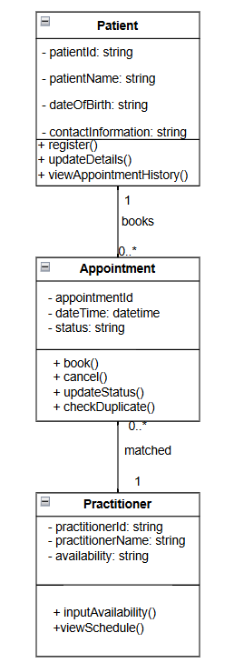

E - AI Design Review
Ask AI to suggest classes and relationships using only confirmed requirements; require supporting requirement IDs.
Prompt: suggest classes and relationships using only confirmed requirements; require supporting requirement IDs.

F - Compare and Decide
Record at least one accepted, modified and rejected AI suggestion.
🧱 1. Class: Patient - ACCEPTED
Supporting Requirements:
- FR-04 (search for patient information)
- In Scope: Manage patients, Record patient information
- User Story: patient wants to view contact information
Attributes (suggested)
- patientID
- name
- contactInformation
Suggestion Validity
- Attributes are evidence-based, because the system must store and retrieve patient information.
- ContactInformation structure is a question requiring validation, because requirements do not specify which fields (phone/email/address).
🧱 4. Class: SystemAdministrator – MODIFIED
Supporting Requirements:
- FR-10 (system can be updated and patched)
- User Story: schedule system updates
Attributes (suggested)
- adminID
- updateSchedule
Suggestion Validity
- Class is evidence-based, because update scheduling and patching are confirmed requirements.
- updateSchedule structure is a question requiring validation, because requirements do not define how updates are stored.
🧱 5. Class: ClinicManager - REJECTED
Supporting Requirements:
- FR-12 (generate basic reports)
- User Story: generate basic reports
Attributes (suggested)
- managerID
Suggestion Validity
- Class is evidence-based, because report generation is confirmed.
- Report contents require validation, because “basic reports” is undefined.
🔗 Relationships (with requirement support)
1. Patient 1.. — 0.. Appointment**
Evidence-based:
- FR-01 (record bookings)
- FR-04 (search patient information)
- Appointment must reference a patient.
2. Practitioner 1.. — 0.. Appointment**
Evidence-based:
- FR-02 (availability)
- FR-05 (search practitioner information)
- FR-11 (practitioner inputs availability)
- Appointments require a practitioner.
3. Practitioner 1 — 1 Schedule/Availability
Evidence-based:
- FR-02 (display availability)
- FR-11 (input availability)
Validation needed:
- Whether availability is a separate class or just an attribute.
4. SystemAdministrator 1 — * UpdateSchedule
Evidence-based:
- FR-10 (system updates)
- User Story (schedule updates)
Validation needed:
- Whether updates are stored as objects or simple timestamps.
5. ClinicManager 1 — * Report
Evidence-based:
- FR-12 (generate basic reports)
Validation needed:
- What constitutes a “basic report”.

G - Python Skeletons
Create simple Patient, Practitioner and Appointment class skeletons.
class Patient:
patient_id = x
patient_name = y
contact_information = z

def update_information():
pass

def view_appointment_history():
pass

class Practitioner:
practitioner_id = x
practitioner_name = y
availability = z

def input_availability():
pass

def view_schedule():
pass

class Appointment:
appointment_id = x
date_time = y
status = z

def book():
pass

def cancel():
pass

H - Consistency Check
Check model-code consistency; do not implement full behaviour yet.

Reflection
What modelling decision was hardest? Where did AI over-design? What evidence supported your final choices?
The hardest modelling decision was in regards to the appointment, as unlike patient or practitioner is a function rather than a user. For this task AI did not over design and did give decent suggestions, I believe AI took my prompt and didn’t go too complex. For the time being, I accepted only patient and clinic manager and system administrator were modified or rejected as this is the beginning of the project and I want to understand the system more before I can consider suggestions for any other class other than patient, practitioner and appointment.

