SmartCare v0.3 - Domain Model Workbook
Week 6 student resource

Requirement-to-Concept Trace
Requirement | Concept | State/behaviour | Decision
FR-01: The system will allow appointment bookings to be recorded. | Appointment | State | Keep
FR-02: The system will display practitioner availability. | Practitioner | State | Keep
FR-03: The system will archive appointment bookings. | Appointment | Behaviour | Keep
FR-04: The system will allow receptionists to search for a patient's information. | Patient | Behaviour | Keep
FR-05: The system will allow receptionists to search for a practitioner's information. | Practitioner | Behaviour | Keep
FR-06: The system will display the clinic's daily schedule. | Appointment | Behaviour | Keep
FR-07: The system will allow receptionists to input an appointment booking into the schedule. | Appointment | Behaviour | Keep
FR-08: The system will allow receptionists to cancel appointment bookings. | Appointment | State | Keep
FR-09: The system will send a reminder via a registered phone number to patients the day before their appointment. | Patient | Behaviour | Keep
FR-10: The system can be maintained and updated by the system administrator. | System administrator | Behaviour | Keep
FR-11: The system will allow practitioners to input their availability into the system. | Practitioner | State | Keep
FR-12: The system will allow the clinic manager to generate basic operational reports on clinic's activity. | Clinic manager | State | Keep
NFR-01: The system must save appointment bookings in schedule within 3 seconds or less 99.9% of the time. | Appointment | Behaviour | Keep
NFR-02: All patient information must be encrypted as per Privacy Act 1988. | Patient | Behaviour | Keep
NFR-03: The system's availability must maintain at 99.9% during peak business hours. | System administrator | Behaviour | Keep
NFR-04: Receptionists must be able to search and find specific patient information in the system within 2 seconds or less 99.9% of the time. | Patient | Behaviour | Keep
NFR-05: The system must be documented for new developers to understand the system code within 1 week. | System administrator | Behaviour | Keep
NFR-06: The system must provide feedback to user on system activity. | System administrator | Behaviour | Keep

CRC Cards

Patient
Responsibilities | Collaborators
Store patient details | Appointment
View appointment history | Appointment

Practitioner
Responsibilities | Collaborators
Input availability | Appointment
View schedule | Appointment

Appointment
Responsibilities | Collaborators
Book/cancel/update appointment | Patient
Book practitioner | Practitioner

UML Class Diagram
Insert/draw UML here. Include defensible relationships and multiplicities.
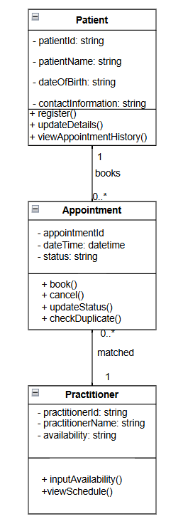

Design Rationale
Explain class selection, responsibility allocation and key relationships.
Class selection of patient, practitioner and appointment were chosen as they are the basic classes for the system. The responsibilities they were each given are based on its own data. They were given attributes and methods that relevant to them. As for the relationships, patient is related to appointment, and then appointment is related to practitioner.

AI Design Review Record
Prompt:
Please fill this table: AI suggestion Evidence Decision Reason Model change (5 rows) for this design rationale: Class selection of patient, practitioner and appointment were chosen as they are the basic classes for the system. The responsibilities they were each given are based on its own data. They were given attributes and methods that relevant to them. As for the relationships, patient is related to appointment, and then appointment is related to practitioner.
AI suggestion | Evidence | Decision | Reason | Model change
Clarify minimum attributes for Patient (e.g., contact info fields) | Assumption requiring validation — requirements say “record patient information” but do not specify fields. | Accept | Patient must exist, but attribute details need stakeholder confirmation. | Add placeholder attributes; mark detailed fields as TBD.
Include Practitioner availability as a structured element (e.g., time blocks) | Evidence‑based — FR‑02 and FR‑11 require displaying and inputting availability. | Accept | Availability is a confirmed requirement and must be represented. | Add an Availability attribute or separate class linked to Practitioner.
Appointment must link to both Patient and Practitioner | Evidence‑based — FR‑01, FR‑07, FR‑08 require booking, scheduling, cancelling. | Accept | Appointment cannot exist without both parties; confirmed by multiple FRs. | Keep Appointment with FK links to Patient and Practitioner.
Define Appointment status values (booked, cancelled, archived) | Assumption requiring validation — status is implied but not defined. | Accept | Status is needed for FR‑08 (cancel) and FR‑03 (archive), but values must be confirmed. | Add a status attribute; mark allowed values as TBD.
AI RESPONSE AI RESPONSE My decision AI RESPONSE AI RESPONSE

