**Software Requirements Specification**

**for**

**Copy Cat (CAT)**

**Version 1.0 approved**

**Prepared by Emily Pascua**

**Stephanie Gutierrez**

**Daniel Caceres**

**Marco Argentieri**

**CS 3337 - Jose Macias and Richard Cross**

**October 9, 2017**

# Table of Contents

Table of Contents................................................................................................................... pg 2

Revision History.....................................................................................................................pg 4

1. Introduction................................................................................................................ pg 5
   1. Purpose........................................................................................................... pg 5
   2. Intended Audience and Reading Suggestions................................................ pg 5
   3. Product Scope................................................................................................ pg 5
   4. Definitions, Acronyms, and Abbreviations .................................................. pg 5
   5. References......................................................................................................pg 6
2. Overall Description.................................................................................................... pg 8
   1. Product Perspective........................................................................................ pg 8
   2. Product Functions...........................................................................................pg 8
   3. User Classes and Characteristics....................................................................pg 9
   4. Operating Environment.................................................................................. pg 9
   5. Design and Implementation Constraints........................................................ pg 9
   6. User Documentation...................................................................................... pg 10
   7. Assumptions and Dependencies.................................................................... pg 10
   8. Apportioning of Requirements...................................................................... pg 10
3. External Interface Requirements............................................................................... pg 12
   1. User Interfaces............................................................................................... pg 12
   2. Hardware Interfaces....................................................................................... pg 14
   3. Software Interfaces........................................................................................ pg 14
   4. Communications Interfaces........................................................................... pg 15
4. Requirements Specification....................................................................................... pg 16
   1. Functional Requirements............................................................................... pg 17
   2. External Interface Requirements................................................................... pg 19
   3. Logical Database Requirements.................................................................... pg 19
   4. Design Constraints......................................................................................... pg 20
5. Other Nonfunctional Requirements........................................................................... pg 22
   1. Performance Requirements............................................................................ pg 22
   2. Safety Requirements...................................................................................... pg 22
   3. Security Requirements................................................................................... pg 22
   4. Software Quality Attributes........................................................................... pg 22
   5. Business Rules............................................................................................... pg 22
6. Other Requirements....................................................................................................pg 24

Appendix A: Glossary............................................................................................................ pg 25

Appendix B: Analysis Models............................................................................................... pg 26

Appendix C: To Be Determined List......................................................................................pg 27

# Revision History

|  |  |  |  |
| --- | --- | --- | --- |
| **Name** | **Date** | **Reason For Changes** | **Version** |
| Everyone | 10/2/2017 | Document missing information | .000005 |
| Everyone | 10/4/2017 | Document missing information | .00001 |
| Daniel Caceres | 10/7/2017 | Document missing information | .005 |
| Stephanie | 10/8/2017 | Document missing information | .01 |
| Marco & Emily | 10/8/2017 | Document missing information | .5 |
| Everyone | 10/8/2017 | Final touches | 1.0 |

# 1. Introduction

This document describes the android application Communication with Automated Translation (CAT) also known as CopyCat and its many functions which include immediate translation between languages through messaging. It also goes over the many intended requirements of the project. CopyCat android-only instant messenger software with automatic translation among a group of people. Our instant messenger will be a phone application and will rely on a unique username to register onto the system. The app will support notification of an incoming text. Every user shall be able to select the language that they would want to read the incoming text in.

## 

## 1.1 Purpose

This SRS document is version 1.0 and contains specifics of the instant messenger application: CopyCat. In this document, the application’s functions, purpose and proposed requirements are described in a software engineer’s perspective as well as business individual’s standpoint making this document incredibly flexible to all types of people. In general, this document is meant to outline the design of CopyCat.

## 1.2 Intended Audience and Reading Suggestions

The SRS document contains the overall details, descriptions, and instructions of this project accessible to the many readers interested in the project. This document is intended to be viewed by the developers to review the content of the project in full detail and to understand the purpose of the project and its path of execution. This document is also meant to be viewed by the user to understand any phrases, such as acronyms, used in this to get a coherent understanding of the materials used in this project. This document is designed for a tester to understand the contents of the project such as its requirement details.

## 1.3 Product Scope

CopyCat is an android application that will help users communicate throughout the globe or amongst individuals who speak different languages. CAT will achieve this by supporting automated real-time translation with instant messaging.

## 1.4 Definitions, Acronyms, and Abbreviations

CAT - Communication with Automated Translation

GUI - Graphical User Interface

API - Application Program Interface

HTTP- Hypertext Transfer Protocol

JSON- JavaScript Object Notation

RPC- Remote Procedure Call

## 1.5 References

Google Translate API

Author: Google

Version Number: Not specified

Date: 9/11/17 - End of Project

Source: https://cloud.google.com/translate/

Google Translate API Documents

Author: Google

Version Number: Not specified

Date: 9/11/17 - End of Project

Source: Cloud.google.com/translate/docs/

Android Studio Documentation

Author: Creative Common Attribution

Version Number: 2.5

Date: 9/11/17 - End of Project

Source: <https://developer.android.com/studio/intro/index.html>

CSULA Server

Author: CSULA

Version Number: Not specified

Date: 9/11/18 - End of Project

Source: cs3.calstatela.edu:8080/cs3220stu/

Socket.io Documentation

Author: MIT

Version Number: Not Specified

Date: 9/11/18 - End of Project

Source: <https://socket.io/docs/>

# 2. Overall Description

CopyCat (CAT) is an android-only instant messenger software with automatic translation among a maximum of five people. Our instant messenger will be a phone application for Android 5.0 smart phones. The application will rely on a unique username to enter the chat room and distinguish and communicate amongst the other users. The application may support private messaging so users can talk to other users outside of the general chatroom. On top of that, the application will support notification of an incoming text. Every user shall be able to select the language they would want to read the incoming text and will also get to choose the language they’re currently speaking. The language the user has chosen to read will be used to translate the other user’s languages so that the said user understands what every other user in the chatroom is saying.

## 2.1 Product Perspective

The software application is similar to most chatting apps currently on the market. Like the many chat apps users will create an account and have access to a list of contacts in which they are able to communicate with. The big difference this application will have to most communication applications is the instant translation feature. The instant translation feature will translate what the user communicates to the language specified to the receiving end. The motivation for this application is to be able communication with others that know different languages that of the users.

## 2.2 Product Functions

* Login screen: will allow the user to sign onto CopyCat.
  + Unique username: will allow other users to distinguish amongst each other
* Instant messaging: In a chat room environment, users will have the ability to communicate among each other real-time.
  + Automatic translation: ability to choose what language received language
  + Communication amongst a group of people
  + User will be notified when new message is received
  + Users can also send pictures to each other
* List of Contacts: shows users who are in chat currently. Users will be listed by their unique usernames.
* Settings: User will have the ability to change some already-inputted information.
  + The user will have the ability to change their already chosen unique username.
  + The user will have the ability to change the language they’re reading in and the language they’re typing in.
* Android only.

## 2.3 User Classes and Characteristics

* Cross-seas business meetings
  + Frequency of use: High
  + Technical Expertise: Basic Smartphone Usage Skills
  + Educational Level: Basic Reading Skills
  + Characteristics: Two different languages minimum, chat system used to translate

back and forth in between messaging conversations to communicate on a professional level.

* Multi-language Families
  + Frequency of use: Intermediate
  + Technical Expertise: Basic Smartphone Usage Skills
  + Educational Level: Basic Reading Skills
  + Characteristics: Two different languages minimum, chat system used to translate back and forth in between messaging conversations to communicate in a casual setting.
* Students
  + Frequency of use: Intermediate
  + Technical Expertise: Basic Smartphone Usage Skills
  + Educational Level: Basic Reading Skills
  + Characteristics: Application can be used without translation when communicating but can be if needed with students who speak other languages in both professional and casual setting.

## 2.4 Operating Environment

The application will live on Android 5.0 and later devices. Google Translate API is a software application that will help guide our project to function properly.

## 2.5 Design and Implementation Constraints

* Hardware Limitations
  + Only Android Devices will be able to use the application.
  + Non-Android Devices such as the iPhone won’t be able to use application.
* Translation Limitations
  + The translation within the Application will be done with Google Translation API, therefore following Google Translate's translation limitations.
  + Any user typos or slang won’t be translated due to Google Translator's inability to translate errors.
  + In a case of the user puts the incorrect language (either the language they’re reading in or the language they’re typing in), then incoming text will fail to display or translate in the language they desire.
  + There may be some grammatical errors in the translated text.
* Memory Constraints
  + User won’t be able to revisit previous messages once application was closed.
  + Application may only be able to hold a chatroom of only five people.

## 2.6 User Documentation

* SRS Documentation
  + Includes the software requirements and functions in an average individual’s understanding to a more technical software engineer’s perspective.
* CopyCat website
  + Includes user friendly information about the application (importance, the authors, and how to use the application) and how to get the application on user’s android device.

## 2.7 Assumptions and Dependencies

* The Application will be using Google Translation API.
* The Application will also use Android 5.0. Possible issues will be when a newer version of Android is released causing it to be outdated.

## 2.8 Apportioning of Requirements

* Friends List: will allow users to add each other on a listed friends list and communicate privately amongst each other one-on-one outside of the chat room.
* Photos: sending photos to each other on the group chat and (if implemented) individually.
* Password: User will be able to register with a unique username and a password then will be able to sign back onto their account if program was closed.
  + Unique username may require a phone number.
* User features:
  + Ability to change the font size, and messenger’s theme.
  + Ability to change unique username once already chosen.
  + Ability to add friends.

# 

# 3. External Interface Requirements

## 3.1 User Interfaces

**1.1 Screen Layout**

1.1.1 Main Screen

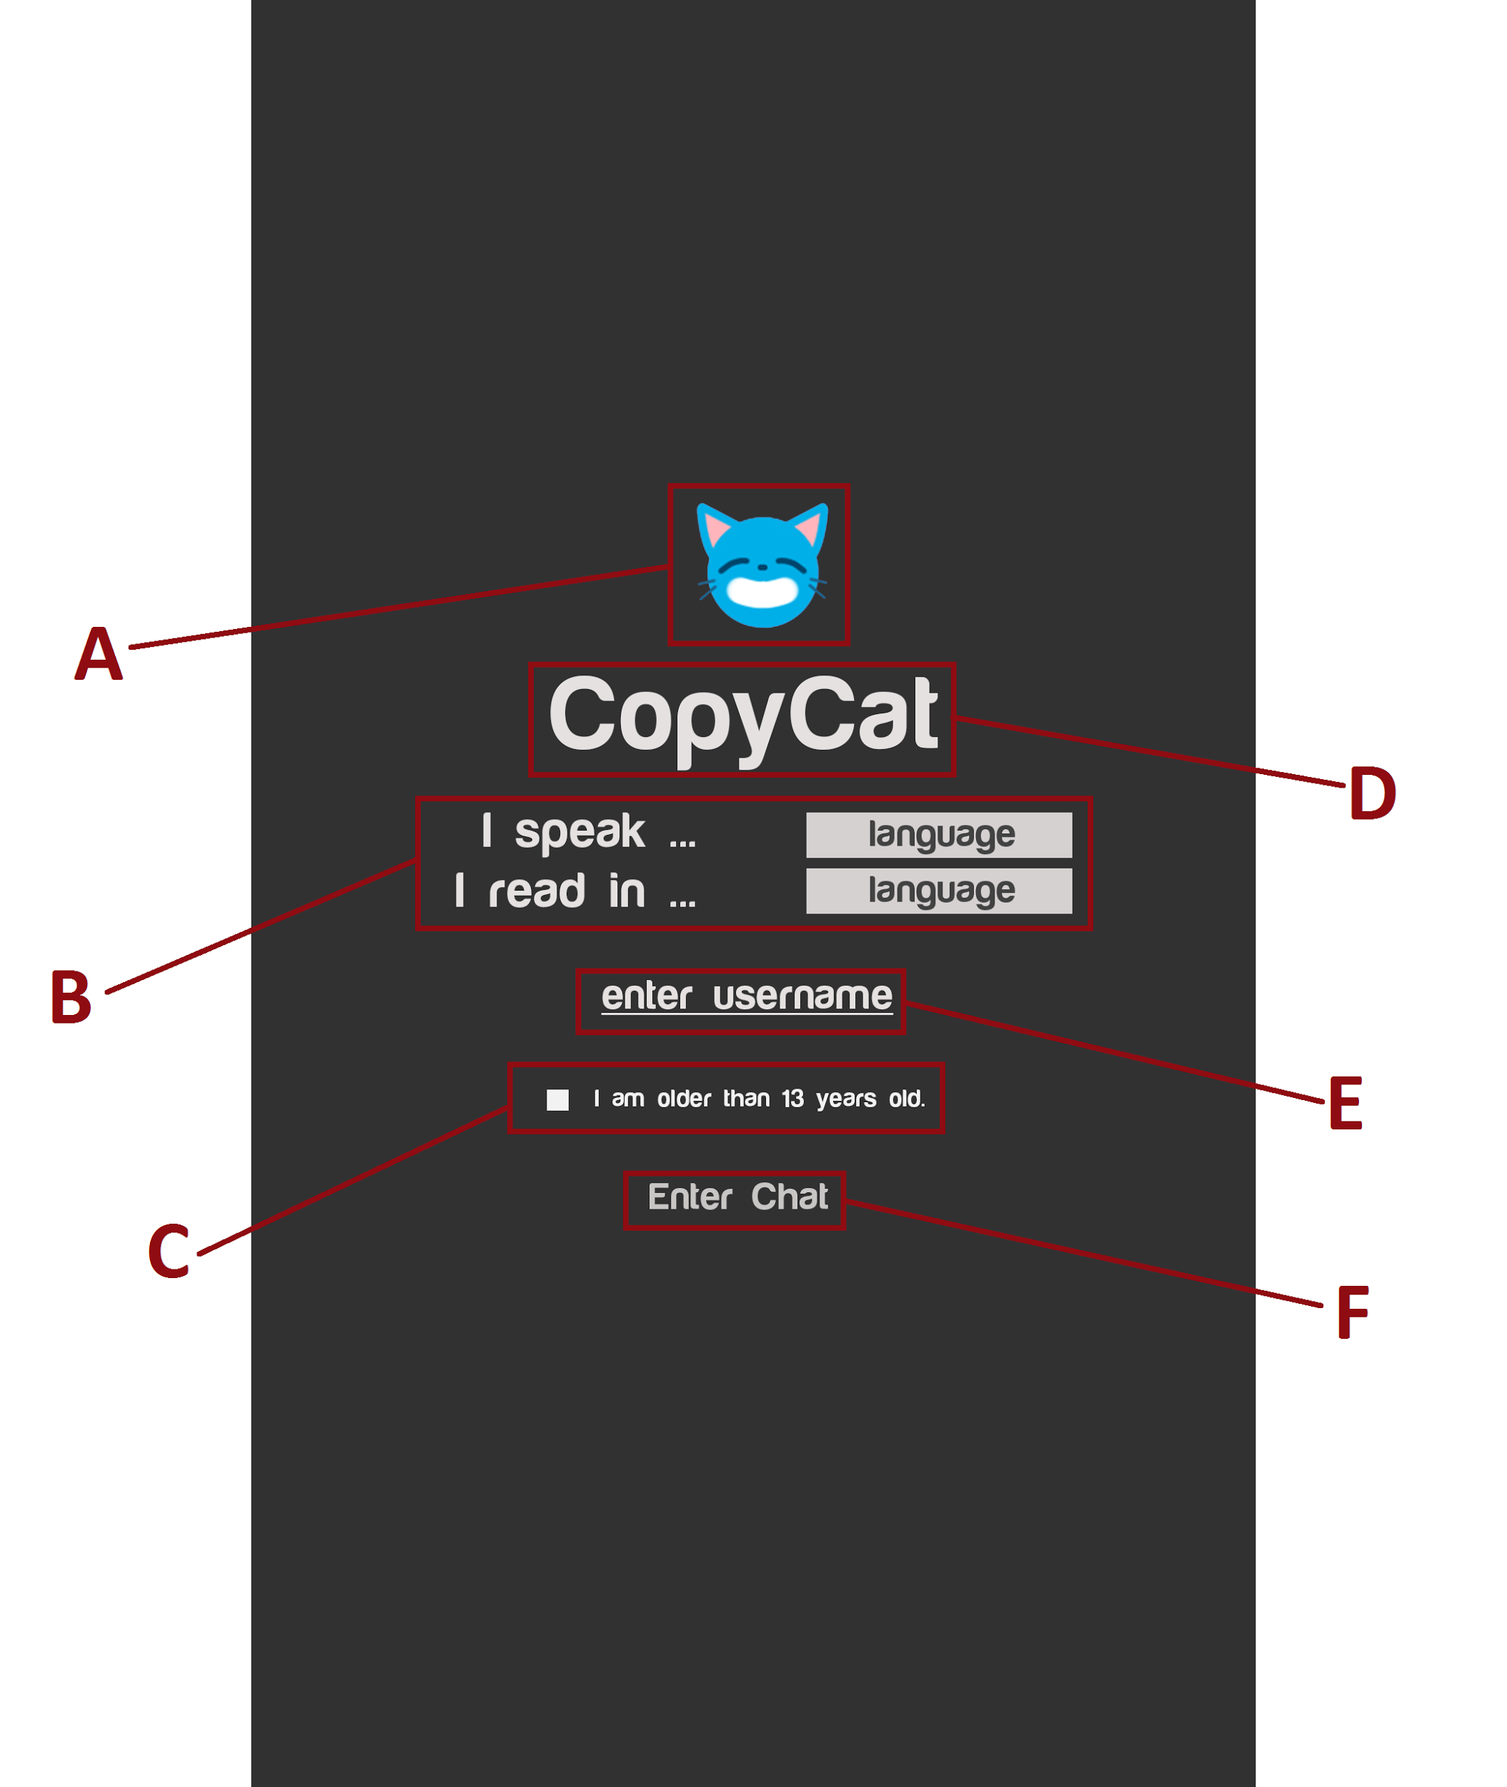

**Figure 1** extremely temporary intended layout for the

entrance page, changes will likely be made.

A. Logo

* Displays CopyCat’s logo.
* This will be an image.

B. Language

* Displays a drop down list prompting the user to select what language they speak in and what language they want to read incoming text in.
* Uses font Harabara Mais Demo.

C. Age Restriction

* Checkbox that requires the user to be of age in order to join chat room.

D. Main Header

* Displays name of application: CopyCat.
* Uses font Harabara Mais Demo in hex color #e0dcdc.

E. Username

* Text Field for the user’s unique username.

F. Enter Chat Button

* Enter chat button that once pressed user enters chat if all fields (B, E, F) are filled and meet specifications.

1.1.2 General Chat

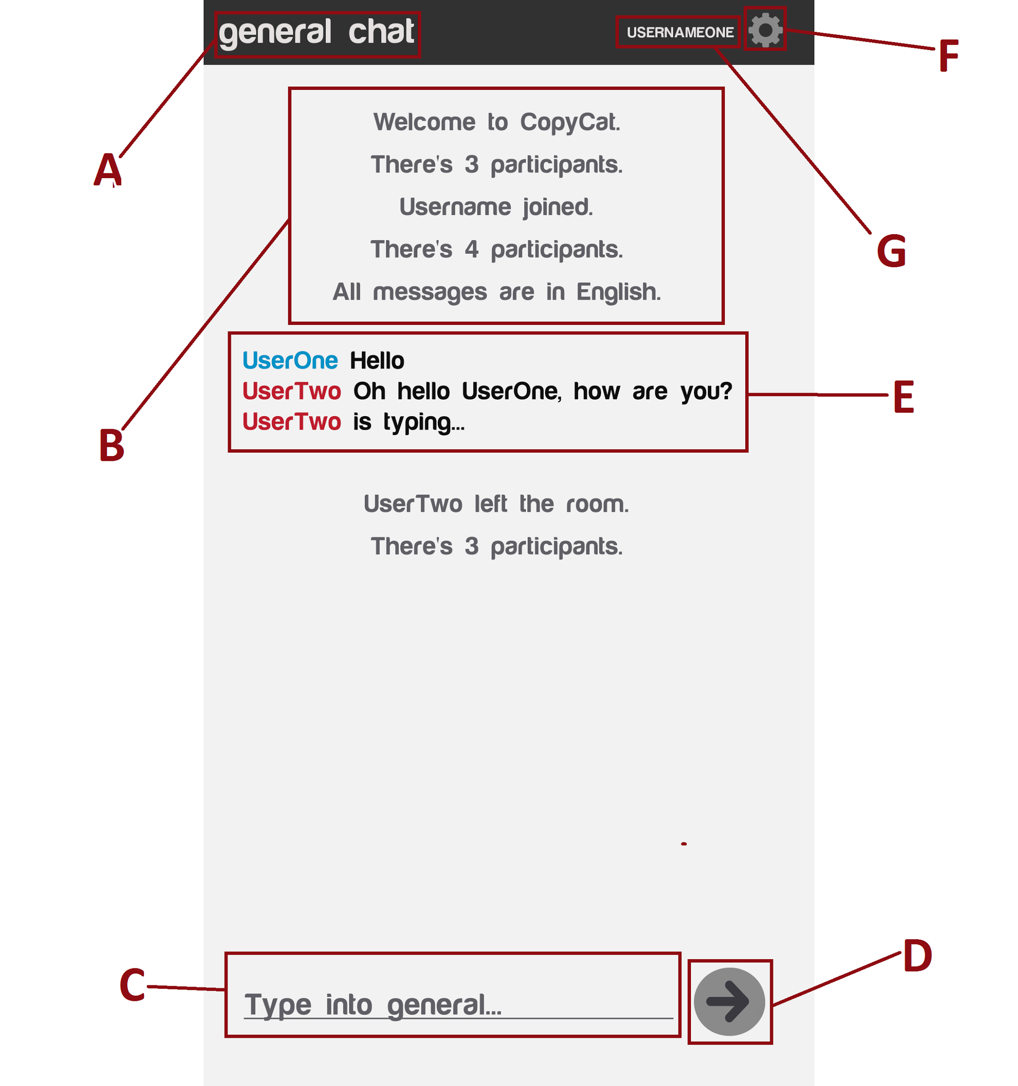

**Figure 2** extremely temporary intended layout for the

general chat, changes will likely be made.

A. Main Header

* Displays the name of the current chat.
* Uses font Harabara Mais Demo in h1 in hex color #e0dcdc.

A.1 General Chat

* If the user is in the general chat, then the main header will display “general chat”.
* If the user enters a private chat, the header will change from general chat to private chat (Refer to A.2 Private Chat).

A.2 Private Chat

* If the user isn’t in the general chat and is instead in the private chat, then the main header will display the unique username of whom the user is in a private chat with.
* If the user exits the private chat, then the header will change back to general chat.

B. System Message

* Displays the system messages which includes: introductory message, number of participants, the unique username of new users who join the chat, and what language the user is reading in.
* Uses font Harabara Mais Demo in hex color #5f5f65.

C. Text Field

* Displays the text the user types in.
* Uses font Harabara Mais Demo in hex color #99999c.
* If user’s message is longer than text field, message will follow the latest typed character and message will drag along it.

E. Message Section

* Displays the translated text from corresponding users.
* Each unique user will have any of the following hex colors assigned to them (max five capacity): #2d9ecd, #c54853, #9549c5, #5dc549, and #c5a949.

D. Enter Button

* Allows the user to submit their message by pressing on icon.
* This button will be an image.

F. Settings

* Re-navigate to the settings windows which includes the translation settings, general settings, and the sign-out.

G. User Name

* Displays the unique username of the user in all caps.
* Uses font Harabara Mais Demo in hex color #e0dcdc.

## 3.2 Hardware Interfaces

The supported devices are devices that run Android version 5.0 and later. The software will use the keyboard function from the device in order to relay messages to the person they are speaking with. The software will also utilize the internet in the device in order to communicate with other users on the application.

## 3.3 Software Interfaces

* Google Translate API https://cloud.google.com
* nodeJS 8.6.0 https://nodejs.org/
* socket.IO 2.0 <https://socket.io/>

We will be using Google Translate API which is highly responsive integrating dynamic translation and language detection. We will use the API by making direct HTTP requests to the server, as well as using Cloud API client libraries. We will use the clients to access the API via HTTPS request, and the HTTP body will use JSON arrays to support RPC methods.

## 3.4 Communications Interfaces

The application will be using cs3.calstatela.edu server to launch. Also, the application may also have a launch website that will contain information on the application and guide users how to get on their android device.

# 

# 4. Requirements Specification

**1.1 Login Screen**

* The system shall have a login screen that will require a unique username.
* The system should require a password to authenticate.
* The system shall require the user to choose a language to read the messages.
* The system shall require the user to choose a language to type the messages.
* The system shall have an age requirement checkbox to assure the user is of proper age.
  + The system won’t allow the user to enter the chatroom if they don’t meet the age requirements.
* The system shall allow the user to pick their desired language they would want to view incoming languages in.
  + The system shall allow the user to change this by navigating the settings.

**1.2 Username**

* The system shall require a username from the user that is unique to the entire chat.
  + The system shall allow the user to pick any username as long as it’s unique.
* The system may allow the user to use their phone number as a unique key to later allow them to change their username.

**1.3 Password**

* The system may have a password to register the user.
* The system may allow the user to change their password.

**1.4 Instant Messaging**

* The system shall be able to send messages back and forth between two or more users
* The system shall notify the user whenever a new message is received.
* The system shall allow the user to view other users who are present in the chatroom.
* The system shall allow the users to view what users are in the room via their unique username.
* The system shall notify the chat room whenever other users have entered or left the chat
* The system shall notify the chat room when another user is currently typing.

1.4.1 Translation

* The system shall allow the user to pick the desired language they want to read from users.

1.4.2 Sending Pictures

* The system may allow the user to send pictures among each other via the group chat.
* The system may allow the user to send pictures among each other individually via chat.

**1.5 Navigation Tab**

* The system shall have a menu page directing the user to assorted options in the application.
* The system shall have a sign out option that will allow the user to leave the chatroom and be prompted to the login screen.

1.5.1 General Chat Room

* The system should show the current chat that the user is connected to.
* The system may show the various chats that the user has connected to.

1.5.2 Settings

* The system shall have two different settings: the general settings and the translation settings.

1.5.2.1 General Settings

* The system shall give the user the option to allow notifications.
* The system shall give the user the option to change the language the user reads in.
* The system shall give the user the option to change the language the user types in.

1.5.2.2 Translation Settings

* The system shall give the user the option to change the language they are speaking in and the language they want to read in.

1.5.3 Friend list

* The system may allow the user to navigate the add friend tab through the navigation page.
* The system may allow the user to add a friend by entering their unique username through the navigated add friend tab.
* The system may allow the user to view the date when they added their friend.

1.5.3.1 Private Chat

* The system may allow the user to privately chat to an added friend via friend list (refer to 1.5.3).

## 4.1 Functional Requirements

**1.1 Main Screen**

1.1.1 Username

* The system shall only accept the user to enter the chat room if they enter a valid unique username, else they will be confronted with error message: invalid username.
* The system shall only accept a username of string length less than or equal to maximum characters or greater than or equal to minimum characters, else user will be confronted with error message: invalid username.

1.1.2 User Conditions

* The system shall have the user accept the terms of conditions before entering the chatroom else, they will be confronted with error message: conditions not met.
* The system shall assure the user is of less than required age restriction else, they will be confronted with error message: conditions not met.

1.1.3 Password Requirements

* The system shall only accept user’s inputted password if password doesn’t exceed the maximum string length, else user will be confronted with error message: password is too long.
* The system shall only accept user’s inputted password if password isn’t below minimum string length, else user will be confronted with error message: password is too short.
* The system shall only accept user’s inputted password if password isn’t identical to said user’s unique username, else user will be confronted with error message: password can’t be the same as your username.
* The system shall only accept user’s inputted password if password has at least one capital character, else user will be confronted with error message: password is missing a capital letter.
* The system shall only accept user’s inputted password if password has at least three numbers *n*, else user will be confronted with error message: password is missing “amount of inputted numbers - *n*” numbers.

**1.2 Messaging**

* The system shall only accept a message if there is a message typed if there isn’t a message typed into the chat box, then the user won’t be able to submit the message.

1.2.1 Translation

* The system shall only translate the message from user if and only if user one and user has two different registered under languages.
* The system shall input message in the user’s chosen language only if user’s chosen language is different from language of the corresponding user’s language.
* The system shall output message translated to user two’s language only if user’s chosen language is different from language of the corresponding user’s language, else the corresponding user’s language will be left alone.
* The system shall leave the inputted text in original language if wasn’t able to translate (due to grammatical and spelling errors in original language).

1.2.2 Sending Pictures

* The system shall only accept and post image if image is below application’s required maximum picture size (pixels), else picture won’t be posted and outputted error message: picture is too huge.
* The system shall only accept and post image if image file is of the following extensions: png, jpg, or gif, else picture won’t be posted and outputted error message: picture of wrong extension.

**1.3 Navigation Tab**

1.3.1 Translation Settings

* The system shall only update the language if the language spoken or the language read differs from the previous inputted language spoken or language read, else the language will remain the same.

1.3.2 General Settings

* The system shall only update any changes made in general settings if they differ from the previous information.

1.3.3 Sign out

* The system shall log and redirection the user back to the entrance page if pressed.
* The system will notify the chatroom that the user has left the chat.

## 4.2 External Interface Requirements

1.1 User Login

* The system shall require input to the software for when the user signs into the application is the username followed by the password; the purpose of this information is to connect the user to their account. This relates to the messages that the user will be sending.

1.2 Translation

* The system shall use another form of input is the messages, messages will be translated upon input, the output will be the translated message in the language designated by the user on the opposite end.

1.2.1 Google API

* The system shall require the user to input the type of language they will speak in. This data will be used with the translation API. The user will also input the type of language they shall read in. This data will be used with the translation API and convert the received message into the selected language of choice.

1.3 Messages

* The system shall send information in JSON format for parsing and generating.

## 4.3 Logical Database Requirements

1.1 User Assets

* The system shall use the database to store the userID and the user’s preferred language to read and speak in.
* The system may use the database to store user password, user email, user phone number.
* The system shall use the database to take keep information that may be lost if the application was closed.

1.2 Translation

* The system shall save previously displayed messages in the database for a short amount of time (to translate).
  + The system shall save these messages to be used and processed through the API translation.

1.3 Time and Dates

* The system shall save the last time the user has connected to the application will be stored into the database to show when the user has last used the application.

1.4 Friend list

* The system shall save the user's contact list and will be stored in the database so that if the application was closed, the friends list would be saved once logged back on.

## 4.4 Design Constraints

1.1 Translation API

* The system may mess up the translation, if the incoming text was not accurate but implied it will therefore lose meaning once processed through translation.
* The system may mess up translation of slang or street language due to Google’s inability to detect slang or street language.

1.2 Device

* The system shall only allow the application to be able to be used by Android supported devices, Windows and IOS phones will not have access to the application.

1.3 Username and Password Retrieval

* The system shall not be able to recover loss information, if a user loses their password or username, then they won’t be able to retrieve them.

1.4 Oversized Photos

* The system shall not be able to to support large photos that exceed picture size limits; if the user tries to post a picture larger than the maximum size in the chat box, it won’t be resized, and instead the user will have to resize the photo outside the application and retry.

1.5 Full Chatroom

* The system may not allow the user to enter the chatroom once the chatroom reaches the maximum capacity (5 unique users), then nobody else will be able to join the application and will have to wait and retry.

# 

# 

# 

# 5. Other Nonfunctional Requirements

## 5.1 Performance Requirements

* A total of five users will be supported in the general chat box.
* Users can communicate with only five other users individually.
* Messages will be handled via our server which will use the Google Translate API to handle messages that are in a foreign language.
  + Messages that remain the same language will the same language and won’t be “retranslated” or won’t go through the translation if they’re the same language.
* Messages in the message box will be reset once met maximum characters for message box.

## 5.2 Safety Requirements

1. An age restriction will be applied to prevent accidents regarding underage users.
2. Algorithm to stop blatant spamming (which may create a slow-down).
3. Once the chat room has reached the maximum number of characters, the application will reset the chat room of any past messages to prevent the application from crashing.
4. A restriction of only five users at a time to prevent the application from crashing.

## 5.3 Security Requirements

* Users will be identified by their phone number.
* Users will have a password only known to them. Other users won’t have access to this information.

## 5.4 Software Quality Attributes

The application itself will be completely reusable. The Google Translate API is maintained by Google, a very respected tech company. The translation service is reusable, but may not be 100% accurate due to the nature of its complexity.

## 5.5 Business Rules

A. Translation:

A user will choose a language to read in, and the language in which they are typing in. Therefore, a user may theoretically want to type in English and wish to read in Spanish. Essentially the rule is that the user must choose the parameters of which language they want to read and write.

# 

# 

# 

# 

# 

# 

# 

# 

# 

# 

# 

# 6. Other Requirements

* The application will need to be translated to multiple languages for the use of the intended audience which are users all around the world.
* Users must be over the age of 13 to use the application. Users under the age of 13 require parental guidance/permission.

**Appendix A: Glossary**

Refer to section 1.4 of section 1.

# Appendix B: Analysis Models

This project didn’t use any analysis models.

# Appendix C: To Be Determined List

This project doesn’t intend to use any new references.