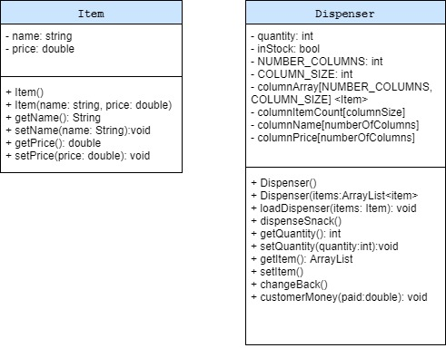

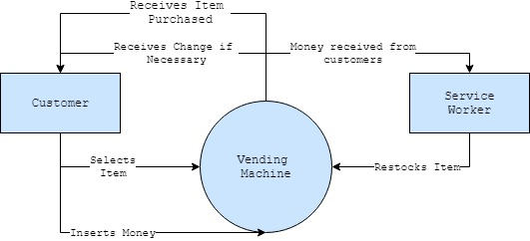

**Customer Input:**

A1

A2

A3

A4

B1

C1

D1

E1

B2

C2

D2

E2

B3

B4

C3

C4

D3

D4

E3

E4

OK

You just purchased:

*Item name*

Cancel

OK

Are you sure you want to purchase?

**User is able to input their selection, amount of money, and then purchase the item. Once selection has been made, a confirmation box will appear. This will verify that the customer wants to continue their purchase. The customer is then notified that their purchase has been made.**

Selection

Insert:

Purchase

**Service Worker:**

OK

*Item* has been restocked.

Updated quantity: *item quantity*

Cancel

Update

Quantity:

Select item to restock:

**Service worker can update stock by clicking on the restock button. They are then able to input which item to restock as well as increase the quantity of the item. They are notified when the item has been restocked and is shown the updated quantity of the item.**

Restock

E4

E3

D4

D3

C4

C3

B4

B3

E2

D2

C2

B2

E1

D1

C1

B1

A4

A3

A2

A1