**Emily Raventos – Personal User Manual (Chapter 1)**

**My Style**

I like to get things done. I can be enthusiastic about projects/assignments. When I have a task or a deadline, I like to have a plan to complete it. I’m detail oriented and tend to be a perfectionist. My personality, based on the Myers Briggs Personality test, is ISFJ. I’m an introvert, but I do have social tendencies. I love working by myself but also can work well with a team. I really appreciate kindness in the workplace and love it when team members are willing to pause what they’re doing to help someone else if needed.

I can be indecisive on little matters, when I do make decisions, I like to consider every factor and often make pros-cons lists to help me decide. I don’t tolerate rudeness, whether it’s with me or a teammate and I don’t tolerate laziness. People need to pull their weight in group assignments.

**What I value**

Some of the things I value are honesty, participation, hard work and fun. It’s important to me to be able to have fun while I work without compromising too much of my team’s efficiency or productivity. Everyone has different strengths and it’s important to me that every member of the team participates and tries to help. In addition to that I love having fun! Who doesn’t? I love being able to make jokes or share stories as we work. Find the balance between having a good time and being productive and we’re golden.

**What I don’t have patience for**

I don’t have a lot of patience for people who are too prideful, pushy, or lazy. I have low patience for those who see life as “my way or the highway.” I value good teamwork and a collaborative environment. At the same time though “beating around the bush” or hidden meanings in conversations are not high on the list of things I have patience with. It’s best to be open and up front about things. It’s a lot more efficient when we can get straight to the point, address any concerns, and continue to work. If someone has an idea that they think might work better I’m all ears and try to be open to suggestions, so suggest it!

**How best to communicate with me**

The best way to communicate with me is just by being up front. I’m a pretty open book but realize not everyone’s the same way. I try to give the benefit of the doubt for any misunderstandings. It’s best to clear the air early on before things get confusing. The way I write is usually straight and to the point so if I’m communicating over text, email, etc. it’s good to keep that in mind.

**How to help me**

I’ve been getting better at this, but I don’t always ask for help. One of my weaknesses is that I can be stubborn and once I start working on something I like to figure it out on my own. This isn’t always the best or most effective way, though. Something that I appreciate is when people offer help, even if I don’t need it I appreciate the thought.

**What people misunderstand about me**

One misunderstanding I’ve come across is that people think I get stressed often when working on assignments. I get invested in whatever it is I’m working on and like to get it done. This can be kind of intense sometimes and may give the impression that I’m overly stressed about getting it done. While this may be the case in some situations, I generally just feel the need to get something done efficiently and productively and don’t really like delays. Not because I’m stressed, but because I can get a little too focused.

**Personal User Manual (Chapter 2)**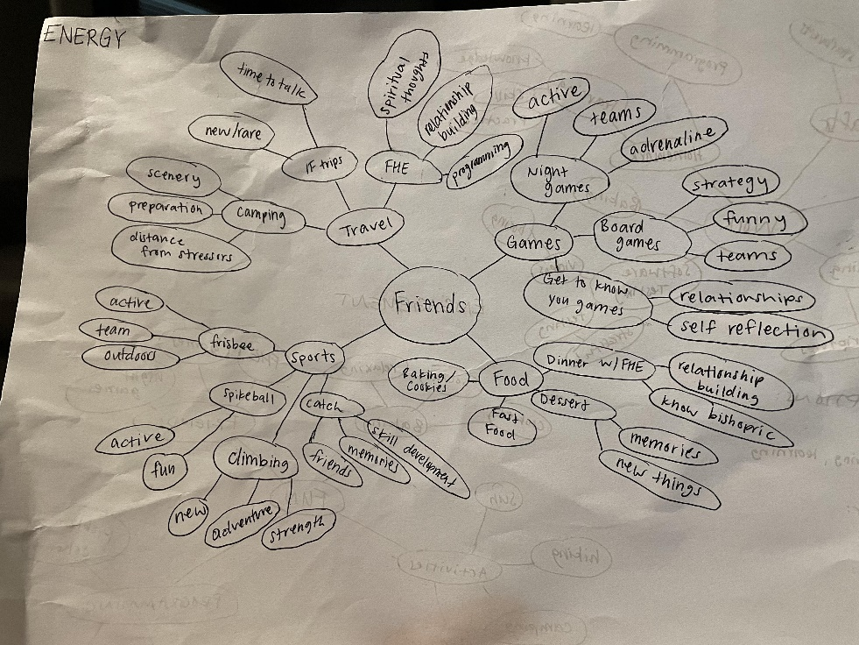

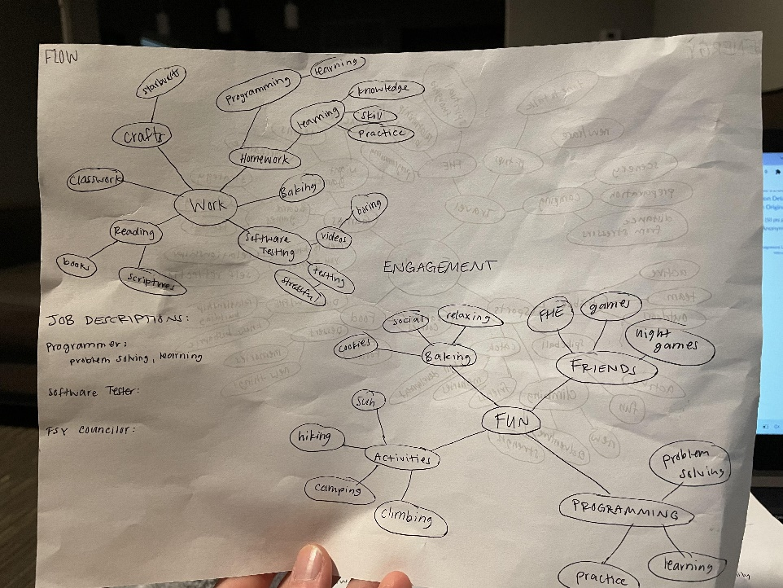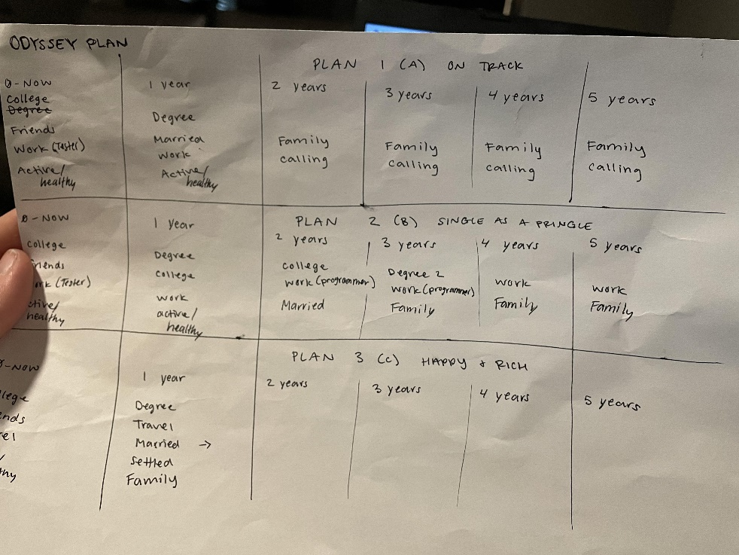

**Good Time Journal**

**Monday:**

1. Work – structured, individual work and meetings, at the apt,
2. Class
3. Helped Kattia
4. Work
5. FHE – energy, engagement
6. Target with friends – energy, engagement
7. Games with friends – energy, engagement

**Tuesday:**

1. Work
2. Skipped class
3. Sun
4. Helped Josh
5. Work
6. Karrie Anne’s with friends
7. Homework
8. Nap
9. Park (catch/frisbee/hammock) with friends
10. Games with friends
11. Pancakes with sister

**Wednesday:**

1. Homework at 5:45
2. Work
3. Clean checks
4. Class
5. Class
6. Class
7. Work
8. Homework

**Thursday:**

1. Work
2. Class
3. Due date moved for Mid-term
4. Sit in the sun
5. Class
6. Hammocking
7. Work
8. Homework
9. Watch “Super 8”
10. Taco Bell
11. Homework
12. Obi-Wan Kenobi

**Friday:**

1. Work
2. Park with Aspen
3. Homework
4. Nature Park with friends
5. Pizza, ice cream and Stranger Things! All night long

**Saturday:**

1. Sleep in a little
2. Homework
3. Grocery Shopping
4. Walk outside
5. Homework
6. Games with FHE guys

Something that surprised me is how much my social life impacts the good times I have. Relationships are so important. I’m an introvert and I still love having those close relationships with friends and family.

**Compass**

Work is so good for you. Doctrine and Covenants 60:13 says, “Thou shalt not idle away thy time…” We are told to be Christlike, serve others, focus outwards. Work is a big way to do that. Work also gives us a purpose, big or small. You can be working on homework and have a purpose, or you could be a fireman/police officer and have a purpose. Totally different scales and ways to view a purpose, but work does give us a purpose.

The Gospel is central to our lives. Working towards building God’s Kingdom, our conversion, relationships, etc. helps us progress and become more like Him. Following the commandments take work, but we receive so many blessings from that.

We should always be working, in one form or another, throughout our life. Occasionally work and life could clash if priorities are mixed up or totally lost. There are times when I get absorbed in work or homework and fail to balance my scripture study and health goals. This is not good, I need to be better at not letting work take over what’s most important in my life.

**Health, Work, Play, Love Dashboard**

