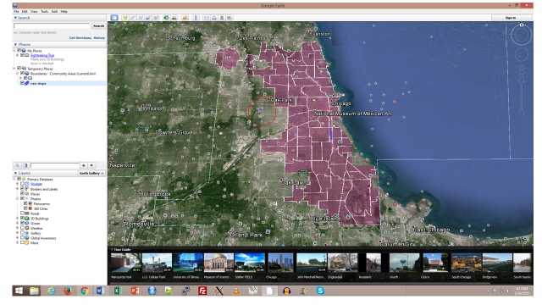

<?xml version="1.0" encoding="UTF-8"?>

<kml xmlns="http://www.opengis.net/kml/2.2" xmlns:gx="http://www.google.com/kml/ext/2.2" xmlns:kml="http://www.opengis.net/kml/2.2" xmlns:atom="http://www.w3.org/2005/Atom">

<Document>

<name>KmlFile</name>

<StyleMap id="defaultStyle">

<Pair>

<key>normal</key>

<styleUrl>#defaultStyle0</styleUrl>

</Pair>

<Pair>

<key>highlight</key>

<styleUrl>#defaultStyle1</styleUrl>

</Pair>

</StyleMap>

<Style id="defaultStyle0">

<LineStyle>

<width>1.5</width>

</LineStyle>

<PolyStyle>

<color>7dff0055</color>

</PolyStyle>

</Style>

<Style id="defaultStyle1">

<LineStyle>

<width>1.5</width>

</LineStyle>

<PolyStyle>

<color>7dff0055</color>

</PolyStyle>

</Style>

<Placemark>

<name>Cat Polygon</name>

<description>MeowMix Neigborhood</description>

<styleUrl>#defaultStyle</styleUrl>

<gx:balloonVisibility>1</gx:balloonVisibility>

<Polygon>

<tessellate>1</tessellate>

<outerBoundaryIs>

<LinearRing>

<coordinates>

-87.80349714293789,41.84311938979147,0 -87.80065301250298,41.84316266503029,0 -87.79827778637693,41.84459643631794,0 -87.79750713656618,41.8453685389298,0 -87.79684069031545,41.846167685342,0 -87.79681581147909,41.84640783059398,0 -87.79609704405529,41.84696940015279,0 -87.79520965121714,41.84735024318839,0 -87.79331483624894,41.84858703752402,0 -87.79340487979056,41.85070823806392,0 -87.80378448709622,41.85039833255646,0 -87.80349714293789,41.84311938979147,0

</coordinates>

</LinearRing>

</outerBoundaryIs>

</Polygon>

</Placemark>

</Document>

</kml>