Emily Webber

Policy Memo

November 12, 2015

Student ID 457896

**Removing the Bias: Elections and Human Emotion**

For the next presidential election, it is clear we must compensate for human emotion. Sixteen years ago the future of the White House was decided by a slim margin of votes recounted by volunteers in Florida. Democrats and Republicans were given equal samples of votes from counties across the state and tagged each as a vote for Al Gore or George W. Bush. A statistical analysis reveals that both Republican and Democrat volunteers were more likely to code a ballot for their candidate of choice, but that Democrats were twice as likely to do so. As policymakers, it is our duty to guard against human error to the fullest extent possible. I recommend recruiting paid ballot coders from among people who did not vote in the election and are not registered with a political party in the United States. This will minimize the bias inherent in political preference, and allow for the election process to continue unhindered.

The volunteers selected for the NORC study of the 2000 election were not allowed to have made a financial contribution to or actively volunteered on a campaign. The researchers then looked at various factors which may or may not be correlated with a difference in re-coding ballots. In particular they calculated the impact of being aligned with a given political party, and how that can be used to assess the probability of coding for a candidate of choice. For both parties, the probability of coding for a given candidate falls if that candidate is of the opposing party, but rises if the candidate is of the supported party. The chart below demonstrates the variety in probability.

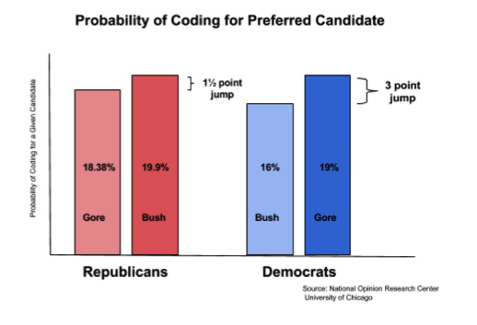

Among Democrats the probability of coding for Bush was 16%, while the probability of coding for Gore jumped 3 points to 19%. Among Republicans the probability of coding for Gore was 18.38%, while the probability of coding for Bush jumped only 1½ points to 19.9%. This demonstrates that political identification has a clear impact on how a volunteer will designate a ballot.

To correct for this flaw of human emotion in the upcoming 2016 election, it is necessary to take action. I recommend recruiting paid ballot coders from people who are not registered to vote and have no political affiliation. With a smaller degree of interest in the outcome of elections, the probability of having biased ballot coding can decrease. This is crucial to preserve the integrity of the democratic process as much as is possible.