Emily Vasquez

Module 7 Final Project

CS-210-18179-M01 Programming Languages

In the program we have a class GroceryBookKeeper.

The class can:

1) Can read Product list given a file

2) Can keep backup on file "/tmp/frequency.dat" with the Products and their frequencies

3) Can print the products and their frequencies

4) Given a specific product, it can print it's frequency

5) Can make a histogram with products and frequencies

In the beginning we need the user to give input the path to the product list.

We check if the file exists and is readable , otherwise the program will exit.

Keep a backup of the products with their frequencies on "/tmp/frequency.dat".

Run a loop until the user selects the option to Exit the program.

In the loop we print the prompt and ask the user to select an option.

If the option is not integer, input is invalid and we ask for new input.

If the option is not one of 1,2,3,4 supported options, input option is invalid so we ask for new input.

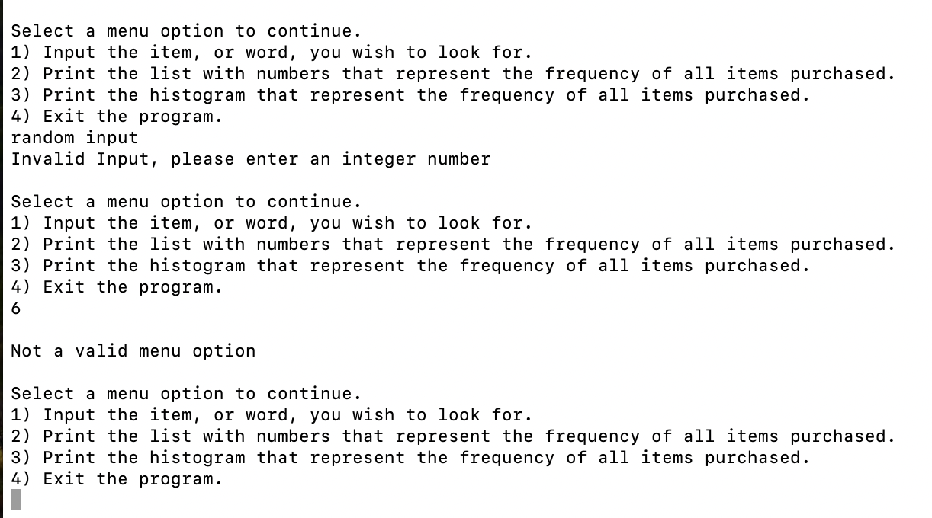

Otherwise, according to the option we perform the corresponding operation.

Option 1: Ask user to input an item name and we print this item with it's frequency (how many times it appears on the input file)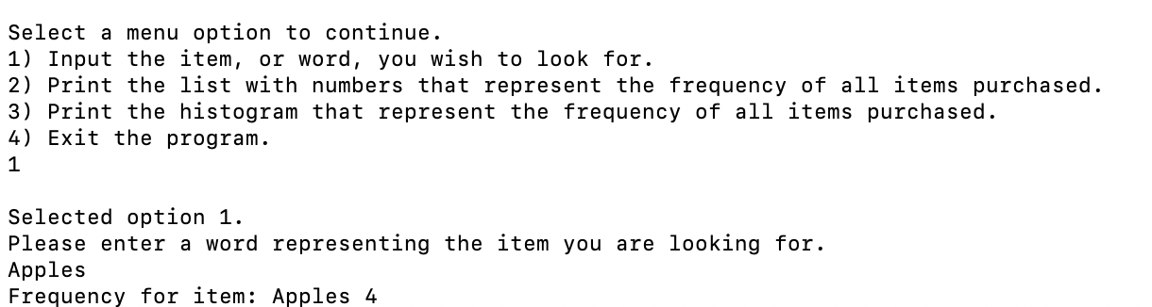

Option 2: Print the list with numbers that represent the frequency of all items purchased.

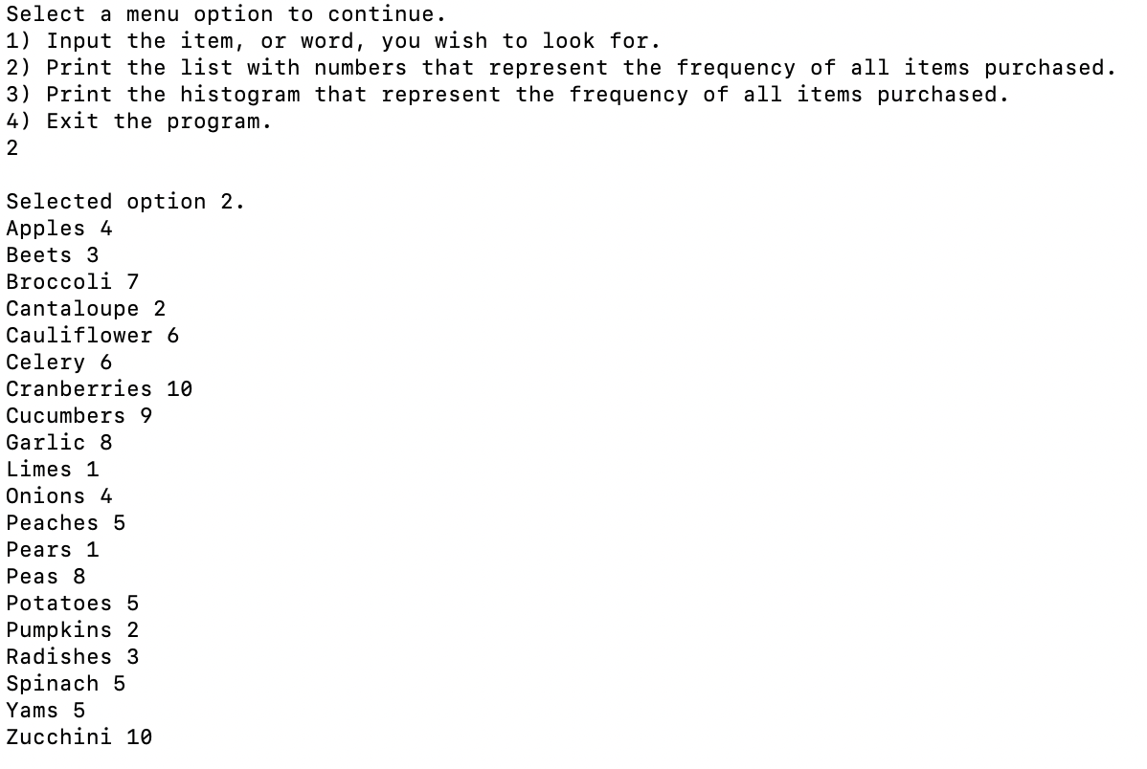

Option 3: Print the histogram that represent the frequency of all items purchased.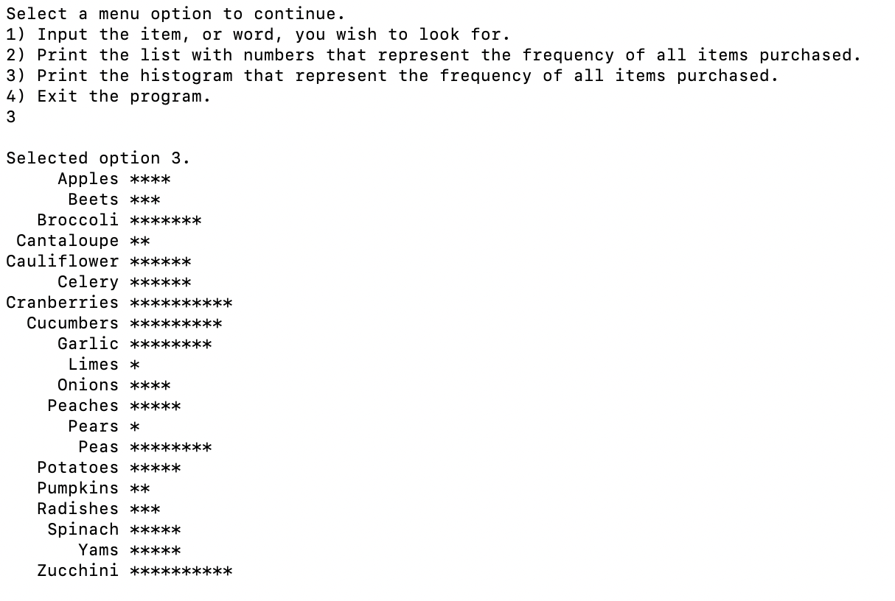

Option 4: Exit the program

