Emily Vasquez
CS-340 Client/Server Development
Module 7 – Project 2
Grazioso Salvare Animal Rescue Dashboard

Project Overview
Grazioso Salvare works to find dogs that are great candidates for search and rescue training. Once trained, these dogs can help rescue people or other animals in dangerous situations. To make this easier, Grazioso Salvare teamed up with a non-profit that runs five animal shelters around Austin, Texas. This non-profit shares their shelter data with Grazioso Salvare.
The company I work for, Global Rain, was brought in to build a dashboard so staff do not have to manually dig through all those shelter records anymore. Instead, they can just open the app, pick a rescue type, and instantly see which dogs fit the criteria.
The app is built with Python using Dash and pulls data from a MongoDB database with records from the Austin Animal Center. When you interact with the dashboard, it queries the database in real time and updates a data table, a breed pie chart, and a map all at once. It was a really fun project because everything reacts dynamically to each other.
Traditional database searching can be a huge pain and super slow. This module makes it way easier by giving programmatic access to the shelter data, letting you run complex queries and get real-time updates. Basically, it turns hours of manual work into just a few lines of Python code.

What the Dashboard Does
Here is a walkthrough of each part of the dashboard and what it looks like when it runs.
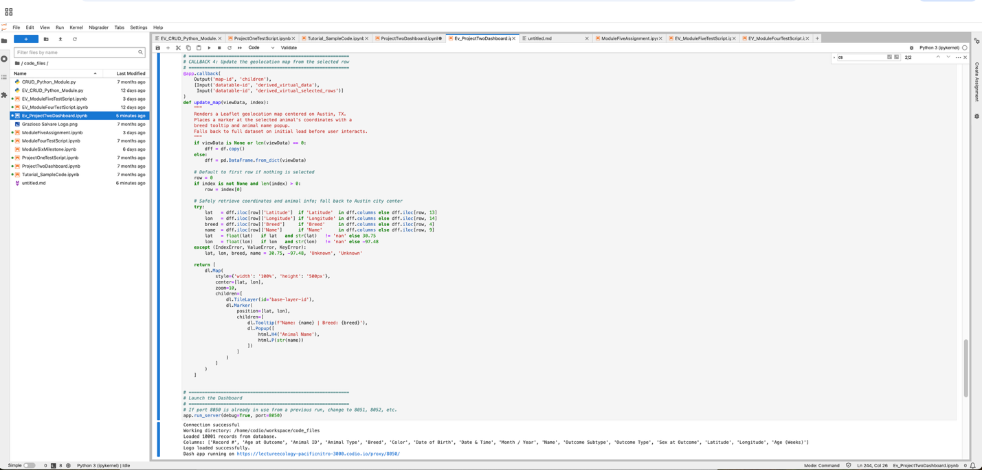

Starting State
When you first open the dashboard it loads every animal in the database with no filters applied. You can see the radio buttons at the top, the full data table in the middle, and the breed chart and map side by side at the bottom. The Grazioso Salvare logo and my name are always visible in the header.
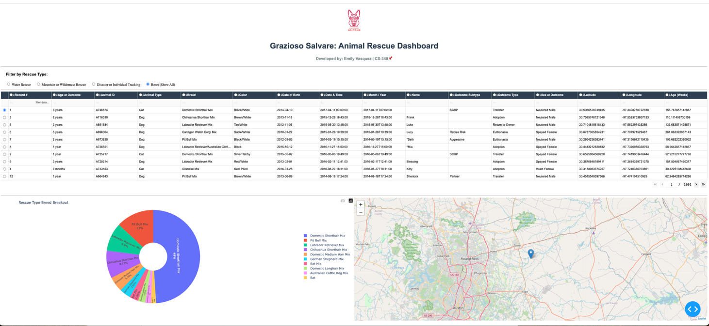

Water Rescue Filter
Clicking Water Rescue filters everything down to Labrador Retriever Mix, Chesapeake Bay Retriever, and Newfoundland dogs that are Intact Female and between 26 and 156 weeks old. The chart and map update on their own to match whatever is in the table.
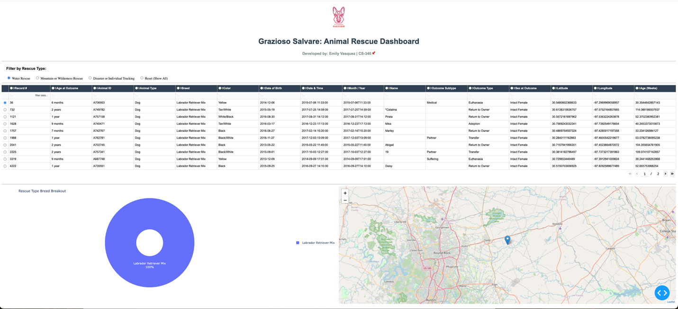

Mountain or Wilderness Rescue Filter
This filter pulls up German Shepherds, Alaskan Malamutes, Old English Sheepdogs, Siberian Huskies, and Rottweilers. They need to be Intact Male and between 26 and 156 weeks old.
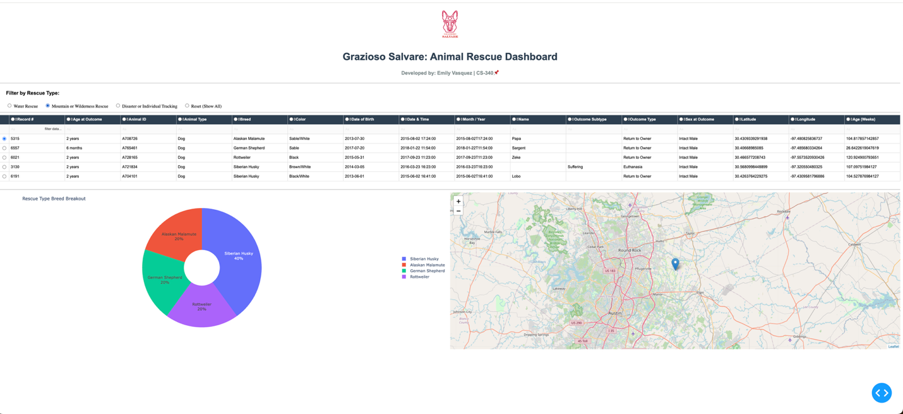

Disaster or Individual Tracking Filter
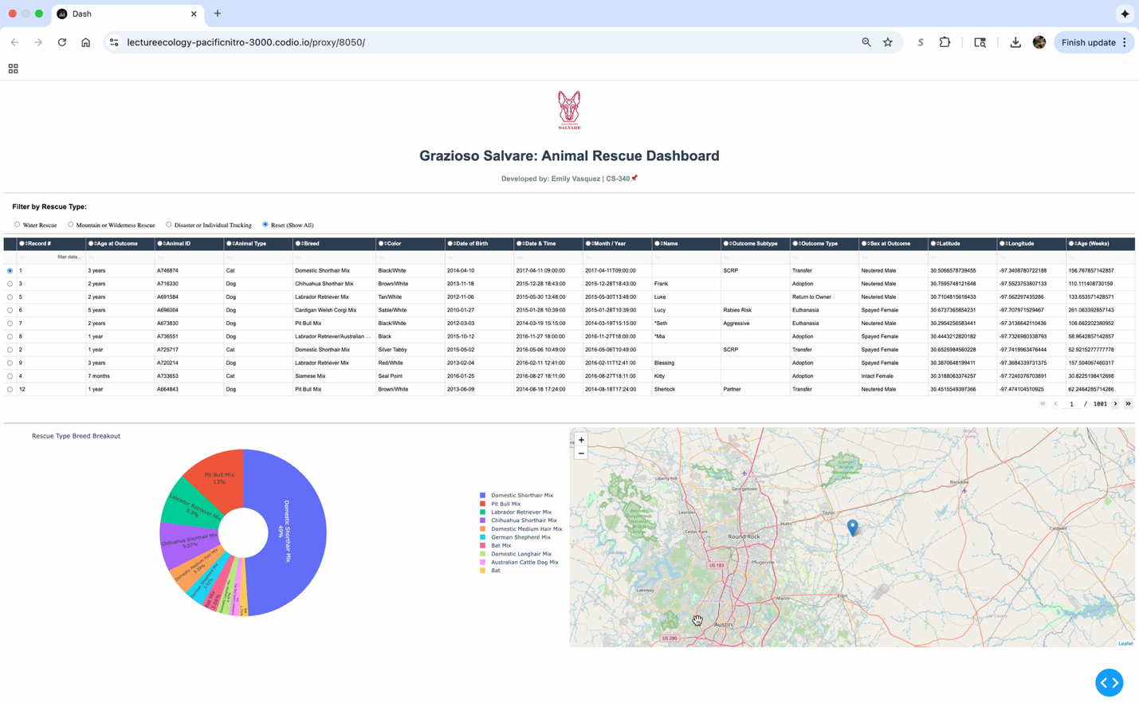
This one looks for Doberman Pinschers, German Shepherds, Golden Retrievers, Bloodhounds, and Rottweilers that are Intact Male and between 20 and 300 weeks old. It has the widest age range out of the three filters.
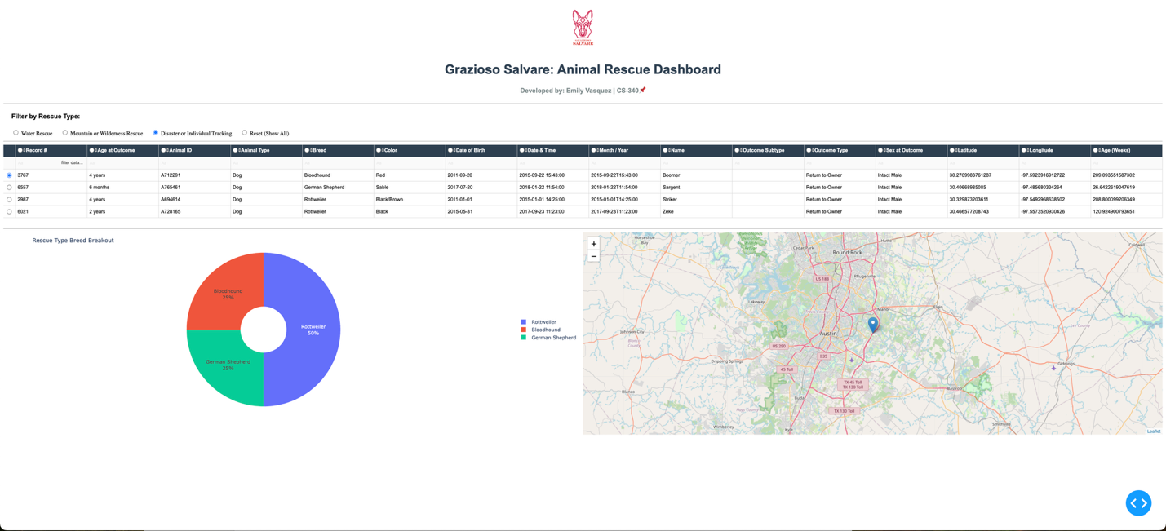

Reset

Clicking on reset clears everything and brings the dashboard back to the starting state. All records show up again and the chart and map go back to their default view.
Double Click to PLAY Video

Filter Criteria
This table shows the exact breed, sex, and age range each rescue type filter is looking for. These came straight from the Grazioso Salvare specification.
Rescue Type | Preferred Breeds | Sex | Age (weeks)
Water Rescue | Labrador Retriever Mix, Chesapeake Bay Retriever, Newfoundland | Intact Female | 26 - 156
Mountain or Wilderness Rescue | German Shepherd, Alaskan Malamute, Old English Sheepdog, Siberian Husky, Rottweiler | Intact Male | 26 - 156
Disaster or Individual Tracking | Doberman Pinscher, German Shepherd, Golden Retriever, Bloodhound, Rottweiler | Intact Male | 20 - 300

Tools I Used and Why

MongoDB
I used MongoDB for the database and it was a good fit for this kind of data. Animal shelter records are kind of messy because not every animal has every field filled in. MongoDB handles that well because it stores records as flexible documents instead of strict rows, so missing fields are not a problem.
The other big reason I picked it is that it works really naturally with Python. The PyMongo library lets you write queries as Python dictionaries, which made it easy to build dynamic queries based on whatever the user selected. Filtering by breed, sex, and age range all in one query was simple using operators like $and, $or, $gte, and $lte.
It also connects directly with pandas, so once I got results back I could turn them into a DataFrame in one line and pass them straight to the Dash table component.
MongoDB Docs: https://www.mongodb.com/docs/
PyMongo Docs: https://pymongo.readthedocs.io/

Dash
Dash is what makes the whole thing interactive. It is a Python framework that lets you build web apps without writing any JavaScript, which worked great since this whole project is Python. You define the layout using Python classes and then write callback functions that handle what happens when a user clicks or changes something.
For example when someone clicks a radio button, Dash automatically runs the right callback, queries the database, and pushes the updated data to the table, chart, and map all at once. I did not have to manually wire any of that together.
I used JupyterDash to run the app inside Jupyter Notebook, Dash Leaflet for the interactive map, and Plotly Express for the donut chart.
Dash Docs: https://dash.plotly.com/
Dash Leaflet: https://www.dash-leaflet.com/
Plotly Express: https://plotly.com/python/plotly-express/
JupyterDash: https://github.com/plotly/jupyter-dash

Other Libraries
- pandas: used to convert MongoDB query results into DataFrames and feed them into the Dash components.
- NumPy: used for numerical support during data processing.
- base64: used to embed the logo image directly into the dashboard header so it loads without needing a separate file server.

Steps I Took to Build This
- Set up the database. I imported the Austin Animal Center CSV into MongoDB and set up a database user with the right read and write permissions.
- Built the CRUD module. I wrote the AnimalShelter class in EV_CRUD_Python_Module.py. It wraps all the PyMongo operations so the dashboard just calls db.read(query) without having to manage the database connection directly.
- Designed the layout. I put together the dashboard layout with the logo header, my name, the radio filter, the data table, the donut chart, and the map. The chart and map sit side by side using a flex div.
- Added friendly column names. The raw MongoDB field names like age_upon_outcome_in_weeks are not great to show users. I made a COLUMN_LABELS dictionary to rename everything to something more readable like Age (Weeks) and applied it in all the callbacks.
- Wrote the callbacks. I wrote four callbacks: one to filter the table from the radio button, one to update the breed chart from the visible rows, one to highlight selected columns, and one to move the map marker when you select a row.
- Tested the filters. I wrote standalone verification queries to make sure each rescue type filter was actually returning records from the database before trusting the dashboard.
  - 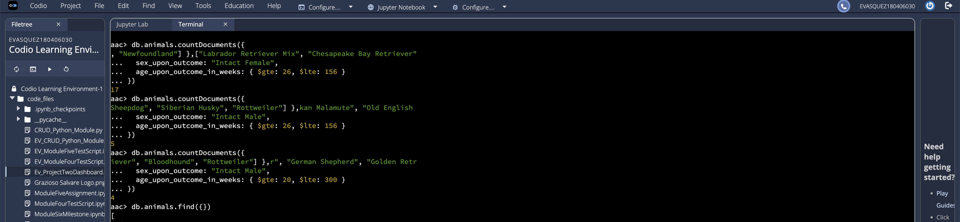
  - Check # of matching returns per rescue type filter
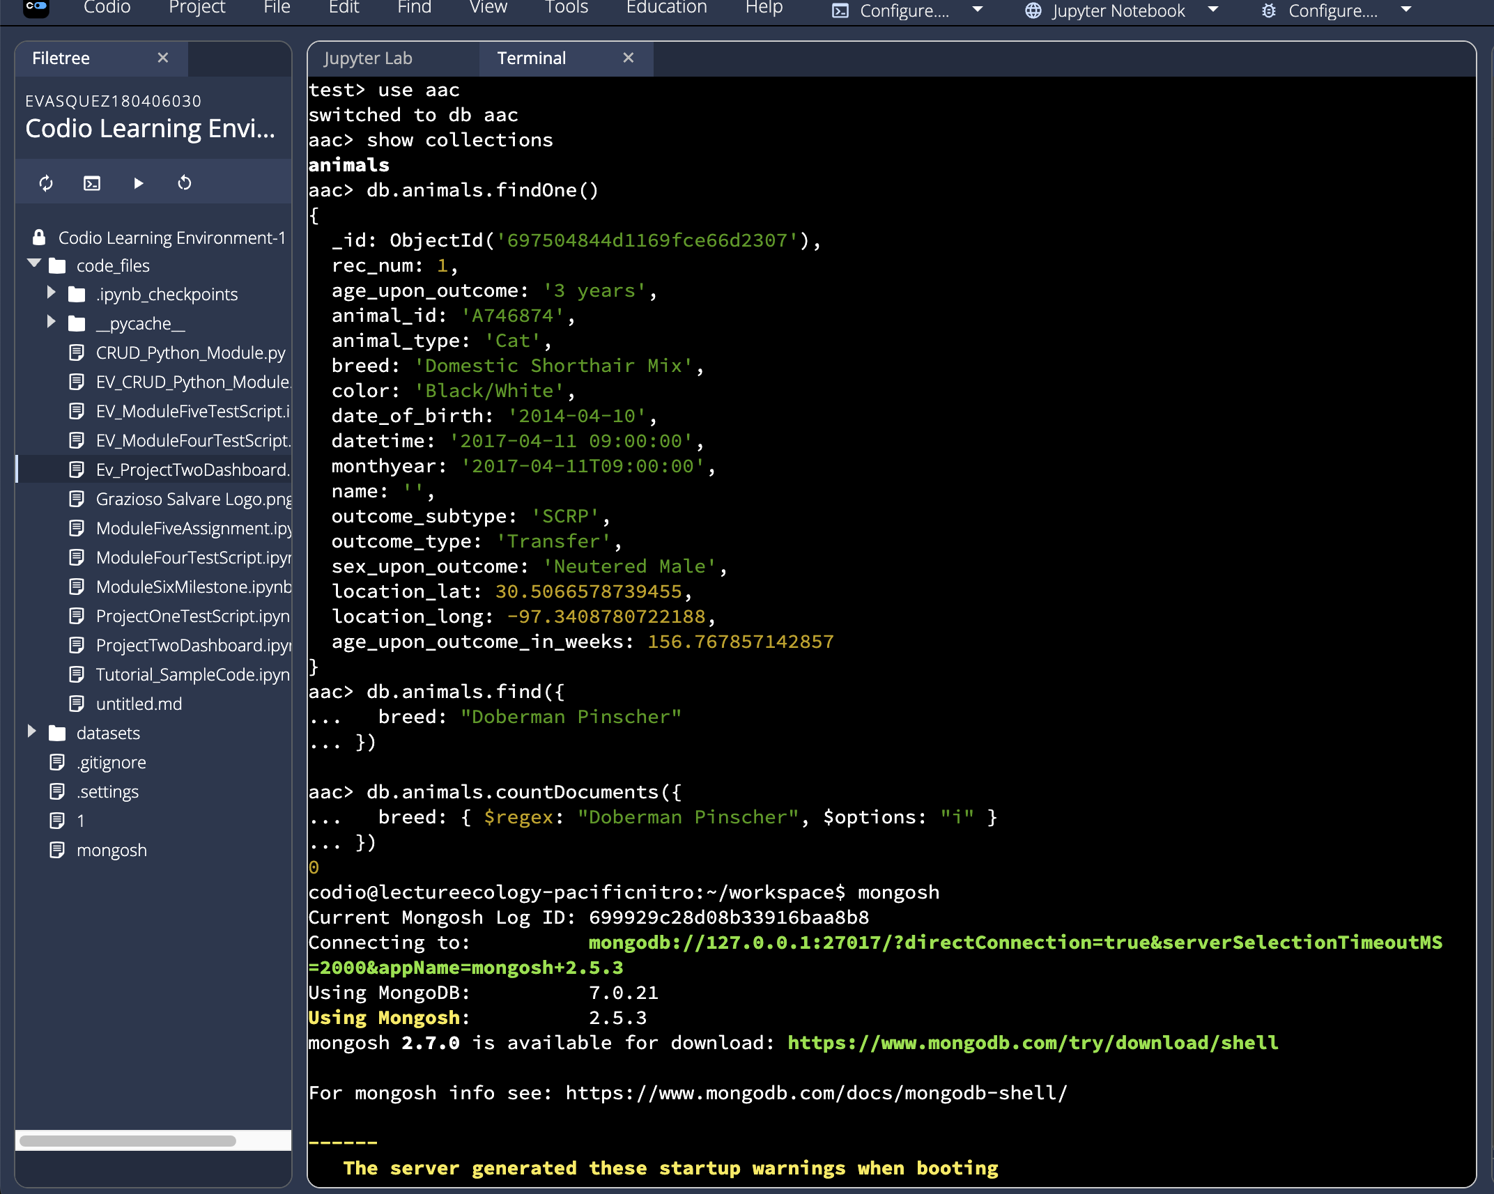
Check for Breed that was in rescue type filter but did not show up in my dashboard.

Troubleshooting
Problem | Solution
Authentication failed | Verify username/password and permissions
Can't import module | Check file location and Python path
Empty results from read() | Verify query syntax and data exists

References
Austin Animal Center. (2020). Austin animal center outcomes [Data set]. City of Austin, Texas Open Data Portal. https://doi.org/10.26000/025.000001
MongoDB. (n.d.). MongoDB documentation. https://www.mongodb.com/docs/
PyMongo. (n.d.). PyMongo documentation. https://pymongo.readthedocs.io/

