# **Product Requirements**

|  |  |
| --- | --- |
| **DETAIL** | |
| Target Release |  |
| Epic |  |
| Document Stats | Draft |
| Document Owner | EmilyVu |
| Product Owner |  |
| Designer |  |
| Tech Lead |  |
| Techincal writters |  |
| QA |  |
| Document version | 0.1 |

## Objective

## Success Metrics

List project goal the metrics that to judges its success

|  |  |
| --- | --- |
| **Goal** | **Metric** |
| Implement the new sale workflow |  |

## Assumptions

## Milestones

## Requirements

|  |  |  |  |  |  |
| --- | --- | --- | --- | --- | --- |
|  | Requirements | User Story | Importance | Jira Issue | Notes |
| 1 | Build the rule and workflow KYC customer | User Story 1 | Highest |  |  |
| 2 | Build the pre-offer base on basic customer information | User Story 2 | Highest |  |  |
| 3 | Build the logic offer limit for client base on customer group | User Story 3 | Highest |  |  |

#### User Story 1: As if sale team member, I expected system can support verify customer, show the result for user can review and edit. That will support the sale member reach the SLA and improve customer experience

**Acceptance Criteria**

* Implement the UI to customer information are name, date of birth, phone number, identifier number
* Validate input
  + Phone number, identifier don’t include text
  + Name don’t include the number(s)
  + Date of birth should have vietnamese’s date format (dd/MM/yyyy)
  + Identifier must have length **equal** 9 or 12 characters
  + Phone number must have length **equal** 10 numbers, start with 0 at first
* Implement the API to verify customer
  + Input: customer name, date of birth, identifier number, other identifier number, inforsource
  + Output: ClientCode (if the client isn’t exist response null), comprehension array – include all the result compare between input data with internal/external about client.
  + Logic handle:
    - Step 1: Search customer by each input (phone, identifier number, other identifier number)
    - Compare each output from Step 1 with each other and with name input, date of birth input
    - Response the result matched or not matched
    - If the result has any not matched show the message base on scenario (detail in excel file)
* Mapping the output to the UI (excel file)

**Workflow**

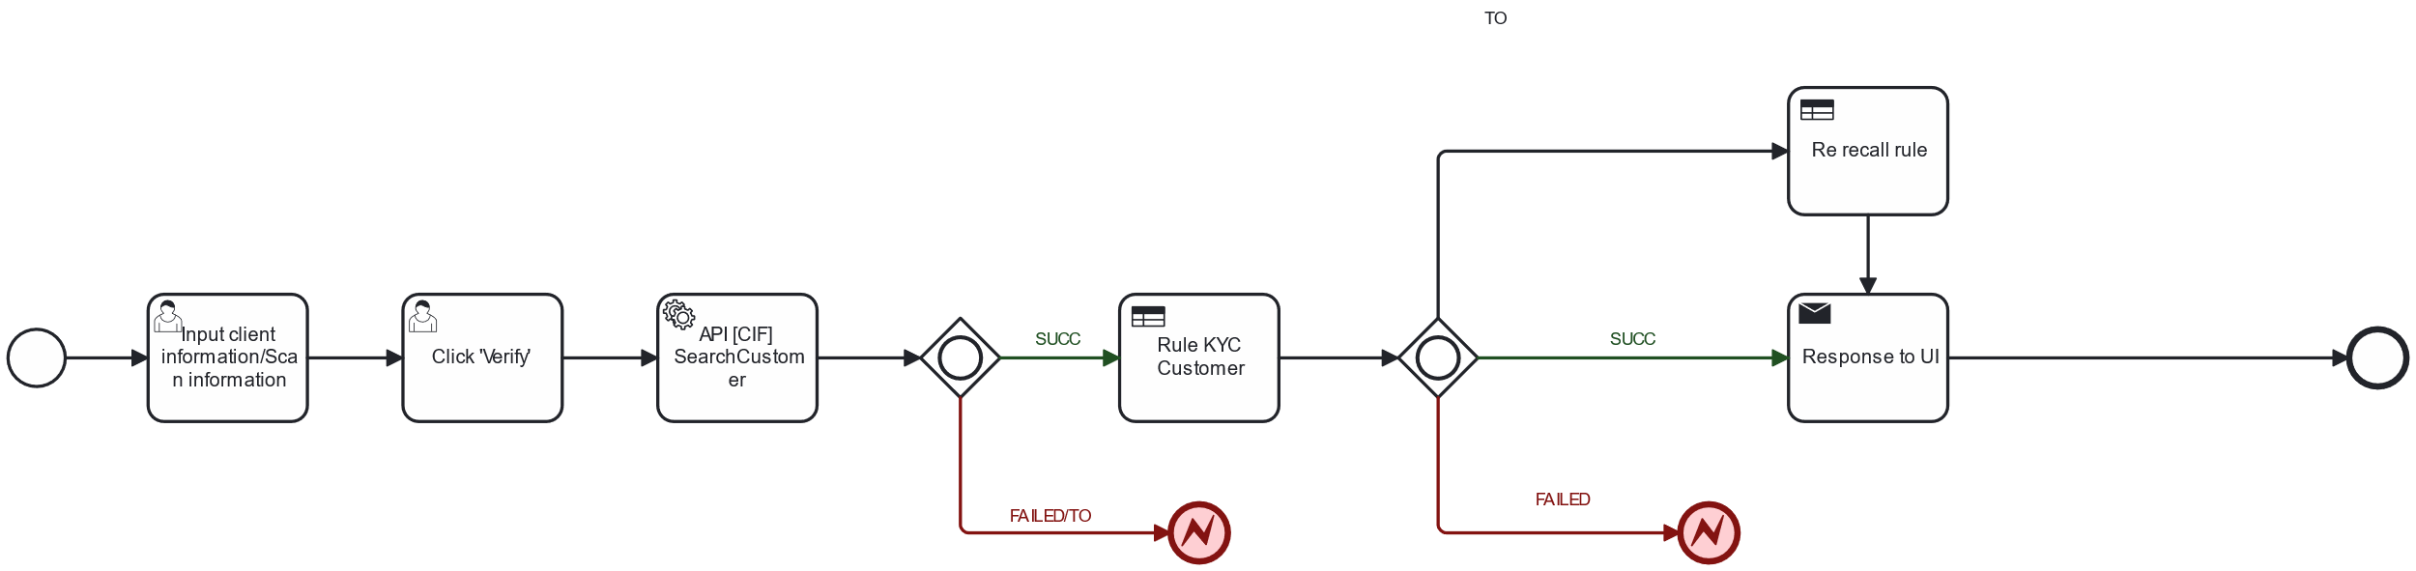

#### User Story 2: As if the product owner, I want IT can build the new workflow sale base on the customer portrait (scorecard). The new sale workflow will support us can share benefit and risky, then find separate the group customer to focus on.

**Acceptance Criteria**

* Build the UI for sale team just input some basic information
  + Client Information – not Editable (from step KYC)
  + Customer Income – require, include number, Min = 3.000.000, Max = 2.000.000.000
  + Income Proof – not require, dropdown list
  + Application form information
    - Amount
    - Tenor
    - Original Repayment Method
* Build up the API get limit and offer from limit and output to integration with UI
  + Input: Client Information, Application information
  + Output
    - FinalLimit
    - List Offers: list object have the information
      * OfferAmount
      * OfferTenor
      * ListOfferTenor
      * Original Payment Method
      * Interest Rate
  + Logic
    - Call ScoreCard model to get customer group
    - Mapping input of API [Limit] GetFinalLimit
    - Call API [Limit] GetFinalOffer

**Workflow**

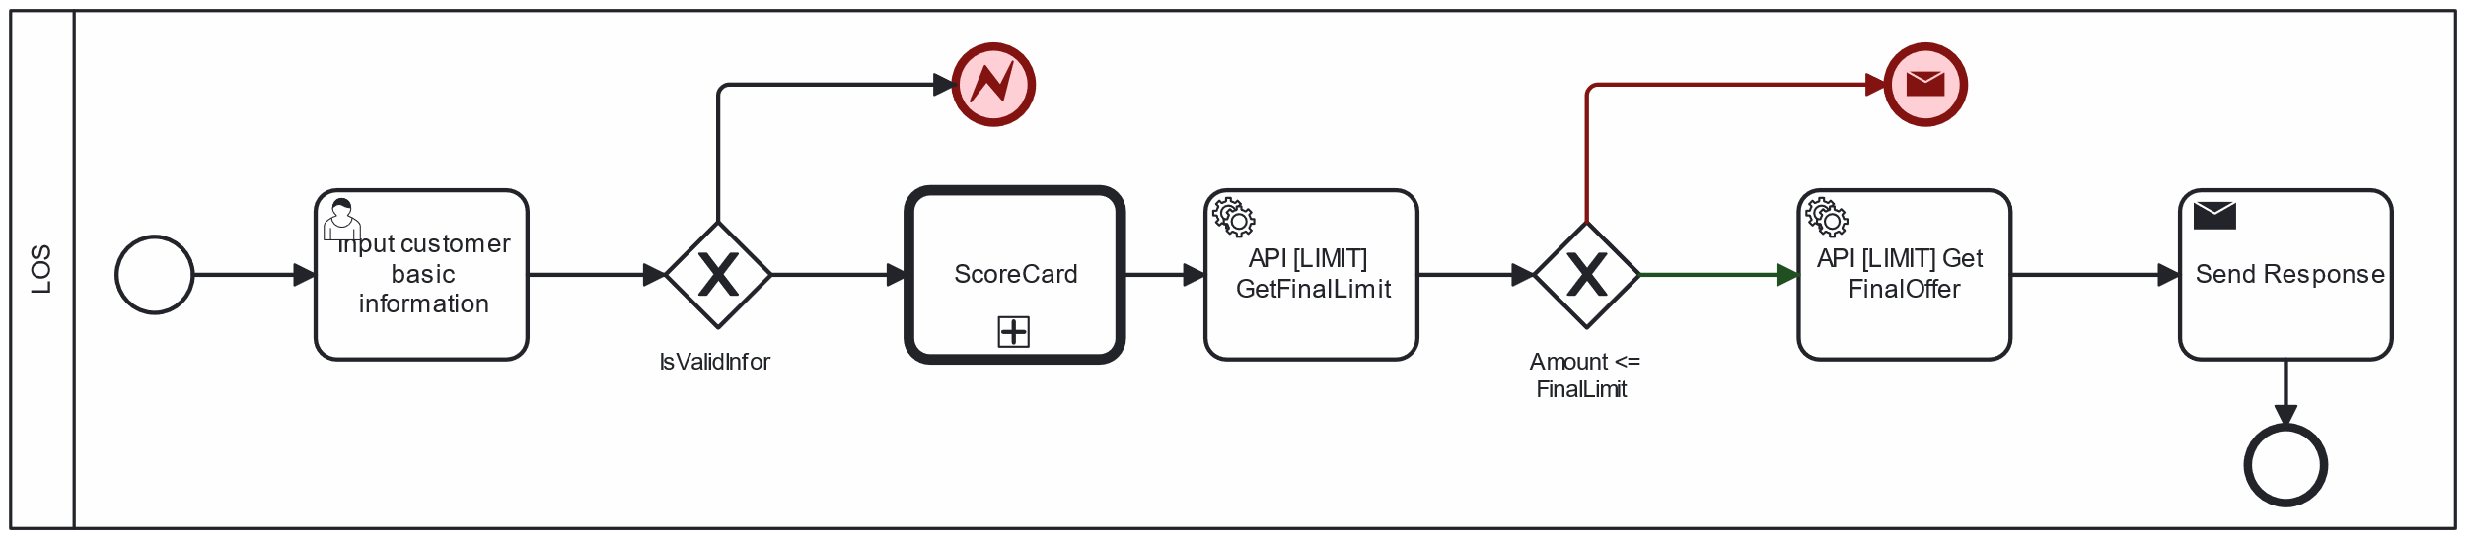

#### User Story 3: As if LOS system, I want the LIMIT can build logic offer limit for customer base on customer portrait.

**Acceptance Criteria**

* Implement rule to define product for each customer group
* From the product, calculated financial parameters
  + **FinalLimit = Min (MaxLoanByPTI, MaxLoanByLTV, MaxLoanByProduct)**
  + **MaxEMI = MaxPTI * CustomerIncome * 1000000**
  + **RequestEMI = pmt(InterestRate, Tenor, Amount)**
* Compare FinalLimit and Amount
  + IF Amount > FinalLimit => Stop flow and throw message
  + IF Amount <= FinalLimit THEN compare RequestEMI và MaxEMI
    - **IF RequestEMI >= MaxEMI => Offer = (Amount, Tenor)**
    - **IF RequestEMI < MaxEMI**
      * Re calculated Tenor **= Nper (CPV, MaxEMI, Số tiền vay)**
      * Verify **Tenor** and ListTenor valid (base on product). IF Tenor < Min OR Tenor > Max THEN show message. ELSE ListTenor = [Tenor,MaxTenor]

**Workflow**

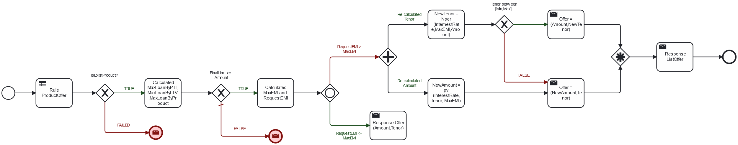

## User interaction and design

<https://www.figma.com/design/k7Dfw5SFms5dRMxYNTOzyq/LOS-m%E1%BB%9Bi---WEB-admin?node-id=1074-5749&t=exYzJCMb6wPgqRHc-0>

## Open Questions

|  |  |  |
| --- | --- | --- |
| Question | Answer | Date Answered |
|  |  |  |

## Out Of Scope