1. List countries that have held both SIGMOD and VLDB.

(select location

from CONFERENCE

where NAME='SIGMOD')

intersect(

select location

from conference

where NAME='VLDB');

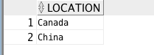

1. List for each location the total number of conferences held in descending order.

select location,count(ID)

FROM CONFERENCE

group by LOCATION

order by count(ID) desc;

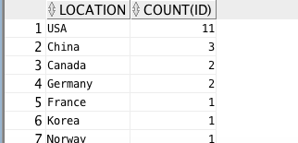

1. How many papers in the dataset contain the word “database” in their title?

select count(ID)

from PUBLICATION

where TITLE like '%database%';

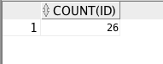

1. Among the keywords “network” and “database”, which of them have occurred more in the title of papers  in the database?

select count(t.ID),count(s.ID)

from PUBLICATION t,PUBLICATION s

where t.TITLE like '%database%' and s.TITLE like'%network%';



1. Generate a table containing two columns one containing the year and the second containing the number of  papers in that year containing the term XML in the title. Note that such an output is often referred to as a histogram in data analysis.

select c.YEAR, count(p.ID)

from PUBLICATION p, CONFERENCE c

where p.TITLE like'%XML%'

group by c.YEAR;

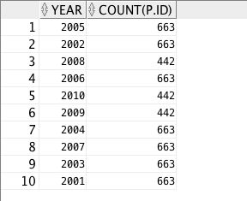

1. What are the three conferences (and years) that had the smallest number of papers? (example format of the output: VLDB 2013).

with temp as(

select count(p.id),c.NAME, c.YEAR

from publication p,conference c

where p.CID=c.ID

group by c.name,c.year

order by count(p.id) asc

) select t.name,t.year from temp t where ROWNUM<=3;

1. What are the three conferences that had the largest number of papers?

select count(p.id),c.NAME

from publication p,conference c

where p.CID=c.ID

group by c.name

order by count(p.id) desc;

1. Output VLDB, SIGMOD and ICDE in descending order based on the number of papers that have published in each of these conferences across the dataset.

select count(p.id),c.NAME, count(p.id)

from publication p,conference c

where p.CID=c.ID

group by c.name

order by count(p.id) desc

1. Which last name for authors is the most common one in this database?  (search)

SELECT [a.Name], LEFT([a.Name],CHARINDEX(' ',[a.Name] + ' ')-1) AS FIRST_NAME,

SUBSTRING([a.Name],CHARINDEX(' ',[a.Name] + ' ')+1,LEN([a.Name])) AS LAST_NAME

FROM author a

select name,count(ID)

from AUTHOR

group by NAME

order by count(id) DESC;

1. Which country has hosted ICDE the most number of times and how many times? (The output should be  two columns of a single table.)

select location,count(ID)

from conference

where name = 'ICDE'

group by location

order by count(ID) desc;

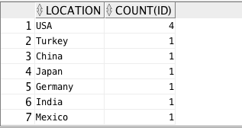

1. Name the author(s) with the highest number of publications to both VLDB and SIGMOD.

(Select distinct a.name,count(p.id)

From author a, authorpublication d, publication p, conference c

Where a.id=d.aid and d.pid=p.id and p.cid=c.id and C.NAME='SIGMOD'

Group by a.name

Order by count(p.id) desc;)

INTERSECT

Select distinct a.name,count(p.id)

From author a, authorpublication d, publication p, conference c

Where a.id=d.aid and d.pid=p.id and p.cid=c.id and C.NAME='VLDB'

Group by a.name

Order by count(p.id) desc;

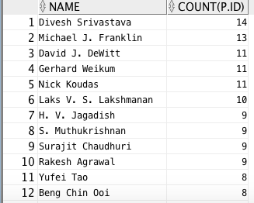

1. What is the average number of papers published in SIGMOD, VLDB, and ICDE between 2001 and 2005  (including 2001 and 2005)?

select avg(count(p.id)) as avernum

from publication p,conference c

where p.CID=c.ID and c.year between 2001 and 2005

group by c.name,c.year



1. Which year of SIGMOD has the lowest value of average authors per paper?

Hint: The Average Number of Authors per Paper (ANAP) for an author A is computed as follows: For each of publication Pi of A find the total number Ni of authors (including A) in Pi.The ANAP is the the sum of all Ni's for all Pi's of A divided by the total number of publications of A.

1. Which author has the third highest value of average authors per paper?

Select name

From author natural join

1. List the year(s) in which all three of the conferences VLDB, ICDE and SIGMOD, were held outside  USA.

select year

from conference

where NAME not in(select NAME

from conference

where location='USA');

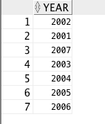

1. List the conference(s) held only outside USA

select distinct name

from conference

where NAME not in(select DISTINCT NAME

from conference

where location='USA');

