### Company frontend explained 1. Login and Access

**Logging In**

* To access the full functionality of the application, you need to be logged in.
* If you are not logged in, click on the **Login** link in the sidebar. This will redirect you to the login page. (Doesn’t currently work because of routing)

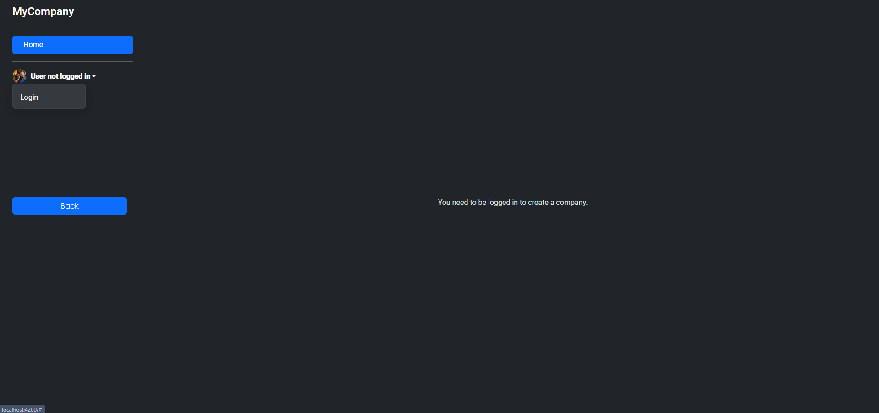

**User Profile**

* After logging in, the username will appear in the dropdown menu in the sidebar. You can click on it to:
  + **Delete Company** (if you own a company)
  + **Update Company** (if you own a company)

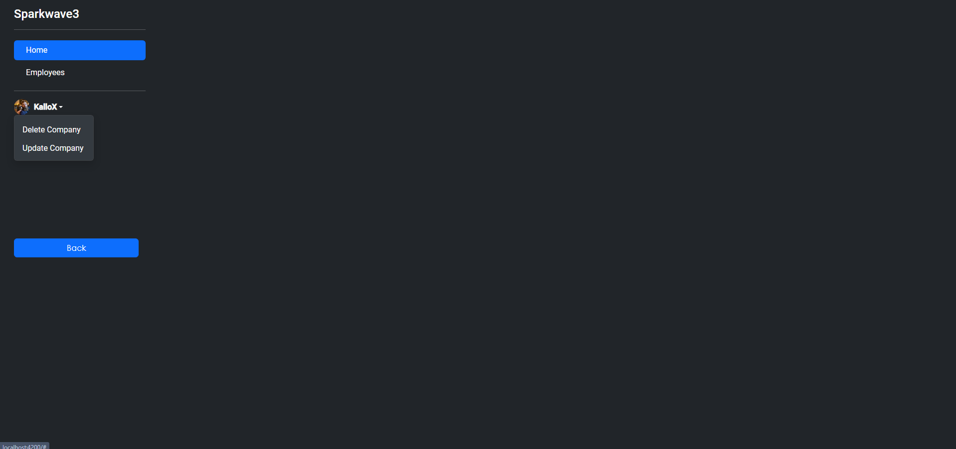

**2. Home Page**

**Create a Company (If Not Created Yet)**

* When you log in, if you don't already have a company, you'll see a button labeled **Create Company**.
* Clicking this button will reveal a form to create your company. You must fill out the following fields:
  + **Company Name**: Name of your company.
  + **Company Phone**: Contact number for your company.
  + **Company Description**: Short description of your company.
  + **Company Email**: Email address for your company.
  + **Company Address**: Physical address of your company.
  + **Avatar Image**: Upload an image to represent your company (optional).
  + **Verification PDF**: Upload a verification PDF to validate your company.

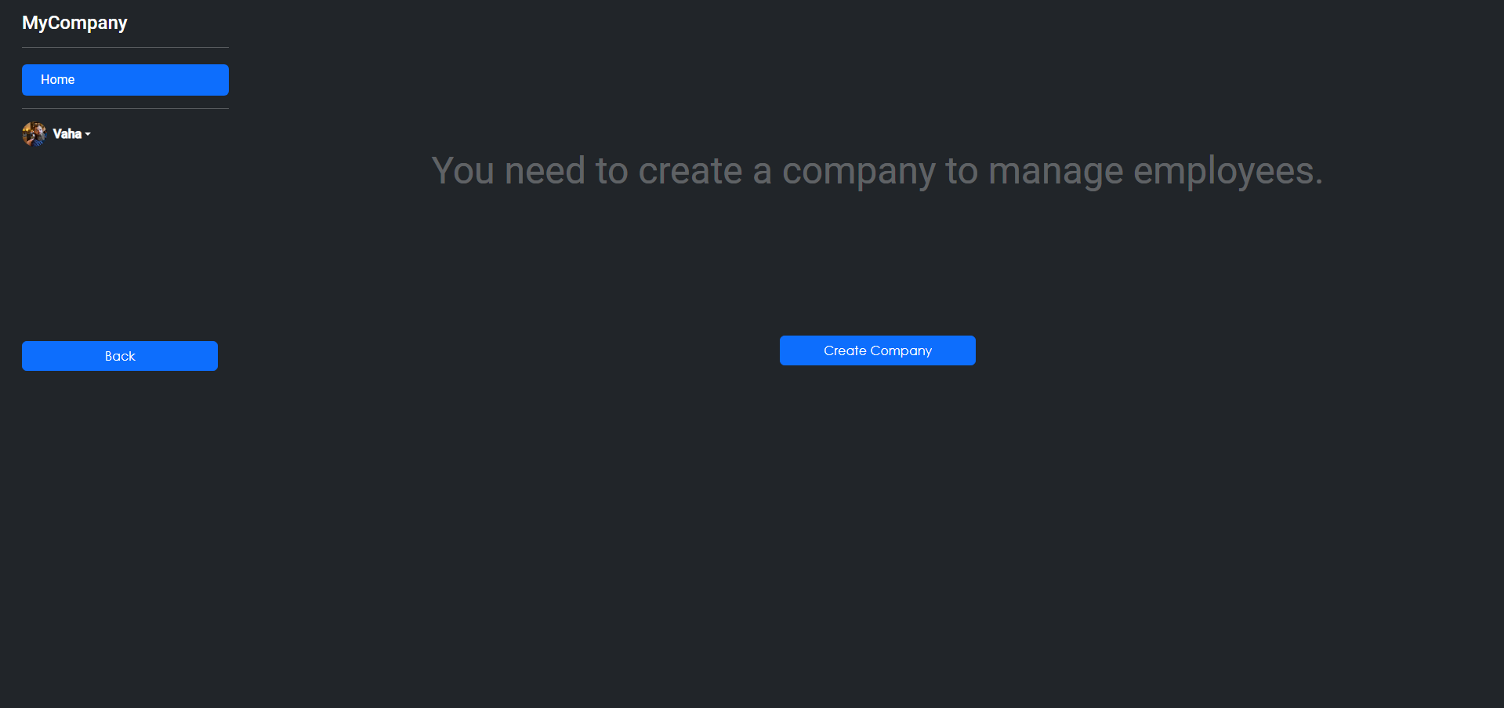

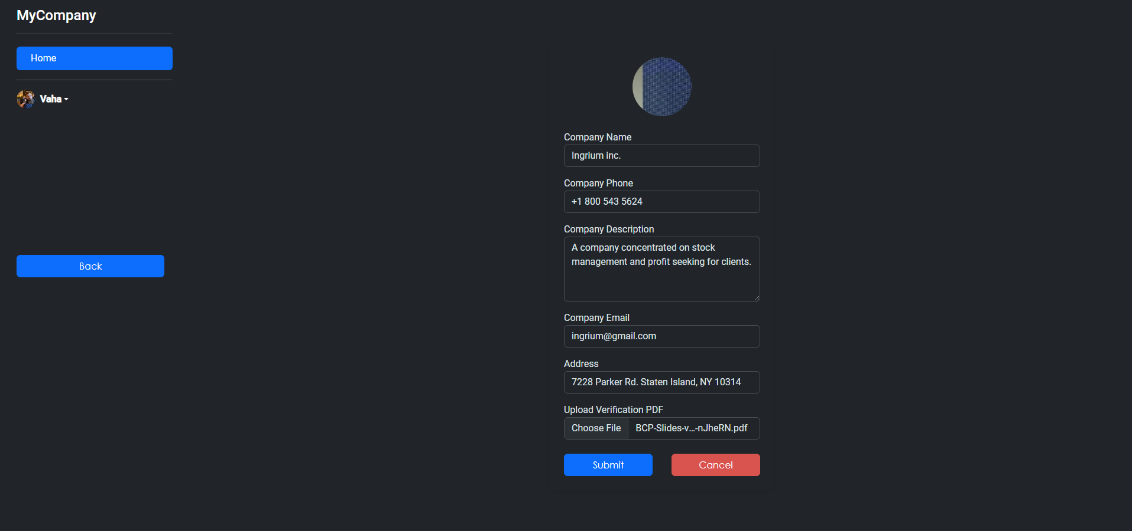

**Company Information Display**

* Once the company is created, the name of your company will be displayed in the sidebar instead of the default "MyCompany."
* If your company is successfully created, the **Create Company** button will be hidden.

**Update Company**

* If you have already created a company, you can update its details by clicking the **Update Company** link in the dropdown menu under your username in the sidebar.
* This will show a form where you can modify the company name, phone, email, description, address, and avatar.

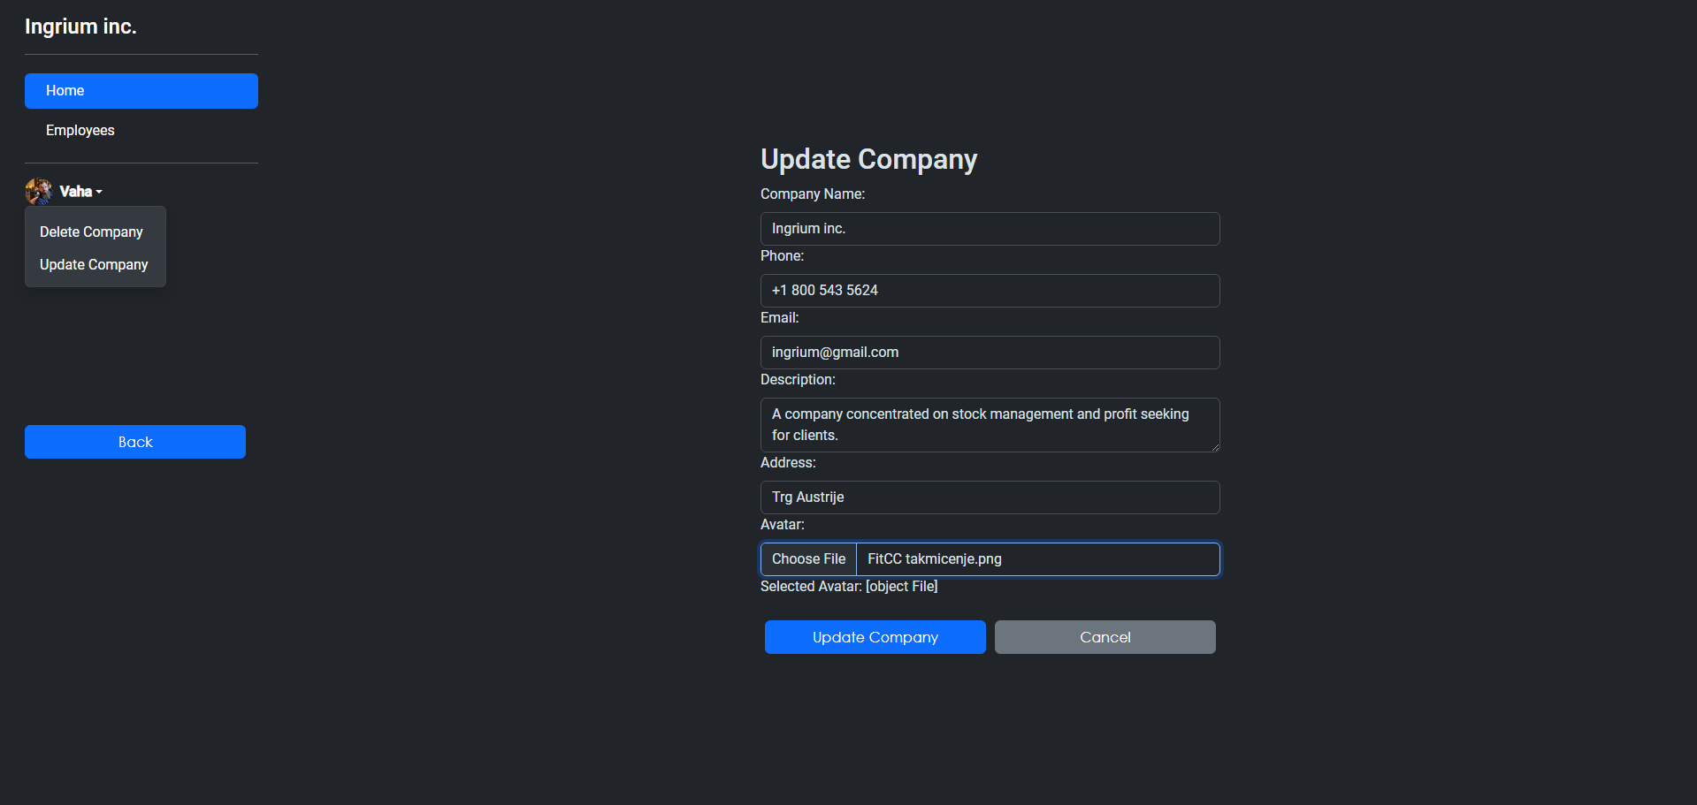

**3. Employees Management**

**Accessing Employees Section**

* Once logged in and if you have a company, the **Employees** link will be available in the sidebar.
* Clicking on this will take you to a table where you can view all employees associated with your company (this is a preview, with full functionality coming soon).

**Employee Table (Still in progress NOT WORKING, JUST VISUAL)**

* The employee table displays the following columns:
  + Employee ID
  + Last Name
  + First Name
  + Title
  + Title of Courtesy
  + Birth Date
  + Hire Date
  + Address
* For each employee, there are options to **Update** or **Delete** the employee.
  + **Update**: Click the button to update employee details.
  + **Delete**: Click the button to remove the employee from the list.

**Adding New Employees (Still in progress NOT WORKING)**

* You can add a new employee by clicking the **Add Employee** button. This button will trigger a form to enter employee details.

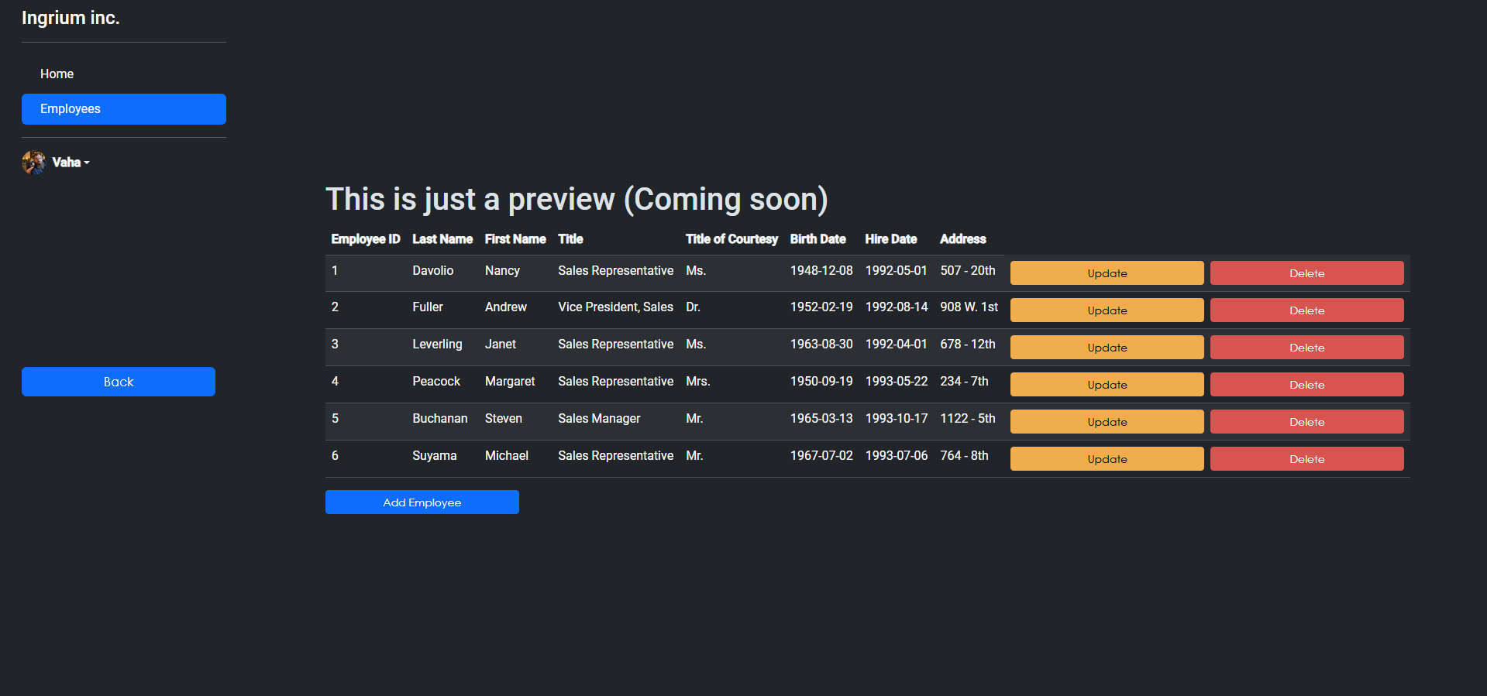

**4. Sidebar and Navigation**

**Sidebar Navigation**

* The sidebar includes navigation links to different sections of the app:
  + **Home**: Returns to the home page where you can manage your company.
  + **Employees**: Takes you to the employee management section (if your company is created).
  + **User Profile**: Displays your username and provides options to log out, update your company, or delete your company.

**Back Button**

* At the bottom of the sidebar, there is a **Back** button that takes you back to the public home page.

**5. File Uploads**

**Company Avatar (Still in progress NOT WORKING)**

* You can upload a custom avatar for your company. This avatar will be displayed in the sidebar next to the company name.
* To upload an avatar, click on the avatar circle in the **Create Company** form. You will be prompted to select an image file.

**Verification PDF (Still in progress NOT WORKING)**

* A PDF file is required during the company creation process for verification purposes.
* Click on the **Upload Verification PDF** field to choose and upload the appropriate PDF file.

**6. Form Submissions and Cancellations**

**Form Submission**

* After filling out the company creation or update form, click **Submit** to save the changes.

**Form Cancellation**

* If you want to cancel the form at any time, click **Cancel** to reset the form and hide it from view.

**7. Special Features**

**No Company Overlay**

* If you are logged in but haven't created a company, a semi-transparent overlay will appear on the home page informing you that you need to create a company in order to manage employees.

**Update Company**

* You can edit the details of your existing company by clicking **Update Company** from the dropdown menu. This will bring up a form where you can update various fields like company name, phone, email, description, address, and avatar image.

**8. Logging Out (Still in progress NOT WORKING, NO VISUAL)**

* To log out, click on the **Logout** link in the user profile dropdown menu. This will log you out of the application, and you will no longer be able to access company or employee management until you log in again.

**Code explanation behind the front end:**

**DashboardComponent**

This is the core component of the dashboard, where a user can manage their company data, employee details, and perform various actions like creating, updating, and deleting companies.

**1. Component Properties**

* **Visibility Toggles:** isFormVisible and updateFormVisible are flags that control the visibility of the forms for creating and updating a company, respectively.
* **Company Data:** Properties like companyName, companyPhone, companyEmail, etc., store the company's data.
* **Avatar Preview:** avatarPreview is used to store the selected image preview.
* **User and Company Status:** isLoggedIn, hasCompany and userId help manage user authentication status and whether the user already has a company linked to their account.
* **Employees:** A predefined list of employees, probably for demonstration purposes, representing various employees in the company.
* **Selected File:** selectedFileName is used for managing the file that will be uploaded when updating the company (like an avatar image).

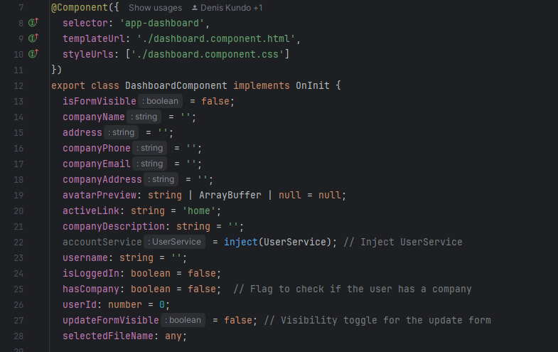

**2. Constructor and Initialization (ngOnInit)**

* The UserService and CompanyService are injected into the component. These services manage user and company data.
* ngOnInit() is responsible for checking if the user is logged in and retrieving user-specific company details:
  + **User Check:** It uses userService.getCurrentUser() to check if a user is logged in.
  + **Company Data Fetch:** If logged in, the component fetches the company data associated with the logged-in user by calling companyService.getCompanyByUserId(this.userId).
  + **Company Existence:** It also checks whether the user already has a company with companyService.checkIfCompanyExists.

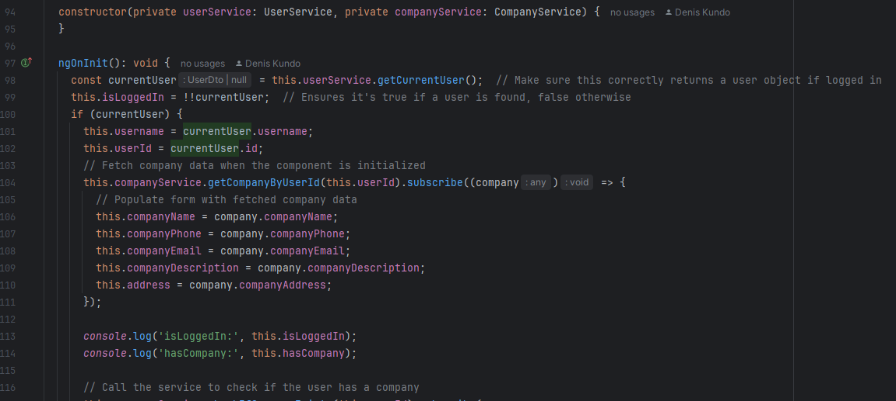

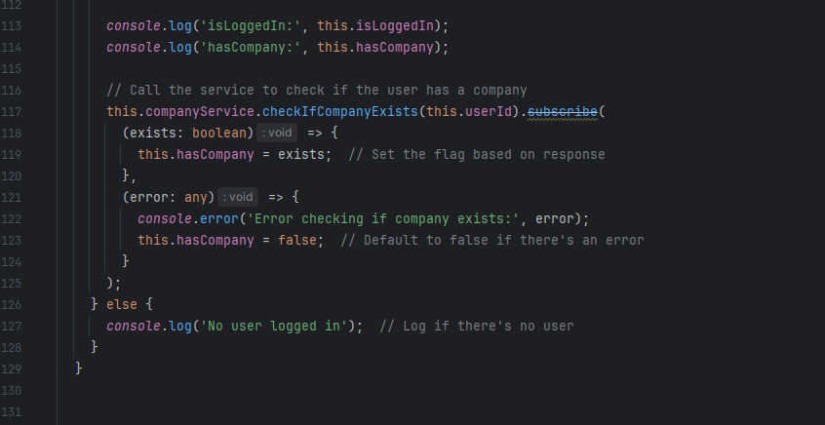

**3. Method Implementations (Still in progress NOT WORKING)**

* **updateEmployee & deleteEmployee**: These methods are for managing employee data (though they are placeholders, they log actions to the console for now).
  + updateEmployee is meant to update the employee data, while deleteEmployee removes an employee from the local employees array.
* **addEmployee**: This method, which is not yet implemented, would be used for adding new employees.

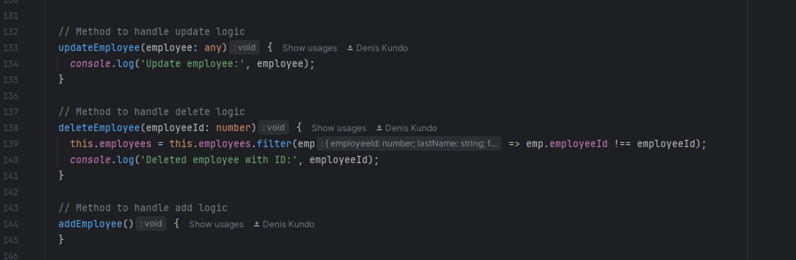

* **Form Management:**
  + showForm toggles the visibility of the form used to create a new company.
  + submitForm handles the creation of a company by calling companyService.createCompany() and passing the form data. On success, the form is reset, and the page reloads.
  + cancelForm simply hides the form and resets the fields.

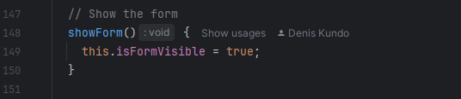

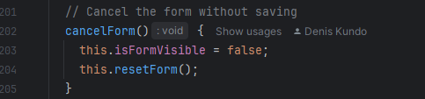

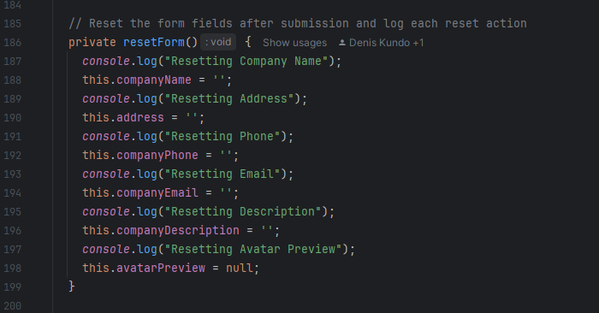

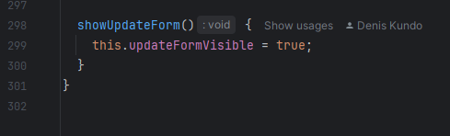

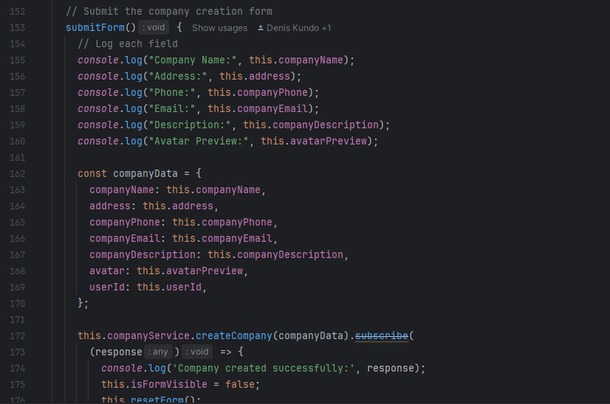

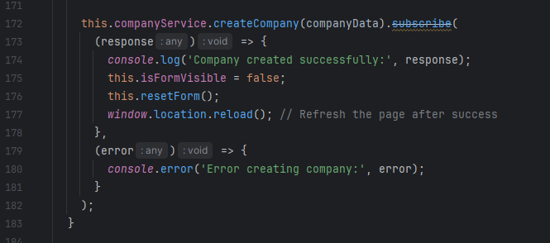

* **File Handling:**
  + onFileSelected and onPdfSelected handle file selection for uploading an avatar or PDF respectively. In onFileSelected, the file is read as a Data URL (for image previews).
  + onFileChange sets the selected file to selectedFileName, used when updating the company.

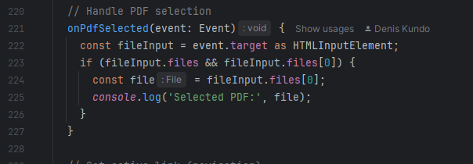

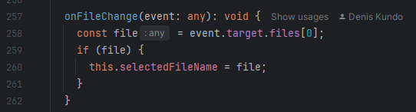

* **Company Update:**
  + updateCompany sends the updated company data to the server via companyService.updateCompanyByUserId.

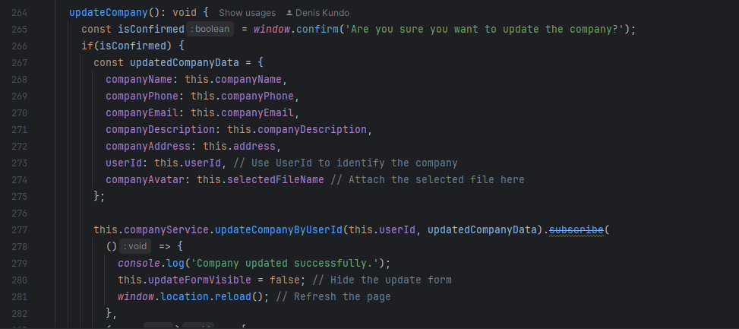

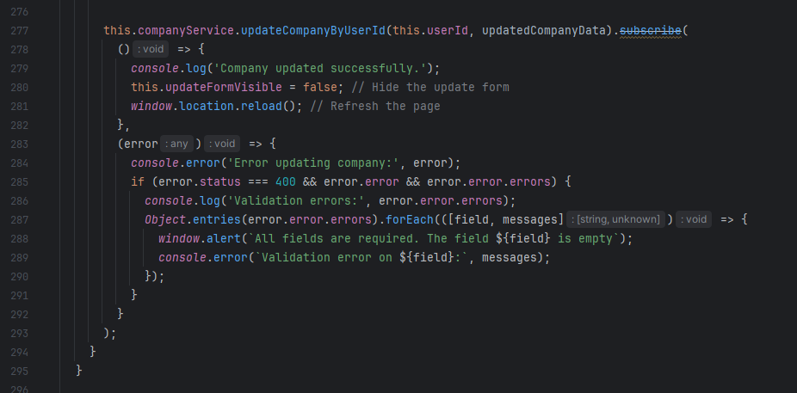

* **Navigation:**
  + setActive sets the active link, which likely changes the appearance of the current navigation link.

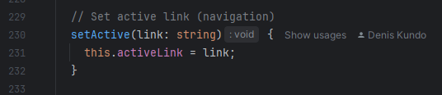

**4. Delete and Update Confirmation**

* The deleteCompany and updateCompany methods include confirmation prompts. Before performing these actions, the user must confirm via window.confirm.
  + For the deleteCompany method, the company is deleted by calling the companyService.deleteCompanyByUserId.
  + For updateCompany, the company data is sent to the backend for updating, including optional avatar image uploads (handled with FormData).

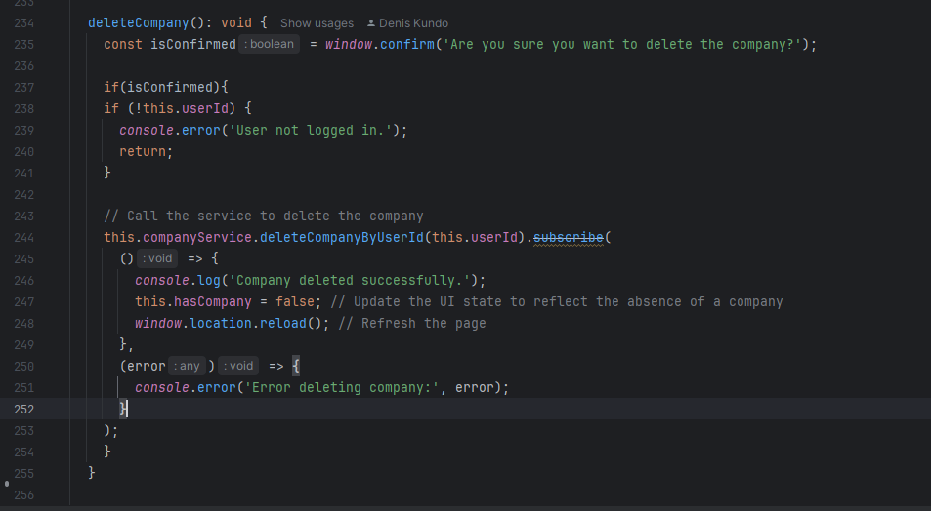

**CompanyService**

This service provides methods for interacting with the backend API related to companies. It performs HTTP requests to create, update, delete, and fetch company data.

**1. HTTP Methods**

* **checkIfCompanyExists(userId)**: A GET request that checks if a company exists for the logged-in user.

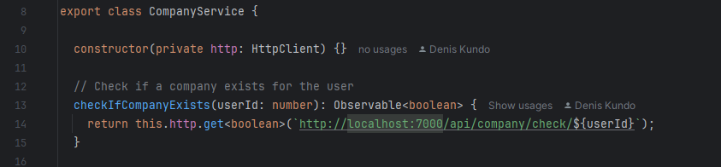

* **getCompanyByUserId(userId)**: A GET request to fetch the company data for the logged-in user.

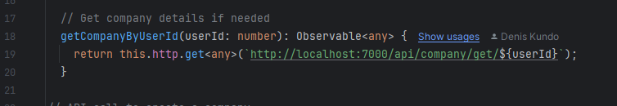

* **createCompany(companyData)**: A POST request to create a new company. It sends the company data along with the avatar image as FormData.

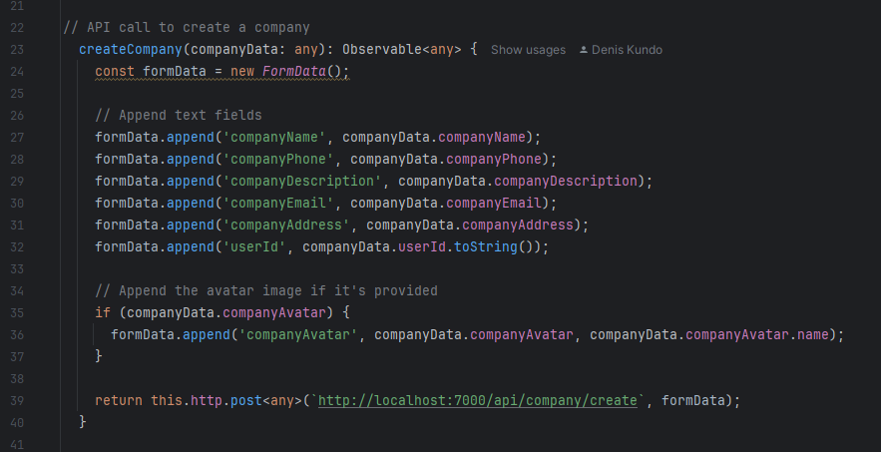

* **deleteCompanyByUserId(userId)**: A DELETE request to delete the company associated with the given user ID.



* **updateCompanyByUserId(userId, companyData)**: A PUT request to update the company data for the given user ID. Like createCompany, it uses FormData to handle text fields and optional file uploads.

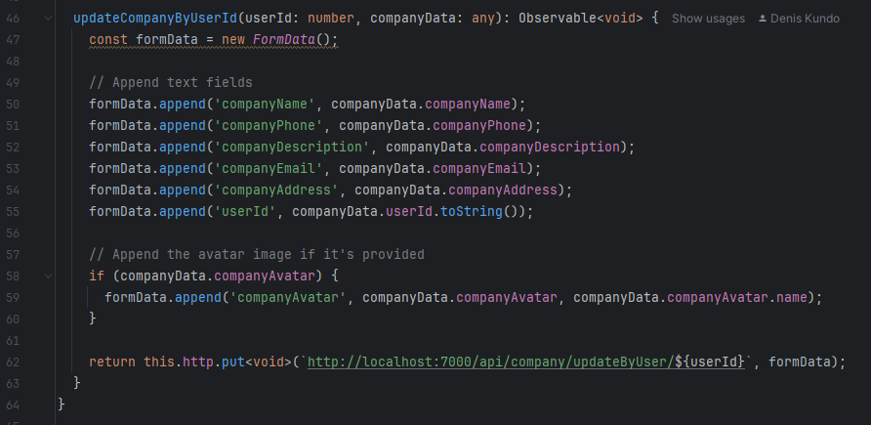

**CompanyRoutingModule**

This module handles the routing for the company section of the app. It defines the routes for the company dashboard:

* **Default Route:** Redirects to dashboard if no path is specified.
* **Dashboard Route:** Maps to DashboardComponent.
* **Wildcard Route:** Redirects any unmatched routes to the home page.

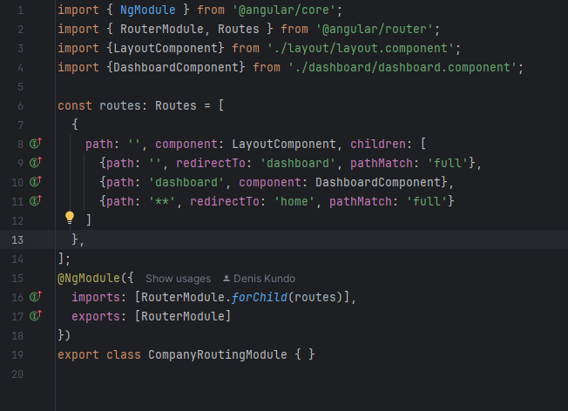

**How the Logic Fits Together**

1. **User Authentication & Company Check**: On initialization (ngOnInit), the component checks if the user is logged in and if they have an associated company. The UI is updated based on whether the user has a company.
2. **Form Handling**: Users can create or edit a company using the forms. Upon submission, the data is sent to the backend via the CompanyService.
3. **Employee Management**: Employees can be added, updated, or deleted (though employee management is more likely part of the larger app and is currently static).
4. **File Management**: The user can upload files (avatars) when creating or updating the company, using the onFileSelected and onFileChange methods.
5. **Page Refresh & Error Handling**: After a company is successfully created or updated, the page reloads to reflect the new data. Errors (e.g., validation errors) are logged, and the user is notified if fields are missing.