

**Smoke & gas detector**

**Course:** CS304-Computer Architecture

**Professor:** Ali Abd Almisreb

**Group members:**

Tarik Talić 170302149

Emin Ždralović 170302043

Almina Raščić 190302161

Mirza Mujović 170302029

Kenan Kaknjo 170302102

Sarajevo, 2020.

Introduction:

We live in a time where gas is becoming more influential. We started using gas supply more than we think, without even realizing it. Starting from our home, going through the kitchen, most ovens in Sarajevo use gas. Gas is also used for heating in cold days in almost 80% of households in Sarajevo. We can find it also in cars. Gas is cheaper than fuel or electricity. Knowing this we need to be aware that a leak of gas can cause death. Because of this, we came up with an idea of a practice and cheap version of a gas & smoke detector that will help us to prevent any risky situation.

Goal:

The goal of our group project is to make a small device that will be installed above the gas-using device. By detecting any leak of smoke or gas the device will produce a strong and intensive sound to warn you about the leak. Also, our goal is to target most of the worlds population, which means it will be available to those with a low, medium and high income.

Technology:

To make this product worldwide popular we first have to make and test a prototype. For this prototype we have to use certain technology and equipment. We plan to use Arduino tool set.

Arduino tool set includes the following:

1. Vero board
2. Arduino nano/ Arduino uno
3. MQ-135 sensor (gas sensor)
4. LED lights
5. Connectors
6. Buzzer (speaker, connects directly to Arduino)

Arduino tool set (graphical representation):

***(*PICTURES ARE LISTED ACORDING TO THE LIST OF NEEDED ITEMS*)***

***(* Ex. Picture 1 is a Vero board etc.*)***

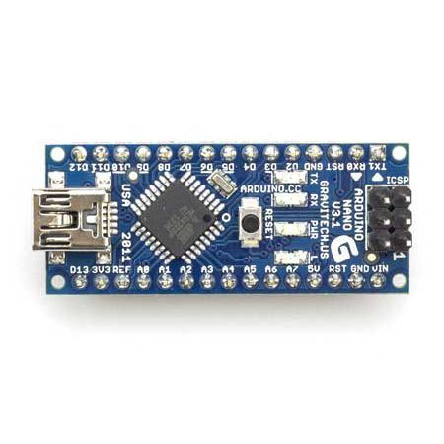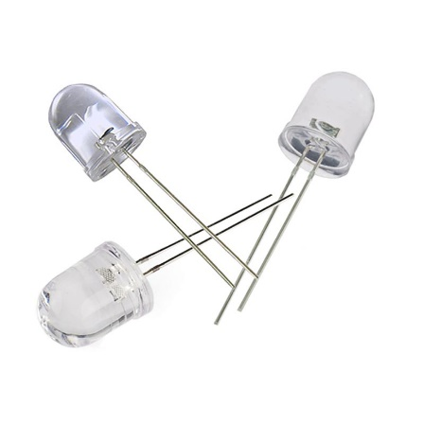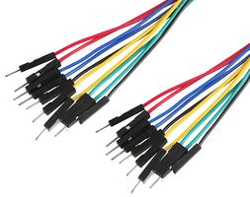

Code Screenshots:

