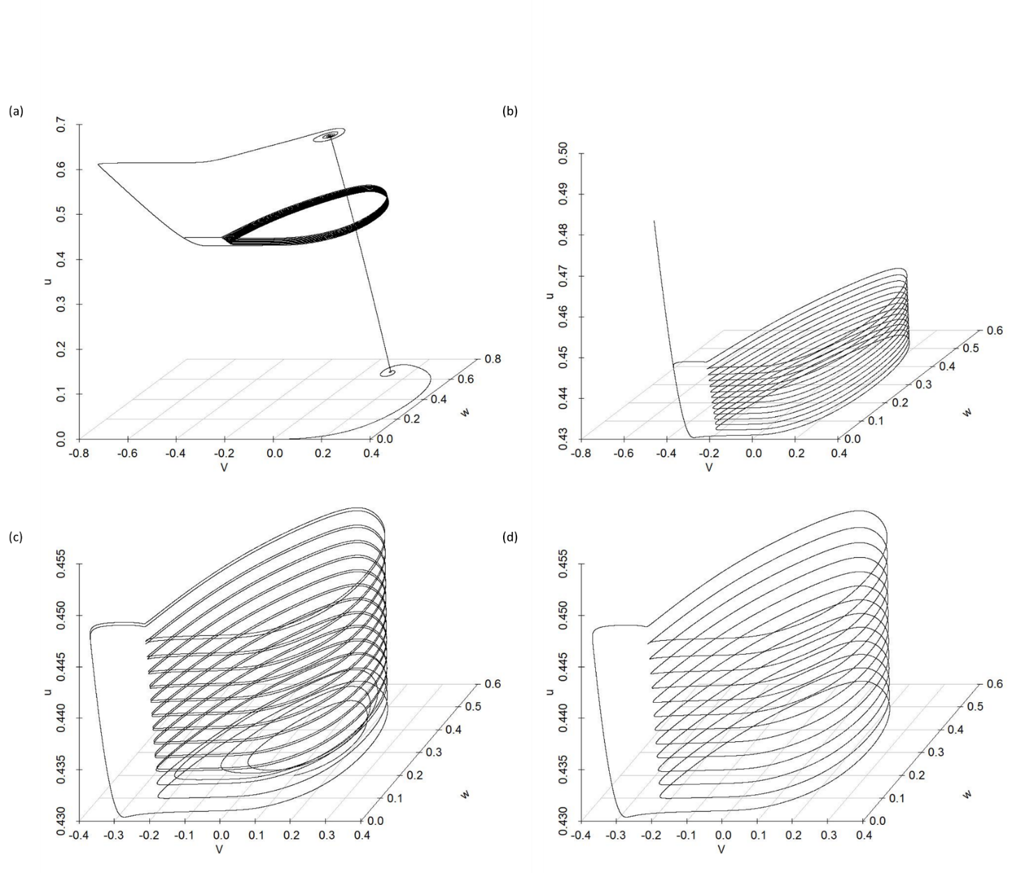**Figure 1.** The 3-D plots showing the changes in V, w, and u across time. Time is implicit in the diagrams. (a) The phase portrait for the initial state of V=0, w=0, and u=0, for (0-3000) time range. (b) The zoomed-in plot in (a) focuses on the (2100-3000) time range. (c) The phase portrait for the initial state of V=0.1, w=0.2, and u=0.43 is for (0-3000). (d) The zoomed-in version of the plot in (c) focusing on the (2100-3000) time range.

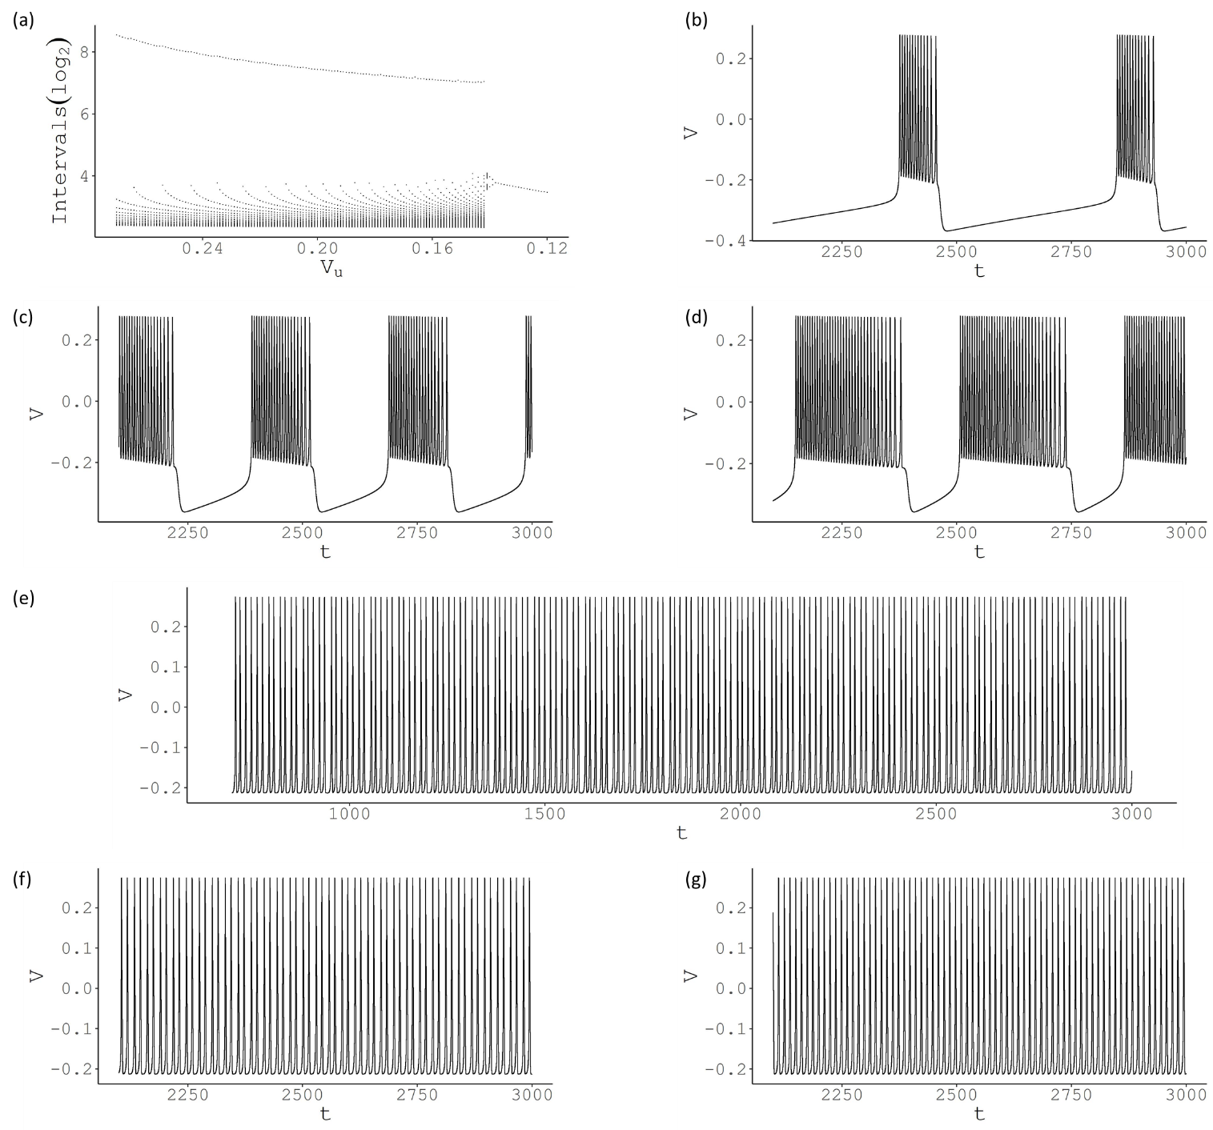**Figure 2.** The change in firing behaviour for various values of Vu. (a) For high values of Vu, a large interval between spikes is observed that shows the period between bursts and many short intervals for the spikes within the bursts. Around 0.14 value, it reaches a chaotic region before switching to period-2 and period-1 bursting. The plot is displayed in log scale, and the x-axis is in descending order to be consistent with the original article. (b) Membrane potential (V) is plotted against time t for Vu = 0.272. Large inter-burst intervals and 13 spikes per burst are observed. (c) The number of spikes per bursts increases to 21, and inter-burst intervals decrease for Vu = 0.2. (d) When Vu reaches 0.145, there are 36 spikes per burst. (e) For Vu = 0.1415, no bursting behaviour is observed with chaotic intervals. (f) The period-2 pattern is reached with Vu = 0.14. (g) The period-1 pattern is reached with Vu = 0.13.

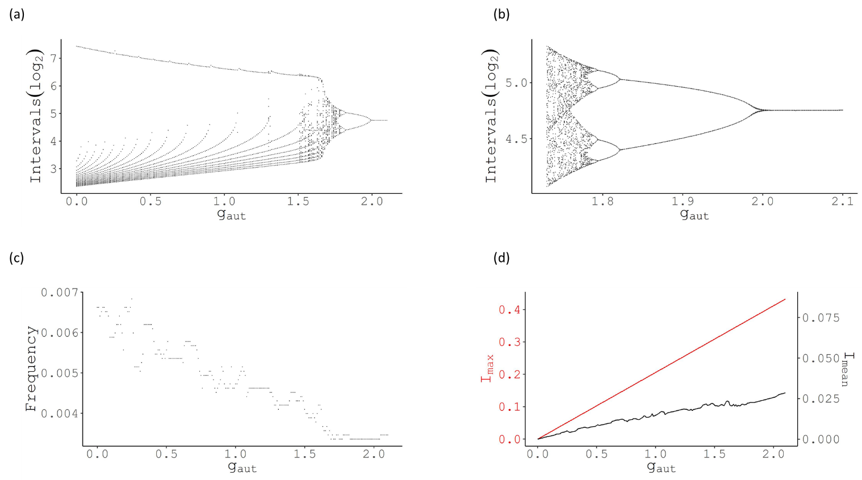**Figure 3.** The change in firing behaviour for various values of gaut. (a) For low values of gaut, a large interval between spikes is observed that shows the period between bursts and the number of short intervals for the spikes within the bursts. Around 1.7 value, it reaches a chaotic region before switching to period-8, period-4, period-2 and period-1 bursting. The plot is displayed in the log scale. (b) The zoomed-in version of the plot in (a) shows the chaotic to periodic transition. (c) The frequency of spikes shows a decreasing trend with increasing gaut. (d) Both Imean and Imax increase as gaut increases.

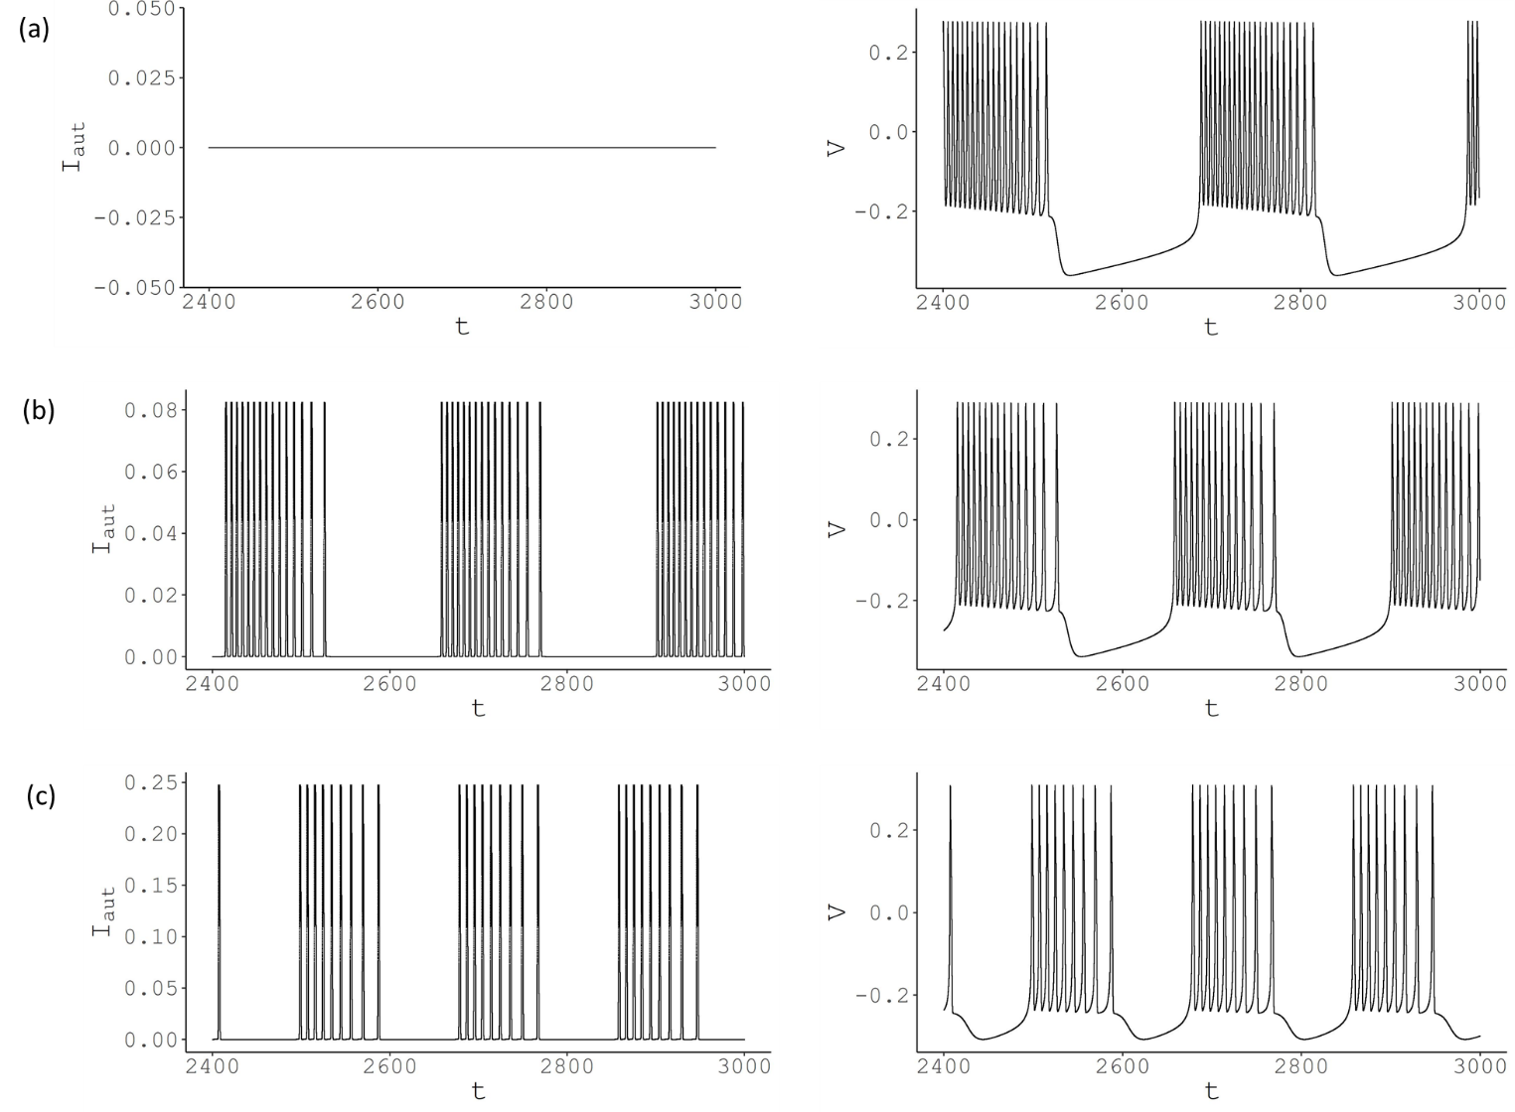**Figure 4.** The bursting behaviour observed for various values of gaut. (a) gaut = 0, ((b) gaut = 0.4, (c) gaut = 1.2. The left-hand side graphs show the current, right-hand side graphs display the membrane potentials. The value of Iaut increases with gaut, as seen by the scale change of the y-axes.

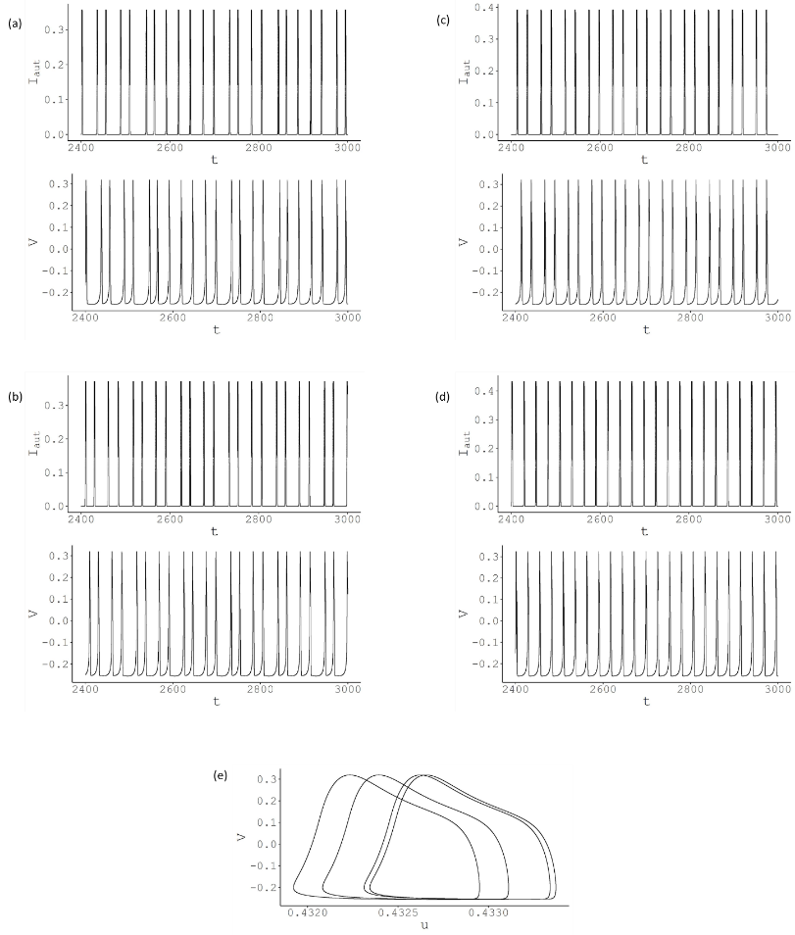

**Figure 5.** The spiking behaviour observed for various values of gaut. (a) gaut = 1.73, (b) gaut = 1.8, (c) gaut = 1.9 (d) gaut = 2.1. The top graphs show the current, and the bottom graphs display the membrane potentials. The value of Iaut increases with gaut, as seen by the scale change of the y-axes. (e) The phase portrait of V versus u for gaut = 1.8.