Sequence analysis
RNAG: A New Gibbs Sampler for Predicting RNA Secondary Structure for Unaligned Sequences
Donglai Wei¹, Charles.E.Lawrence^{2,*}
¹Department of Mathematics, Brown University, Providence, Rhode Island, United States of America
²Division of Applied Mathematics and the Center of Computational Molecular Biology, Brown University, Providence, Rhode Island, United States of America
Received on XXXXX; revised on XXXXX; accepted on XXXXX

Associate Editor: XXXXXXX

abstract
Motivation: RNA secondary structures play an important role in the function of many RNAs, and structural features are often key to their interaction with other cellular components. Thus, there has been considerable interest in the prediction of the secondary structures for RNA families. In this paper, we present a new algorithm, RNAG, to predict consensus secondary structures for unaligned sequences using the blocked Gibbs sampler, which has theoretical advantage in convergence time. This algorithm iteratively samples from the conditional probability distributions P(Structure | Alignment) and P(Alignment | Structure), and in so doing refines the models of both Alignment and Structure. We use a hierarchical clustering method to characterize the shape of the posterior space, γ-centroid estimator to generate a prediction from sampled structures and credibility limits to characterize the uncertainty.
Results: An analysis of 17 RNA families shows substantially improved structural prediction based on PPV-SEN curves comparisons, the compactness of sampled structures around their ensemble centroids for all but two families, at least eleven families with well separated clusters. In general, the distances between the references structures and the predicted structures were large compared to the variation among structures within the ensemble.
Availability: The python implementation of the RNAG algorithm and the repeatable results in Section 3.1.1 in this paper are available at http://ccmbweb.ccv.brown.edu/rnag.html
Contact: Charles_Lawrence@brown.edu

introduction
Non-coding RNAs (ncRNA) and RNA regulatory motifs in mRNAs play important roles in gene regulation and other cellular functions. They are often characterized by evolutionarily conserved secondary structures that are critical to their functions. The identification of conserved RNA secondary structures in related sequences provides a promising avenue for the characterization of novel ncRNA genes and RNA regulatory motifs.

1.1 Structure prediction for single sequence
Three main classes of probabilistic models of P(S|Q) for the prediction of the secondary structure (S) for a single sequence (Q), are currently available: the most popular is a thermodynamic model that supposes that RNA structures may be described by Boltzmann statistics, like Mfold (Zuker et al., 1981). The second model includes phylogenetic information into folding, like PETfold (Seemann et al., 2008). The third method abandons the bio-physical model in favor of machine learning algorithms to empirically infer structure based on probabilistic graphical models like CONTRAfold (Do et al., 2008) or nonparametric methods, like KNETfold (Bindewald et al., 2006).
Early algorithms, Mfold (Zuker et al., 1981) and RNAfold (Hofacker et al., 1994), use dynamic programming to find the most probable structure (MPS), the “minimum free energy structure” (MFE). However, MPS is often not representative of the Boltzmann weighted ensemble of structures, represented by feasible binary matrices, in the high dimensional discrete spaces, where even the most probable structure has incredibly low probability, and there is not fundamental principled reason for MPS to be included in the high weight region of the Boltzmann space (Carvalho et al., 2008). Thus, alternative estimators which gain information from the full ensemble of structures have emerged, including Centroid estimators (Ding et al., 2005; Carvalho et al., 2008) and the related maximum expected accuracy (MEA) estimator (Do et al., 2008). Also, a generalization of centroid estimator, γ-centroid (Hamada et al., 2009; 2010), permits the balancing of false positive and false negative errors based on the tunable parameter γ. Moreover, the focus on finding MPS without uncertainty analysis implicitly assumes that RNA exists only in one single stable state, which is often not the case for many RNAs, and almost certainly not the case of mRNAs. To address this issue, sampling algorithms, like Sfold (Ding et al., 2005), provide a method to characterize the full ensemble of structures (Mathews 2006) and Bayesian confidence limits, a.k.a. credibility limits, provide a method to delineate the uncertainty of an estimate (Newberg et al., 2009; Webb et al., 2008).

1.2 Structure prediction for multiple unaligned sequences
Now, the problem becomes harder since the extra unknown alignment (A) of the sequences enters and the model changes to P(S,A|Q).
To take one step back, let us suppose the alignment of sequences is given and the model degenerates into P(S|A,Q), which is similar to the single sequence case. The goal is to identify structural features common to these sequences based on shared statistical patterns. Mutual information (Gutell et al., 1992) and stochastic context-free grammars (SCFG) (Sakakibara et al., 1994; Knudsen et al., 1999) have been effectively used to detect and model complementary covariations that are indicative of conserved base pairing interactions. Maximum weighted matching (MWM), a graph-theoretical approach, was introduced to predict common secondary structures allowing pseudoknots (Cary et al., 1995; Tabaska et al., 1998). RNAalifold (Hofacker et al., 2002) incorporates both thermodynamic parameters and sequence covariation for prediction and permits sampling of consensus structures from its probabilistic model.
To solve the alignment problem, there are generic alignment algorithms like ClustalW2 (Ramu et al., 2005) and Probcons (Do et al., 2005) without incorporation of structural information which fall under the model P(A|Q). In order to better predict alignment for RNA sequences specifically, algorithms under the model P(A|S,Q), which gain information from the consensus structure, are more appealing. In one approach, structures of individual sequences are predicted separately and abstractions of these structures are aligned (Giegerich et al., 2004; Steffen et al., 2006; Siebert et al., 2005). Another approach (Ji et al., 2004) applies graph-theory to compare and find stems conserved across multiple sequences first, and then assembles conserved stem blocks to form consensus structures in which pseudoknots are permitted. The probabilistic covariance model (Eddy et al., 1994) employs the stochastic context free grammar (SCFG) model to multiply aligned sequences using a given consensus structure. This algorithm iterates between parameters estimation and alignment prediction using Expectation Maximization (EM) algorithm, and after convergence permits sampling of structures.
There is a “chicken and egg” problem for these two classes of algorithms: good RNA sequence alignment (A) depends on a specified consensus structure (S) and good consensus structure (S) prediction dependents of good alignments (A). One approach described in Sankoff (1985), is to simultaneously aligns and folds RNA sequences with dynamic programming algorithm. However its computational complexity is O(n⁶), too high to be of practical value. Heuristics based on simplifications and additional restrictions of Sankoff algorithm for multiple sequences (more than two) have been developed, like FoldalignM (Torarinsson et al., 2007), mLocARNA (Will et al., 2007), Murlet (Kiryu et al., 2007) and RNA Alignment and Folding (RAF) (Do et al, 2008).
Another way out is to iteratively predict structure and alignment conditional on each other. Earlier works focused on optimization with EM algorithm (Eddy et al., 1994) and Simulated Annealing Algorithm (Lindgreen et al.. 2007). Recently, approaches that draw samples from probabilistic models using Markov chain Monte Carlo (MCMC) procedures have been described. Meyer (2007) employs a Metropolis-Hasting algorithm that makes proposals for local alignment and structures changes and accepts them probabilistically. However, the convergence of these local-move algorithms tends to require a very large number of sampling steps in the high dimensional space of secondary structures. Another variation is RNAsampler (Xing et al. 2007), which heuristically iterates between the alignment and pieces of possible stems of the multiple sequences.
Gibbs sampling introduced by Geman and Geman (1984), is another popular MCMC procedure. Inspired by a theorem of Liu (1994) concerning accelerated convergence of various Gibbs samplers, here we propose a blocked sampling algorithm that iterates between alignment (A) and structures (S). In Liu's theorem 1, three alternative Gibbs sampling approaches are considered: 1) the standard Gibbs samples in which each of the random variables (RV) are sampled individually; 2) the grouped Gibbs sampler in which two or more of the RV are sampled jointly in blocks; and 3) the collapsed Gibbs sampler in which at least one of the RVs is removed from the problem via integrations. He compares their convergence speed rates on their forward operators, F_{s}, F_{g}, F_{c}, respectively. The theorem shows that norms of these operators are ordered as follows ||F_{c}|| ≤ ||F_{g}|| ≤ ||F_{s}||. Thus the expected number of iterations until convergence follows the reverse order. However, as he points out, if the computation required at each iteration to either sample blocks or to remove random variables via integration is too large, then any improvements in convergence rate may not be worth of the added computational expense. Thus the key is to find efficient procedures for blocking or integrating.

methods

2.1 Sampling Algorithm: Composite probabilistic model
Consider the probabilistic model P(A,S|Λ_{A},Λ_{S},Q) for multiple sequences Q, where hidden variables are: A the alignment, S the consensus structure and Λ_{A},Λ_{S} the corresponding parameters of A,S prediction steps. The goal is to find samples from the joint distribution P(A,S|Λ_{A},Λ_{S},Q). The blocked Gibbs sampler, RNAG, described here achieves this by iteratively sampling from the conditional probability P(S^{(t)}|A^{(t-1)}, Λ_{S},Q) and P(A^{(t)}|S^{(t-1)}, Λ_{A} ,Q) for the t-th iteration. Notice that our algorithm provides a generic framework, where several of current algorithms can fit into each of these two sampling steps. Specifically, RNAG proceeds as follows:
2.1.1 Alignment Initialization In theory, it does not matter if the algorithm starts from an initial alignment or an initial consensus structure. Here we begin with an initial alignment A⁽⁰⁾ produced by Probcons (Do et al., 2005) under the model P(A|R).
2.1.2 Iteration Step
- Sample consensus structure (S^{(t)}) given alignment (A^{(t-1)}) To sample from P(S^{(t)}|A^{(t-1)}, Λ_{S},Q), we employ RNAalifold (Bernhart et al., 2008), which combines thermodynamic parameters and empirical parameters estimated from the aligned sequences using a default covariation weight Λ_{S}.
- Sample alignment (A^{(t)}) given consensus structure (S^{(t-1)}) To sample from P(A^{(t)}|S^{(t-1)}, Λ_{A},Q), we employ the Infernal package (Nawrocki et al.,2009). Λ_{A} is the empirical parameter estimates (parameters for SCFG model) obtained from P(Λ_{A} |S^{(t-1)},A^{(t-1)},Q) using Expectation Maximization (EM) algorithm. Given Λ_{A}, a multiple alignment is sampled from P(A^{(t)}|Λ_{A} , S^{(t-1)} ,Q) using the SCFG model.

2.2 Sample analysis: Characterize the posterior space
As described by Mathews (2006), sampling from the Boltzmann weighted space of secondary structures can provide a full characterization of this space. Here the RNAG sampler draws samples from this very high dimensional space of structures and alignments. In this analysis our attention is focused on the sampled structures, though the multiple alignments also evolve during the sampling. We employ clustering analysis to characterize the overall shape of the posteriors space of structures and credibility limits (Newberg et al., 2009; Webb et al., 2008) to delineate uncertainty in predicted structures.
2.2.2 Clustering analysis Boltzmann weighted ensembles of RNA secondary structure can exhibit complex shapes, which often include multiple modes (Ding et al., 2006). Here we examine the shape of the probabilistically weighted posterior space using a hierarchical clustering procedure like that employed by Ding et.al (2006) for a single sequence.
Direct comparison of the sampled consensus structures is impractical because of the dependence of the indices of the bases of sampled structures on the alignment. Thus, we follow the second evaluation procedure in Hamada et al.(2010), projecting the consensus structure back onto each sequence and use hierarchical clustering method on the projected structures.
2.2.2 Centroid Estimator In this analysis we employ γ-centroid estimators for structure prediction and for the comparison of alternative predictive methods. Ding et.al (2005) first proposed the use of the centroid estimator for the prediction of RNA secondary structure. Carvalho et al. (2008) employed statistical decision theory to show the advantages of centroids estimators over traditional highest scoring estimators such as the minimum free energy structure. Hamada et al. (2009) introduced the γ-centroid as a generalization of the centroid estimator that provides a means to balance sensitivity and positive predictive value (PPV) and accordingly can be used to compare procedures over the range of this tradeoff. We employ the γ-centroid estimator for such comparisons and the original centroid estimator in calculation of bias and variance.

Evaluation Metric
2.3.1 Prediction Accuracy We compare the predicted structure for each sequence with its reference structure and calculate the score of sensitivity and positive predictive value (PPV). Sensitivity is the fraction of known pairs correctly predicted and PPV is the fraction of predicted pairs in the known structure (Mathews, 2004). Using γ-centroid estimation, we can interpolate a curve on PPV-SEN plane based on different γ value (Hamada et al., 2010). Notice that there are two different ways of calculating the average PPV/SEN in the current literature. The first method calculate PPV/SEN for each test case and average over them while the second calculate the score from the total number of True Positive (TP), False Positive (FP) and False Negative (FN) of all tests. For most of the time, these two methods give similar results but the second one places more weight on the result for long sequence. For the comparison the relative performance of the algorithm across RNA families, we use the area under the curve, acquired with linear interpolation, as a qualitative measure.
2.3.2 Uncertainty Analysis
- Credibility Limit: Any prediction of structure provides only a point estimate of secondary structure, but gives no information about the uncertainty of that estimate. We employ Bayesian confidence limits, a.k.a. credibility limits to characterize this uncertainly (Newberg et al., 2009; Webb et al., 2008). These limits compute the radius of the smallest sphere centered at the estimate containing 95% of the posterior weighted space.
- Bias-Variance Analysis: In any prediction based on finite data involving comparison with a reference, deviations from the reference involves two components, bias and variance, where the bias measures the hamming distance between the mean structure and the reference, while the variance gives the variation around the mean. In this discrete setting, the mean is almost certainly not a feasible RNA secondary structure because it is very unlikely to be integer valued. Accordingly, here we measure bias as the distance between the structure in the ensemble that is nearest to the mean in the least squares sense, the centroid, and the reference structure (Carvalho et al., 2008), and the variance around the centroid of the ensemble. We also obtain variances around cluster centroids.
- Separation index: To assess how well separated the clusters are relative to the variation within clusters we use the following separation index
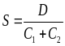 (1)
,where D is the Hamming distance between the two centroids of the two largest clusters, and 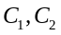 are the 95% credibility limits around the two largest cluster centroids. When the index is at least 1 no more than 5% of the structures from either cluster are within the 95% credibility limit of the other cluster, and thus we say the two largest clusters are well separated.

results
For all the experiment below, we employed RNAG for a burning period of 1000 sampling iterations and the next 1000 sampled structures were used for analyses. We followed Hamada et al. (2010) and picked 17 γ-centroid estimators where γ∈{2^{k}: −5 ≤ k ≤ 10,k∈Z}∪{6} to interpolate the curve on the PPV-SEN plane. In order to compare with known results in the literature, we strictly followed their ways of calculating average PPV/SEN. We used the first method described in Sec. 2.3.1 for experiments in Sec.3.1 and the second method for experiments in Sec.3.2.

Comparison of accuracy
In our first accuracy assessment, we evaluated RNAG using the BRAliBASE II dataset. We chose the first dataset from BRAliBASE II, which contains collections of around 100 five-sequence subalignments sampled from five specific Rfam families (5S rRNA, gourp II intron, SRP, tRNA and U5). In particular, we did not use SRP for quality issues claimed on the website. We repeated the experiment in Do et al. (2007) and the results are plotted on PPV-SEN plane in Figure 1.
Fig 1. Performance of different secondary structure prediction methods in PPV-SEN plane for MASTR dataset. PPV=TP/P= TP/(TP+FP), SEN=TP/T=TP/(TP+FN)
Fig 2. Performance of different secondary structure prediction methods in PPV-SEN plane for 4 RNA families (5SRNA, group II intron, tRNA and U5) in BRAliBASE II dataset.

We also obtained the dataset use in the benchmarking of MASTR RNA secondary structure prediction program. We repeated the experiment in Do et al. (2007) and the results are plotted on PPV-SEN plane in Figure 2.
In both cases, we see that most of the results from current algorithms fall in the lower-left region of the PPV-SEN curve produced by RNAG, which indicates significant improvement.

A sample survey of Rfam
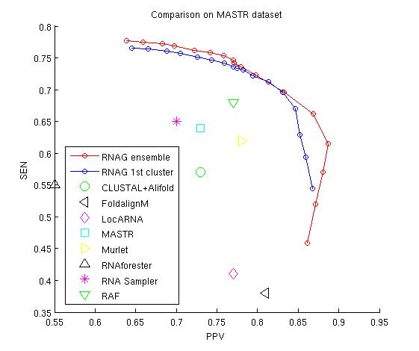
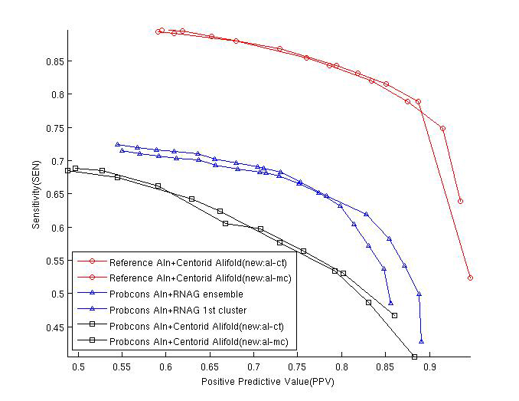
Above, the datasets are extremely restricted in their coverage of the space of RNA families. In order to have a larger sample of Rfam, we conducted experiment on the benchmarking dataset of Murlet (Kiryu et al. 2007), which contains 85 reference alignments of 10 sequences taken from 17 RNA families in the Rfam database (Griffiths-Jones et. al., 2005). This choice permits comparison with the
Fig 3.CentroidAlifold structure prediction from Probcons initial alignment and reference alignment act as lower/upper bound for RNAG respectively

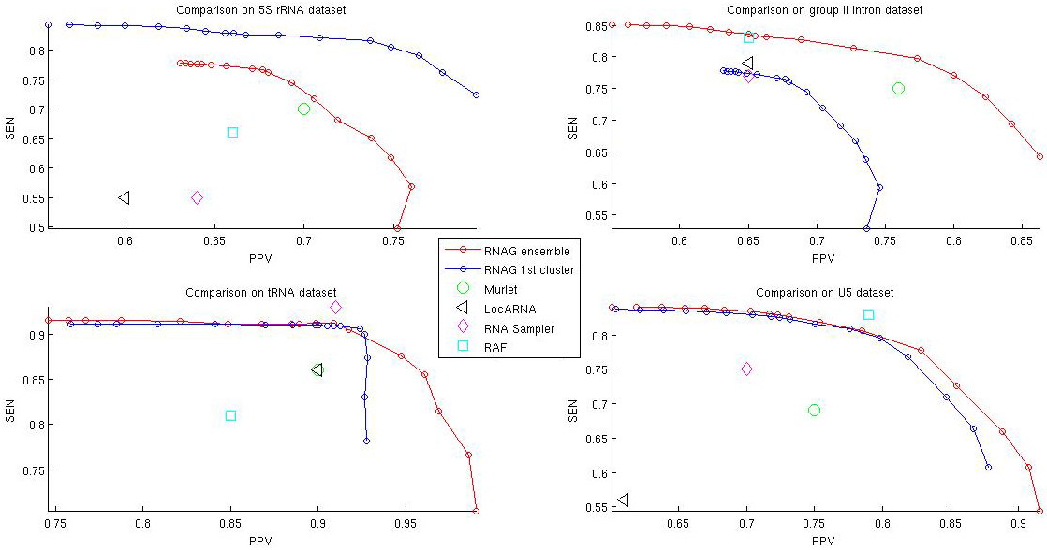
performance of CentroidAlifold (Hamada et al., 2010), the state-of-the-art algorithms for structure prediction from fixed alignment.

3.1.1 Bound for Accuracy performance In Figure 3, we show the lower and upper bound for the performance of RNAG. Starting from the same initial alignment from Probcons, RNAG performs better than CentroidAlifold since it improves the alignment during the iterations though still not close to the reference alignments. Since we are using RNAalifold for structure prediction given the alignment, RNAG performs worse than CentroidAlifold if start from the reference alignment.
3.1.2 Investigation on the number of unaligned sequences To assess the contribution from multiple sequences, we took N (2≤N≤10) random sequences from each of the 85 sub-alignments in Kiryu et al. (2007), ran RNAG on these subsets of sequences and averaged over 10 independent runs except for N=10. As Figure 2 shows, additional sequence improves prediction of the reference structure but with decreasing increment as indicated by the small improvement from 8 to 10 sequences. This effect is also reflected in the area under the PPV-SEN curve as shown in Table 1. Notice in Table 1 that the bias decreases with the number of sequences in the alignment but with decreasing gains, which is in agreement with improvements in the area under the PPV-SEN curves. Also, notice that the standard deviations,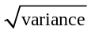, around the centroid estimators also decrease with the number of sequences in the alignment and are consistently small compared to the biases. In addition, notice that the 95% credibility limits are 4 to 5 times greater than the standard deviations, indicating that the distances from the centroids are far from normally distributed, and that the area under the PPV-SEN curve for the ensemble centroid is consistently higher than those for either of the cluster centroid.
3.1.3 A Detailed Look into each Family
The above results describe the overall performance of RNAG for this data set, but don't reveal differences across the families. In Table 2, we list the bias-variance statistics, area under PPV-SEN curve and cluster statistics for each family. As this table indicates
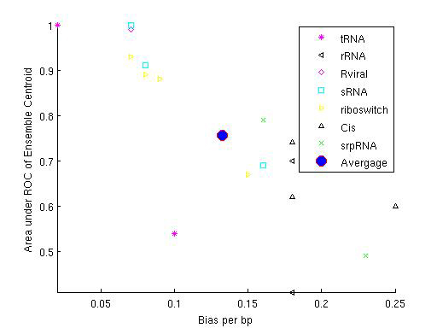
Fig 4. Improvement of PPV-SEN curves with number of sequences involved in the prediction.
Fig 5. 2D plot to cluster different RNA families by Bias per base pair (bp) and Area under the PPV-SEN of Ensemble Centroid
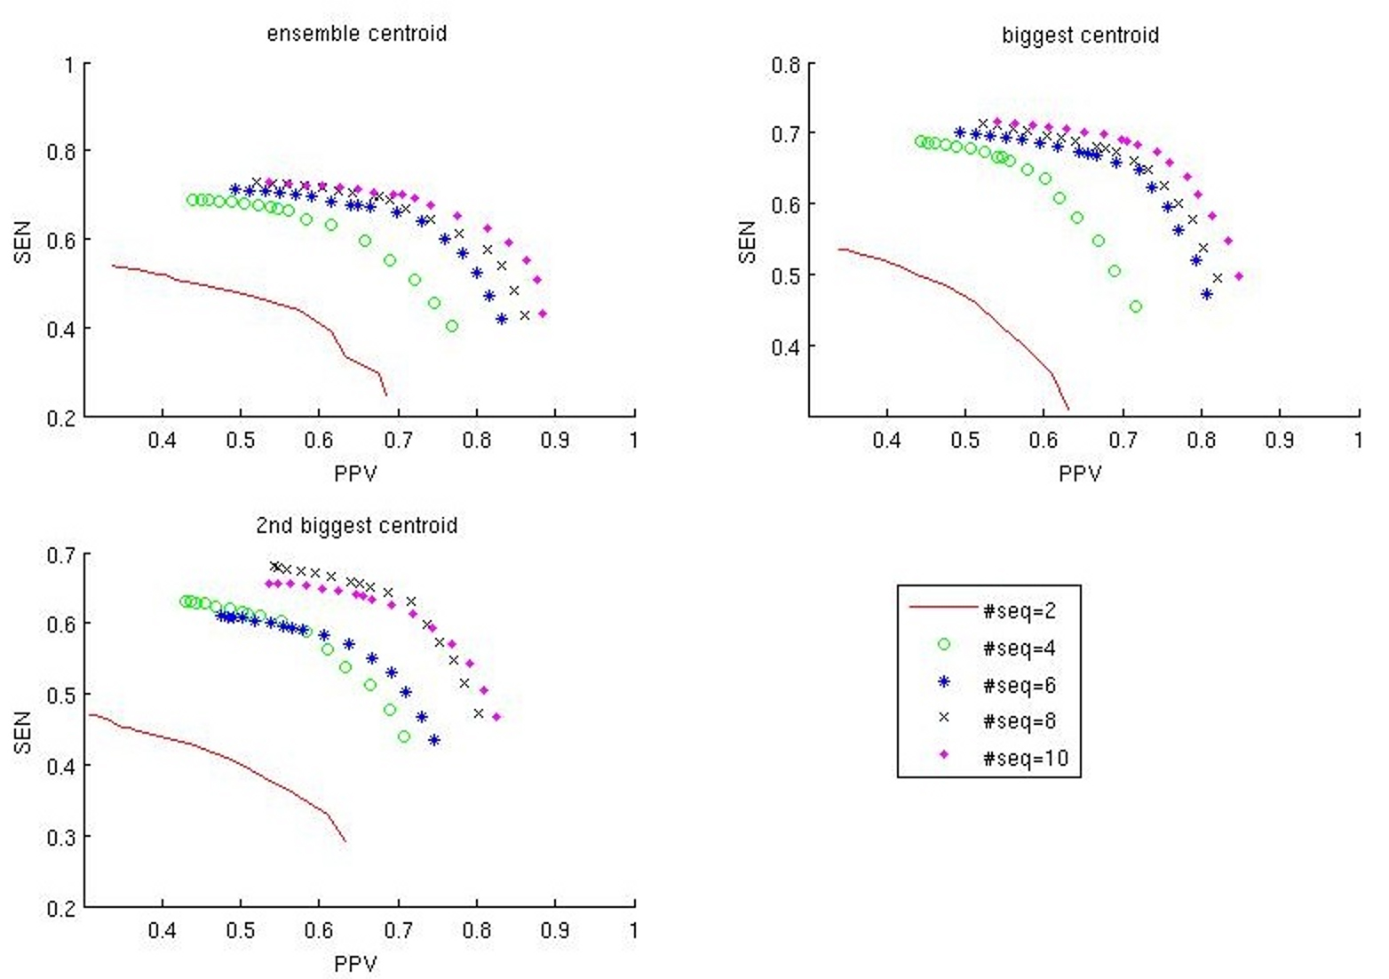
there is considerable variability in the biases and areas under the PPV-SEN curves between the families, which reflects the fact that the ability to predict the references structure varies widely between families. Figure 3 highlights this variability and shows that there is strong correlation between bias and the area under the PPV-SEN curve. Notice that the normalized 95% ensemble credibility limits are under 10% for all but four of the families, which indicates that in most families the probabilistically weighted ensembles are quit tightly compact around the centroid of the full ensemble. Normalization was obtained by dividing Hamming distances by the lengths of the sequences. In spite of this eleven families have a separation score of at least 1 as indicated by the last column in table 2. , This indicates that the cluster centroids are well separated for these nine families since the distanced between the centroids of the two clusters is at least as large as the sums of the 95% credibility limits of two clusters. Finally notice that the biases, which give the distances between the predicted structures and the references structure, are more than twice as large as the standard deviations of the distances of ensemble members around the predicted structures.
Table 3. Hamming distance from the centroids of the two largest clusters to the reference structure in Rfam. The value for the 2nd cluster is in the bracket.
Test#/#seqs | 2 | 5 | 7 | 10
1 | 0.18(0.11) | 0.04(0.06) | 0.06(0.08) | 0.05(0.14)
2 | 0.17(0.24) | 0.04(0.07) | 0.06(0.08) | 0.07(0.18)
3 | 0.08(0.27) | 0.05(0.03) | 0.04(0.01) | 0.01(0.03)
4 | 0.11(0.08) | 0.06(0.16) | 0.05(0.02) | 0.07(0.05)
5 | 0.15(0.06) | 0.03(0.14) | 0.04(0.13) | 0.06(0.04)

3.3 Detecting the structure of a Riboswitch:

A riboswitch is part of an mRNA molecule that binds a small target molecule, and changes its conformation. It has been reported that the existence of bimodality in structure space is the indication of a riboswitch at least for the SAM family of riboswitches (Giegerich et al.,1999; Freyhult et al., 2007).
Here, we examine the 105nt SAM riboswitch with EMBL accession number AE016750.1/132874-132778. The test dataset consists of 5 sub-alignments of 10 sequences from SAM family. In each sub-alignment, the first sequence is the target RNA mentioned above and the rest are manually chosen uniformly from the phylogenetic tree of SAM family. As shown in Table 3, the bias of the cluster centroid estimators from RNAG decreases with the increase of the number of sequences. The centroid of the larger of the two clusters is almost always closer to the reference than that from the smaller. As the table indicates with 10 sequences the centroid of the larger cluster predicts the references structure in Rfam quite well, while the centroid of the second structure doesn’t. In reality, two different structures of SAM are known experimentally (Montange et al., 2006), shown in Figure 6. The reference structure corresponds to the SAM-off situation and the structure for SAM-on cannot be predicted by current models since the binding of SAM alters the structural ensemble substantially. Our finding of well separated clusters for eleven families and two of the four riboswitch families indicates that the existence of distinct clusters is not sufficient to indentify riboswitches.

Discussions
RNAG not only inherits the advantage of the sampling method but also enjoys theoretically convergence advantage over the Metropolis-Hasting algorithm employing local moves, which may easily get stuck in a local energy well. Furthermore, since it samples full valid secondary structure, RNAG enjoys advantage over iteration algorithms that perform this step heuristically.

Potential Improvement of RNAG
From Figure , we can see a big gap between the result of RNAG and the state-of-art performance of structure prediction from reference alignment. However, the performance can be improved in several ways. First, the auxiliary packages that RNAG now uses (Probcons, RNAaliifold,Infernal) are used with their default options and default values. Performance may be improved by exploiting the full strength of these packages and by choosing parameters from cross-validation. Moreover, RNAG is only a framework for computation and the auxiliary packages above can be replaced by any other packages that are designed for P(A|Q), P(S|A,Q) and P(A|S,Q). Furthermore, RNAG now takes the theoretical ad-
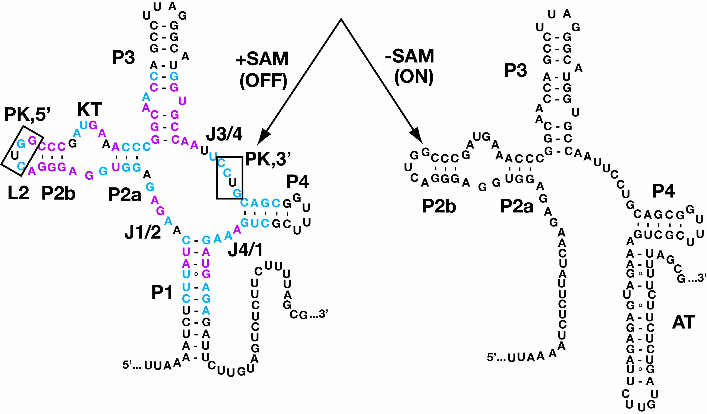
Fig 6. Experiment result of two distinct secondary structures for SAM RNA family 2D plot to cluster different RNA families. The left structure is close to the reference structure in Rfam and right one cannot be predicted by current models which do not capture the interaction with the extra molecule.
vantage of blocked Gibbs Sampler by grouping parameters to sample into S and A. With a little more effort, we can speed up the convergence rate by integrating out A from the model and take the advantage of collapsed Gibbs Sampler.

Validity of the reference structure
Our findings of substantial biases, suggest that either current alignment and structural models are deficient, that we haven’t sampled long enough to achieve convergence, or that several of the references structures in Rfam are not reflective of the structural and sequence features common to RNA families. Specifically, many of the reference structures in Rfam are obtained from crystal structures or from in vitro experiments and may not reflect structure features common among family members as key interacting factors are not present in these experiments. This suggests an alternative goal for align-fold algorithms aimed at RNA family identification: correct classification of sequences to families, similar to that reported by Webb et.al (2002) for protein sequences. As the database of Rfam families have been obtained based on alignments to specify “reference structure”, it will be a particularly difficult challenge to demonstrate that there is an alternative structure, which is superior in the identification of family members. Of course arguments based on deviations from in-vitro experiments do not hold for reference structures obtained by covariation analysis. Thus comparisons of performances in family membership may require the use of reference sets obtained through independent experiments, such as experiments using immunoprecipitation (IP) methods. The existence of small variances indicates that an alternative estimator that trades of variance to reduce bias may yield lower overall deviations.

Confusion of maximum expected accuracy(MEA)
In recent publications, maximum expected accuracy (MEA) estimators are widely used as a better representative than the previous MFE estimator. However, we find the name of MEA misleading. If the MEA is calculated on the basis of base pairs instead of individual bases then this estimator corresponds to the centroid or γ-centroid. But our findings of large biases of these estimators indicate that expected "accuracy" is misleading in that there is no assurance about these estimators having minimum departure from an outside reference structure. However, these estimators do return estimates that have minimum variance, and thus in the least squared sense they are the most reproducible of all estimators in the posterior weighted space. Accordingly, they would be better described as Maximum expected precision (MEP) estimators, or perhaps preferably by the non buoyant name that defines them as centroid or γ-centroid estimates.

Conclusion
In this study, we introduce a blocked Gibbs Sampler (RNAG) to predict secondary structure for unaligned RNA sequences. RNAG confronts the high time complexity of the align-fold problem by capitalizing on Liu’s findings on blocked Gibbs sampling. As Figure 1 shows that the new algorithm delivers substantial improvement during PPV-SEN performance. However, as with any MCMC procedure, evidence of convergence of the burn in can’t be guaranteed. Also, in the current implementation of this algorithm little has been done to obtain fast code or an efficient stopping rule. So there is substantial room for improvement in implementation speed. Furthermore, this procedure and others like it may not be ideal for structure prediction since if it works perfectly, it will only capture structural and sequential feature common to a set of input sequences, much as motif finding algorithms capture sequence characteristics common to transcription factor binding sites in multiple sequences. Nevertheless, here we show that RNAG does a better job at predicting reference structures than extant procedures while providing a fuller characterization of the shape of the posterior space including characterization of multimodal features and ascertainment of uncertainty in structural predictions.
acknowledgements

References
Bafna V,et al Consensus folding of unaligned RNA sequences revisited. J. Comput. Biol. 200613:283-295.
Bindewald, E and Shapiro B.A (2006): RNA secondary structure prediction from sequence alignments using a network of k-nearest neighbor classifiers. RNA. 12(3): 342-352 (2006).
Bernhart,S.H. et al. (2008) RNAalifold: improved consensus structure prediction for RNA alignments. BMC Bioinformatics, 9, 474–484.
Carvalho L, Lawrence C. (2008) Centroid estimation in discrete high-dimensional spaces with applications in biology. Proc. Natl Acad. Sci. USA. 2008105:3209-3214.
Cary RB, Stormo GD.(1995) Graph-theoretic approach to RNA modeling using comparative data. Proc. Int. Conf. Intell. Syst. Mol. Biol. 19953:75-80
Ding Y, Chan CY, and Lawrence CE. (2005) RNA Secondary Structure Prediction by Centroids in a Boltzmann Weighted Ensemble. RNA, 11 (8):1157-1166.
Ding Y, Chan CY, and Lawrence CE (2006) Clustering of RNA secondary structures with application to messenger RNAs, Journal of Molecular Biology, 359: 554–571
Do, C.B., Foo, C.-S., and Batzoglou, S. (2008) A max-margin model for efficient simultaneous alignment and folding of RNA sequences. Bioinformatics 24: i68-i76.
Do, C.B., Mahabhashyam, M.S.P., Brudno, M., and Batzoglou, S. (2005) PROBCONS: Probabilistic Consistency-based Multiple Sequence Alignment. Genome Research 15: 330-340.
Eddy SR, Durbin R (1994) RNA sequence analysis using covariance models. Nucleic Acids Res.22:2079-2088.
Freyhult .E, Moulton.V, Clote P. (2007) Boltzmann probability of RNA structural neighbors and riboswitch detection. , Bioinformatics. 2007 Aug 1523(16):2054-62. Epub Jun 14.
Geman, S. and D. Geman (1984). Stochastic relaxation, Gibbs distributions, and the Bayesian restoration of images. IEEE Trans. Pattern Analysis and Machine Intelligence 6: 721-741
Giegerich R., Haase D. and Rehmsmeier M. (1999) Prediction and visualization of structural switches in RNA, Pac. Symp. Biocomput., Pages: 126-137,
Giegerich R, et al (2004) Abstract shapes of RNA. Nucleic Acids Res.32:4843-4851.
Gorodkin J, et al (2001) Discovering common stem-loop motifs in unaligned RNA sequences. Nucleic Acids Res.29:2135-2144.
Griffiths-Jones S, et al (2005) Rfam: annotating non-coding RNAs in complete genomes. Nucleic Acids Res.33:D121-D124.
Gutell R.R.,Power, A., Hertz, G.Z., Putz, E.J. and Stormo, G.D.(1992) Nucleic Acids Res. 20: 5785-5795
Hamada M, Sato K, Asai K (2010) Improving the accuracy of predicting secondary structure for aligned RNA sequences. Nucleic Acids Res. Sep 15. doi: 10.1093/nar/gkq792
Hamada, M., Kiryu, H., Sato, K., Mituyama, T., & Asai, K. (2009),“Prediction of RNA Secondary Structure Using Generalized Centroid Estimators,” Bioinformatics,25(4), 465–473. doi:10.1093/bioinformatics/btn601.
Hofacker IL, Fekete M, Stadler PF. (2002) Secondary structure prediction for aligned RNA sequences. J. Mol. Biol. 2002319:1059-1066.
Hofacker,I.L. et al. (2004) Alignment of RNA base pairing probability matrices.Bioinformatics, 20, 2222–2227.
Hofacker I.L. et.al (1994) Fast Folding and Comparison of RNA Secondary Structures. Monatshefte f. Chemie 125: 167-188
Holmes,I. and Rubin,G.M. (2002) Pairwise RNA structure comparison with stochastic context-free grammars. Pac. Symp. Biocomput., 163–174.
Holmes,I. (2005) Accelerated probabilistic inference of RNA structure evolution. BMC Bioinformatics, 6, 73–77.
Ji Y, Xu X. and Stormo, G.D.(2004) A graph theoretical approach for predicting common RNA secondary structure motifs including pseudoknots in unaligned sequences. Bioinformatics 200420:1591-1602
Kiryu,H. et al. (2007) Murlet: a practical multiple alignment tool for structural RNAsequences. Bioinformatics, 23, 1588–1598.
Kiryu,H. Tabei,Y.,Kub,T. and Asai,K. (2007) Robust prediction of consensus secondary structures using averaged base pairing probability matrices. Bioinformatics 200723:434-441.
Knudsen B, Hein J (1999) RNA secondary structure prediction using stochastic context-free grammars and evolutionary history. Bioinformatics 199915:446-454.
Lindgreen S., Gardner P.P. and Krogh A. (2007): MASTR: Multiple alignment and structure prediction of non-coding RNAs using simulated annealing, Bioinformatics, 23(24):3304-11
Liu, J.S. (1994). The collapsed Gibbs sampler in Bayesian computations with applications to a gene regulation problem. Journal of the American Statistical Association, 89: 958-966.
Mathews D.H. (2006) Revolutions in RNA Secondary Structure Prediction J. Mol. Biol. 359, 526–532
Mathews DH, Turner DH (2002) Dynalign: an algorithm for finding the secondary structure common to two RNA sequences. J. Mol. Biol. 317:191-203.
Meyer I. M. and Miklos I., SimulFold: Simultaneously Inferring RNA Structures Including Pseudoknots, Alignments, and Tress Using a Bayesian MCMC Framework, PLoS Computational Biology (2007) 3(8): e149
Montange, R.K, Batey R.T. (2006) Structure of the S-adenosylmethionine riboswitch regulatory mRNA element Nature 441, 1172-1175
Nawrocki E. P., Kolbe D. L., and Eddy S. R.,(2009) Infernal 1.0: Inference of RNA alignments , Bioinformatics 25:1335-1337
Newberg L. and Lawrence C. (2009) Exact calculation of distributions on integers, with application to sequence alignment. Journal of Computational Biology, 16(1), 1-18
Ramu C.et al., (2003) Multiple sequence alignment with the Clustal series of programs. Nucleic Acids Res 31 (13):3497-5000
Sakakibara Y, et al (1994) Stochastic context-free grammars for tRNA modeling. Nucleic Acids Res. 22:5112-5120.
Sankoff D Simultaneous solution of the RNA folding, alignment and protosequence problems. SIAM J. Appl. Math. 198545:810-825.
Seemann SE, Gorodkin J, Backofen, R.( 2008) Unifying evolutionary and thermodynamic information for RNA folding of multiple alignments. Nucleic Acids Research, 36(20):6355-6362,
Siebert S, Backofen R MARNA: multiple alignment and consensus structure prediction of RNAs based on sequence structure comparisons. Bioinformatics 200521:3352-3359.
Steffen P, et alRNAshapes: an integrated RNA analysis package based on abstract shapes. Bioinformatics 200622:500-503.
Tabaska JE, et al An RNA folding method capable of identifying pseudoknots and base triples. Bioinformatics 199814:691-699.
Torarinsson,E. et al. (2007) Multiple structural alignment and clustering of RNA sequences. Bioinformatics, 23, 926–932
Touzet H,Perriquet O (2004) CARNAC: folding families of related RNAs. Nucleic Acids Res. 32:W142-W145.
Webb BJ, Liu JS, Lawrence CE (2002), BALSA: Bayesian Algorithm for Local Sequence Alignment. Nucleic Acids Res, 30(5):1268-1277.rescu,A.
Webb-Robertson, B.-J.M., McCue, L.A., and Lawrence,C.E. (2008) Measuring global credibility with application to local sequence alignment. PLoS Comput. Biol. 4, e1000077.
Will,S. et al. (2007) Inferring noncoding RNAfamilies and classes by means of genomescale structure-based clustering,. PLoS Comput. Biol., 3, e65–e65.
Xing Xu, Yongmei Ji, and Gary D. Stormo (2007) RNA Sampler: a new sampling based algorithm for common RNA secondary structure prediction and structural alignment Bioinformatics, August 23: 1883 - 1891.
Zuker M, Stiegler P. (1981) Optimal computer folding of large RNA sequences using thermodynamics and auxiliary information. Nucleic Acids Res. Jan 109(1):133–148

Table 1.Effects of the number of sequences. In order to normalize bias, standard deviation(std) and credibility limit with respect to the sequence length, we divide them by the averaged sequence length for the family.

#seqs | Area under PPV-SEN curve |  |  | Bias | Std | #samples |  |  | 95% Credibility Limit
#seqs | ensemble | 1st cluster | 2nd cluster | Bias | Std | 1st cluster | 2nd cluster | 1st +2nd cluster | ensemble | 1st cluster | 2nd cluster
2 | 0.44 | 0.46 | 0.41 | 0.27 | 0.04 | 728.13 | 150.76 | 878.89 | 0.21 | 0.14 | 0.11
3 | 0.61 | 0.60 | 0.55 | 0.20 | 0.03 | 793.15 | 124.94 | 918.09 | 0.14 | 0.10 | 0.07
4 | 0.63 | 0.61 | 0.56 | 0.20 | 0.03 | 791.66 | 115.00 | 906.66 | 0.14 | 0.09 | 0.06
5 | 0.65 | 0.64 | 0.59 | 0.17 | 0.03 | 802.20 | 113.24 | 915.44 | 0.12 | 0.08 | 0.05
6 | 0.67 | 0.67 | 0.59 | 0.16 | 0.03 | 800.50 | 111.66 | 912.16 | 0.11 | 0.07 | 0.05
7 | 0.70 | 0.68 | 0.63 | 0.15 | 0.03 | 795.52 | 111.92 | 907.44 | 0.10 | 0.07 | 0.05
8 | 0.70 | 0.68 | 0.68 | 0.15 | 0.03 | 797.56 | 116.19 | 913.75 | 0.10 | 0.07 | 0.04
9 | 0.71 | 0.69 | 0.66 | 0.14 | 0.02 | 790.59 | 122.38 | 912.97 | 0.09 | 0.06 | 0.04
10 | 0.72 | 0.71 | 0.66 | 0.13 | 0.02 | 792.85 | 125.11 | 917.96 | 0.09 | 0.06 | 0.04

Table 2. Statistics for each of 17 RNA families. Bias, standard deviation(std) and credibility limit are normalized with respect to the sequence length as they are in Table 1.
RNA Family | RNA type | mean length | Bias | Std | Credibility Limit |  |  | PPV-SEN Area |  |  | # Samples |  |  | Separation  Index
 |  |  |  |  | ensemble | 1st cluster | 2nd cluster | ensemble | 1st cluster | 2nd cluster | 1st+2nd | 1st cluster | 2nd cluster | Separation  Index
T-box | tRNA | 244 | 0.10 | 0.01 | 0.06 | 0.04 | 0.02 | 0.54 | 0.52 | 0.47 | 926 | 826 | 100 | 1.00
t-RNA | tRNA | 73 | 0.02 | 0.01 | 0.03 | 0.01 | 0.01 | 1.00 | 0.99 | 0.91 | 949 | 888 | 61 | 2.50
5S-rRNA | rRNA | 116 | 0.17 | 0.02 | 0.07 | 0.05 | 0.03 | 0.70 | 0.70 | 0.67 | 922 | 751 | 171 | 0.88
5-8S-rRNA | rRNA | 154 | 0.18 | 0.03 | 0.14 | 0.10 | 0.08 | 0.41 | 0.40 | 0.26 | 907 | 744 | 163 | 0.56
Retroviral-psi | Rviral | 117 | 0.07 | 0.05 | 0.15 | 0.11 | 0.05 | 0.99 | 0.99 | 0.45 | 981 | 952 | 29 | 1.25
U1 | sRNA | 157 | 0.16 | 0.02 | 0.06 | 0.06 | 0.02 | 0.69 | 0.69 | 0.63 | 988 | 928 | 60 | 1.13
U2 | sRNA | 182 | 0.08 | 0.02 | 0.05 | 0.05 | 0.02 | 0.91 | 0.90 | 0.70 | 981 | 941 | 40 | 1.14
Sno-14q-I-II | sRNA | 75 | 0.07 | 0.03 | 0.12 | 0.08 | 0.07 | 1.00 | 0.91 | 0.84 | 838 | 636 | 202 | 0.47
Lysine | riboswitch | 181 | 0.07 | 0.02 | 0.06 | 0.05 | 0.03 | 0.93 | 0.93 | 0.83 | 983 | 923 | 60 | 0.88
RFN | riboswitch | 140 | 0.15 | 0.03 | 0.11 | 0.06 | 0.06 | 0.67 | 0.64 | 0.59 | 820 | 574 | 246 | 0.58
THI | riboswitch | 105 | 0.08 | 0.02 | 0.07 | 0.06 | 0.02 | 0.89 | 0.88 | 0.75 | 968 | 869 | 99 | 1.13
S-box | riboswitch | 107 | 0.09 | 0.02 | 0.07 | 0.03 | 0.03 | 0.88 | 0.87 | 0.74 | 945 | 806 | 139 | 1.17
IRES-HCV | Cis | 261 | 0.25 | 0.05 | 0.21 | 0.16 | 0.08 | 0.60 | 0.57 | 0.44 | 936 | 877 | 59 | 1.00
SECIS | Cis | 64 | 0.17 | 0.02 | 0.08 | 0.02 | 0.02 | 0.74 | 0.71 | 0.72 | 840 | 679 | 161 | 1.50
UnaL2 | Cis | 54 | 0.18 | 0.03 | 0.06 | 0.02 | 0.02 | 0.62 | 0.62 | 0.61 | 867 | 752 | 115 | 1.00
SRP-bact | srpRNA | 93 | 0.16 | 0.03 | 0.12 | 0.04 | 0.04 | 0.79 | 0.78 | 0.70 | 834 | 646 | 188 | 2.75
SRP-euk-arch | srpRNA | 291 | 0.23 | 0.01 | 0.04 | 0.03 | 0.02 | 0.49 | 0.48 | 0.47 | 921 | 837 | 84 | 0.80
Avg |  | 142 | 0.13 | 0.02 | 0.09 | 0.06 | 0.04 | 0.76 | 0.74 | 0.63 | 926 | 826 | 100 | 0.90

*To whom correspondence should be addressed.

