SUPPLEMENTARY INFORMATION

- Comparison on BRAliBASE II dataset:
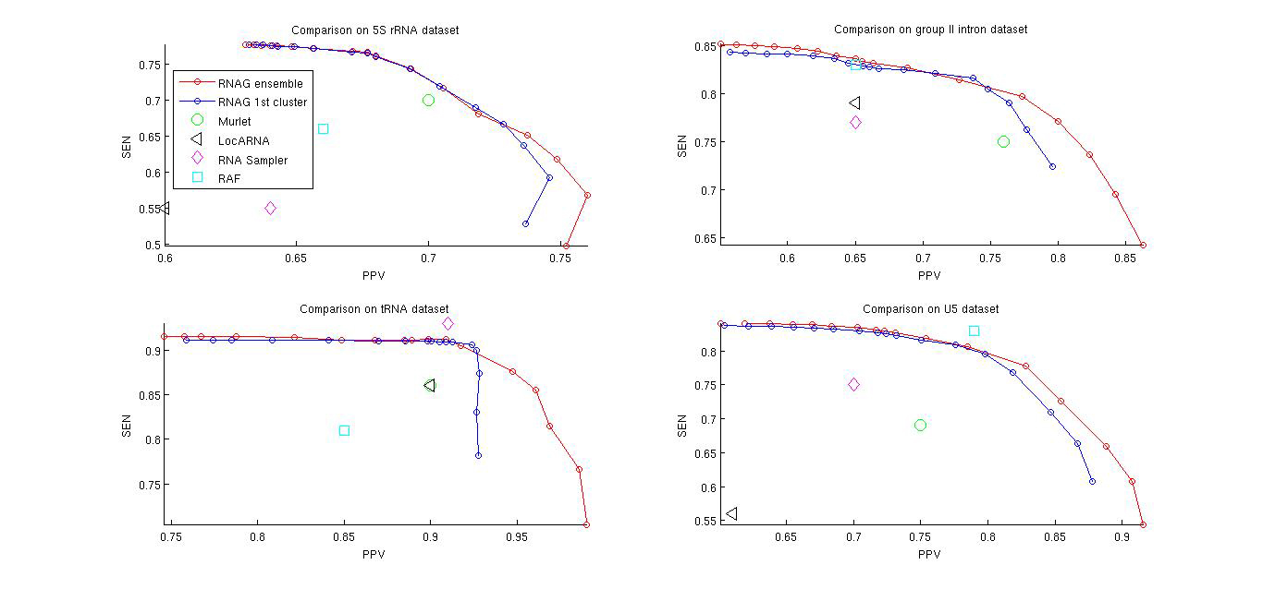
Fig 1. Average performance of different secondary structure prediction methods in PPV-SEN plane for 4 RNA families (5SRNA, group II intron, tRNA and U5) from BRAliBASE II dataset respectively.

Though RNAG doesn’t work uniformly better than other align-fold algorithms, we can see that RNAG significantly improves the accuracy of secondary structure prediction.
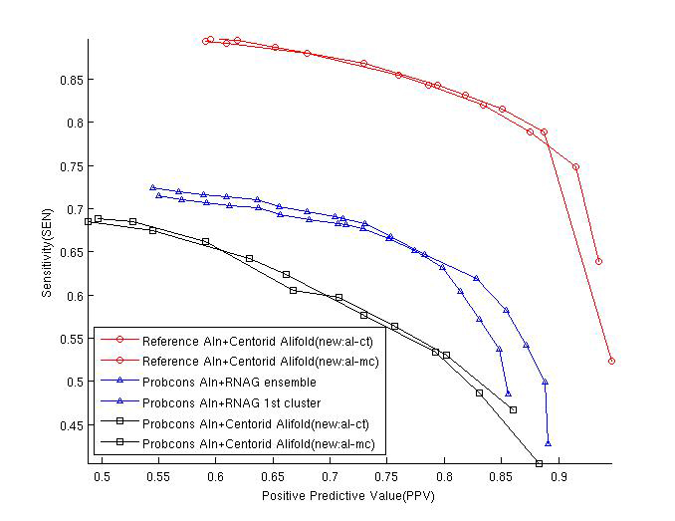
- Comparison on Murlet benchmarking dataset:
Fig 2.CentroidAlifold structure prediction from Probcons initial alignment and reference alignment act as lower/upper bound for RNAG respectively

Though Centroid Alifold only does structure prediction from fixed alignment, it may be still interesting to compare RNAG with it to get the lower and upper bounds of accuracy performance, shown in Figure 2. Starting from the same initial alignment from Probcons, RNAG performs better than CentroidAlifold since it improves the alignment during the iterations though still not close to the reference alignments. Since CentroidAlifold is the state-of-the-art structure prediction given the alignment, RNAG performs worse than Centroid Alifold started from the reference alignment.

