Comparison Among
Naïve Mean-field(bj), Collapsed Mean-field(csb) and ME algorithm
for Dirichlet Process Mixture Model

Donglai Wei
2010.3.18
- Comparison of the Performance
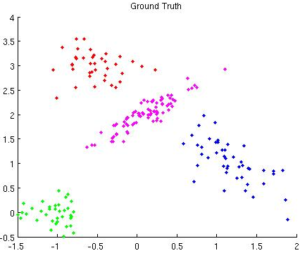
Synthetic Data: 200 data points, Mixture of 4 Gaussian distributions.

 | Blei-Jordan  (SIS 10 th) |  | Blei-Jordan  (SIS 0th) |  | Collapsed (csb) |  | ME
 | K=10 | K=20 | K=10 | K=20 | K=10 | K=20
#cluster  (mean,  std) | 4.1  (0.3) | 4.1  (0.3) | 5.50  (1.58) | 5.40  (1.50) | 6.2  (1.6) | 6.3  (0.94) | Bottom-up: 4  Top-down: 4  Local-search:  - random scheme:17(1.44)  (merge into 12.6 (6.2))  - normal scheme: 12 (merge into 5)
Rand  Index | 0.999  (1e-4) | 0.999  (1e-3) | 0.97  (0.01) | 0.98  (0.02) | 0.97  (0.22) | 0.83  (0.09) | Bottom-up: 1  Top-down: 1  Local-search:  1) random scheme:0.80  after merging: 0.88(0.1)  2) normal scheme: 0.85 (0.97)

Algorithm1: Naïve Mean-Field (Blei-Jordan)

Test:
Initial Cluster number: 10, 20
Stopping threshold for free energy: 1e-10
Initialize the soft assignment with Sequential Importance Sampling : 0th, 10th

Remark:
  - Initialize with SIS 10th gives perfect result.
  - Without SIS, the performance of BJ algorithm may differ significantly even for our simple test case. Also some local minimas where the algorithm gets stuck are kind of funny, Like the one in the lower-left with 5 clusters, the red cluster is “splitted” by the yellow one.
 | Blei-Jordan  (SIS 10 th) |  | Blei-Jordan  (SIS 0th)
 | K=10 | K=20 | K=10 | K=20
#cluster  (mean, std) | 4.1 (0.3) | 4.1 (0.3) | 6.89 (1.27) | 7.56 (1.70)
Rand Index | 0.999(1e-4) | 0.999 (1e-3) | 0.97 (0.02) | 0.93 (0.04)

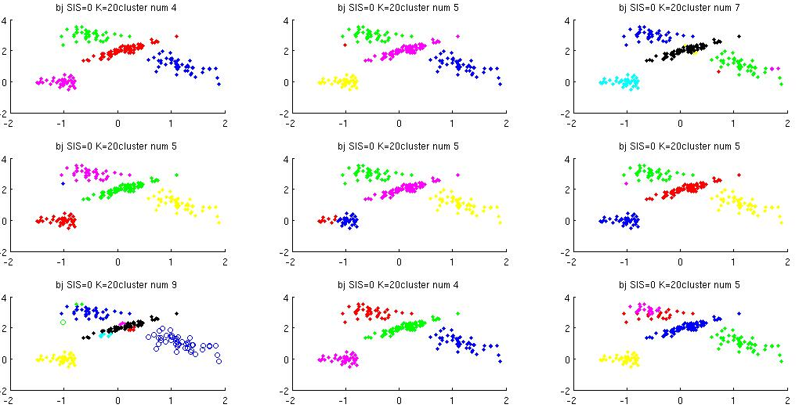
Algorithm2: Collapsed Mean-Field with Stick-Breaking Construction(csb)

Test:
Initial Cluster number: 10, 20
Stopping threshold for free energy: 1e-10

Remark:
a) Added with auxiliary parameters, collapsed methods may lead to more local minimas. Thus, different initiations of cluster numbers and soft cluster assignment vary significantly.

 | Collapsed Meanfield (csb)
 | K=10 | K=20
#cluster (mean, std) | 5.6 (1.6) | 7.4 (2.0)
Rand Index | 0.90 (0.11) | 0.87 (0.09)

K=20
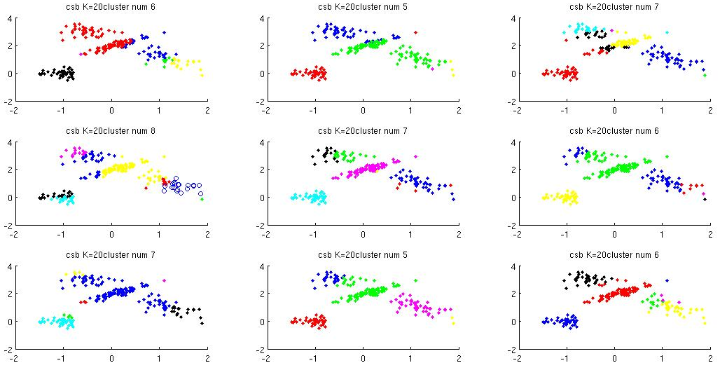

Algorithm2: Collapsed Mean-Field with Stick-Breaking Construction(csb)

(continued..) K=10

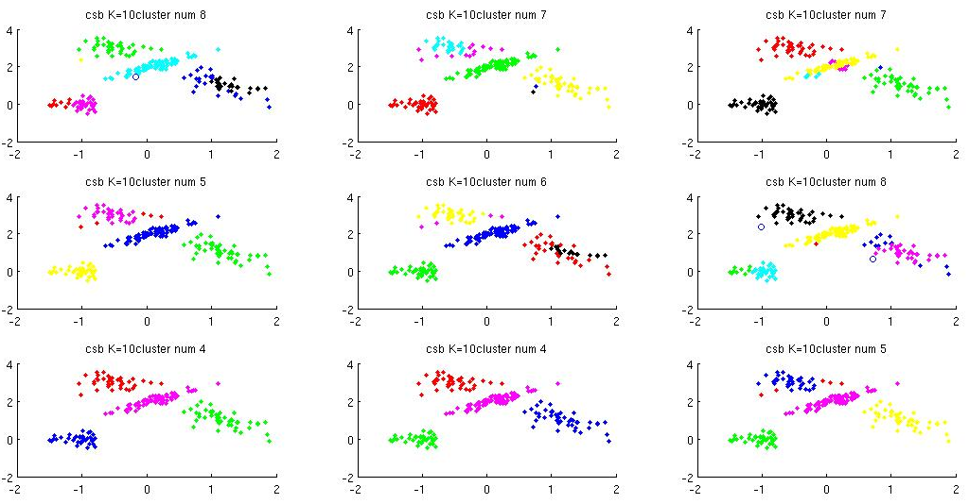

Algorithm 3: ME

Test:
Initial Cluster assignment:
- Bottom-up, Local Search: 1:200 (every data forms its own cluster)
- Top-down: 1 (every data belongs to the same cluster)
Prior for Local Search: Bottom-up, top-down

Remarks:
a) In this simple case, Bottom-up and Top-down method works perfectly well. But when facing with complicated real data, Bottom-up may be costly and Top-down may be heuristic.
b) For the local-search method, initialization of the hyper-parameter really matter. Claimed in the paper, the Bottom-up prior is uninformative since bottom-up method may be too greedy. But here informative may help

 | ME
#cluster | Bottom-up: 4  Top-down: 4  Local-search:  a) top-down prior: 12 (merge into 5)  a) bottom-up prior: 56 (merge into 12)
Rand Index | Bottom-up: 1  Top-down: 1  Local-search:  a) top-down prior: 0.85 (0.97)  b) bottom-up prior: 0.73 (0.82)

