***Mazhar Zorlu Anadolu Teknik***

***ATP 11-A PERFORMANS ÖDEVİ***

***C# ve SQLite Kullanarak***

***OTOPARK OTOMASYONU***

***Öğretmen: Bülent Vardal***

***Öğrenci: Emir Büyükyıldırım***

***No:96***

1.C# FORMS TASARIMI

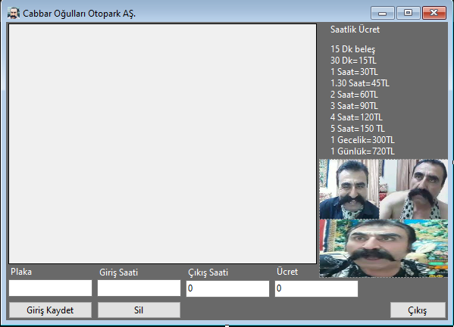

2.SQLite KODLARI

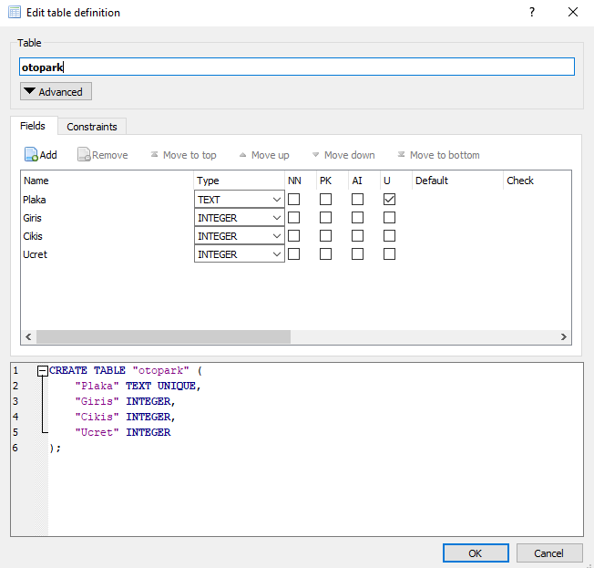

3.C# KODLARI

using System.Data;

using System.Data.SQLite;

using System.Numerics;

namespace eb96performs

{

public partial class Form1 : Form

{

public Form1()

{

InitializeComponent();

}

private void listele()

{

SQLiteConnection baglanti =

new SQLiteConnection

("Data Source=E:\\Projelerim\\otopark.db;version=3");

baglanti.Open();

SQLiteDataAdapter da =

new SQLiteDataAdapter("SELECT * FROM otopark", baglanti);

DataSet ds = new DataSet();

da.Fill(ds, "otopark");

dataGridView1.DataSource = ds.Tables["otopark"];

baglanti.Close();

}

private void Form1_Load(object sender, EventArgs e)

{

listele();

}

private void button1_Click(object sender, EventArgs e)

{

string plaka = textBox1.Text;

string giris = textBox2.Text;

string cikis = textBox3.Text;

string fiyat = textBox4.Text;

SQLiteConnection baglanti =

new SQLiteConnection

("Data Source=E:\\Projelerim\\otopark.db;version=3");

baglanti.Open();

SQLiteCommand komut = new SQLiteCommand();

komut.Connection = baglanti;

komut.CommandText = "INSERT INTO otopark values('" + plaka + "','" + giris + "','" + cikis + "','" + fiyat + "')";

komut.ExecuteNonQuery();

baglanti.Close();

listele();

textBox2.Clear();

textBox3.Clear();

textBox4.Clear();

}

private void textBox2_TextChanged(object sender, EventArgs e)

{

}

private void button2_Click(object sender, EventArgs e)

{

string plaka = textBox1.Text;

SQLiteConnection baglanti =

new SQLiteConnection

("Data Source=E:\\Projelerim\\otopark.db;version=3");

baglanti.Open();

SQLiteCommand komut = new SQLiteCommand();

komut.Connection = baglanti;

komut.CommandText = "DELETE FROM otopark WHERE plaka='" + plaka + "'";

komut.ExecuteNonQuery();

baglanti.Close();

listele();

textBox1.Clear();

textBox2.Clear();

textBox3.Clear();

textBox4.Clear();

}

private void button3_Click(object sender, EventArgs e)

{

string plaka = textBox1.Text;

string giris = textBox2.Text;

string cikis = textBox3.Text;

string fiyat = textBox4.Text;

SQLiteConnection baglanti =

new SQLiteConnection

("Data Source=E:\\Projelerim\\otopark.db;version=3");

baglanti.Open();

SQLiteCommand komut = new SQLiteCommand();

komut.Connection = baglanti;

komut.CommandText = "update otopark set fiyat='" + textBox4.Text + "',cikis='" + textBox3.Text + "',plaka='" + textBox1.Text + "',giris='" + textBox2.Text + "')";

komut.ExecuteNonQuery();

baglanti.Close();

listele();

textBox1.Clear();

textBox2.Clear();

textBox3.Clear();

textBox4.Clear();

}

private void button3_Click_1(object sender, EventArgs e)

{

Close();

}

}

}

4.KAYNAKÇA

Tamamen şahsım tarafından yapıldı.