Contents
Contents i
Revisions ii
1 Introduction 1
1.0 Document Purpose 1
1.1 Product Scope 1
1.2 Intended Audience and Document Overview 1
1.3 Definitions, Acronyms and Abbreviations 2
1.4 Document Conventions 2
1.5 References 2
2 Overall Description 3
2.0 Product Perspective 3
2.1 Product Functionality 4
2.2 Users and Characteristics 4
2.3 Operating Environment 5
2.4 Design and Implementation Constraints 6
2.5 User Documentation 6
2.6 Assumptions and Dependencies 7
3 System Features 9
3.1 USE CASE DIAGRAM 9
3.2 USE CASE DESCRIPTION 10
1. Other Non-functional Requirements 29
4.0 Performance Requirements 29
4.1 Safety and Security Requirements 29
4.2 Software Quality Attributes 29
Appendix A – REQUIREMENT MODELS 31
1. BUSINESS ACTIVITY DIAGRAM 31
2. CLASS DIAGRAM 48
3. SYSTEM SEQUENCE DIAGRAM 49

Revisions
Version | Primary Author(s) | Description of Version | Date Completed
1.0 | Ahmad Emir Erfan bin Mohd Zubri | Information about the revision. This table does not need to be filled in whenever a document is touched, only when the version is being upgraded. | 00/00/00

Introduction

Document Purpose
This Software Requirements Specification (SRS) describes the functional and non-functional requirements for the Centralized Web-Based System for Stress Induction Methods.

The purpose of this document is to provide a detailed description of the system's functionality, performance requirements, and operational constraints. The system is designed to assist researchers in conducting stress-induction experiments by providing a centralized platform for managing participants, administering stress-induction methods, recording responses, and generating experiment data.

This document serves as a reference for developers, researchers, project supervisors, testers, and other stakeholders involved in the development and implementation of the system. It ensures that all parties have a clear understanding of the system’s objectives, features, and requirements.

Product Scope
The Centralized Web-Based System for Stress Induction Methods is a web-based platform developed to support researchers in conducting stress-induction experiments in a structured and efficient manner.

The system centralizes different stress-induction methods into a single platform where researchers can manage participant information, conduct experimental sessions, and collect research data. By digitizing these processes, the system helps reduce manual errors, improve data organization, and enhance the efficiency of research activities.

The platform allows researchers to create participant profiles, initiate stress-induction tests, monitor experiment progress, and store experiment results in a centralized database. This centralized approach ensures better accessibility, consistency, and management of research data.

Intended Audience and Document Overview
This SRS document is intended for stakeholders who are involved in the development and use of the Centralized Web-Based System for Stress Induction Methods.

- Developers: Developers will use this document as a guideline for designing, implementing, and maintaining the system according to the defined requirements.
- Researchers: Researchers will use the system to manage participants, conduct stress-induction experiments, and collect research data.
- Project Supervisors: Project supervisors will review this document to ensure that the system meets the research objectives and project requirements.
- Testers: Testers will use this document to verify whether the system meets the specified functional and non-functional requirements.
- Participants: Participants are individuals involved in the stress-induction experiments who interact with the system during experimental sessions.

Definitions, Acronyms and Abbreviations
Terms | Definition
SRS | Software Requirements Specification.
Researcher | A user responsible for conducting experiments and managing research data
Participant | An individual who participates in the stress-induction experiment
Stress Induction Method | A controlled experimental technique used to induce stress for research purposes
Experiment Session | A session where participants complete stress-induction tasks
System | Centralized Web-Based System for Stress Induction Methods.

Document Conventions
This document follows the IEEE Software Requirements Specification (SRS) standard format. The document is organized into sections that describe the system overview, functional requirements, non-functional requirements, and system features.

Consistent formatting and terminology are used throughout the document to ensure clarity and readability for all stakeholders involved in the project.

References
The development of the Centralized Web-Based System for Stress Induction Methods is based on the requirements of the Final Year Project and research materials related to stress-induction methodologies.

Overall Description

Product Perspective
The Centralized Web-Based System for Stress Induction Methods is a centralized system developed to assist researchers in conducting stress-induction experiments efficiently and effectively. The system aims to improve the current methods of conducting the test which the current method uses manual stress test and manual recording.

By centralizing the stress-induction methods in one single platform, the system allows researchers to manage the participant, conduct different type of test in one platform which can reduce the risk of data loss, inconsistency, and human error.

They system consists of the following major components:

- User Management Module: Handles authentication and role-based access control for system users, including administrators, and researchers.
- Participant Management Module: Stores participant information such as participant ID, participant information, and session records.
- Experiment Session Module: Guide participants through the experiment process by presenting stimuli, recording responses, measuring reaction times, and monitoring sessions progress.
- Data Storage and Processing Module: Stores experiment data securely and performs automatic calculations such as reaction time averages, error rates, and stress scores.
- Reporting and Export Module: Generates experiment information and allows researchers to export raw data and reports in formats such as CSV for analysis and PDF for summary report.

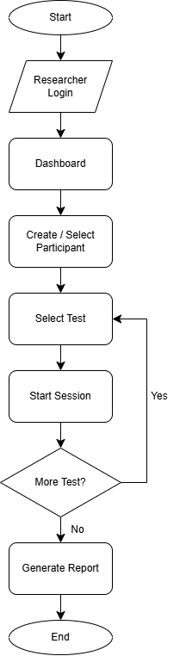

Product Functionality
The Centralized Web-Based System for Stress Induction Methods offers the following major functions:

- User Management:

- Allow researchers and administrators to securely log into the system.
- Manage user roles such as administrator and researcher.
- Control access permissions to ensure only authorized users can configure experiments or export data.

- Participant Management:

- Create and store participant profiles using pseudonymous participant IDs.

- Stress Test Management:

- Guide researchers through the experiment process step-by-step.
- Present stress-induction stimuli to participants during the session.
- Monitor experiment progress in real time.
- Allow participants to repeat experiment sessions while storing each session separately.

- Reporting:

- Generate automatic experiment summary reports.
- Provide raw data.
- Allow export in formats such as CSV and PDF.

Users and Characteristics
The Centralized Web-Based System for Stress Induction Methods is designed to be functioned to multiple users with different roles and responsibilities. The characteristics of these users are detailed below:

- Administrator

- Characteristics: Responsible for managing system configuration, user accounts, and system settings. The administrator ensures that the platform operates securely and efficiently.
- Frequency of Use: Moderate
- Privilege Levels: Full administrative access, including managing researcher accounts, configuring system settings, monitoring system activity, and maintaining data security.
- Technical Expertise: Advanced knowledge of system administration and database management.

- Researcher

- Characteristics: Responsible for conducting stress-induction experiments using the system. Researchers configure experiment templates, manage participant information, initiate experiment sessions, and analyze experiment data.
- Frequency of Use: High
- Privilege Levels: Authorized to create and manage experiment templates, manage participant records, conduct experiment sessions, view experiment results, and export research data.
- Technical Expertise: Moderate, including basic system navigation, experiment configuration, and data analysis tasks.

- Participant

- Characteristics: Individuals who participate in stress-induction experiments conducted by researchers. Participants interact with the system only during experiment sessions when responding to stimuli presented by the system.
- Frequency of Use: Low to moderate
- Privilege Levels: Limited access to interact with experiment tasks during testing sessions. Participants cannot access system management features.
- Technical Expertise: Basic computer usage skills required to interact with experiment tasks and respond to stimuli.

Operating Environment
The Centralized Web-Based System for Stress Induction Methods operates within a secure and centralized environment. The following describes the hardware, software, and subsystems that support the system:

- Hardware Platform
- Server Requirements: The system will run on a dedicated server with a minimum of:
- Processor: AMD Ryzen 5 or equivalent
- RAM: 12 GB
- Storage: 500 GB SSD
- Client Devices:
- Desktop computers or laptops for administers and researchers
- Desktop computers or laptops for test sessions with participants

- Operating System and Versions
- Server OS: Windows Server
- Client OS: Windows 10/11 for desktops and laptops

- Operating System and Versions
- Database Management System: MariaDB
- Web Server: Apache HTTP Server
- Application Framework: PHP
- User Interface: Browser-based interface optimized for Chrome, Firefox, and Edge

Design and Implementation Constraints
The development of the Centralized Web-Based System for Stress Induction Methods must address several constraints that will limit the choices available to developers. These constraints are categorized below:

Type Of Constraints | Constraints
Hardware | Test sessions must be conducted using desktop computers or laptops to ensure accurate display of stimuli and reliable measurement of participant responses and reaction times.
Network | The system requires a stable internet connection to ensure experiment data can be recorded and stored without interruption. Network instability may affect the experiment session.
Software | The system must be developed as a web-based application using PHP, MariaDB database, and accessed through modern web browsers.
Security and Privacy | Participant data must be stored securely, and access must be restricted to authorized researchers and administrators only.
Language Requirements | The application must be developed using the English language to ensure consistency and usability for researchers

User Documentation
The Centralized Web-Based System for Stress Induction Methods will include comprehensive user documentation to support all user groups in effectively operating the system. The documentation components are as follows:

- User Manuals
- Administrator Manual: Includes instructions for managing user accounts, maintaining system settings, and monitoring system activities.
- Researcher Manual: Provides detailed guidance on managing participant information, configuring experiment templates, conducting stress-induction sessions, and generating experiment reports.

- Tutorials
- Interactive Tutorials: Step-by-step walkthroughs that guide researchers on how to create participants, configure experiments, and run experiment sessions.
- Video Tutorials: Visual demonstrations of key system features, such as starting experiment sessions, recording participant responses, and exporting experiment data.

- Quick Reference Guides
- One-page reference documents summarizing essential tasks for system users, such as creating experiment templates, running experiment sessions, and exporting research data.

Assumptions and Dependencies
The development and successful operation of the Centralized Web-Based System for Stress Induction Methods are based on the following assumptions and dependencies. Any changes to these factors may significantly affect the project’s development and system performance.

Assumptions

- Hardware Availability:

- All end-user devices (desktop computers or laptops) meet the minimum hardware requirements such as at least 8GB RAM and a modern processor to ensure smooth system performance during experiment sessions.

- Network Infrastructure:

- The operating environment will have a stable and reliable internet connection to ensure that experiment data can be transmitted and stored in the database without interruption.

- User Access and Training:

- Researchers and administrators will receive sufficient guidance or training to operate the system effectively.
- All system users will have unique login credentials and are responsible for maintaining the security of their accounts.

- Software Compatibility:

- The system will operate on supported operating systems such as Windows 10/11 or macOS.
- Modern web browsers such as Brave, Google Chrome, Firefox, and Microsoft Edge will remain compatible with the system throughout its usage.

- Organizational Support:

- The research team and project supervisor will provide the necessary support and feedback to ensure the successful development and testing of the system.

- Research Environment:

- Experiment sessions will be conducted using desktop computers or laptops to ensure accurate presentation of stimuli and proper measurement of reaction time.
- Participants will follow the instructions provided by the researcher during experiment sessions.

Dependencies

- Database Management System (DBMS):

- The system depends on the proper configuration and availability of the MariaDB database management system for storing participant data and experiment results.

- Web Server and Hosting Environment:

- The system requires a web server and hosting environment capable of supporting the web application and maintaining reliable access for researchers.

- Development Tools:

- The development of the system depends on tools such as Visual Studio Code for coding and Draw.io for system design diagrams.

- Browser Compatibility:

- The system depends on modern web browsers to function properly, including Brave, Google Chrome, Firefox, and Microsoft Edge.

- Data Security and Privacy:

- The system must follow appropriate data protection practices to ensure that participant information and experiment results are stored securely and accessed only by authorized users.

- Stakeholder Feedback:

- Continuous feedback from stakeholders, including researchers and the project supervisor, is necessary to ensure the system meets research requirements and project objectives.

System Features

USE CASE DIAGRAM
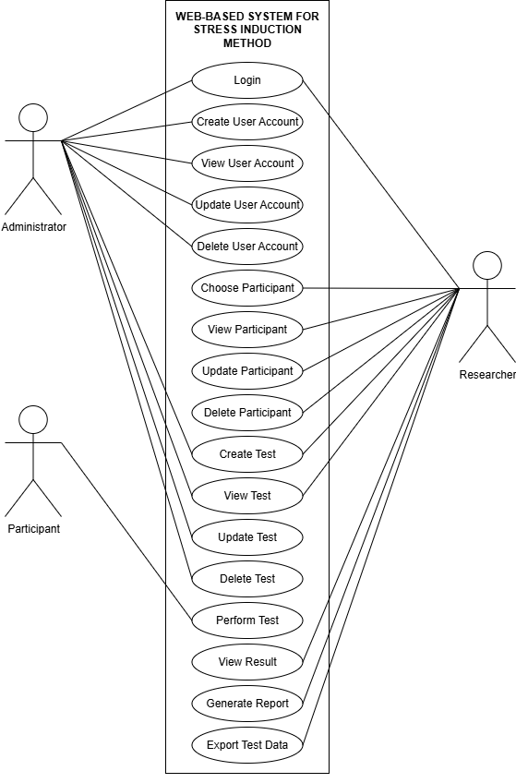

USE CASE DESCRIPTION

UC001 Login
Use Case ID: | UC001
Use Case Name: | Login
Created By: | Ahmad Emir Erfan bin Mohd Zubri | Last Updated By: | Ahmad Emir Erfan Bin Mohd Zubri
Date Created: | 31/3/2026 | Date Last Updated: | 31/3/2026

Actor: | Administrator, Researcher
Description: | Allow authorized users to authenticate and access the web-based system.
Preconditions: | The actor must have registered account in the system with valid username and password.
Postconditions: | The actor is successfully login using the correct username, password and roles.
Priority: | High
Frequency of Use: | High
Normal Course of Events: | Actor | System
Normal Course of Events: | - Navigates to the system’s login page.  - Enter username and password then clicks “login”. | - Displays the login form.  - Validates the entered credentials from the database. Grant access if valid.
Alternative Courses: | If actor forgets password, they can click “Forgot Password” to reset the password.
Exceptions: | If the actor enters incorrect credentials, the system displays an “Invalid username or password” error message and require them to try again.
Includes: | None
Notes and Issues: | Implement an account lockout mechanism after 3-5 failed login attempts to prevent brute-force attacks.

UC002 Create User Account

Use Case ID: | UC002
Use Case Name: | Create User Account
Created By: | Ahmad Emir Erfan Bin Mohd Zubri | Last Updated By: | Ahmad Emir Erfan Bin Mohd Zubri
Date Created: | 31/3/2026 | Date Last Updated: | 31/3/2026

Actor: | Administrator
Description: | Allows the Administrator to register a new user account into the system for new Researchers or Administrators.
Preconditions: | The Administrator must be logged into the system with valid administrative credentials.
Postconditions: | A new user account is created, saved in the database, and is ready for use.
Priority: | High
Frequency of Use: | Low to Moderate
Normal Course of Events: | Actor | System
Normal Course of Events: | - Navigates to the "User Management" section and selects "Create Account".  - Enters the new user's details (name, role, email, etc.) and submits. | - Displays the account creation form.  - Validates the inputted data.  - Saves the new account to the database.  - Displays a success message.
Alternative Courses: | If the Administrator cancels the operation before submitting, the system discards any entered data and returns to the previous menu.
Exceptions: | If required fields are left blank, or if the email/username already exists in the system, it displays a validation error message and highlights the problematic fields.
Includes: | None
Notes and Issues: | Password should be encrypted in the database. The system could use the temporary password for new user to use.

UC003 View User Account

Use Case ID: | UC003
Use Case Name: | View User Account
Created By: | Ahmad Emir Erfan Bin Mohd Zubri | Last Updated By: | Ahmad Emir Erfan Bin Mohd Zubri
Date Created: | 31/3/2026 | Date Last Updated: | 31/3/2026

Actor: | Administrator
Description: | Allows the Administrator to view the details of a specific user account (such as another Administrator or Researcher) registered in the web-based system.
Preconditions: | 1. The Administrator must be logged into the system with valid administrative credentials.  2. The selected account must be exist in database.
Postconditions: | The requested user account details are displayed on the screen.
Priority: | Medium
Frequency of Use: | Moderate
Normal Course of Events: | Actor | System
Normal Course of Events: | - Navigates to the "User Management" section on the administrative dashboard.  - Clicks or selects the "View" action for a specific user account from the user list. | - Receives the request and retrieves the specific user information (e.g., name, role, email) from database.  - Displays the user account details securely on the screen.
Alternative Courses: | If the Administrator clicks "Back" or cancels the operation, the system returns to the main user management list.
Exceptions: | If the system fails to retrieve the account information due to a database connection issue, it displays a failure message (e.g., "Unable to load user data") and records the error in the system logs.
Includes: | Search functionality for filtering user accounts by name, ID, or role before selecting one to view.
Notes and Issues: | Ensure that sensitive information (e.g., user passwords) remains encrypted and is not visible to the Administrator viewing the profile.

UC004 Update User Account

Use Case ID: | UC004
Use Case Name: | Update User Account
Created By: | Ahmad Emir Erfan Bin Mohd Zubri | Last Updated By: | Ahmad Emir Erfan Bin Mohd Zubri
Date Created: | 31/3/2026 | Date Last Updated: | 31/3/2026

Actor: | Administrator
Description: | Allows the Administrator to modify the details of an existing user account (such as updating an email address, changing a role, or resetting a password) within the system.
Preconditions: | The Administrator must be logged into the system with valid credentials (The user account to be updated must already exist in the database).
Postconditions: | The modified user account details are successfully saved and updated in the database.
Priority: | Medium
Frequency of Use: | Low to Moderate
Normal Course of Events: | Actor | System
Normal Course of Events: | - Navigates to the "User Management" section.  - Searches for and selects the "Edit" action for a specific user account.  - Modifies the necessary information in the provided form and clicks "Save". | - Retrieves the selected user's current profile data from the database and displays it in an editable form.  - Validates the newly entered data upon submission (e.g., checking for valid email formats).  - Updates the user's record in the database.  - Displays a success message confirming the update.
Alternative Courses: | If the Administrator clicks "Cancel" before saving, the system discards any unsaved changes and returns to the previous page.
Exceptions: | If the Administrator enters an email address or username that is already taken by another account, the system displays a validation error message and highlights the conflicting field.
Includes: | Search functionality to locate the specific user account.
Notes and Issues: | All account updates should be recorded by the system logging feature (noting which Administrator made the change and at what time) to ensure traceability and security.

UC005 Delete User Account

Use Case ID: | UC005
Use Case Name: | Delete User Account
Created By: | Ahmad Emir Erfan Bin Mohd Zubri | Last Updated By: | Ahmad Emir Erfan Bin Mohd Zubri
Date Created: | 31/3/2026 | Date Last Updated: | 31/3/2026

Actor: | Administrator
Description: | Allows the Administrator to permanently remove a user account (such as a Researcher or another Administrator) from the web-based system.
Preconditions: | 1. The Administrator must be logged into the system with valid credentials.  2. The user account targeted for deletion must exist in the database.
Postconditions: | The selected user account is permanently removed from the system, and their access is revoked.
Priority: | Medium
Frequency of Use: | Low
Normal Course of Events: | Actor | System
Normal Course of Events: | - Navigates to the "User Management".  - Searches for the specific user account and clicks the "Delete" action.  - Confirms the deletion in the prompt dialogue. | - Displays a confirmation prompt warning the Administrator that this action is irreversible.  - Upon confirmation, executes the deletion query to remove the user's data from the MariaDB database.  - Refreshes the user list and displays a successful deletion message.
Alternative Courses: | If the Administrator clicks "Cancel" on the confirmation prompt, the system aborts the operation and returns to the user list without making any changes.
Exceptions: | If the system fails to delete the account due to existing dependencies (e.g., the Researcher account is currently linked to active test data), the system blocks the deletion and displays an error message explaining the dependency.
Includes: | Search functionality to filter and locate the specific user account before deletion.
Notes and Issues: | Consider implementing a "soft delete" (deactivating the account instead of a hard database removal) to preserve system logging and maintain the integrity of past test records associated with the user.

UC006 Choose Participant

Use Case ID: | UC006
Use Case Name: | Choose Participant
Created By: | Ahmad Emir Erfan Bin Mohd Zubri | Last Updated By: | Ahmad Emir Erfan Bin Mohd Zubri
Date Created: | 31/3/2026 | Date Last Updated: | 31/3/2026

Actor: | Researcher
Description: | Allows the Researcher to select a specific registered participant from the system to assign stress induction tests (like the Stroop Test, MIST, or TSST), view their profile, or analyze their test results.
Preconditions: | The Researcher must be logged into the system with valid credentials (The participant must already have a registered profile in the database).
Postconditions: | A specific participant is selected and set as the active subject for subsequent administrative or testing actions.
Priority: | High
Frequency of Use: | High
Normal Course of Events: | Actor | System
Normal Course of Events: | - Navigates to the "Participant Management" or "Participants" list section.  - Searches or scrolls to find the specific participant.  - Clicks on the participant's name or selects the "Choose/Select" action. | - Retrieves and displays the list of available participants from the database.  - Processes the selection.  - Directs the Researcher to the specific participant's profile or enables participant-specific actions (e.g., "Assign Test", "View Results").
Alternative Courses: | If the Researcher navigates away without making a selection, the system clears any search parameters and remains on the default participant list.
Exceptions: | If the Researcher searches for a participant ID or name that does not exist in the database, the system displays a "Participant not found" message and prompts them to adjust their search criteria.
Includes: | Search and filtering functionality (by name, ID, or date registered) to easily locate the participant.
Notes and Issues: | This use case is a critical prerequisite to ensure that all generated test data, video recordings, and system logs are accurately linked to the correct participant's profile to prevent data mismatch.

UC007 View Participant

Use Case ID: | UC007
Use Case Name: | View Participant
Created By: | Ahmad Emir Erfan Bin Mohd Zubri | Last Updated By: | Ahmad Emir Erfan Bin Mohd Zubri
Date Created: | 31/3/2026 | Date Last Updated: | 31/3/2026

Actor: | Researcher
Description: | Allows the Researcher to view the detailed profile and information of a specific participant in the system.
Preconditions: | The Researcher must be logged into the system with valid credentials.  The participant must exist in the database.
Postconditions: | The requested participant details are successfully displayed.
Priority: | Medium
Frequency of Use: | Moderate to High
Normal Course of Events: | Actor | System
Normal Course of Events: | - Navigates to the "Participants" section.  - Clicks the "View" button next to a specific participant's name. | - Receives the request and retrieves the participant's profile data from the database.  - Displays the participant's account and details on the screen.
Alternative Courses: | If the Researcher clicks the "Back" button, the system returns to the main participant list page.
Exceptions: | If the system fails to retrieve the participant information due to a database connection issue, it displays a "Failed to load participant data" error message and logs the system error.
Includes: | Search functionality to filter participants by name or ID.
Notes and Issues: | Participant data must be kept confidential and secure. Only authorized Researchers should be able to view the profiles of participants assigned to their specific studies.

UC008 Update Participant

Use Case ID: | UC008
Use Case Name: | Update Participant
Created By: | Ahmad Emir Erfan Bin Mohd Zubri | Last Updated By: | Ahmad Emir Erfan Bin Mohd Zubri
Date Created: | 31/3/2026 | Date Last Updated: | 31/3/2026

Actor: | Researcher
Description: | Allows the Researcher to modify the details or profile information of an existing registered participant within the system.
Preconditions: | The Researcher must be logged into the system with valid credentials.  The participant record to be updated must already exist in the database.
Postconditions: | The modified participant details are successfully saved and updated in the database
Priority: | Medium
Frequency of Use: | Low to Moderate
Normal Course of Events: | Actor | System
Normal Course of Events: | - Navigates to the "Participants" section.  - Searches for and selects the "Edit" action for a specific participant.  - Modifies the necessary profile information in the provided form and clicks "Save". | - Retrieves the selected participant's current profile data from the database and displays it in an editable form.  - Validates the newly entered data upon submission.  - Updates the participant's record in the database.  - Displays a success message confirming the update.
Alternative Courses: | If the Researcher clicks "Cancel" before saving, the system discards any unsaved changes and returns to the participant list or profile view page.
Exceptions: | If required fields (e.g., age, gender) are left blank, or if an invalid format is entered, the system displays a validation error message and highlights the conflicting field.
Includes: | Search functionality to locate the specific participant before updating.
Notes and Issues: | All updates to participant profiles should be recorded by the system logging feature to ensure a clean and organized record of changes for research integrity.

UC009 Delete Participant
Use Case ID: | UC009
Use Case Name: | Delete Participant
Created By: | Ahmad Emir Erfan Bin Mohd Zubri | Last Updated By: | Ahmad Emir Erfan Bin Mohd Zubri
Date Created: | 31/3/2026 | Date Last Updated: | 31/3/2026

Actor: | Researcher
Description: | Allows the Researcher to permanently remove a participant's profile and demographic data from the web-based system.
Preconditions: | The Researcher must be logged into the system with valid credentials.  The targeted participant must exist in the database.
Postconditions: | The selected participant's profile is permanently removed from the system.
Priority: | Medium
Frequency of Use: | Low
Normal Course of Events: | Actor | System
Normal Course of Events: | - 1. Navigates to the "Participants” section on the dashboard.  - Searches for the specific participant and clicks the "Delete" action.  - Confirms the deletion in the prompt dialogue. | - Displays a confirmation prompt warning the Researcher that this action is irreversible.  - Upon confirmation, executes the deletion query to remove the participant's data from the database.  - Refreshes the participant list and displays a successful deletion message.
Alternative Courses: | If the Researcher clicks "Cancel" on the confirmation prompt, the system aborts the operation and returns to the participant list without making any changes.
Exceptions: | If the participant has existing test records (e.g., completed Stroop, MIST, or TSST sessions), the system may block the deletion to preserve research data integrity and instead prompt the Researcher to anonymize or archive the record.
Includes: | Search functionality to filter and locate the specific participant before deletion.
Notes and Issues: | This deletion action must be recorded by the system logging feature to keep a clean and organized record of events that occurred during the research process.

UC010 Create Test

Use Case ID: | UC010
Use Case Name: | Create Test
Created By: | Ahmad Emir Erfan Bin Mohd Zubri | Last Updated By: | Ahmad Emir Erfan Bin Mohd Zubri
Date Created: | 31/3/2026 | Date Last Updated: | 31/3/2026

Actor: | Researcher
Description: | Allows the Researcher to configure and create a new stress induction test session, choosing between the Stroop Test, MIST, or TSST Arithmetic Task.
Preconditions: | The Researcher must be logged into the system with valid credentials.
Postconditions: | A new test configuration is saved in the database and is ready to be assigned to participants.
Priority: | High
Frequency of Use: | High
Normal Course of Events: | Actor | System
Normal Course of Events: | - Navigates to the test management section and selects "Create Test".  - Selects the desired stress induction method (Stroop Test, MIST, or TSST Arithmetic Task).  - Configures test parameters (e.g., duration of 3 to 5 minutes, subtraction gaps for TSST, or difficulty levels) and submits. | - Displays the test configuration form based on the selected method.  - Validates the inputted parameters.  - Saves the newly created test to the database.  - Displays a success message to the Researcher.
Alternative Courses: | If the Researcher cancels the operation before submitting, the system discards the configuration and returns to the previous menu.
Exceptions: | If invalid parameters are entered, the system displays a validation error message and highlights the required fields.
Includes: | None
Notes and Issues: | The system application layer must ensure the configuration correctly sets up the respective phases for the chosen method, such as the Rest, Control, and Experimental phases for MIST.

UC011 View Test

Use Case ID: | UC011
Use Case Name: | View Test
Created By: | Ahmad Emir Erfan Bin Mohd Zubri | Last Updated By: | Ahmad Emir Erfan Bin Mohd Zubri
Date Created: | 31/3/2026 | Date Last Updated: | 31/3/2026

Actor: | Researcher
Description: | Allows the Researcher to view the details and configured parameters of a specific stress induction test session, such as the Stroop Test, MIST, or TSST Arithmetic Task, that has been created in the system.
Preconditions: | The Researcher must be logged into the system with valid credentials.
Postconditions: | The requested test details and parameters are successfully displayed on the screen
Priority: | Medium
Frequency of Use: | Moderate
Normal Course of Events: | Actor | System
Normal Course of Events: | - Navigates to the test management section.  - Searches for a specific test and clicks the "View" action. | - Receives the request and retrieves the specific test's configuration data from the database.  - Displays the test details clearly on the screen for review.
Alternative Courses: | If the Researcher clicks the "Back" button or cancels the operation, the system returns to the main test list page
Exceptions: | If the system fails to retrieve the test information due to a database connection issue, it displays a failure message and automatically logs the error.
Includes: | Search and filtering functionality to locate tests by method type or creation date.
Notes and Issues: | This use case is important for researchers to verify specific parameters, such as the 3 to 5 minutes duration constraints, before assigning the test to a participant.

UC012 Update Test

Use Case ID: | UC012
Use Case Name: | Update Test
Created By: | Ahmad Emir Erfan Bin Mohd Zubri | Last Updated By: | Ahmad Emir Erfan Bin Mohd Zubri
Date Created: | 31/3/2026 | Date Last Updated: | 31/3/2026

Actor: | Administrator, Researcher
Description: | Allows the Administrator or Researcher to modify the details, configurations, or parameters of an existing test within the system.
Preconditions: | The actor must be logged into the system with valid credentials. The specific test record to be updated must already exist in the database.
Postconditions: | The test details are successfully updated, saved in the database, and are ready for use.
Priority: | High
Frequency of Use: | Moderate
Normal Course of Events: | Actor | System
Normal Course of Events: | - Navigates to the "Test Management" section and selects the specific test to edit.  - Modifies the test's details (e.g., parameters, descriptions) in the form and submits. | - Displays the edit form pre-filled with the current test details.  - Validates the inputted updated data.  - Saves the modified test details to the database.  - Displays a success message.
Alternative Courses: | If the actor cancels the operation before submitting, the system discards any entered modifications and returns to the previous menu.
Exceptions: | If required fields are left blank, or if invalid data formats are entered, the system displays a validation error message and highlights the problematic fields.
Includes: | None
Notes and Issues: | Ensure that modifying test parameters does not negatively impact or corrupt any historical results already associated with prior runs of this test.

UC013 Delete Test

Use Case ID: | UC013
Use Case Name: | Delete Test
Created By: | Ahmad Emir Erfan Bin Mohd Zubri | Last Updated By: | Ahmad Emir Erfan Bin Mohd Zubri
Date Created: | 31/3/2026 | Date Last Updated: | 31/3/2026

Actor: | Administrator, Researcher
Description: | Allows an authorized Administrator or Researcher to permanently remove an existing test record from the system.
Preconditions: | The actor must be logged into the system with valid credentials. The specific test record to be deleted must exist in the database.
Postconditions: | The test record is permanently removed from the database and is no longer accessible or visible in the system's active lists.
Priority: | High
Frequency of Use: | Low
Normal Course of Events: | Actor | System
Normal Course of Events: | - Navigates to the "Test Management" section and selects the specific test to delete.  - Clicks the "Delete" button or icon associated with the test.  - Confirms the action in the deletion confirmation prompt. | - Displays a confirmation dialog box asking the user to verify the deletion (e.g., "Are you sure you want to delete this test?").  - Removes the selected test record from the database upon confirmation.  - Displays a success message and refreshes the test list to reflect the removal.
Alternative Courses: | If the actor clicks "Cancel" at the confirmation dialog box, the system aborts the deletion process and returns the user to the previous screen. No data is deleted.
Exceptions: | If the test is currently linked to existing patient/subject results or ongoing active sessions, the system blocks the deletion and displays an error message explaining that the test cannot be deleted due to dependent data.
Includes: | None
Notes and Issues: | It is highly recommended to implement a "soft delete" (changing a database status flag to 'inactive') rather than a "hard delete" (completely wiping the row) to preserve historical data integrity and auditing capabilities.

UC014 Perform Test

Use Case ID: | UC014
Use Case Name: | Perform Test
Created By: | Ahmad Emir Erfan Bin Mohd Zubri | Last Updated By: | Ahmad Emir Erfan Bin Mohd Zubri
Date Created: | 31/3/2026 | Date Last Updated: | 31/3/2026

Actor: | Participant
Description: | Allows a registered Participant to undergo a specific stress induction method or test session and submit their responses or data into the centralized system.
Preconditions: | The actor must be logged into the system with valid credentials. A specific test session must be assigned, active, and made available to them.
Postconditions: | The test session is successfully completed, and the Participant's responses and resulting data are securely saved to the database.
Priority: | High
Frequency of Use: | High
Normal Course of Events: | Actor | System
Normal Course of Events: | - Reviews any pre-test instructions, guidelines, or consent forms and clicks "Start Test".  - Follows the on-screen prompts to interact with the test module, completing any required tasks or questionnaires.  - Clicks "Submit" or "Finish Test" once all stages are completed. | - Displays the test interface, including initial instructions and the first module.  - Initializes the session, starts any required timers, and begins logging the participant's interactions.  - Progresses the participant through the test stages, capturing and validating inputs in real-time.  - Compiles the results, saves the session data securely to the database, and displays a completion thank you message to the participant.
Alternative Courses: | If the Participant needs to stop, they can click "Quit Test" or close the session.
Exceptions: | If the system loses connection to the database or experiences a critical error during the session, it displays an error alert to the Participant. The system should attempt to auto-save locally to prevent data loss and instruct the Participant to contact an administrator.
Includes: | None
Notes and Issues: | The system must ensure a smooth, responsive, and distraction-free user interface during the session, as technical lag or glitches could alter the participant's state and inadvertently skew the test results.

UC015 View Result

Use Case ID: | UC015
Use Case Name: | View Result
Created By: | Ahmad Emir Erfan Bin Mohd Zubri | Last Updated By: | Ahmad Emir Erfan Bin Mohd Zubri
Date Created: | 31/3/2026 | Date Last Updated: | 31/3/2026

Actor: | Researcher
Description: | Allows the Researcher to access, view, and analyze the individual results and data metrics collected from completed test sessions.
Preconditions: | The Researcher must be logged into the system. There must be completed test session data stored in the database.
Postconditions: | The system successfully retrieves and displays the requested test results in the researcher's interface for analysis.
Priority: | High
Frequency of Use: | High
Normal Course of Events: | Actor | System
Normal Course of Events: | - Navigates to the "Results" section of the dashboard.  - Selects a specific test to find a particular result set.  - Clicks on the specific result entry to view detailed data. | - Retrieves the stored data metrics and session logs from the database.  - Formats the raw data into visual charts, tables, or summary metrics as per the system's analysis configuration.  - Displays the full result view on the Researcher's screen.
Alternative Courses: | None
Exceptions: | If the selected result data is missing or has been corrupted during the save process, the system displays a "Data Error" message and suggests contacting the system administrator.
Includes: | None
Notes and Issues: | Since the Participant no longer has access to this view, the interface can focus on more technical data.

UC016 Generate Report

Use Case ID: | UC016
Use Case Name: | Generate Report
Created By: | Ahmad Emir Erfan Bin Mohd Zubri | Last Updated By: | Ahmad Emir Erfan Bin Mohd Zubri
Date Created: | 31/3/2026 | Date Last Updated: | 31/3/2026

Actor: | Researcher
Description: | Allows the Researcher to compile and aggregate collected test data into a formal, structured report for academic or clinical analysis.
Preconditions: | The Researcher is logged into the system. There must be existing test results stored in the database.
Postconditions: | A structured report is generated and displayed to the Researcher, with the option to save or print.
Priority: | High
Frequency of Use: | Moderate
Normal Course of Events: | Actor | System
Normal Course of Events: | - Navigates to the "Report" section of the system.  - Selects the type of report required.  - Defines the report parameters, such as the date range, specific test types, or participant cohorts.  - Clicks the "Generate Report" button. | - Validates the selected parameters.  - Queries the database to aggregate and calculate the necessary data points (averages, peaks, trends).  - Formats the data into a structured report layout with necessary headers, charts, and summary tables.  - Displays the generated report on the screen for review.
Alternative Courses: | If the Researcher wishes to keep a digital copy, they can click "Save as PDF" or "Print". The system then triggers the device's print or save dialogue.
Exceptions: | If no data matches the selected filters/parameters, the system displays a message: "No data found for the selected criteria" and prompts the Researcher to adjust the filters.
Includes: | None
Notes and Issues: | Reports should be designed to be "presentation-ready," meaning they should include clear titles, timestamps of when the data was pulled, and legend descriptions for any charts included.

UC017 Export Test Data

Use Case ID: | UC017
Use Case Name: | Export Test Data
Created By: | Ahmad Emir Erfan Bin Mohd Zubri | Last Updated By: | Ahmad Emir Erfan Bin Mohd Zubri
Date Created: | 31/3/2026 | Date Last Updated: | 31/3/2026

Actor: | Researcher
Description: | Allows the Researcher to download raw test data from the system in various file formats (such as CSV, Excel, or JSON) for external statistical analysis or archival purposes.
Preconditions: | The Researcher must be logged into the system. There must be existing test data available in the database.
Postconditions: | The system generates a downloadable file containing the requested data, which is successfully saved to the Researcher's local device.
Priority: | Moderate to High
Frequency of Use: | Moderate
Normal Course of Events: | Actor | System
Normal Course of Events: | - Navigates to the "Data Export” section of the system.  - Selects the dataset to be exported (e.g., specific tests, date ranges, or participant groups).  - Selects the preferred file format.  - Clicks the "Export" button. | - Validates the selection and gathers the raw data from the database.  - Converts the data into the chosen file format, ensuring proper column headers and data types.  - Compiles the file and initiates a download prompt in the Researcher's browser.  - Logs the export action for auditing purposes.
Alternative Courses: | None
Exceptions: | If the system fails to generate the file due to a server-side error or database timeout, it displays an error message: "Export Failed. Please try a smaller data range or contact support."
Includes: | None
Notes and Issues: | Raw data exports should strictly follow data privacy protocols. Ensure that sensitive participant identifiers are either encrypted or removed (anonymized) depending on the Researcher's specific access level and the system's privacy settings.

Other Non-functional Requirements

Performance Requirements
The system must provide a smooth and responsive interaction to ensure that the researchers can conduct the test, and the participants can perform the test efficiently. The system should respond to user actions such as button clicks, and page navigation.

Database operations including storing participants information, retrieving test question, and recording participants reaction must be complete within 2 seconds to avoid delays during the test. Reaction time recording and response must be processed accurately.

Safety and Security Requirements
The system must ensure the security and confidentiality of research data and participant information. All sensitive data, including participant records and experiment results, must be stored securely in the system database.

User authentication must be implemented to restrict system access only to authorized administrators and researchers. Passwords must follow strong security standards, including a combination of uppercase letters, lowercase letters, numbers, and special characters.

To prevent data loss, the system must implement automatic data saving during experiment sessions and ensure secure data transmission between the client and server. Access to participant data must be restricted according to user roles.

Additionally, system activities such as user logins, experiment sessions, and data modifications should be logged to maintain accountability and traceability.

Software Quality Attributes
4.2.1 Adaptability:
The system is designed to be adaptable so that additional stress-induction methods or test modules can be integrated in the future. The flexible system architecture allows researchers to create new experiment templates and configure parameters without major system changes.

4.2.2 Maintainability:
The system is developed with a modular structure that allows developers to easily maintain and update the software. Bug fixes, feature improvements, and security updates can be implemented efficiently without affecting other system components.

4.2.3 Portability:
The system is a web-based platform that can be accessed through modern web browsers which support major operating system such as Windows and macOS.

4.2.4 Reliability:
The system ensures reliable operation by securely storing experiment data and participant information. The database system is designed to maintain data integrity and reduce the risk of data loss during experiment sessions.

4.2.5 Usability:
The system uses a user-friendly interface designed for individuals with basic computer knowledge, ensuring ease of use. It is accessible for any devices with internet connection, providing convenience and flexibility for users to connect and use the system anywhere.

4.2.6 Performance Efficiency:
The system is optimized to provide efficient performance during experiment sessions. It ensures that stimuli presentation, response recording, and data processing occur quickly and accurately to support real-time experiment execution.

Appendix A – REQUIREMENT MODELS

BUSINESS ACTIVITY DIAGRAM
BAD001 Login
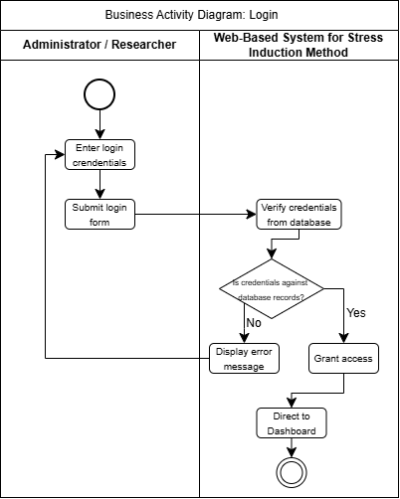

BAD002 Create User Account
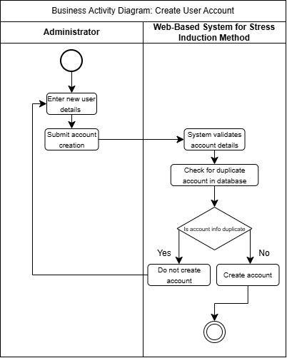

BAD003 View User Account
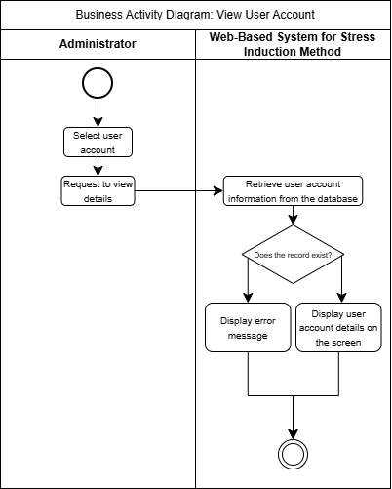

BAD004 Update User Account Account
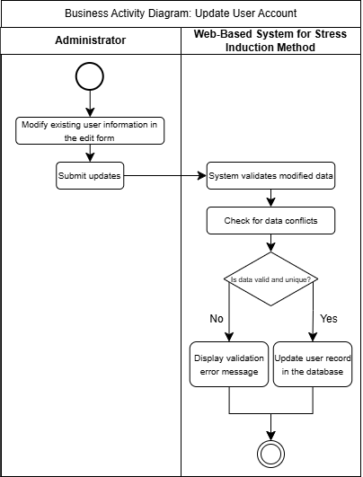

BAD005 Delete User Account
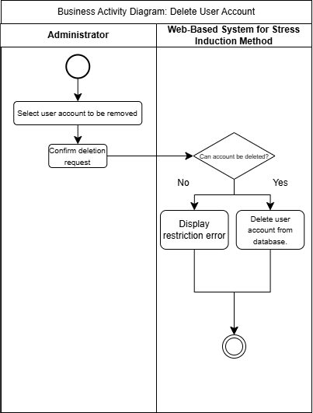

BAD006 Choose Participant
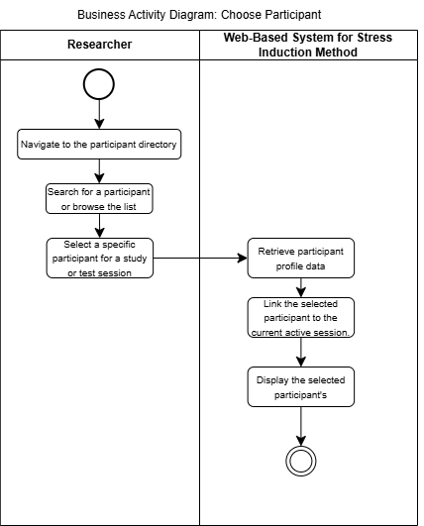

BAD007 View Participant
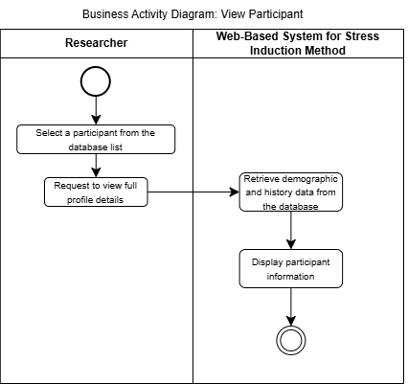

BAD008 Update Participant
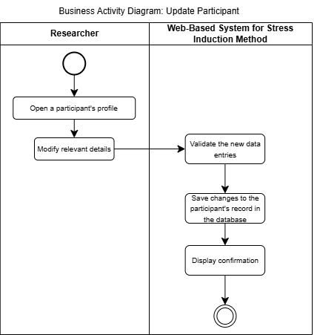

BAD009 Delete Participant
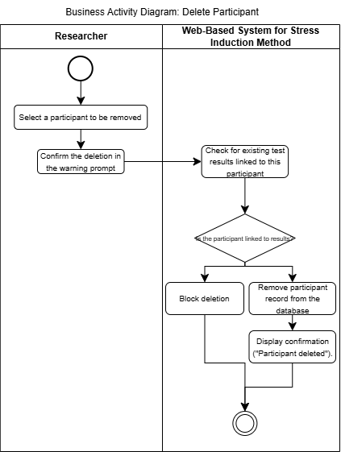

BAD010 Create Test
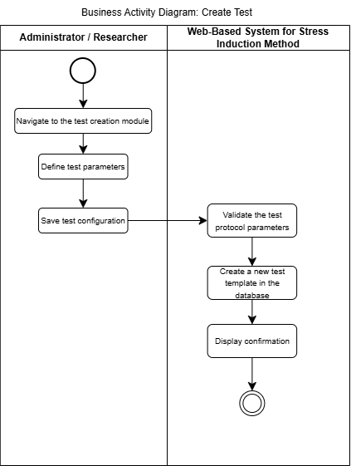

BAD011 View Test
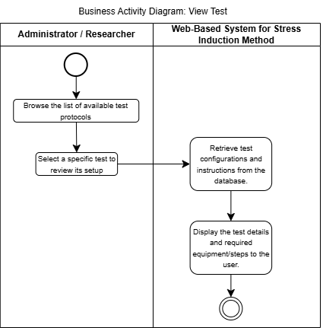

BAD012 Update Test
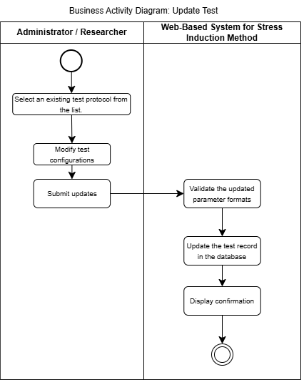

BAD013 Delete Test
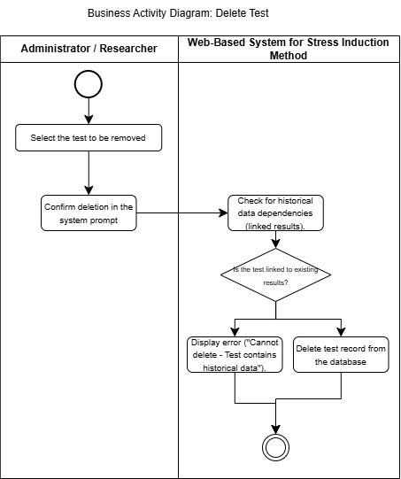

BAD014 Perform Test
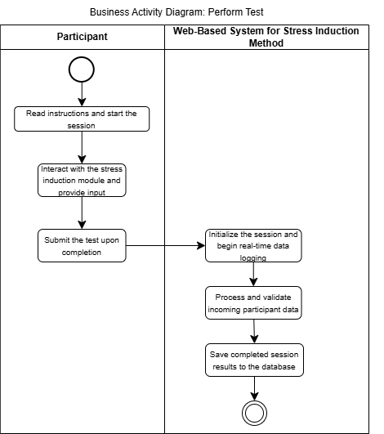

BAD015 View Result
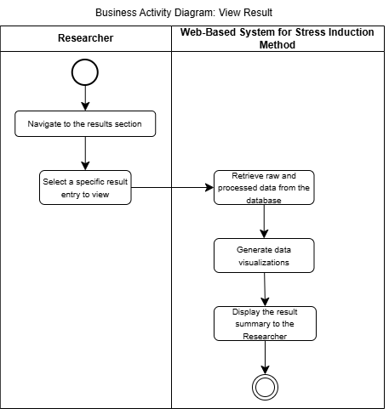

BAD016 Generate Report
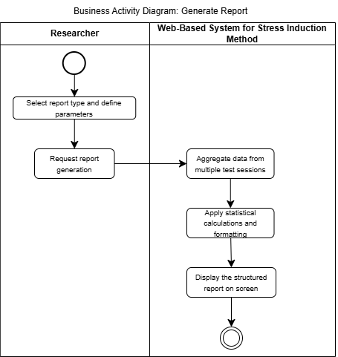

BAD017 Export Test Data
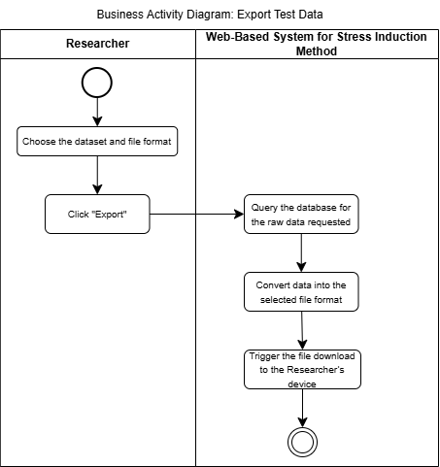

CLASS DIAGRAM

Domain Class Diagram
Centralized Web-Based System for Stress Induction Methods

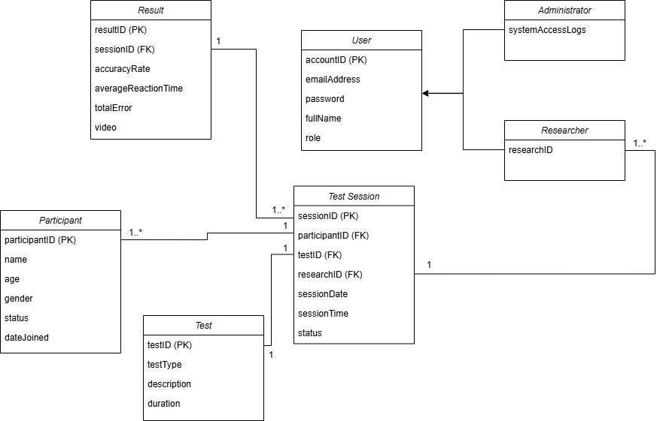

SYSTEM SEQUENCE DIAGRAM
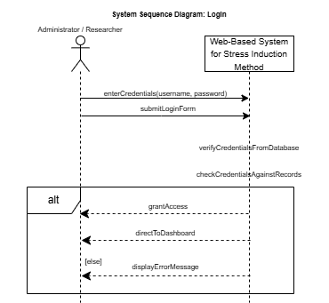
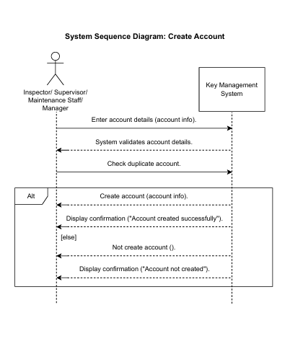
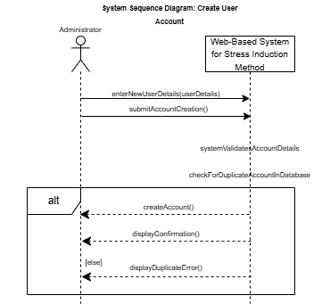

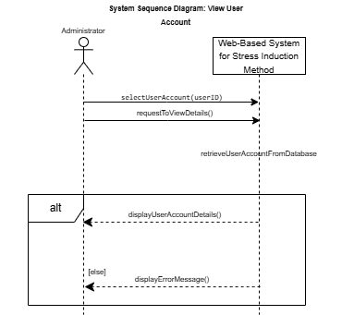
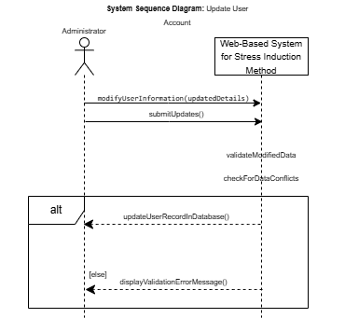
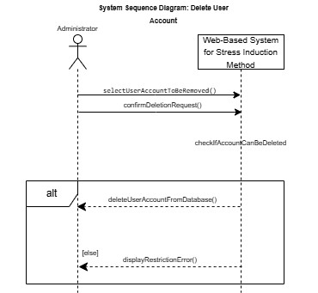

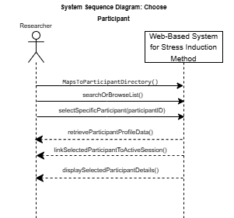

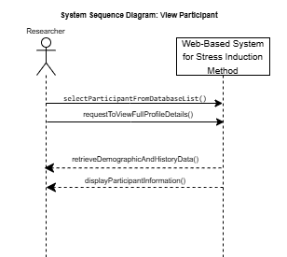

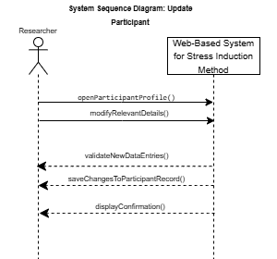

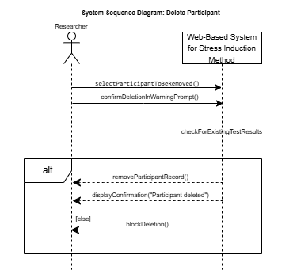

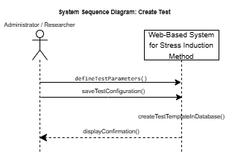

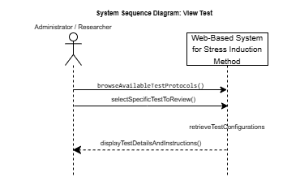

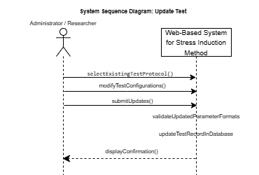

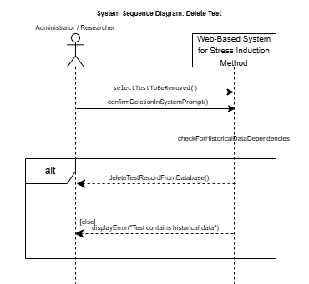

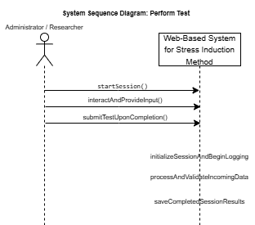
Participant

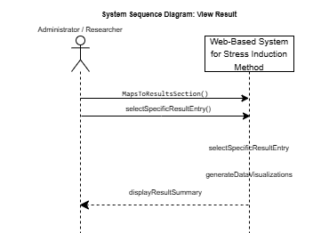
Researcher
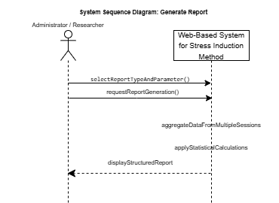
Researcher

