**To:** The Department of Mathematical Engineering

**From:** Emirhan Şahin, 20058057

**Course:** MTM4552Image Processing

**Subject:** High-Pass Filters on Spatial Domain

**Date:** 16.05.2024

**Contents**

**High-Pass Filters on Spatial Domain** 3

**Chapter 1: Understanding Filters in Image Processing: An Introduction** 3

**1.1) Overview of Image Processing Filters:** 3

**1.2) Types of Image Processing Filters** 4

**1.3) Spatial Domain Filtering** 4

**Chapter 2: Enhancing Image Details: Exploring High-Pass Filters** 6

**2.1) Definition and purpose of high-pass filters.** 6

**2.2) How high-pass filters enhance edges and details in images.** 7

**Chapter 3: Types of High-Pass Filters** 8

**3.1) Gaussian High-Pass Filter:** 8

**3.2) Laplacian Filter:** 8

**3.3) Sobel Filter:** 8

**3.4) Prewitt Filter:** 9

**3.5) Roberts Cross Filter:** 9

**Chapter 4: Application Examples** 9

**4.1) Edge Detection:** 9

**4.2) Sharpening:** 10

**4.3) Noise Reduction:** 10

**Conclusion** 10

**References** 11

# **High-Pass Filters on Spatial Domain**

This report aims to provide information about high-pass filters in the spatial domain. Accordingly, the subject will be analysed in 4 chapters.

## **Chapter 1: Understanding Filters in Image Processing: An Introduction**

Filters are used to shape visual data to meet a variety of needs in image processing, from enhancing detail to suppressing noise. With this use case, they are indispensable in image processing.

### **1.1) Overview of Image Processing Filters:**

Image processing filters are essential instruments that we use to make simple changes in an image or make the colours appear more beautiful. Pixel values of an image can be modified by filters as the filters can change the appearance of an image in different ways. They are involved in the imaging processes and take care of the fundamental characteristics of image processing like noise reduction, edge detection, and image enhancing.

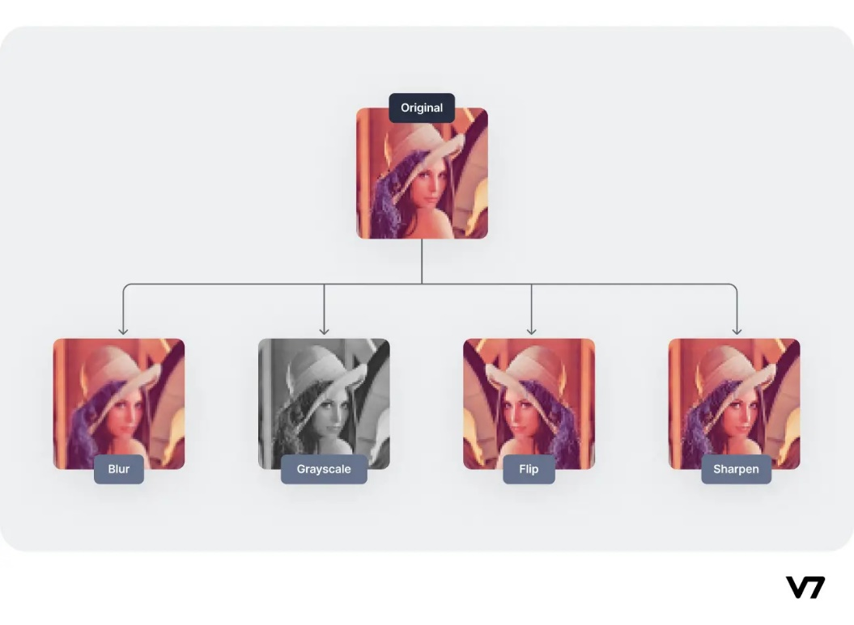

### **1.2) Types of Image Processing Filters**

Filters can be analysed in two different types: **Spatial domain filters** and **frequency domain filters.** Spatial domain filters, which work directly on the spatial domain representation of an image, are the focus of this report. They include common filters such as low-pass, high-pass, and median filters.

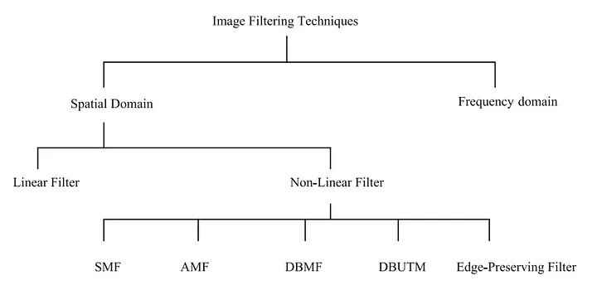

### **1.3) Spatial Domain Filtering**

Spatial domain filtering involves applying a filter directly to the pixel values of an image. This process is typically performed using convolution, where a filter kernel is applied to each pixel in the image to produce a modified pixel value. Spatial domain filtering is computationally efficient and widely used in image processing applications.

Spatial filtering technique is a method that takes the pixels of an image for a direct pathway. Size extraction for the mask is completely based on the prime pixels of its centre. This mask is slid upon the image such that the central point of the mask passes through every single pixel of the image.

**Classification based on linearity:**

There are two types:

1. Linear Spatial Filter

2. Non-linear Spatial Filter

**General Classification:**

Smoothing Spatial Filter: Smoothing filter is used for blurring and noise reduction in the image. Blurring is pre-processing steps for removal of small details and Noise Reduction is accomplished by blurring.

**Types of Smoothing Spatial Filter:**

1. Linear Filter (Mean Filter)

2. Order Statistics (Non-linear) filter

These are explained as following below.

#### **Mean Filter:**

Linear spatial filter is simply the average of the pixels contained in the neighbourhood of the filter mask. The idea is replacing the value of every pixel in an image by the average of the grey levels in the neighbourhood define by the filter mask.

**Types of Mean filter:**

* Averaging filter: It is used in reduction of the detail in image. All coefficients are equal.
* Weighted averaging filter: In this, pixels are multiplied by different coefficients. Canter pixel is multiplied by a higher value than average filter.

#### **Order Statistics Filter:**

It is based on the ordering the pixels contained in the image area encompassed by the filter. It replaces the value of the centre pixel with the value determined by the ranking result. Edges are better preserved in this filtering.

**Types of Order statistics filter:**

* **Minimum filter:** 0th percentile filter is the minimum filter. The value of the centre is replaced by the smallest value in the window.
* **Maximum filter:** 100th percentile filter is the maximum filter. The value of the centre is replaced by the largest value in the window.
* **Median filter:** Each pixel in the image is considered. First neighbouring pixels are sorted, and original values of the pixel is replaced by the median of the list.

**Sharpening Spatial Filter:** It is also known as derivative filter. The purpose of the sharpening spatial filter is just the opposite of the smoothing spatial filter. Its main focus in on the removal of blurring and highlight the edges. It is based on the first and second order derivative.

First order derivative:

* Must be zero in flat segments.
* Must be non zero at the onset of a grey level step.
* Must be non zero along ramps.

First order derivative in 1-D is given by:

$$f^{'}=f\left(x+1\right)-f(x)$$

Second order derivative:

* Must be zero in flat areas.
* Must be zero at the onset and end of a ramp.
* Must be zero along ramps.

Second order derivative in 1-D is given by:

$$f^{'}=f\left(x+1\right)+f\left(x-1\right)+2f(x)$$

## **Chapter 2: Enhancing Image Details: Exploring High-Pass Filters**

### **2.1) Definition and purpose of high-pass filters.**

High-pass filters emphasize edges and fine details in images by amplifying high-frequency components while reducing low-frequency ones. They are used to sharpen images and enhance features for tasks like edge detection and texture analysis in various fields, including photography and computer vision.

### **2.2) How high-pass filters enhance edges and details in images.**

High-pass filters are performing of the role of enhancing edges and details in images by making high frequency components of image with amplification to show rapid intensity variations that are created by pictures, textures, and fine edges. Considering this, how they make that happen is described below.

**Frequency Separation:** High-pass filters remove the image to parts of it which contain both high-and low-frequency components. High-frequency components usually constitute for sudden change in the intensity, like edges and details, whereas low-frequency components are responsible for gradual or smooth transitions.

**Emphasis on Edges:** Through the deprivation or suppressions of the low frequency components, high-pass filters simply employ their ability to increase the support between pixels having different intensity values. So, edges are defined and easier to recognize.

**Detail Enhancement:** High-pass filters, by means of amplifying variations in pixel intensity within limited areas of the picture, highlight the small details. This intensification brings forth fine details such as patterns, textures, and structures that would appear either obscured or blurred without that scale.

**Image Sharpening:** Applying a high-pass filter on an image will improve the sharpness of the image. This is because the contrast along edges will be increased, and the visual acuity will consequently be enhanced. This leads to sharper and more distinct-looking contours with edges that are crisper and details that are more visible.

**Selective Enhancement:** High-pass filters provide the ability to precise highlighting of certain details or areas of the picture. Through the adjustment of the filter parameters or by using combined multiple filters users are able to fine-tune the process of enhancement precisely according to their necessities and personal choices.

Consequently, high-pass filters tend to be the cornerstone of image enhancement technology since they selectively emphasise high-frequency components, thus helping to enhance the clarity, definition, and visual quality of images for such applications as edge detection, texture analysis, feature extraction, and digital image processing.

## **Chapter 3: Types of High-Pass Filters**

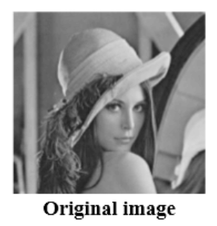

### **3.1) Gaussian High-Pass Filter:**

The Gaussian high-pass filter is a marriage of the Gaussian blur and the high-pass filter. It first blurs the image using a Gaussian kernel to remove low-frequency components, then subtracts the smoothed image from the original to highlight high-frequency components, leaving sharp edges and details to come out while reducing noise.

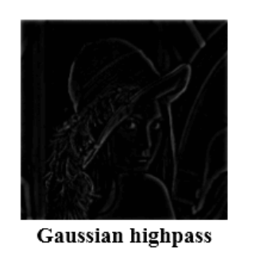

### **3.2) Laplacian Filter:**

The Laplacian filter performs the second order derivative computation of the image to detect the sharp intensity changes like edges. It exaggerates signals with sudden transitions in power by emphasizing high frequency components, which in turn makes it great for edge detection and image sharpening tasks.

### **3.3) Sobel Filter:**

The Sobel Filter is a gradient-based edge detector that determines the gradient magnitude at each pixel position. The edge detection algorithm is comprised of two separate convolution kernels that are one for vertical edges and another for horizontal edges. The Sobel kernels are then used to convolute the image, enabling the detection of edges in different directions.

### **3.4) Prewitt Filter:**

As the Sobel filter, the Prewitt filter is one of the gradient-based edge detector filters used to underline edges in the digital images. It uses separate convolution kernels for vertical and horizontal edges, which results in directional detection.

### **3.5) Roberts Cross Filter:**

The Roberts Cross filter is a simple edge detection filter that utilizes a pair of 2×2 convolution kernels to approximate the magnitude and the direction of the gradient. The convolution of these kernels with the image allows the filter to find edges where there is abrupt intensity change.

## **Chapter 4: Application Examples**

### **4.1) Edge Detection:**

High-pass filters are extensively used for edge detection in various image processing tasks such as object recognition, medical imaging, and autonomous navigation.

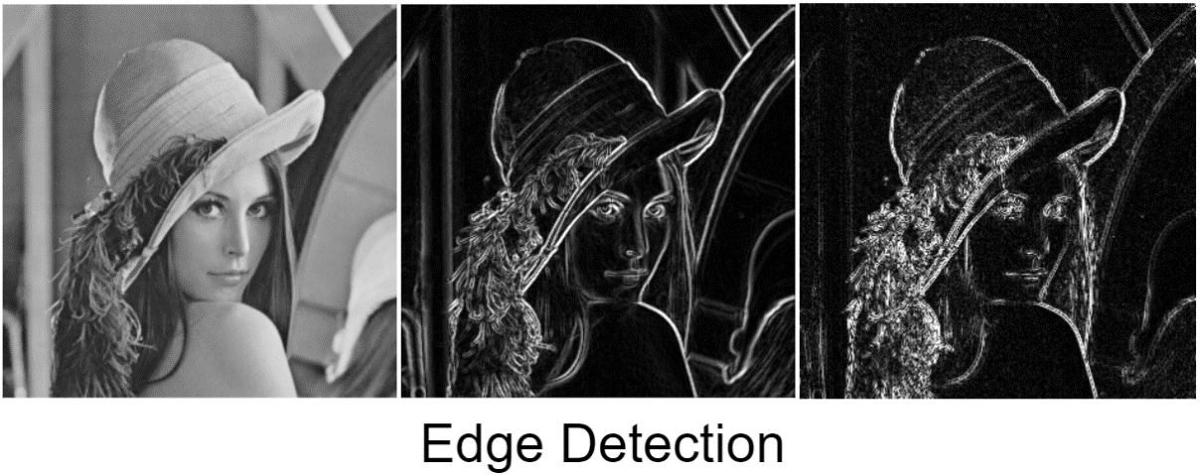

### **4.2) Sharpening:**

With attention to high frequency components high-pass filters help create crisp and clear images.

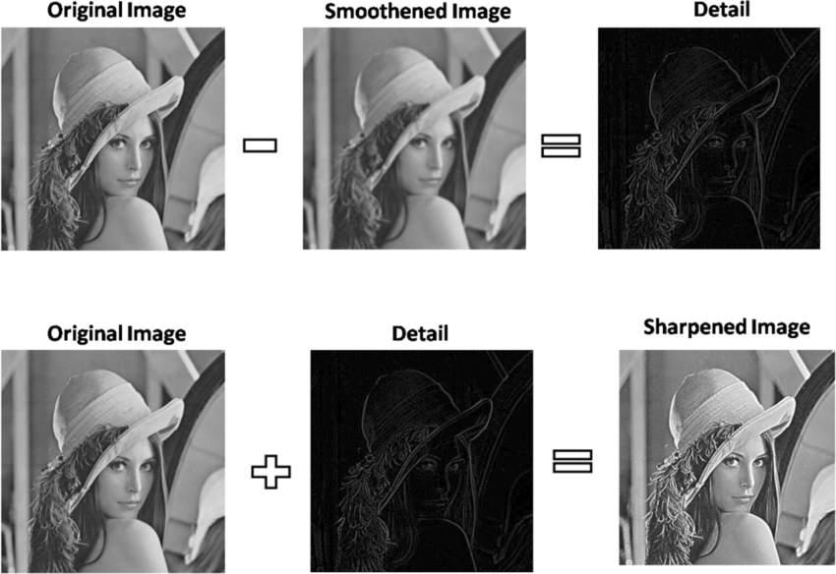

### **4.3) Noise Reduction:**

High-pass filters act like noise removal filters by attenuating low-frequency noise but preserving high-frequency image traits.

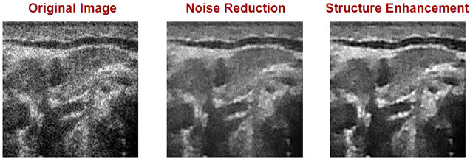

## **Conclusion**

In the spatial domain, the fast filters are use the most for image processing applications like edge detection, sharpening and noise removal. Understanding their algorithms, forms of execution, and implementation is crucial to provide integrated solutions of multiple tasks using methods of computer vision and medical imaging.

## **References**

Erdem, E. (n.d.). *BBM 413 Fundamentals of Image Processing Spatial Filtering*. Retrieved May 16, 2024, from <https://web.cs.hacettepe.edu.tr/~erkut/bbm413.f16/slides/05-spatial-filtering.pdf>

GeeksforGeeks. (2018, January 26). *Digital Image Processing Basics*. GeeksforGeeks; GeeksforGeeks. <https://www.geeksforgeeks.org/digital-image-processing-basics/>

GeeksforGeeks. (2019a, December 5). *Difference between Low pass filter and High pass filter*. GeeksforGeeks; GeeksforGeeks. <https://www.geeksforgeeks.org/difference-between-low-pass-filter-and-high-pass-filter/>

GeeksforGeeks. (2019b, December 6). *Spatial Filtering and its Types*. GeeksforGeeks; GeeksforGeeks. <https://www.geeksforgeeks.org/spatial-filtering-and-its-types/>

*High Pass vs Low Pass Filters - Javatpoint*. (2021). Www.javatpoint.com. <https://www.javatpoint.com/dip-high-pass-vs-low-pass-filters#:~:text=Highpass%20filters%20(sharpening)&text=As%20lowpass%20filter%2C%20it%20also,highpass%20filter%2C%20Gaussian%20highpass%20filter.>

Jeffrey. (2022, August 31). *Digital Image Processing: Edge Detection - NTUST-AIVC - Medium*. Medium; NTUST-AIVC. <https://medium.com/ntust-aivc/digital-image-processing-edge-detection-29aa84a8fd60>

shashika dilhani. (2021, August 5). *Digital Image Processing Filters - shashika dilhani - Medium*. Medium; Medium. <https://medium.com/@shashikadilhani97/digital-image-processing-filters-832ec6d18a73>

Simplilearn. (2021, April 29). *What Is Image Processing : Overview, Applications, Benefits, and More*. Simplilearn.com; Simplilearn. <https://www.simplilearn.com/image-processing-article#:~:text=Image%20processing%20is%20the%20process,certain%20predetermined%20signal%20processing%20methods.>