**Metal Snail**

**Team Synapse**

Garrett McSpadden

Conor Adamson

Kevin Guadarrama

Sean Kramer

Enrique Balleza

**February 6, 2019**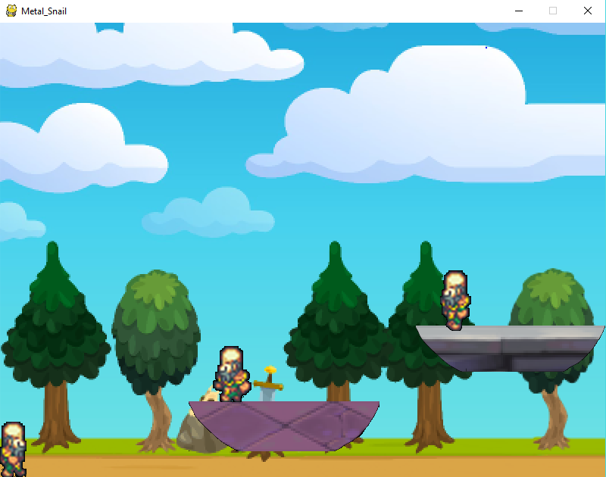

**Elevator Pitch-**

Metal Snail is a 2D action platformer that pays homage to Metal Slug in a new fantasy setting. The game will feature multiple stages that will include enemy encounters along with platforming puzzles that will lead the players through the world of Xarcadia. The player will have the ability to increase their arsenal by unlocking new spells for use in combat. The main objective of the game is to have fun and try to have the high score.

**Game Summary-**

**CORE GAME LOOP:**

Explore levels→ Defeat enemies to raise your score → Get the highest score you can

**FOCUS:**

Combat

Platforming

Levels

COMBAT -

Combat will consist of different spells the character is able to learn along the way.

Each spell is cast from the core of the player and will travel forward along that path until it either hits an enemy or passes of the screen.

Enemies will have different amounts of health therefore some will require more hits to kill.

PLATFORMING -

Platforms will be placed into each level/scene in order to give the player obstacles that they must move around while trying to defeat enemies.

They will also play a key part in whether the player is able to unlock more powerful spells or not.

LEVEL –

The game will feature four playable levels that will have the player exploring the world of Xarcadia.

Each level will feature different platform puzzles, some of which may result in extra score, extra lives, or a possible new spell for the player to use.

**CONTROLS**

W - Jump

A – move left

D – move right

Space – fire spell

E – change current spell