
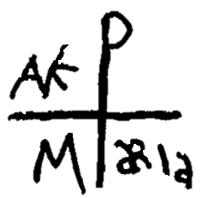
LEITURAS PARA A CELEBRAÇÃO DA PALAVRA
Paróquia Santa Maria dos Pobres - Comunidade 06

Tema:
Históricos | Profetas | Cartas | Evangelho
JS 13, 2+ | EZ 1, 28 | AP 19, 12 | LC 1, 5-25
JS 15, 33 | EZ 17 | AP 1, 17 | MT 1, 14
GN 11, 30 | EZ 16, 5-21 | HB 11, 32 | LC 11, 8
GN 15, 1-15 | JR 1, 5 | 1COR 24, 10 | MT 1, 20+
1SM 1 | ECLO 48, 10-11 | AP 1, 8+ | LC 1, 41
NM 6, 1+ | DN 8, 16 |  | MT 17, 10-13+
GN 32, 30 | DN 9, 21 |  | MT 3, 23-24
EX 3, 14+ | DN 8, 18 |  | MC 1, 1+
LV 9, 12 | DN 10, 15-19 |  | MT 8, 10+
EX 33, 20 | EZ 1, 28S |  | LC 18, 1-8
JZ 3, 10+ | IS 44, 6 |  | LC 10, 22
JZ 18, 12 | IS 48, 12
JS 19, 41 | DN 6, 23
GN 38, 12 | IS 63, 1
JS 15, 10
JS 19, 43
GN 34, 4
GN 24, 3-4
GN 28, 1-2
JZ 3, 10
1SM 17, 34S
2SM 23, 20
1RS 10
2SM 23, 11
JZ 16, 31
JZ 14, 15-18
JZ 15, 20
JS 19, 40+
GN 16, 7
GN 29, 23-27
1SM 5, 2S
JS 15, 41
JS 19, 27
GN 18, 11
JZ 13, 2-5
1SM 1, 20+
NM 6, 2-3
TB 12, 15

 | Trecho | Munição | Leitor | Salmo
1ª Leitura
2ª Leitura
3ª Leitura
Evangelho
Ambiental |  |  | Entrada
Paz |  |  | Final

