Milestone 3 - R vs. Python Preference Analysis through the RStudio Community Survey

Xiaolong Ge

### 1. Goal

The objective of this project is to utilize the information collected from the RStudio community survey to understand the factors influencing the preference for R or Python among people like data scientists. And predict the possible trend of preference of using R or Python in the future.

### 2. Data Source

The primary source of data is the annual R Community Survey conducted by RStudio, which is hosted on GitHub. Accessing this data requires cloning the GitHub repository where the survey results are stored. Initially, I intended to use the use_git_clone() function from the usethis package to get the contents of the repository, but after reading the package description, I found that this function has been removed in the latest version. So instead I used the clone() function from the git2r package. The data files are all in TSV format and provide comprehensive demographic information about the survey respondents and R usage patterns. However, the data set is not suitable for all types of analyses; for example, respondents’ answers may be self-selected or biased towards more engaged community members, which is not always representative of the entire R user community.

Given the nature of the data, I chose to focus on specific aspects such as demographics, professional background, and specific R usage details across years. I pulled from multiple annual surveys and brought them together to create a comprehensive data set. Also, in order to process the multilingual results, I translated all Spanish-language questionnaires and their results so that they could be processed in English. The processed data set contains responses from several years and provides a solid basis for trend analysis within the R community. Additionally, because the survey questions varied from year to year, I had to assign different codes to process each year’s results before they could be integrated. To columns that have not appeared in other data sets, I use NA values to fill them. Detailed data extraction and initial processing scripts can be found in Appendix 2.1.

To analyze survey data effectively, a function has been designed that offers various features to handle responses with considerable flexibility. This function includes the rm.na parameter, which dictates the treatment of NA values in the data set: setting rm.na = TRUE excludes NA values from the calculation, ensuring that percentages are based on non-missing responses only, whereas rm.na = FALSE includes them, reflecting the total number of responses including missing ones. Furthermore, the sort parameter controls the ordering of results; setting sort = TRUE will arrange the outcomes by their frequency, while sort = FALSE returns them in the order they appear in the data set.

Additionally, there’s another function can split multiple answers separated by commas within a single response and aggregate these into a nested list format, facilitating detailed analysis of each individual component of the responses. This split-and-summarize approach is particularly useful for handling multiple-choice questions or questions allowing multiple responses. Moreover, the function provides a feature to extract the most frequently occurring responses, enabling users to focus on the top ‘N’ results, which can be particularly insightful for prioritizing key areas in data interpretation. This approach and its functionalities are detailed in Appendix 2.2 of the report.

### 3. Data Processing

As shown through the code below, there are a total of 73 attributes in the data set. Due to the specificity of the data being the result of a questionnaire, we can’t be sure which columns are important at the beginning, so even though there are a lot of columns, we have to keep them instead of deleting them.

However, for the information collected in the data set, we have to do some processing. The first is the time information in the questionnaire, we need to convert the Qtime column in the survey, the purpose of which is to convert the original datetime string to a datetime object (of type POSIXct or POSIXlt ) in R, so that it can be analysed at a later time, in particular, here we have specified that the time zone is the one of Auckland, New Zealand, and the before and after cases are as follows:

est <- locale(tz = "Pacific/Auckland")  
survey_combined$Qtime <-  
 parse_datetime(as.character(survey2$Qtime),  
 format = "%m/%d/%Y %H:%M:%S",  
 locale = est)

**Before:**

## [1] "12/13/2019 9:50:30" "12/13/2019 9:50:38" "12/13/2019 9:51:19"   
## [4] "12/13/2019 9:53:51" "12/13/2019 10:01:03" "12/13/2019 10:04:42"

**After:**

## [1] "12/13/2019 9:50:30" "12/13/2019 9:50:38" "12/13/2019 9:51:19"   
## [4] "12/13/2019 9:53:51" "12/13/2019 10:01:03" "12/13/2019 10:04:42"

Secondly, for the open text answers to the gender question in the questionnaire, we have to convert all the text to lower case to ensure that all the data can be processed in a consistent format. We also remove the whitespace before and after the strings to eliminate any extra spaces that may occur before and after the strings due to irregularities in typing. Finally, a regular expression [[:punct:]] is used to match any punctuation and replace it with an empty string to remove any punctuation that may affect subsequent text processing or analysis.

survey_combined$Qgender <-  
 survey_combined$Qgender %>% tolower() %>% str_trim() %>%   
 str_replace_all("[[:punct:]]", "")  
opentext_gender_dictionary <-  
 read_csv("dictionary/opentext_gender_dictionary.csv")  
gender_dictionary <-  
 opentext_gender_dictionary %>%  
 mutate(Input = str_replace_all(Input, "[[:punct:]]", ""))

**Before:**

## [1] "Female" "Non-binary" "Male" "Male" "male"   
## [6] "Female"

**After:**

## [1] Female Non-binary Male Male male Female   
## 202 Levels: "Gender" is sex stereotypes. "Identifying" with a gender reinforces regressive, sexist stereotypes. Why is there no question about biological sex? ...

We do the same for race-related issues.

opentext_ethnicity_dictionary <-  
 read_csv("dictionary/opentext_ethnicity_dictionary.csv")  
ethnicity_dictionary <- opentext_ethnicity_dictionary %>%  
 mutate(Input = str_replace_all(Input, "[[:punct:]]", ""))

**Before:**

## [1] "Asian" "White" "White" "White" "White" "Ashkenazi"

**After:**

## [1] "Asian" "White" "White" "White" "White" "Ashkenazi"

In addition, we are going to categorise each row in the survey according to the year in the Qr_year column and add or modify the learner_type column to reflect the type of learner. Depending on the year, learners will be categorised as Early Learners (between 1900 and 2016), Recent Learners (2017 and later) or Unknown ( NA ) at very old years (less than 1900).

survey <- survey %>%  
 mutate(learner_type = ifelse(  
 Qr_year < 1900,  
 NA,  
 ifelse(Qr_year <= 2016, "Early Learner", "Recent Learner")  
 ))

**Sample:**

## [1] NA NA NA NA NA NA

The full data processing code will be appended to 3.1.

### 4. Data Exploration

Since our main objective is to analyse and predict the preferences of a specific population for R or Python. Like analysing which groups of people prefer R, or which relevant factors play a bigger role in preferring R, based on survey data obtained in the last three years. So I’m going to start by looking at the types of work people do, and see which groups of people use R the most, so that I can see which groups of people are likely to have a larger share of influence on preferences. Therefore, in this section I will choose to look at the proportional relationship between the number of people using R and the occupations they are in, in the form of generating graphs for the three years from 2018 to 2020.

job_title_totals <- job_titles %>% count(Output, sort = TRUE)  
job_title_responses <- sum(!is.na(survey$Qwork_title))  
job_titles <-  
 job_title_totals %>% mutate(percent = round(n / job_title_responses * 100, 0))  
top_10_titles <-  
 top_n_choices(job_titles, Output, job_title_responses, 10)  
top_10_titles <- top_10_titles %>%  
 mutate(  
 JobTitle = factor(Output, levels = rev(Output)),  
 position = cumsum(percent) - percent / 2,  
 label = ifelse(percent >= 5, paste0(JobTitle, "\n", round(percent), "%"), "")  
 )

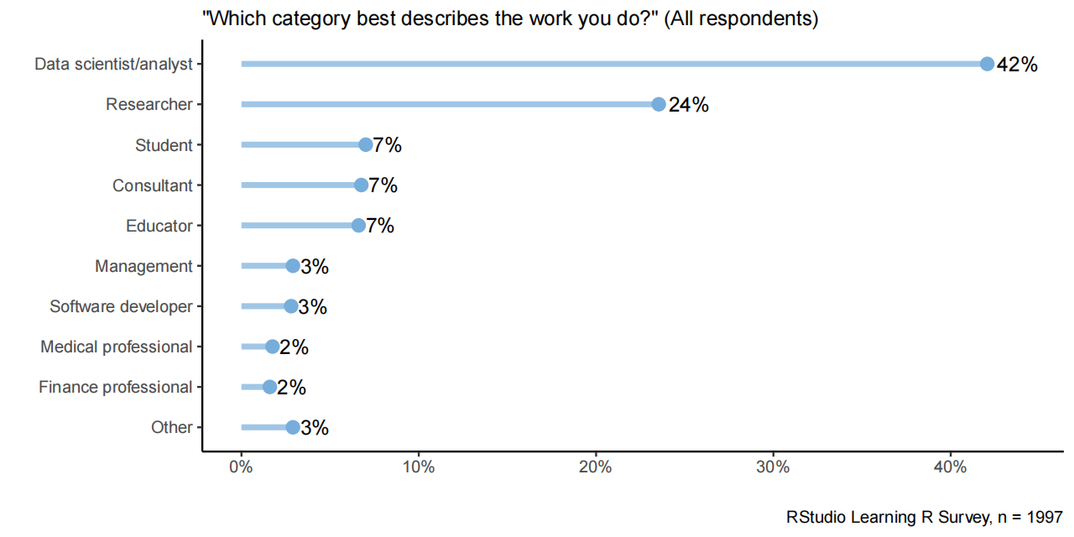 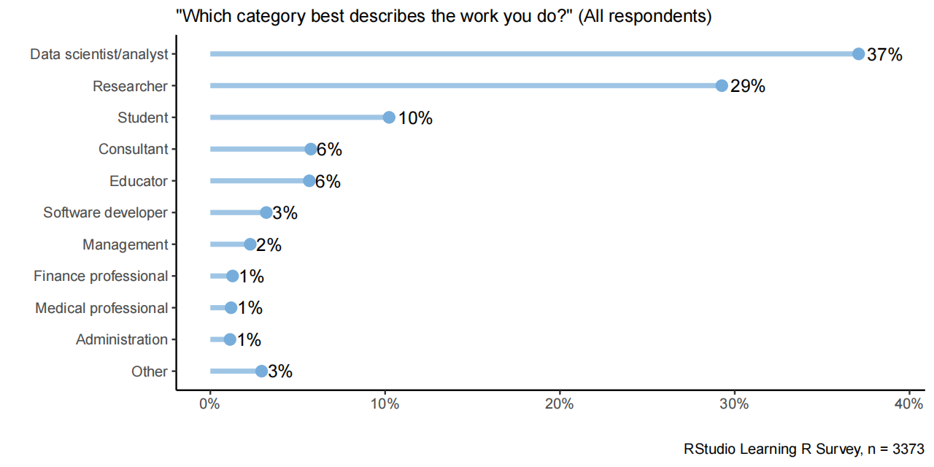 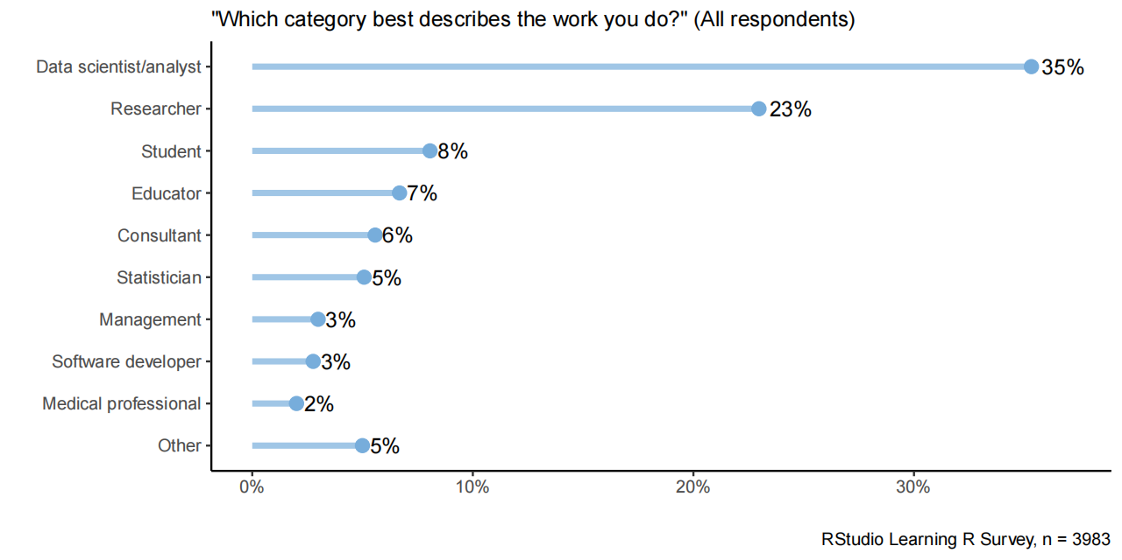

We can see that from 2018 to 2020 (listed from left to right), Data Scientists/Analysts are consistently the largest occupational group, with a percentage of 37% of the 3,373 respondents in the first chart, increasing to 42% of the 1,997 respondents in the second chart. Researchers had the second highest percentage in the first chart at 29 per cent, but dropped to 24 per cent in the second chart. The percentage of students, counsellors, and educators all declined as well. The percentage of management and software developers remained stable, while the percentage of healthcare professionals and financial professionals increased slightly. Overall, the increase in the percentage of data scientists/analysts suggests that their interest in learning about R may be on the rise, despite the decrease in the number of participants in the survey.

Also, whether the preference is affected by gender differences is also a part that I find more valuable to explore, as gender differences may cause people to have different values and ways of thinking. Below are the charts of the preferences for R by gender.

genders <- genders %>%  
 group_by(unit) %>%  
 mutate(  
 percent = round(n / gender_responses * 100),  
 prop_responses = n / gender_responses,  
 position = cumsum(percent) - percent / 2,  
 label = ifelse(percent >= 10, paste0(Qgender, "\n", round(percent), "%"), "")  
 ) %>% arrange(desc(percent))  
genders <- genders %>%  
 mutate(Qgender = factor(Qgender, levels = rev(  
 c("male", "female", "sex and gender diverse", "unclear")  
 ))) %>%  
 drop_na()

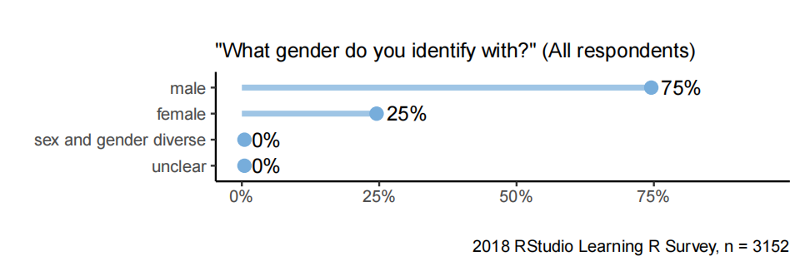 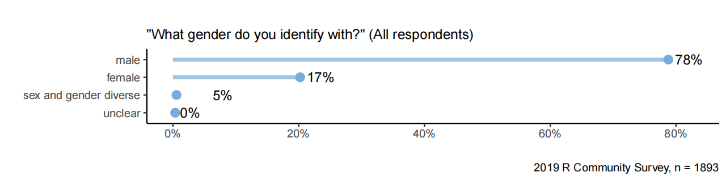 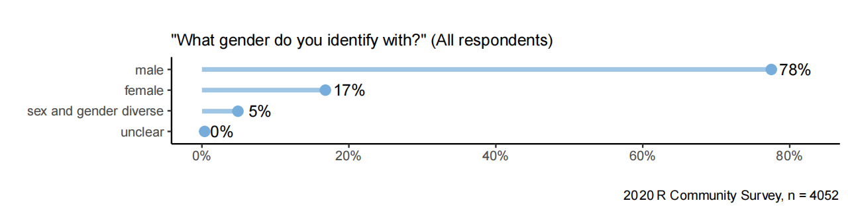

The R Community Survey, conducted between 2018 and 2020, showed that respondents who self-identified as male were in the majority in all years, increasing slightly from 75 per cent in 2018 to 78 per cent in 2019 and 2020. The proportion of female respondents decreased from 25 per cent in 2018 to 17 per cent in the latter two years. The gender and sexual diversity category begins to appear in 2019, accounting for 5 per cent in both that year and 2020, and was not listed in the 2018 survey. The number of respondents increased from 1,893 in 2019 to 4,052 in 2020, indicating a larger survey sample and a better understanding of gender diversity.

The most critical, and I think the factor that determines whether or not people will use R over Python, is the degree of their preference for R to be used under a particular domain. If there is a higher preference for Python over R for a particular application (like data visualisation), then I think that means that people will favour Python in that domain.

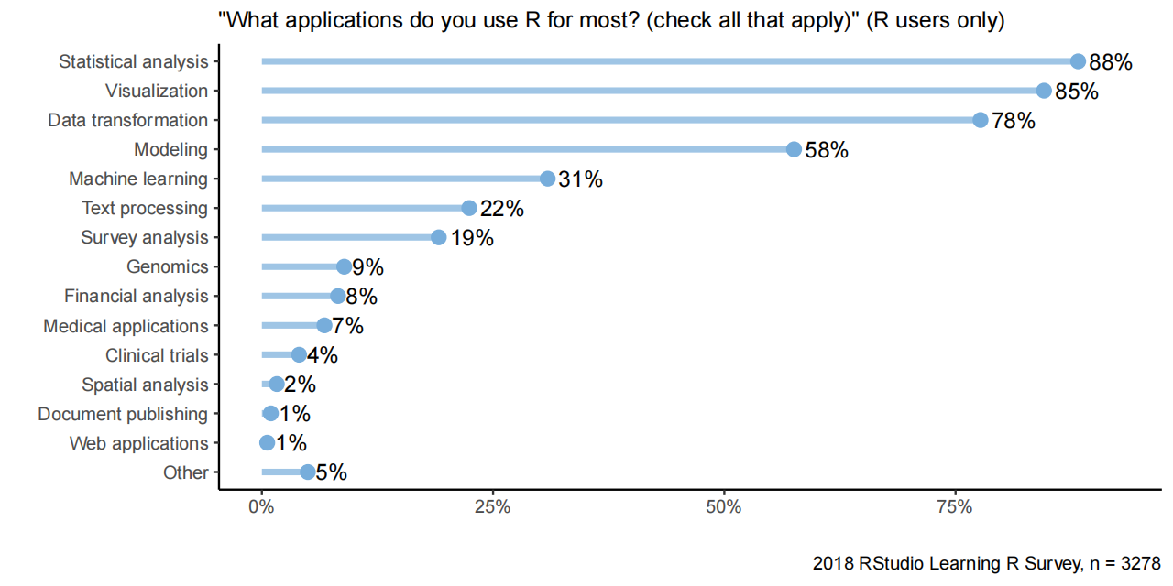 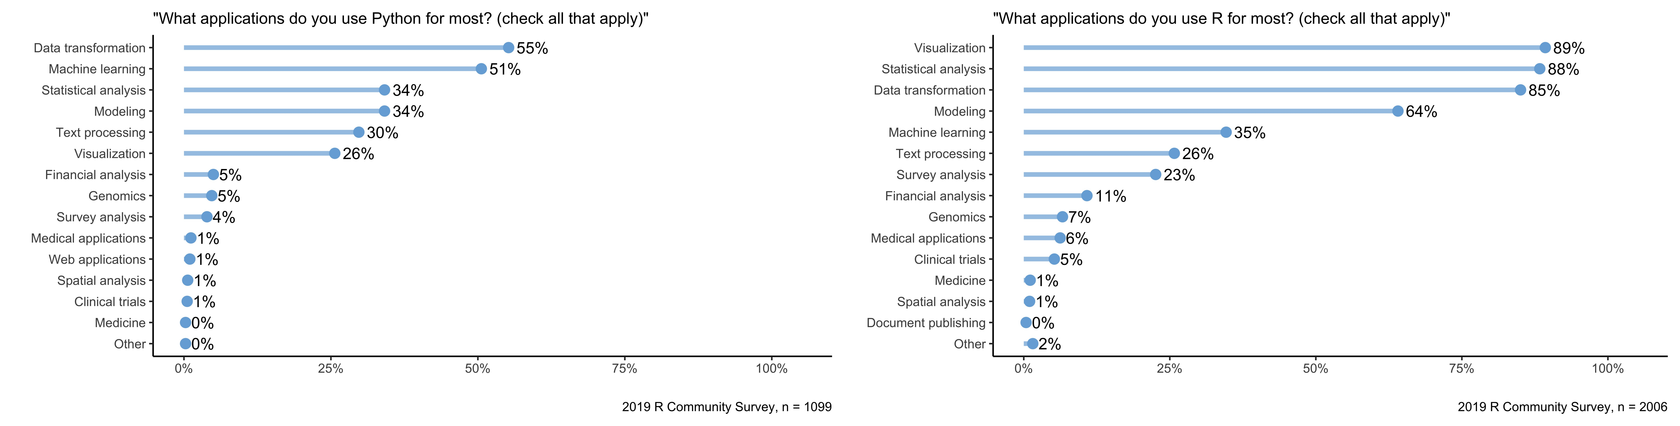 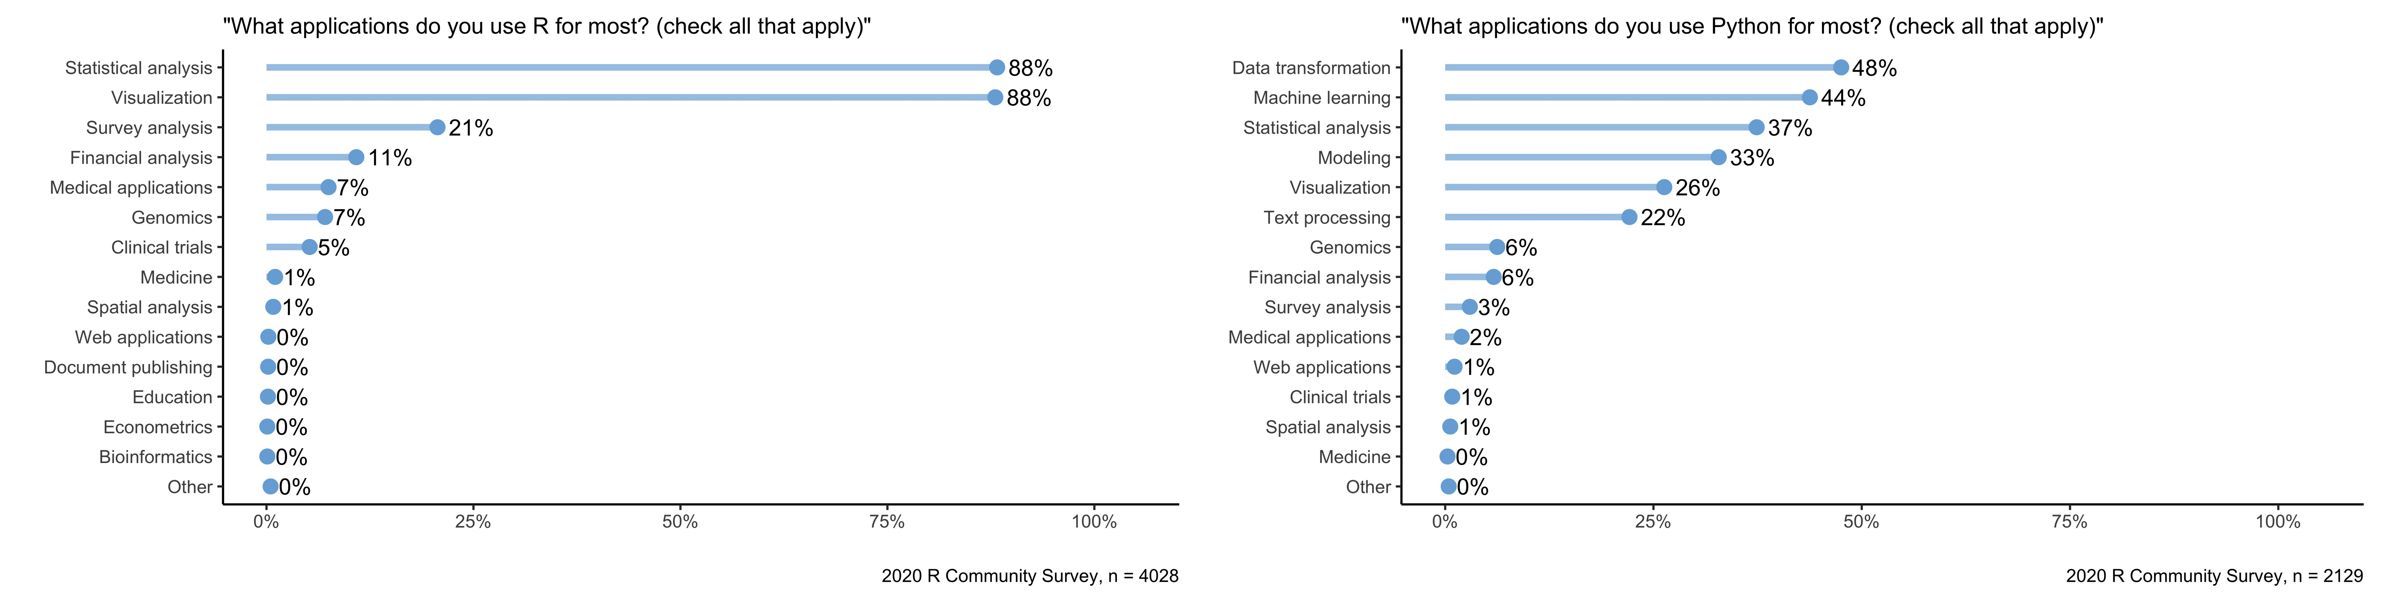

Across the 2018 to 2020 surveys, R is most frequently used for statistical analysis and visualization, consistently scoring the highest among other applications. Machine learning shows a higher prevalence in Python usage compared to R. Data transformation is also common in both R and Python, but it ranks slightly higher in Python applications. Over the years, R maintains its stronghold in statistical analysis and visualization while Python is preferred for machine learning tasks. There’s an observed drop in the percentage of users applying R for data transformation from 2018 to 2020, while Python’s use for data transformation has also declined slightly in 2020. Code of this part will be in Appendix 4.1.

### 5. Analytical Plan

Given the stable preference for statistical analysis and visualization in R and the rise of machine learning in Python, we will examine how these trends correspond with overall language preference. Using logistic regression, we will model language preference as a binary outcome (R vs. Python), with application uses as predictor variables. We will include year-over-year changes in applications as covariates to see if the increase or decrease in certain applications predicts the language preference.

We will also perform a cohort analysis to see if preferences differ among various groups, such as job roles or industries, using the job titles and applications data from the surveys. The cohorts can help us understand if, for example, data scientists are more likely to choose Python for machine learning applications, while researchers might favor R for statistical analysis.

Given the data shows a substantial number of respondents in the “Other” category, we will use text analysis techniques to categorize these open-ended responses, which could uncover additional applications influencing language preference. Finally, we will explore if the year of the survey impacts preference, considering the growth of data science and the development of new packages and features in both languages. This temporal component will be crucial for forecasting future trends, possibly using time-series analysis if data across more years becomes available.

survey_combined$Qr_year <- as.factor(survey_combined$Qr_year)  
survey_combined$Qgender <- as.factor(survey_combined$Qgender)  
survey_combined$Qindustry <- as.factor(survey_combined$Qindustry)  
survey_combined$Qr_experience <- as.factor(survey_combined$Qr_experience)  
  
survey_combined <- survey_combined[!is.na(survey_combined$Qindustry), ]  
survey_combined <- survey_combined[!is.na(survey_combined$Qr_experience), ]  
survey_combined <- survey_combined[!is.na(survey_combined$Qgender), ]  
survey_combined <- survey_combined[!is.na(survey_combined$Qr_year), ]  
  
survey_combined$Qr_enjoyment[is.na(survey_combined$Qr_enjoyment)] <- 0  
survey_combined$Qrecommend[is.na(survey_combined$Qrecommend)] <- 0  
survey_combined$Qpython_enjoy[is.na(survey_combined$Qpython_enjoy)] <- 0  
survey_combined$Qpython_recommend[is.na(survey_combined$Qpython_recommend)] <- 0  
  
survey_combined$Prefer <- ifelse(survey_combined$Qr_enjoyment * 0.6 + survey_combined$Qrecommend * 0.4 >= survey_combined$Qpython_enjoy * 0.6 + survey_combined$Qpython_recommend * 0.4, 1, 0)

library(ranger)  
  
fit.rf <- ranger(Prefer ~ Qr_experience + Qindustry + Qr_year + Qgender, data=survey_combined,  
 importance = 'impurity')  
  
importance(fit.rf)

## Qr_experience Qindustry Qr_year Qgender   
## 13.66884 36.33031 29.32766 19.39071

survey_combined$YearFromTime <- as.numeric(format(survey_combined$Qtime, "%Y"))  
  
# Convert to a factor if categorical year effect is needed, or keep as numeric for trend analysis  
survey_combined$YearFromTime <- as.numeric(survey_combined$YearFromTime)

# Build logistic regression model with YearFromTime as a predictor  
model_time <- glm(Prefer ~ YearFromTime, family = binomial(), data = survey_combined)  
  
# Check the summary to see effects and significance  
summary(model_time)

##   
## Call:  
## glm(formula = Prefer ~ YearFromTime, family = binomial(), data = survey_combined)  
##   
## Coefficients:  
## Estimate Std. Error z value Pr(>|z|)   
## (Intercept) 1503.97502 131.11951 11.47 <2e-16 ***  
## YearFromTime -0.74309 0.06492 -11.45 <2e-16 ***  
## ---  
## Signif. codes: 0 '***' 0.001 '**' 0.01 '*' 0.05 '.' 0.1 ' ' 1  
##   
## (Dispersion parameter for binomial family taken to be 1)  
##   
## Null deviance: 2629.9 on 8515 degrees of freedom  
## Residual deviance: 2480.2 on 8514 degrees of freedom  
## AIC: 2484.2  
##   
## Number of Fisher Scoring iterations: 6

# Create data frame for 2022 prediction  
future_year <- data.frame(YearFromTime = 2022)  
  
# Predict using the model  
future_prediction <- predict(model_time, newdata = future_year, type = "response")  
predicted_probability <- as.numeric(future_prediction)  
  
# Output the predicted probability or value  
print(paste("Predicted probability of preferring R in 2022:", predicted_probability))

## [1] "Predicted probability of preferring R in 2022: 0.80911481903099"

# Prepare data for plotting, including historical and predicted value  
plot_data <- data.frame(  
 Year = c(2018, 2019, 2020, 2021, 2022),  
 Probability = c(  
 predict(model_time, newdata = data.frame(YearFromTime = c(2018, 2019, 2020, 2021)), type = "response"),  
 predicted_probability  
 )  
)  
  
# Plotting the trend  
library(ggplot2)  
ggplot(plot_data, aes(x = Year, y = Probability)) +  
 geom_line() +  
 geom_point() +  
 labs(title = "Trend and Predicted Preference for R in 2022", x = "Year", y = "Probability") +  
 theme_minimal()

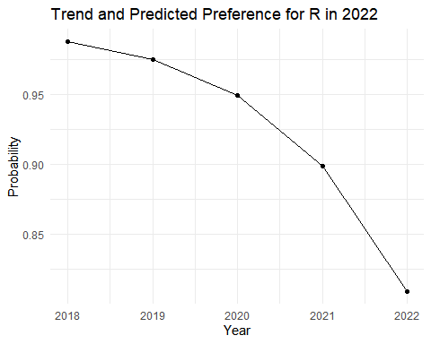

### Appendices

**2.1 Acquisition and integration of survey data:**

library(choroplethr)  
library(choroplethrMaps)  
data(country.map)  
library(tidyverse)  
library(RColorBrewer)  
library(gendercodeR)  
library(ggrepel)  
library(git2r)  
  
#obtaining the GitHUb repository  
path <- file.path("r-community-survey")  
dir.create(path, recursive = TRUE)  
repo <-  
 clone("https://github.com/rstudio/r-community-survey.git", path)  
  
#data of Year 2020  
survey1_name <- "2020 R Community Survey"  
column_formats1 <- cols(  
 Qtime1 = col_datetime(),  
 Qr_experience1 = col_character(),  
 Qhow_to_learn_r1 = col_character(),  
 Qreason_to_learn1 = col_character(),  
 Qr_use1 = col_character(),  
 Qtools1 = col_character(),  
 Qobstacles_to_starting1 = col_character(),  
 Qr_year1 = col_double(),  
 Qr_learning_path1 = col_character(),  
 Qr_reason_experienced1 = col_character(),  
 Qmost_difficult_aspect1 = col_character(),  
 Qr_how_often_used1 = col_character(),  
 Qr_OS1 = col_character(),  
 Qused_for1 = col_character(),  
 Qr_enjoyment1 = col_double(),  
 Qrecommend1 = col_double(),  
 Qtools_with_r1 = col_character(),  
 Qtidyverse_learning1 = col_character(),  
 Qtidyverse_today1 = col_character(),  
 Qlike_best1 = col_character(),  
 Qlike_least1 = col_character(),  
 Qr_problems1 = col_character(),  
 Qr_discover_packages1 = col_character(),  
 Qr_share1 = col_character(),  
 Qr_change1 = col_character(),  
 Qrobot_test1 = col_character(),  
 Qrmarkdown1 = col_character(),  
 Qrmarkdown_apps1 = col_character(),  
 Qrmarkdown_change1 = col_character(),  
 Qshiny1 = col_character(),  
 Qshiny_use1 = col_character(),  
 Qshiny_change1 = col_character(),  
 Qpython_use1 = col_character(),  
 Qpython_apps1 = col_character(),  
 Qpython_tools1 = col_character(),  
 Qpython_enjoy1 = col_double(),  
 Qpython_recommend1 = col_double(),  
 Qpython_change1 = col_character(),  
 Qcoding_languages1 = col_character(),  
 Qfirst_language1 = col_character(),  
 Qyear_born1 = col_double(),  
 Qgender1 = col_character(),  
 Qethnicity1 = col_character(),  
 Qdegree1 = col_character(),  
 Qcountry1 = col_character(),  
 Qindustry1 = col_character(),  
 Qtitle1 = col_character(),  
 Qwork_title1 = col_character(),  
 Qteam_r_users1 = col_character(),  
 Qr_community1 = col_character(),  
 Qevents1 = col_character(),  
 Qhear1 = col_character(),  
 language1 = col_character()  
)  
survey_raw1 <- read_tsv("./data/2020-combined-survey-final.tsv",  
 col_types = column_formats1)  
survey_questions1 <-  
 read_tsv(("./data/2020-combined-survey-names.tsv")) %>%  
 select("Question_name" = english_name, "Question_text" = english)  
respondents_raw1 <- nrow(survey_raw1)  
survey_non_robot1 <- survey_raw1 %>%  
 mutate(robot_test1 = ifelse(!is.na(Qrobot_test), tolower(Qrobot_test), NA))  
survey1 <- survey_non_robot1 %>%  
 filter(!is.na(robot_test1)) %>%  
 filter(  
 robot_test1 == "5" |  
 str_detect(robot_test1, "five") |  
 robot_test1 == "cinco" | robot_test1 == "fife"  
 )  
respondents1 <- nrow(survey1)  
survey_save1 <- survey1  
  
  
#data of Year 2019  
survey_name2 <- "2019 R Community Survey"  
column_formats2 = cols(  
 Qtime = col_character(),  
 Qr_experience = col_character(),  
 Qr_difficulty = col_double(),  
 Qr_length_to_success = col_character(),  
 Qhow_to_learn_r = col_character(),  
 Qreason_to_learn = col_character(),  
 Qr_use = col_character(),  
 Qtools = col_character(),  
 Qobstacles_to_starting = col_character(),  
 Qr_year = col_double(),  
 Qr_learning_path = col_character(),  
 Qr_difficulty = col_double(),  
 Qtime_to_proficiency = col_character(),  
 Qreason_to_learn = col_character(),  
 Qmost_difficult_aspect = col_character(),  
 Qr_how_often_used = col_character(),  
 Qused_for = col_character(),  
 Qr_enjoyment = col_double(),  
 Qrecommend = col_double(),  
 Qtools_with_r = col_character(),  
 Qtidyverse_learning = col_character(),  
 Qtidyverse_today = col_character(),  
 Qlike_best = col_character(),  
 Qlike_least = col_character(),  
 Qr_problems = col_character(),  
 Qr_discover_packages = col_character(),  
 Qr_share = col_character(),  
 Qr_change = col_character(),  
 Qrobot_test = col_character(),  
 Qrmarkdown = col_character(),  
 Qrmarkdown_apps = col_character(),  
 Qrmarkdown_change = col_character(),  
 Qshiny = col_character(),  
 Qshiny_change = col_character(),  
 Qpython_use = col_character(),  
 Qpython_apps = col_character(),  
 Qpython_enjoy = col_double(),  
 Qpython_recommend = col_double(),  
 Qpython_change = col_character(),  
 Qlanguages = col_character(),  
 Qfirst_language = col_character(),  
 Qyear_born = col_double(),  
 Qgender = col_character(),  
 Qethnicity = col_character(),  
 Qdegree = col_character(),  
 Qcountry = col_character(),  
 Qindustry = col_character(),  
 Qtitle = col_character(),  
 Qwork_title = col_character(),  
 Qteam_r_users = col_character(),  
 Qevents = col_character(),  
 Qhear = col_character()  
)  
english_column_names <-  
 read_tsv("./data/survey-questions-2019-en.tsv")  
english_survey <-  
 read_tsv(  
 file = "./data/2019 English R Community Survey Responses.tsv",  
 col_types = column_formats2,  
 col_names = english_column_names$Question_name,  
 skip = 1  
 )  
names(english_survey) <- english_column_names$Question_name  
english_survey$language <- "English"  
spanish_survey <-  
 read_tsv(  
 "./data/2019 Spanish R Community Survey Responses.tsv",  
 col_types = column_formats2,  
 col_names = english_column_names$Question_name,  
 skip = 1  
 )  
names(spanish_survey) <- english_column_names$Question_name  
spanish_survey$language <- "Spanish"  
survey_raw2 <- rbind(english_survey, spanish_survey)  
survey_questions2 <-  
 read_tsv("./data/survey-questions-2019-en.tsv")  
respondents_raw2 <- nrow(survey_raw2)  
survey2 <- survey_raw2 %>%  
 mutate(robot_test = str_to_lower(Qrobot_test)) %>%  
 filter(!is.na(robot_test)) %>%  
 filter(robot_test == "8" |  
 robot_test == "eight" | robot_test == "ocho")  
respondents2 <- nrow(survey2)  
survey_save2 <- survey2  
  
#data of Year 2018  
survey_name3 <- "2018 RStudio Learning R Survey"  
column_formats3 = cols(  
 Qtime = col_datetime(format = ""),  
 Qindustry = col_character(),  
 Qtitle = col_character(),  
 Qwork_title = col_character(),  
 Qlanguages = col_character(),  
 Qfirst_language = col_character(),  
 Qr_experience = col_character(),  
 Qr_year = col_double(),  
 Qtime_to_proficiency = col_character(),  
 Qr_learning_path = col_character(),  
 Qreason_to_learn = col_character(),  
 Qr_use = col_character(),  
 Qr_length_to_success = col_character(),  
 Qr_difficulty = col_double(),  
 Qr_reason_experienced = col_character(),  
 Qr_how_often_used = col_character(),  
 Qr_enjoyment = col_double(),  
 Qr_difficulty_experienced = col_double(),  
 Qtidyverse_learning = col_character(),  
 Qtidyverse_today = col_character(),  
 Qshiny = col_character(),  
 Qunit_tests = col_character(),  
 Qlike_best = col_character(),  
 Qlike_least = col_character(),  
 Qrecommend = col_double(),  
 Qused_for = col_character(),  
 Qmost_difficult_aspect = col_character(),  
 blank_question = col_character(),  
 Qnot_live_without = col_character(),  
 Qcapability_missing = col_character(),  
 Qtools = col_character(),  
 Qchange_one_thing = col_character(),  
 Qyear_born = col_double(),  
 Qgender = col_character(),  
 Qcountry = col_character(),  
 Qethnicity = col_character(),  
 Qdegree = col_character(),  
 Qteam_r_users = col_double(),  
 Qversion_control = col_character(),  
 Qtools_with_r = col_character(),  
 Qobstacles_to_starting = col_character(),  
 Qbiggest_difficulty = col_character(),  
 Qhow_to_learn_r = col_character(),  
 learner_type = col_character(),  
 Qgender_coded = col_character(),  
 Qethnicity_processed = col_character(),  
 Qethnicity_coded = col_character(),  
 number_responses = col_double()  
)  
english_survey <- read_tsv("data/survey_English.tsv",  
 col_types = column_formats3)  
english_survey$language <- "English"  
spanish_survey <- read_tsv("data/survey_Spanish.tsv",  
 col_types = column_formats3)  
spanish_survey <- spanish_survey %>% select(-blank2_question)  
spanish_survey$language <- "Spanish"  
survey3 <- rbind(english_survey, spanish_survey)  
survey_questions3 <- read_csv("data/survey_questions.csv")  
respondents3 <- nrow(survey3)  
  
#data set merge  
library(plyr)  
survey_combined <- rbind.fill(survey1, survey2, survey3)

**2.2 Multiple functions used to pre-process survey data:**

# This tallies up the results for a question  
# rm.na = TRUE to calculate percentages based on non-NA results; set to FALSE   
# to include NAs  
# set sort = TRUE sorts the result by count; set to FALSE to return in whatever   
# order they occur  
tally_question <-  
 function(df,  
 question_name,  
 rm.na = TRUE,  
 sort = TRUE) {  
 quoted_question <- enquo(question_name)  
 filtered_df <- df  
 if (rm.na) {  
 filtered_df <- filtered_df %>%  
 filter(!is.na(!!quoted_question))  
 }  
 results_df <- filtered_df %>%  
 count(!!quoted_question, sort = sort) %>%  
 add_tally(n, name = "nn") %>%  
 mutate(percent = round(n / nn * 100, 1),  
 prop_responses = n / nn)  
 return(results_df)  
 }  
# This tallies up the results for a question  
# rm.na = TRUE to calculate percentages based on non-NA results; set to   
# FALSE to include NAs  
# set sort = TRUE sorts the result by count; set to FALSE to return in whatever   
# order they occur  
tally_question_by_question <-  
 function(df,  
 question_name,  
 by_question_name,  
 # column name to group by  
 rm.na = TRUE,  
 sort = TRUE) {  
 quoted_question <- enquo(question_name)  
 quoted_by_question <- enquo(by_question_name)  
 filtered_df <- df  
 if (rm.na) {  
 filtered_df <- filtered_df %>%  
 filter(!is.na(!!quoted_question))  
 }  
 results_df <- filtered_df %>%  
 count(!!quoted_question, sort = sort) %>%  
 add_tally(n, name = "nn") %>%  
 mutate(percent = round(n / nn * 100, 1),  
 prop_responses = n / nn)  
 return(results_df)  
 }  
# Split and aggregate: derives multiple answers to a single question   
# by separating on commas and returning  
# the results as an embedded list in the dataframe.  
split_and_aggregate <- function(df, question_name) {  
 quoted_question <- enquo(question_name)  
 responses_df <- df %>%  
 summarize(responses = sum(!is.na(!!quoted_question)))  
 splits <- df %>%  
 mutate(items = purrr::map(!!quoted_question, str_split, ", ")) %>%  
 unnest(items)  
 aggregated_items <- splits %>%  
 unnest(items) %>%  
 group_by(items) %>%  
 count(sort = TRUE)  
 aggregated_items <- aggregated_items %>%  
 mutate(num_responses = responses_df$responses)  
 return(aggregated_items)  
}  
# Top N choices: function to distill many possible results   
# to a question to the top N  
# responses, with the rest aggregated into an "Other" answer.  
top_n_choices <-  
 function(df, column_name, total_responses, num = 10) {  
 quoted_column_name <- enquo(column_name)  
 summarized_responses <- df %>%  
 mutate(  
 percent = round(n / total_responses * 100, 1),  
 prop_responses = n / total_responses  
 ) %>%  
 arrange(desc(percent))  
 # Now take these responses and only show the top N, aggregating the rest   
 # into an Other category  
 literals <- head(summarized_responses, num) %>%  
 ungroup()  
 other <- tail(summarized_responses, -num) %>%  
 ungroup() %>%  
 summarize(  
 !!quoted_column_name := "Other",  
 n = sum(n),  
 percent = round(n / first(total_responses) * 100, 1),  
 prop_responses = n / first(total_responses)  
 )  
 top_n <- rbind(literals, other) %>% drop_na()  
 return(top_n)  
 }  
question_text <-  
 function(question_name_string,  
 respondents_note = "",  
 wrap_length = 55)  
 {  
 qtext <-  
 survey_questions %>% filter(Question_name == question_name_string) %>%  
 select(Question_text)  
 if (str_length(qtext$Question_text) >= wrap_length) {  
 return_text <-  
 qtext$Question_text %>% str_wrap(width = wrap_length - 5)  
 } else {  
 return_text <- qtext$Question_text  
 }  
 return(paste0('"', return_text, '" ', respondents_note))  
 }

**3.1 Processing the survey:**

survey1 <- survey_save1  
est <- locale(tz = "Pacific/Auckland")  
survey1$Qtime <-  
 parse_datetime(as.character(survey1$Qtime),  
 format = "%m/%d/%Y %H:%M:%S",  
 locale = est)  
survey1 <- survey1 %>%  
 mutate(learner_type = ifelse(  
 Qr_year < 1900,  
 NA,  
 ifelse(Qr_year <= 2016, "Early Learner", "Recent Learner")  
 ))  
survey1$Qgender <-  
 survey1$Qgender %>% tolower() %>% str_trim() %>%   
 str_replace_all("[[:punct:]]", "")  
opentext_gender_dictionary <-  
 read_csv("dictionary/opentext_gender_dictionary.csv")  
gender_dictionary <-  
 opentext_gender_dictionary %>%   
 mutate(Input = str_replace_all(Input, "[[:punct:]]", ""))  
source("gendercoder/R/genderCode.R")  
survey1 <-  
 genderRecode(  
 survey,  
 method = "narrow",  
 genderColName = "Qgender",  
 outputColName = "Qgender_coded",  
 customDictionary = gender_dictionary  
 )  
survey1 <-  
 survey1 %>%   
 mutate(Qgender_coded = ifelse(Qgender_coded == "", NA, Qgender_coded))  
uncoded_genders <-  
 survey1 %>% group_by(Qgender_coded) %>% count(sort = TRUE)  
write_csv(uncoded_genders, "dictionary/uncoded_genders_language.csv")  
opentext_ethnicity_dictionary <-  
 read_csv("dictionary/opentext_ethnicity_dictionary.csv")  
ethnicity_dictionary <- opentext_ethnicity_dictionary %>%  
 mutate(Input = str_replace_all(Input, "[[:punct:]]", ""))  
survey1 <- survey1 %>%  
 mutate(Qethnicity_processed = ifelse(  
 str_detect(Qethnicity, ","),  
 "Multiple Ethnicities",  
 Qethnicity  
 ))  
survey$Qethnicity_processed <-  
 survey$Qethnicity_processed %>% tolower() %>% str_trim() %>%   
 str_replace_all("[[:punct:]]", "")  
survey1 <- survey1 %>%  
 left_join(ethnicity_dictionary, by = c("Qethnicity_processed" = "Input"))  
uncoded_ethnicities <- survey %>%  
 anti_join(ethnicity_dictionary, by = c("Qethnicity_processed" = "Input")) %>%  
 count(Qethnicity_processed, sort = TRUE)  
write_csv(uncoded_ethnicities,  
 "dictionary/uncoded_ethnicities_language.csv")  
survey <- survey1 %>%  
 mutate(Qethnicity_coded = ifelse(Qethnicity_coded == "Prefer not to answer",  
 NA,  
 Qethnicity_coded))  
collected_ethnicities <-  
 survey %>% group_by(Qethnicity_coded) %>% count(sort = TRUE)

**4.1 Plot and data analysis:**

#lollipop chart  
lollipop_chart <- function(df,  
 column_name,  
 fill_color,  
 title_string = NULL,  
 subtitle_string = "",  
 caption_string = survey_name,  
 pct_accuracy = 1) {  
 quoted_column <- enquo(column_name)  
 nudge_amount <- max(df$prop_responses, na.rm = TRUE) * 0.05  
 df <- df %>%  
 mutate(xaxis_factor = suppressWarnings(fct_relevel(  
 fct_reorder(!!quoted_column, prop_responses), "Other"  
 )))  
 p <- ggplot(df, aes(x = xaxis_factor,  
 y = prop_responses)) +  
 geom_point(color = fill_color, size = 3) +  
 geom_segment(  
 aes(xend = fct_rev(!!quoted_column), yend = 0),  
 color = fill_color,  
 size = 1.5,  
 alpha = .7  
 ) +  
 geom_text(aes(label = scales::percent(prop_responses, accuracy = pct_accuracy)),  
 hjust = -.25,  
 color = "black") +  
 labs(  
 title = title_string,  
 subtitle = subtitle_string,  
 caption = caption_string,  
 x = "",  
 y = ""  
 ) +  
 coord_flip() +  
 scale_y_continuous(limits = c(0, max(df$n) * 1.05)) +  
 scale_y_continuous(labels = scales::percent_format(accuracy = 1),  
 limits = c(0, max(df$prop_responses) * 1.05)) +  
 theme(  
 panel.grid.major = element_blank(),  
 panel.grid.minor = element_blank(),  
 panel.background = element_rect(fill = "transparent", colour = NA),  
 plot.background = element_rect(fill = "transparent", colour = NA)  
 )  
 lollipop_chart_100pc <- function(df,  
 column_name,  
 fill_color,  
 title_string = NULL,  
 subtitle_string = "",  
 caption_string = survey_name,  
 pct_accuracy = 1) {  
 quoted_column <- enquo(column_name)  
 nudge_amount <- max(df$prop_responses, na.rm = TRUE) * 0.05  
 df <- df %>%  
 mutate(xaxis_factor = suppressWarnings(fct_relevel(  
 fct_reorder(!!quoted_column, prop_responses), "Other"  
 )))  
 p <- ggplot(df, aes(x = xaxis_factor,  
 y = prop_responses)) +  
 geom_point(color = fill_color, size = 3) +  
 geom_segment(  
 aes(xend = fct_rev(!!quoted_column), yend = 0),  
 color = fill_color,  
 size = 1.5,  
 alpha = .7  
 ) +  
 geom_text(aes(label = scales::percent(prop_responses, accuracy = pct_accuracy)),  
 hjust = -.25,  
 color = "black") +  
 labs(  
 title = title_string,  
 subtitle = subtitle_string,  
 caption = caption_string,  
 x = "",  
 y = ""  
 ) +  
 coord_flip() +  
 scale_y_continuous(labels = scales::percent_format(accuracy = 1),  
 limits = c(0, 1.05)) +  
 theme(  
 panel.grid.major = element_blank(),  
 panel.grid.minor = element_blank(),  
 panel.background = element_rect(fill = "transparent", colour = NA),  
 plot.background = element_rect(fill = "transparent", colour = NA)  
 )  
   
 #Respondent Job  
 job_title_dictionary <-  
 read_delim(  
 "dictionary/work-title-dictionary.tsv",  
 delim = "\t",  
 col_types = "cc"  
 )  
 job_titles <- survey %>% select(Qwork_title) %>%  
 drop_na() %>%  
 left_join(job_title_dictionary, c("Qwork_title" = "Input"))  
 job_title_exceptions <- survey %>% select(Qwork_title) %>%  
 drop_na() %>%  
 anti_join(job_title_dictionary, c("Qwork_title" = "Input"))  
 job_title_totals <- job_titles %>% count(Output, sort = TRUE)  
 job_title_responses <- sum(!is.na(survey$Qwork_title))  
 job_titles <-  
 job_title_totals %>% mutate(percent = round(n / job_title_responses * 100, 0))  
 top_10_titles <-  
 top_n_choices(job_titles, Output, job_title_responses, 10)  
 top_10_titles <- top_10_titles %>%  
 mutate(  
 JobTitle = factor(Output, levels = rev(Output)),  
 position = cumsum(percent) - percent / 2,  
 label = ifelse(percent >= 5, paste0(JobTitle, "\n", round(percent), "%"), "")  
 )  
 lollipop_chart (  
 df = top_10_titles,  
 column_name = JobTitle,  
 fill_color = params$bar_colors,  
 subtitle_string = question_text("Qwork_title", "(All respondents)"),  
 caption_string = paste0("RStudio Learning R Survey, n = ", job_title_responses)  
 )  
 plot_save("Respondent Job Titles (All Respondents).pdf")  
   
 #Respondent Gender  
 genders <- survey_combined %>%  
 group_by(Qgender) %>%  
 count(sort = TRUE) %>%  
 mutate(unit = 1) %>%  
 drop_na()  
 gender_responses <- sum(genders$n, na.rm = TRUE)  
 genders <- genders %>%  
 group_by(unit) %>%  
 mutate(  
 percent = round(n / gender_responses * 100),  
 prop_responses = n / gender_responses,  
 position = cumsum(percent) - percent / 2,  
 label = ifelse(percent >= 10, paste0(  
 Qgender_coded, "\n", round(percent), "%"  
 ), "")  
 ) %>%  
 arrange(desc(percent))  
 genders <- genders %>%  
 mutate(Qgender_coded = factor(as.character(Qgender_coded), levels = rev(  
 c("male", "female", "sex and gender diverse", "unclear")  
 ))) %>%  
 drop_na()  
 lollipop_chart(  
 df = genders,  
 column_name = Qgender_coded,  
 subtitle_string = question_text("Qgender", "(All respondents)"),  
 title_string = "",  
 fill_color = params$bar_colors,  
 caption_string = paste0(survey_name, ", n = ", gender_responses)  
 )  
 plot_save("Respondent Identified Genders (All Respondents).pdf",  
 height = 2)  
   
 #What do Python used for  
 python_use_dictionary <-  
 read_delim("dictionary/use_dictionary.tsv",  
 delim = "\t",  
 col_types = "cc")  
 uses <-  
 survey %>% mutate(application = purrr::map(Qpython_apps, str_split, ", "))   
 %>% unnest(cols = c(application))  
 apps_used <-  
 uses %>% unnest(cols = c(application)) %>% select(application)  
 parsed_use_used <- apps_used %>%  
 left_join(python_use_dictionary, c("application" = "Input"))  
 parsed_use_exceptions <- apps_used %>%  
 anti_join(python_use_dictionary, c("application" = "Input"))  
 use_responses <- sum(!is.na(survey$Qpython_apps))  
 parsed_use_tally <- parsed_use_used %>% count(Output, sort = TRUE)  
 parsed_use_tally <- parsed_use_tally %>%  
 mutate(  
 percent = round(n / use_responses * 100),  
 prop_responses = n / use_responses  
 ) %>%  
 arrange(desc(percent))  
 app_plot <- head(parsed_use_tally, 15) %>%  
 ungroup() %>%  
 arrange(prop_responses)  
 other <- tail(parsed_use_tally,-15) %>%  
 ungroup() %>%  
 summarize(  
 Output = "Other",  
 n = sum(n),  
 percent = round(n / use_responses * 100),  
 prop_responses = n / use_responses  
 )  
 app_plot <- rbind(other, app_plot) %>% drop_na()  
 app_plot <- app_plot %>%  
 mutate(Output = factor(as.character(Output), levels = Output))  
 lollipop_chart_100pc(  
 app_plot,  
 Output,  
 fill_color = params$bar_colors,  
 subtitle_string = question_text("Qpython_apps", "", 75),  
 caption = paste0(survey_name, ", n = ", use_responses)  
 )  
 plot_save("What Do You Use Python For.pdf")  
 plot_save("What Do You Use Python For.jpg")  
   
 #What do R used for  
 r_use_dictionary <-  
 read_delim("dictionary/use_dictionary.tsv",  
 delim = "\t",  
 col_types = "cc")  
 uses <-  
 survey %>% mutate(application = purrr::map(Qused_for, str_split, ", "))   
 %>% unnest()  
 apps_used <- uses %>% unnest() %>% select(application)  
 parsed_use_used <- apps_used %>%  
 left_join(r_use_dictionary, c("application" = "Input"))  
 parsed_use_exceptions <- apps_used %>%  
 anti_join(r_use_dictionary, c("application" = "Input"))  
 use_responses <- sum(!is.na(survey$Qused_for))  
 parsed_use_tally <- parsed_use_used %>% count(Output, sort = TRUE)  
 parsed_use_tally <- parsed_use_tally %>%  
 mutate(  
 percent = round(n / use_responses * 100),  
 prop_responses = n / use_responses  
 ) %>%  
 arrange(desc(percent))  
 app_plot <- head(parsed_use_tally, 15) %>%  
 ungroup() %>%  
 arrange(prop_responses)  
 other <- tail(parsed_use_tally,-15) %>%  
 ungroup() %>%  
 summarize(  
 Output = "Other",  
 n = sum(n),  
 percent = round(n / use_responses * 100),  
 prop_responses = n / use_responses  
 )  
   
 app_plot <- rbind(other, app_plot) %>% drop_na()  
 app_plot <- app_plot %>%  
 mutate(Output = factor(as.character(Output), levels = Output))  
 lollipop_chart_100pc(  
 app_plot,  
 Output,  
 fill_color = params$bar_colors,  
 subtitle_string = question_text("Qused_for", "", 75),  
 caption = paste0(survey_name, ", n = ", use_responses)  
 )  
 plot_save("What Do You Use R For.pdf")  
 plot_save("What Do You Use R For.jpg")

### EOF