HONG KONG INSTITUTE OF INFORMATION TECHNOLOGY
DIPLOMA IN SOFTWARE ENGINEERING (IT114105)
Contemporary Topics in Software Engineering (ITP4507)
Assignment Report

Student Name: Lam Hei Long
Student ID: 24006876
Class: IT114105-2A

Table of Contents
1. Assumption regarding the problem context 3
1.1 Assumption about the expansion of the system 3
1.2 Assumption about how the user uses the system 3
1.3 Assumption about the operational logic 3
2. Application design with class diagram 4
2.1 Full class diagram 4
2.2 Command Part 5
2.3 Ensemble 7
2.4 Musician 7
3. Discussion on Design Pattern Applied 8
3.1 Factory Pattern 8
3.2 Command Pattern 8
3.3 Memento Pattern 8
3.4 Registry Pattern 8

Assumption regarding the problem context

Assumption about the expansion of the system
- The role in a type of ensemble will always stay the same, no adding or removing role
- The programmer will expand the system by inheriting the base Ensemble class to add more type of ensemble
- The system needs a way to add more command in the future
- The system can add aliases to command in the future

Assumption about how the user uses the system
- The Id for ensemble and musician should be unique
- User will always input meaningful ID and name
- When the user input wrong data, they want to re-input instead of invoke new command

Assumption about the operational logic
- The user will never delete an Ensemble
- Musician will not join multiple ensembles
- Musician will not switch ensemble
- There could be ensemble or musician that have the same name, only Id needs to be unique
- Although task specification only requires modify musician’s instrument and change ensemble name to have undo and redo function. All command that changes something in the system should also be undoable and redoable

Application design with class diagram

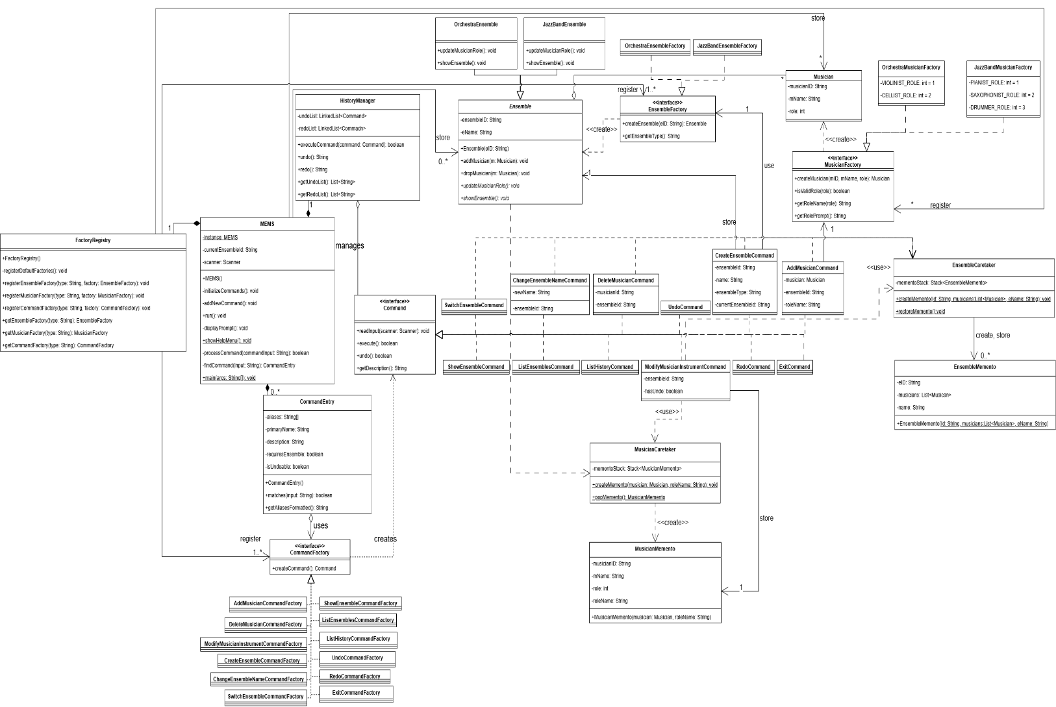
Full class diagram
This diagram is attached to the image folder as MEMS_ClassDiagram.drawio

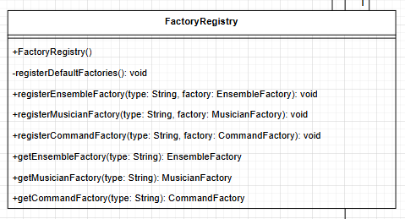
Command Part
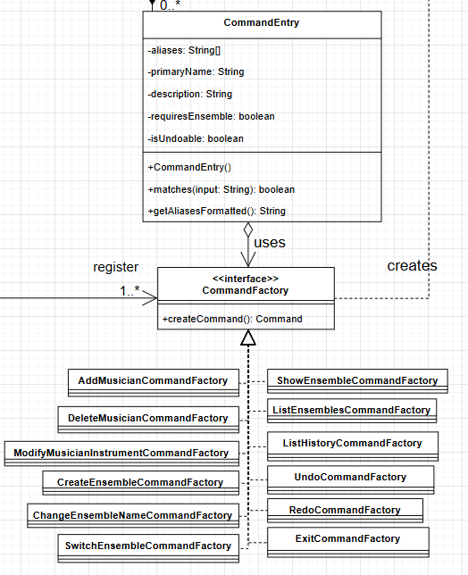
FactoryRegistry register the command Factory

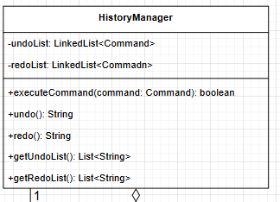
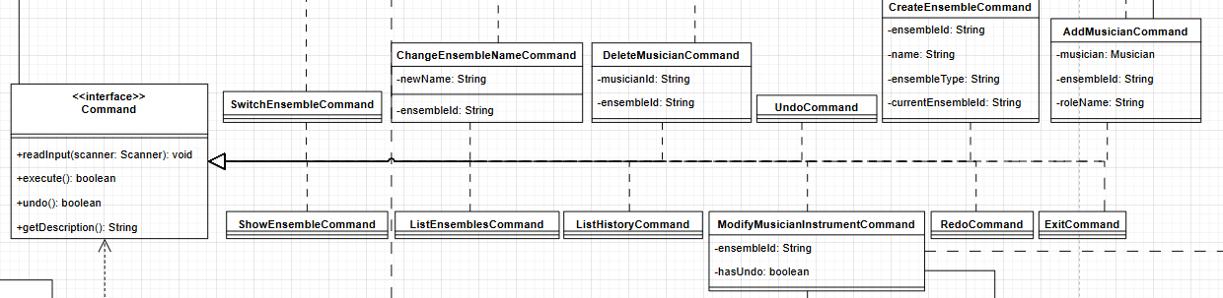
CommandEntry is a wrapper class that contains the command contains the setting of the command, like dose the command require an ensemble to work, if all setting satisfies, CommandEntry use the factory to create a command.

After the command is created, HistoryManager will call the command to prompt the user it’s require information using the readInput function, after prompting, HistoryManager will execute the command and put it to the undo LinkedList. HistoryManager is also responsible for undoing and redoing the command.

Ensemble

Musician

Discussion on Design Pattern Applied

3.1 Factory Pattern

3.2 Command Pattern

3.3 Memento Pattern

3.4 Registry Pattern

Test Plan and Test Case

Normal Operation Test

Error Handling Test

Source Code

Domain

Factory

Command

Registry

Memento

