**INSTITUTO POLITÉCNICO NACIONAL**

**ESCUELA SUPERIOR DE CÓMPUTO**

Laboratory of Fundamental Analysis of Circuits

**Practice 1: Use of the ohmmeter, voltmeter and ammeter in measurements of direct current(DC).**

**GROUP: 1CM9**

**TEAM: 12**

**MEMBERS:**

**José Carlos Hernández Rojas**

**Jesús Gustavo Vargas Pérez**

**José Emiliano Pérez Garduño**

**TEACHER: Edmundo René Durán Camarillo**

**DATE OF ELABORATION: AUGUST, 16TH**

## ***DUE DATE: AUGUST, 23TH***

**I. Theoretical Introduction.**

The current or the voltage can be measured through of ammeters or voltmeters, the figure 1 show 2 forms of meters; one of the analog meter has a measuring needle which moves through a calibrated scale whose angular deflection depends of the magnitude of the variable that it measures.

Meanwhile the another one is a digital meter which show a serie of digits on the screen, indicating the magnitude of the variable that it measures. The second figure show the voltmeter and the ammeter sybols that its used in the diagrams of electronic circuits.

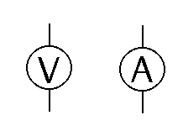

Figure 1.a) Analog Meter b)Digital Meter Figure 2. Volmeter and Ammeter symbols

To measure the current in the chase of a circuit, must open that chase and the ammeter must be connected in serie whit the element of the one which wants to know to its your current. It says that two elements are in serie if one of its extreme is connected with the extreme of another one, and doesn’t exist neither conductive is present. The current that circulate for that trajectory unavoidably go trough of the ammeter.

To measure the voltage between two points the voltmeter must be connected in parallel with the electronic device of the one which wants to know to voltage drop. Tow terminals of tow elements are connected in parallel if the terminals of one are connected whit the terminals of the another one. Doesn’t matter if in that unions are or aren’t another connection. The essential characteristic of the parallel connections is that through the elements exist the same voltage.

**Theoretical Frame:**

Ohmmeter: An ohmmeter is an electrical instrument that measures electrical resistance, the opposition to an electric current. Micro-ohmmeters (microhmmeter or microhmmeter) make low resistance measurements. Me ohmmeters (also a trademarked device Megger) measure large values of resistance. The unit of measurement for resistance is ohms

The first ohmmeters were based on a type of meter movement known as a 'radiometer'. These were similar to the galvanometer type movement encountered in later instruments, but instead of hairsprings to supply a restoring force they used conducting 'ligaments' instead. These provided no net rotational force to the movement. Also, the movement was wound with two coils. One was connected via a series resistor to the battery supply. The second was connected to the same battery supply via a second resistor and the resistor under test. The indication on the meter was proportional to the ratio of the currents through the two coils. This ratio was determined by the magnitude of the resistor under test. The advantages of this arrangement were twofold. First, the indication of the resistance was completely independent of the battery voltage (as long as it actually produced some voltage) and no zero adjustment was required. Second, although the resistance scale was nonlinear, the scale remained correct over the full deflection range.

Ammeter: An ammeter is a measuring instrument used to measure the current in a circuit. Electric currents are measured in amperes (A), hence the name. Instruments used to measure smaller currents, in the milliampere or microampere range, are designated as milliammeters or microammeters.

The relation between electric current, magnetic fields and physical forces was first noted by Hans Christian Ørsted who, in 1820, observed a compass needle was deflected from pointing north when a current flowed in an adjacent wire. The tangent galvanometer was used to measure currents using this effect, where the restoring force returning the pointer to the zero position was provided by the Earth's magnetic field. This made these instruments usable only when aligned with the Earth's field. Sensitivity of the instrument was increased by using additional turns of wire to multiply the effect – the instruments were called "multipliers".

Voltmeter: A voltmeter is an instrument used for measuring electrical potential difference between two points in an electric circuit. Analog voltmeters move a pointer across a scale in proportion to the voltage of the circuit; digital voltmeters give a numerical display of voltage by use of an analog to digital converter.

Voltmeters are made in a wide range of styles. Instruments permanently mounted in a panel are used to monitor generators or other fixed apparatus. Portable instruments, usually equipped to also measure current and resistance in the form of a multimeter, are standard test instruments used in electrical and electronics work. Any measurement that can be converted to a voltage can be displayed on a meter that is suitably calibrated; for example, pressure, temperature, flow or level in a chemical process plant.

A digital voltmeter (DVM) measures an unknown input voltage by converting the voltage to a digital value and then displays the voltage in numeric form. DVMs are usually designed around a special type of analog-to-digital converter called an integrating converter.

II. Development of the practice.

II.1 Use of the ohmmeter.

Measure the value of the resistor whitout connect them to the source voltage as it indicates in the figure 3 and complete the table.

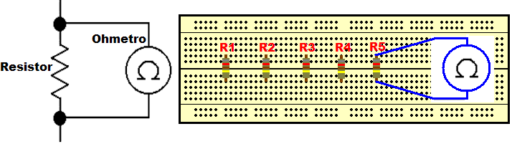

Figure 3. Ohmeter conecction.

|  |  |  |
| --- | --- | --- |
| **Resistencia** | **Medición con el óhmetro digital(Ω)** | **Valor con el código de colores(Ω)** |
| **R1** | **556** | **560** |
| **R2** | **676** | **680** |
| **R3** | **992** | **1K** |
| **R4** | **331** | **330** |

II.2 Use of the Voltmeter

the figure 4 shows how must measure the voltage in an element. Whit the source of voltage turn off, connect the circuit of the figure 5. One time assembled, turn on the source of voltage and complete the table2.

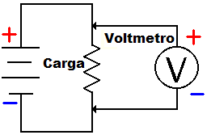

Figure 4. Example of a Voltmeter connection

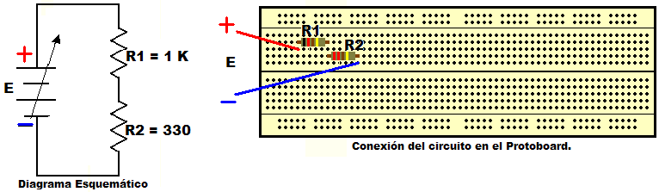

Figure 5. Circuit in Serie.

Table 2. Measures of Voltage

|  |  |  |  |
| --- | --- | --- | --- |
| **Source Voltage** | **Digital multimeter** | | |
| **Voltage in R1 y R2(Volts)** | **Voltage in R1(Volts)** | **Voltage in R2(Volts)** |
| **E=1V** | **1.033** | **0.773** | **0.259** |
| **E=2V** | **1.98** | **1.48** | **0.496** |
| **E=3V** | **2.96** | **2.226** | **0.744** |
| **E=4V** | **4.03** | **3.012** | **1.008** |
| **E=5V** | **5.00** | **3.75** | **1.251** |
| **E=6V** | **5.97** | **4.48** | **1.495** |
| **E=7V** | **7.00** | **5.25** | **1.752** |
| **E=8V** | **8.00** | **5.98** | **1.99** |
| **E=9V** | **8.92** | **6.71** | **2.23** |
| **E=10V** | **9.92** | **7.43** | **2.48** |
| **E=11V** | **10.92** | **8.18** | **2.73** |
| **E=12V** | **1.86** | **8.95** | **2.99** |

II.3 use of the Ammeter.

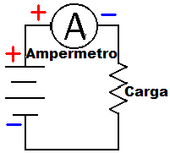The figure 6 shows how would be connected the ammeter to measure the current in one element

Figure 6. Example of Ammeter connection

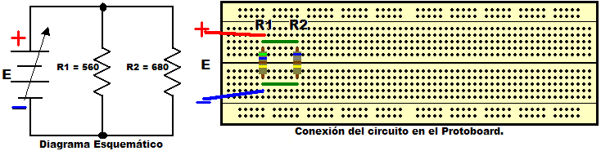

Figure 7. Circuit in Parallel

Whit the source of voltage turned off, assemble the circuit of the figure 7. One time assembled turn on the source of voltage and complete the table 3

|  |  |  |  |
| --- | --- | --- | --- |
| **VOLTAGE SOURCE** | **DIGITAL MULTIMETER** | | |
| **CURRENT TROUGH R1 y R2(mA)** | **CURRENT TROUGH R1(mA)** | **CURRENT TROUGH R2(mA)** |
| **E=1V** | **2.5** | **1.3** | **1.57** |
| **E=2V** | **6.5** | **2.6** | **3.02** |
| **E=3V** | **9.8** | **3.8** | **5.3** |
| **E=4V** | **13.00** | **5.9** | **7.1** |
| **E=5V** | **16.1** | **7.4** | **8.9** |
| **E=6V** | **19.6** | **8.9** | **10.6** |
| **E=7V** | **22.9** | **10.4** | **12.5** |
| **E=8V** | **26.0** | **11.9** | **14.2** |
| **E=9V** | **29.2** | **13.3** | **16.0** |
| **E=10V** | **32.5** | **14.9** | **17.8** |
| **E=11V** | **35.8** | **16.4** | **19.5** |
| **E=12V** | **39.12** | **17.9** | **21.34** |

Table 3. Measures of Current

III. Question list:

**Which are the characteristics of the series circuits?**

The current that flows through a circuit in serie preservs in each element in that circuit. Another difference in this kind of circuits is that the elements are interconnected by only one node

**Which are the characteristics of the parallel circuit?**

The voltage prevails in the whole circuit. Another characteristic is that the elements are interconnected by two nodes.

**Why an ammeter should not be connected in parallel?**

Because the current would flow through the ammeter and, since the ammeter has a very small resistor inside, it would get damaged.

**Why the circuit must be desenergized when measures the resistance of an electric circuit?**

Because the resistor depends on the current that flows on it. If the circuit has a voltage source turned on, then the ohmmeter measures the resistor with two currents, the circuit’s current and the ohmeter’s current, so the measurements will be wrong.

Conclusion.(José Carlos)

Personally appeared me very interesting this first practices because it is the first time that use tools as the pincers, the ammeter and voltmeter. In this practice I learn about the resistors and the parallel and series circuits, the differences between them and how to assemble them.I’m expecting this subject will be very interesting because it is the begin of the knowledge of the hardware.