Diodo Zener de 3.3V

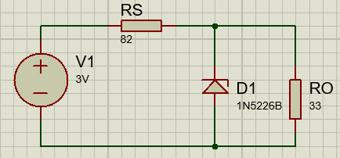

Diodo Zener de 5.1V

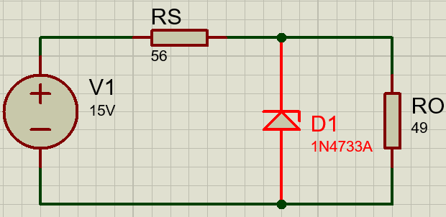

Diodo Zener de 9.0V

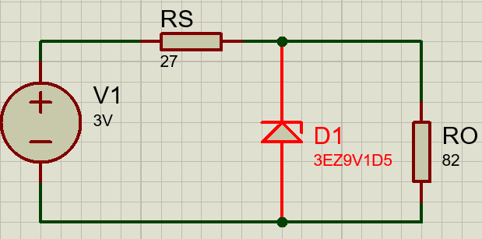

|  |  |  |  |
| --- | --- | --- | --- |
| **Voltaje de la fuente V (V)** | **Voltaje de la resistencia Ro** | | |
| **3.3V** | **5.1V** | **9.0V** |
| 3.0 | 0.86V | 1.40V | 2.26V |
| 4.0 | 1.15V | 1.87V | 3.01V |
| 5.0 | 1.43V | 2.33V | 3.76V |
| 6.0 | 1.72V | 2.80V | 4.51V |
| 7.0 | 2.01V | 3.27V | 5.27V |
| 8.0 | 2.30V | 3.73V | 6.02V |
| 9.0 | 2.58V | 4.20V | 6.77V |
| 10.0 | 2.87V | 4.67V | 7.52V |
| 11.0 | 3.15V | 5.05V | 8.28V |
| 12.0 | 3.30V | 5.16V | 9.00V |
| 13.0 | 3.37V | 5.25V | 9.21V |
| 14.0 | 3.43V | 5.33V | 9.38V |
| 15.0 | 3.49V | 5.41V | 9.52V |

**Regulador de voltaje fijo positivo:**

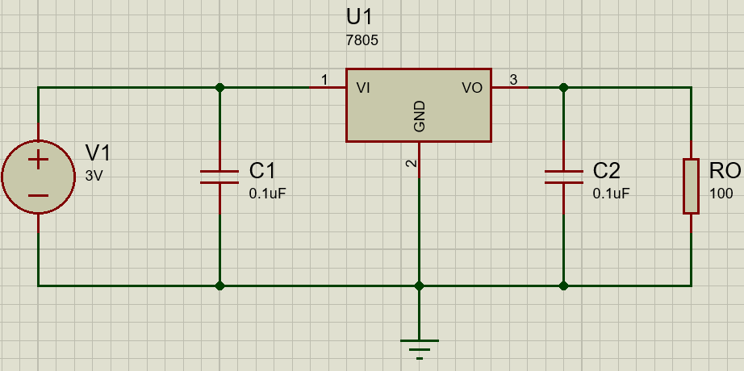

|  |  |  |
| --- | --- | --- |
| **Voltaje de la Fuente V1 (V)** | **Voltaje en la resistencia Ro** | |
| **LM7805** | **LM7812** |
| 3.0 | 1.71V | 1.71V |
| 4.0 | 2.69V | 2.69V |
| 5.0 | 3.67V | 3.67V |
| 6.0 | 4.65V | 4.65V |
| 7.0 | 5.00V | 5.0V |
| 8.0 | 5.00V | 5.0V |
| 9.0 | 5.00V | 5.0V |
| 10.0 | 5.00V | 5.0V |
| 11.0 | 5.00V | 5.0V |
| 12.0 | 5.00V | 5.0V |
| 13.0 | 5.00V | 5.0V |
| 14.0 | 5.00V | 5.0V |
| 15.0 | 5.00V | 5.0V |
| 16.0 | 5.00V | 5.0V |

**Regulador de voltaje fijo negativo**

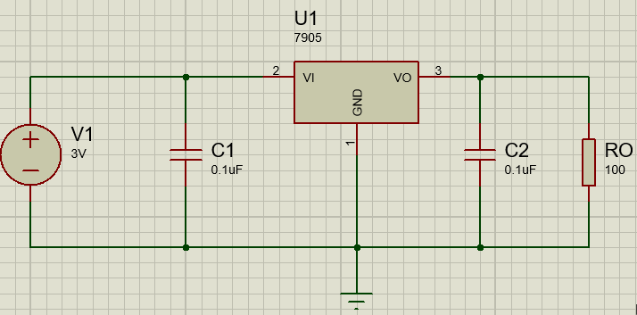

|  |  |  |
| --- | --- | --- |
| **Voltaje de la Fuente V1 (V)** | **Voltaje en la resistencia Ro** | |
| **LM7905** | **LM7912** |
| 3.0 | 0.63 | 0.52 |
| 4.0 | 0.91 | 0.75 |
| 5.0 | 1.19 | 0.99 |
| 6.0 | 1.47 | 1.22 |
| 7.0 | 1.75 | 1.45 |
| 8.0 | 2.03 | 1.68 |
| 9.0 | 2.31 | 1.92 |
| 10.0 | 2.59 | 2.15 |
| 11.0 | 2.87 | 2.39 |
| 12.0 | 3.15 | 2.62 |
| 13.0 | 3.43 | 2.85 |
| 14.0 | 3.71 | 3.09 |
| 15.0 | 3.99 | 3.32 |
| 16.0 | 4.27 | 3.55 |

**Regulador de voltaje variable positivo**

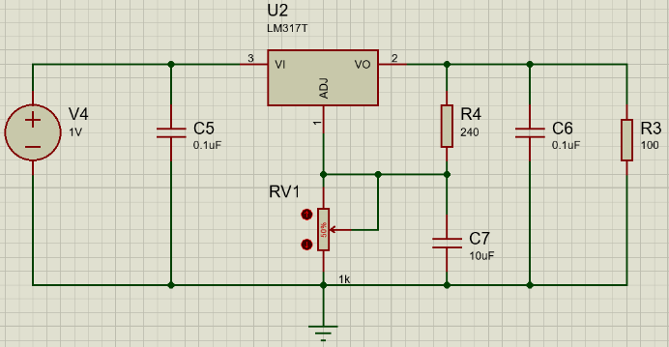

V0MAX = ___________ y V0MIN = _______________

**Regulador de voltaje variable negativo**

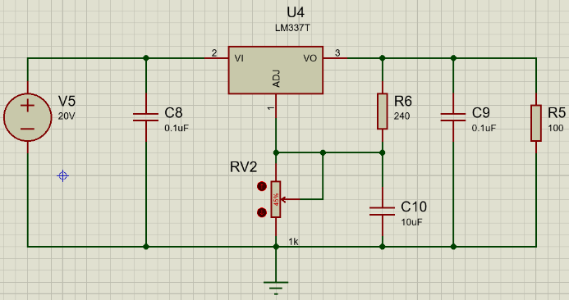

V0MAX = ___________ y V0MIN = _______________