Phase 2 - E-Commerce Application on IBM Cloud Foundry

INNOVATION PHASE

**Problem Statement**:

Build a artisanal e-Commerce platform using IBM foundry. Connect the skilled artisans with the global audience. Showcase handmade products from exquisite jewellry to artistic home decor. Implement secure shopping carts, smooth payment gateway and an intuitive checkout process. Nurture creativity and support small business through an artisan's dream marketplace.

**Personalised recommendation:**

Personalized recommendations, often powered by recommendation algorithms or artificial intelligence, play a critical role in enhancing the user experience in e-commerce applications. These recommendations are tailored to individual users, taking into account their preferences, behavior, and history on the platform. Here's a more detailed explanation of personalized recommendations:

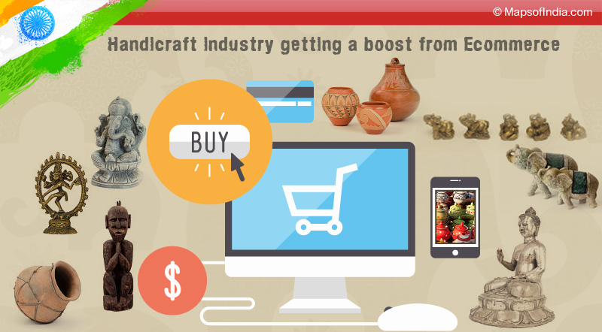

**1. Data Collection:**

* The process begins with the *collection of user data*. This includes a wide range of information such as user demographics, past purchases, search history, products viewed, time spent on the platform, and more. The data can also extend to external sources, like social media profiles or user-generated content.

**2. User Profiling:**

* Based on the collected data, the system creates user profiles. These profiles are essentially digital representations of individual users, encapsulating their preferences, interests, and behavior patterns. For example, the system may identify a user as someone interested in high-end fashion and electronics.

**3. Content Analysis:**

* In content-based filtering, the system analyzes product attributes or characteristics. For instance, if the e-commerce platform is selling clothing, the system will examine details like color, size, brand, style, and material. This analysis helps create a profile for each product.

**4. Collaborative Filtering:**

* Collaborative filtering looks at user behavior and preferences. It identifies users who have similar tastes and suggests products that others with similar profiles have liked or interacted with.

**5. Hybrid Approaches:**

* Many modern recommendation systems use a combination of algorithms. For instance, a hybrid approach might combine collaborative filtering with content-based filtering, providing more accurate and diverse recommendations.

**Wishlist**

A wishlist is a feature commonly found in e-commerce applications and online shopping platforms. It allows users to create a personalized list of products they are interested in but may not be ready to purchase immediately. Here's a detailed explanation of wishlists and their significance:

**1. User interest:**

* Wishlists are a tool for increasing user engagement on an e-commerce platform. They provide users with a way to interact with the website beyond just browsing and purchasing.

**2. Product Noting:**

* Think of a wishlist as a digital bookmark for products. Users can add items they like, aspire to buy, or are considering for future purchases. This saves them from having to search for those products all over again.

**3. Enhanced Shopping Experience:**

* Users appreciate the convenience of wishlists. Instead of having to remember product names or sift through their browsing history, they can quickly access their saved items in one place.

**4. Comparison and Decision-Making:**

* Users often add multiple similar products to their wishlist. This feature enables them to compare items side by side, aiding in the decision-making process. So this will be helpful to the user to get better product and decide which is suitable and satisfy their needs.

**5. Push Notifications:**

* E-commerce platforms can send notifications to users when items on their wishlist go on sale, have limited availability, or are back in stock. This nudges users to complete their purchases.
* Push notifications major role to buy a product if the user left the product int the wishlist for long time then this push notification is helpful to remind them about the product. So the user can buy it.

**6. Gifting:**

* Wishlists are often used as gift registries. Users can share their wishlist with friends and family, making it easier for loved ones to choose appropriate gifts.

Sometimes it helps to present the best gifts to the people.

**7. Abandonment Recovery:**

* For users who abandon their shopping carts, e-commerce platforms can send reminders about the items left behind, potentially motivating users to complete the purchase.

**8. Social Sharing:**

* Some platforms allow users to share their wishlists on social media, enhancing product visibility and potentially driving traffic to the platform. The user can share the products to their groups, friends, family, wherever they need so the another people can also view the product and had chances to buy thohs

**9. Adding and Removing Items:**

* Users can easily add or remove items from their wishlist, giving them full control over the products they wish to track.

Wishlists are a valuable feature in e-commerce applications, offering users a convenient way to save and track products of interest. They enhance user engagement, provide a personalized shopping experience, aid in decision-making, and contribute to both customer and platform insights. Wishlists not only benefit users but also play a role in boosting sales and improving the overall user experience.

**Product review:**

Product reviews are a fundamental component of e-commerce platforms and online shopping. They are written assessments or evaluations by customers who have purchased and used a specific product. These reviews offer insights, feedback, and opinions about the product's performance, quality, and overall user experience. Here's a detailed explanation of the significance and role of product reviews in e-commerce:

**1. User-Created Content:**

* Product reviews are a form of user-generated content. They provide an authentic and unbiased perspective on a product, making them a valuable source of information for potential buyers.

**2. Transparency and Trust:**

* Reviews contribute to the transparency of the e-commerce platform. Customers can read about the experiences of others before making a purchase decision. This transparency builds trust in the platform and the products it offers. Trust reviews of the other person can make clear the doubt of the products so well.

**3. Informed Decision-Making:**

* Shoppers rely on product reviews to make informed decisions. Reviews can highlight both positive and negative aspects of a product, allowing potential buyers to assess whether it meets their needs and expectations. By the user reviews the buyer can get the idea to whether the product is good to buy or not.

**4. Quality Assurance:**

* Product reviews are a quality assurance mechanism. They serve as a check on the product's performance and accuracy of product descriptions provided by the platform.

**5. Peer Recommendations:**

* Customers tend to trust peer recommendations more than marketing messages. Positive reviews from fellow customers act as endorsements, increasing the likelihood of a purchase.

**6. SEO and Discoverability:**

* Product reviews, when properly structured, can improve the search engine optimization (SEO) of the platform. Reviews can contain keywords that potential customers may use in their searches. Keywords can help the user to get the more wished product and related items to the feed.

**7. Improving Customer Satisfaction:**

* Sellers can respond to reviews, addressing any issues or concerns raised by customers. This responsiveness can lead to improved customer satisfaction and loyalty.

**8. Star Ratings:**



* Alongside written reviews, star ratings are a quick way for customers to assess a product's overall quality. Higher ratings can boost a product's visibility and sales. Star rating are pictorial representation so user and the admin can get the review about the product easily.

**9. Filtered Reviews:**

- Many e-commerce platforms allow users to filter reviews based on criteria such as the most recent, most helpful, or highest-rated reviews, helping them find the information they need more easily.

**Flowchart for implementing:**

The above given problem statement can be implemented or the problem can be solved as per the idea given in the previous phase. The ideas is represented through flowchart. By following this flowchart the application can be created easily.

start

User

Admin

Register

Login

nn

login

Search item

Add item category

Online pay

Payment

Wish

list

buy

stop

Review

Logout

Order placed

COD

View item

Report

Add product

Check feedback

Manage order

Manage payment