TITLE
Subtitle or Project Name

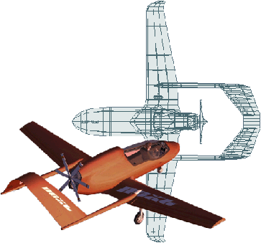…use a pretty graphic!

Submitted To:
CUSTOMER NAME

BY

AUTHOR
COMPANY NAME
ADDRESS

1 December 2007

Approved by:

Big Boss’ Signature

EXECUTIVE SUMMARY

(< 1 page)

(YOUR COMPANY’S NAME) is pleased to present its final report for……

Executive Summary - Must be able to stand alone! Many will only see this.
- What was done
- Why/how
- Key Results
(Use pictures, so upper management can understand it!)
- DO NOT "cut & paste" executive summary from body of report-
restate it freshly!
(If the report is for a contract (or a class), make it VERY clear up here that the contracted/assigned work was all completed. Don't make them hunt to see if you did the job. This isn't a novel - no extra points for a surprise ending!)

Notes Concerning This File:
- This document is copyright (don’t get rich selling it to others!) but you are welcome to use it as a starting point for your report. You may wish to open the File Properties to change the Summary information.
- When making new Headings and when inserting figures, it is easiest to copy an existing one, paste it in, and modify it. This allows you to:
- Right-Click on the Table of Contents and List of Figures to update their information.

Some Friendly Suggestions for Report Authors:
- Use Standard English, which does not include regional slang (“soda pop”) or text-messaging slang (“4” instead of “for”). Avoid even the mildest of swear words.
- All abbreviations and Greek characters should be listed in the Nomenclature section.
- Check spelling and grammar, and learn the common grammar mistakes that make you look like an idiot (its / it’s, that / which, who’s / whose, and a few dozen others).
- Try to avoid the sexism built into our language (designers aren’t always a “he”).
- Pick then keep a consistent “voice”. If writing in the third person (the design was created using….) don’t switch to first person (then I analyzed it…..). Most technical reports are written exclusively in the third person, but there is no hard rule.
- Convert your reports into PDF format (I use PDF995) so that what you see is what they see. PDF is usually smaller and this also makes it harder for someone to steal your text!

TABLE OF CONTENTS

EXECUTIVE SUMMARY ii
TABLE OF CONTENTS iii
LIST OF FIGURES iv
NOMENCLATURE v
1. INTRODUCTION 1
2. BACKGROUND 1
3. STATEMENT OF THE PROBLEM 1
4. APPROACH 2
5. RESULTS (or specific titles) 3
6. SUMMARY & CONCLUSIONS 6
APPENDICES 7
REFERENCES 7

LIST OF FIGURES

figure 1. Vehicle Arrangement Three-View 3
figure 2. Design Data 4
figure 3. Aero (L/D) 4
figure 4. Weights 5

NOMENCLATURE

A = Aspect Ratio (span²/reference area, applied to wings and tails)
C_{L} = Wing Lift Coefficient
CAD = Computer-Aided Design
CFD = Computational Fluid Dynamics
cg = Center of Gravity (mass)
DATCOM = Data Compendium (USAF aerodynamics methodology report)
L/D = Lift-to-Drag Ratio
M = Mach Number
RDS = Aerospace vehicle design software (product of Conceptual Research Corp.)
T/W = Thrust-to-weight ratio
W/S = Wing loading (weight/area)
W_{e} = Empty Weight
VL = Vertical Landing

INTRODUCTION
(< 1 page)

(YOUR COMPANY’S NAME) has completed its contracted effort for…

Introduction must be written as if the Executive Summary is NOT there!)
- What was done/when
- Who/for whom
- Value of results (use)

BACKGROUND
(1/2 to 4 pages)

There are many aircraft missions calling for…..

Background presents more detail on why the study was done, what else is going on that affects what you will show, defines context, sets the stage, etc…

This section should get them interested enough to read the rest!

STATEMENT OF THE PROBLEM
(1/2 to 2 pages)

The fundamental problem addressed by this research study is the technical means for allowing an aircraft to…..

The Statement of Problem should obviously follow from material in the background section, and specifically defines and limits the “scope" of the effort.

APPROACH
(1 to 10 pages)

The overall project approach is described in this section…………..

Air vehicle analysis was done using the methods of Raymer …

The Approach section should give a clear and repeatable description of how you tackled the problem, with enough information for a knowledgeable person to reproduce the results you are about to present. This should include the assumptions used, the tools and methods, the steps of the research or study, etc… This may be broken out by task.

Alternatively, there can be an Approach subsection beginning each section of the RESULTS.

RESULTS (or specific titles)
(2 to 10 pages)

The Results Section is the main “meat” of the report, presenting the actual findings, significant output of tests or calculations and other analysis. This MUST be readable, not pages of computer output (those go in the Appendices). Use a lot of pictures! Results should include problems encountered, believability of results, and accuracy estimates, if suitable.

The Results section can be broken into several sections if that makes more sense for the type of work being reported. In reporting on vehicle design studies I usually have separate sections titled System Requirements, Design Concept, Design Analysis, and Cost-Effectiveness (or something similar). Or, those could be subheadings as follows:

Task 1: System Requirements
Requirements for this system were defined by…..

Task 2: Design Concept
From these requirements, an initial design concept was prepared as shown in figure…..

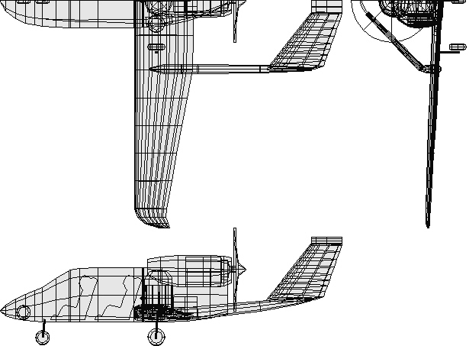

- Vehicle Arrangement Three-View

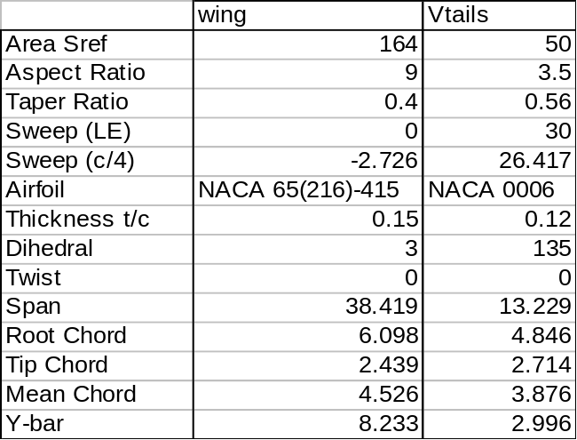

- Design Data

Task 3: Design Analysis

The vehicle design was analyzed using the methods of …

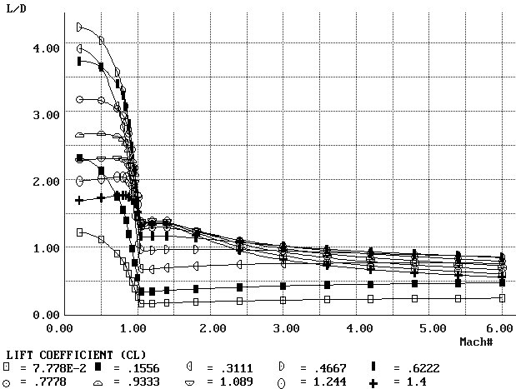

- Aero (L/D)

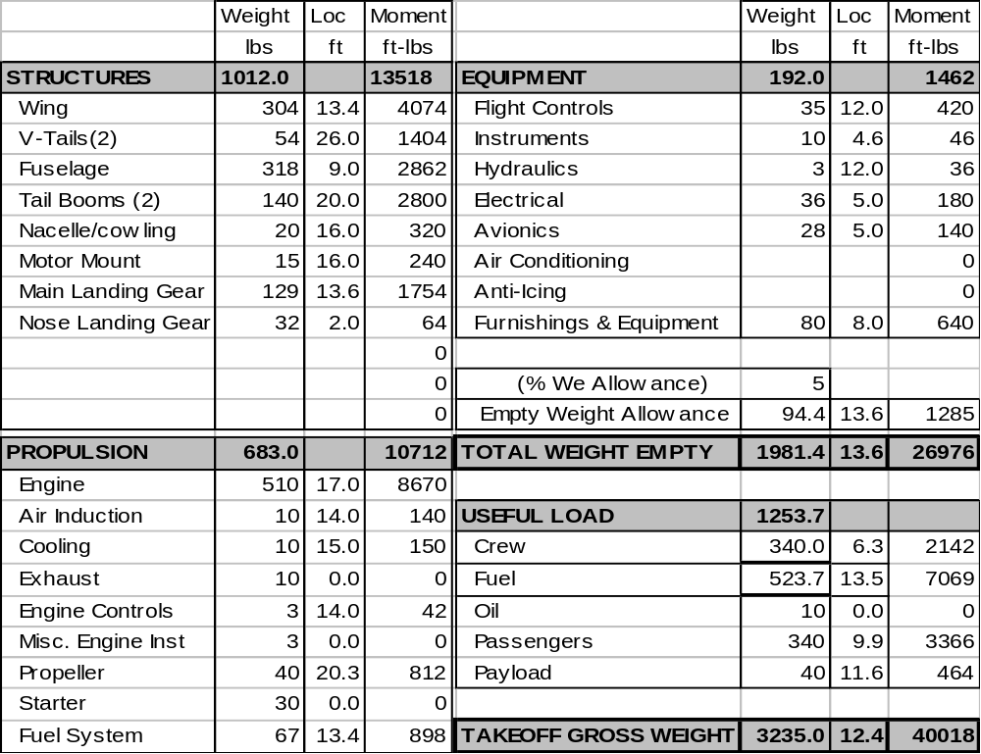

- Weights

Task 4: Cost-Effectiveness

Cost was estimated using……

SUMMARY & CONCLUSIONS
(1/2 to 2 pages)

(YOUR COMPANY’S NAME) has completed its contracted effort for ….

If they have read this far, the Summary and Conclusions section tells them what to believe and remember from all you’ve presented. It should briefly restate the background and problem, then lead them through the approach and technical results you found. Then, it should clearly state what you think they should conclude as a result, such as “this project is feasible and affordable” (but don’t use that cliché phrase!). Keep it short – if you can get them to remember two things about your study for six months afterwards, you are doing good!

Do not use prior text here – cut-and-paste is not your friend. You should never present new or additional information including graphics in this section, but I often throw in a pretty picture at the end, such as…...

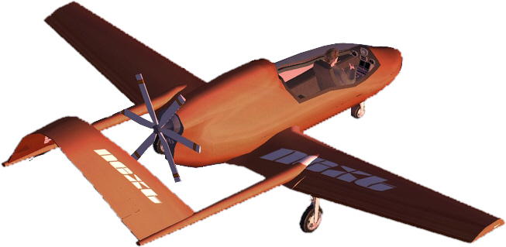

APPENDICES

Rest of the tables/graphs, Computer Listings, whatever…
Appendices can be before or after References.

REFERENCES

Raymer, D., AIRCRAFT DESIGN: A Conceptual Approach, American Institute of Aeronautics and Astronautics, Washington, D.C., Fourth Edition 2006

