SQL Database Project: Flight Management Airlines, Bookings and Tickets Database
Nnaemeka Emmanuel Akubuo | Student ID: 25022069 | Synthetic flight booking database (SQLite) | Individual report
1. Overview
The data is for an imaginary flight booking system: 6 airlines, 20 airports, 36 aircraft, 60 routes, 4,000 flights in 2026, 4,000 passengers, 3,500 bookings, 9,381 tickets and 14,285 extra services bought with them. It has 10 related tables, 61 columns and 35,296 rows, plus two views. 5 tables exceed the 1,000-row requirement: ticket_extras (14,285), tickets (9,381), flights (4,000), passengers (4,000) and bookings (3,500). All four scales of measurement are covered (Section 3). The database is a SQLite file named Flight_management_system.db of about 2.8 MB, built by the SQL script Flight_management_system_script.sql.
2. How the data was generated
The data was created by one SQL script (Section 6) that runs directly in SQLite, with no other language and no external data. It drops and recreates every table, inserts the fixed reference data, builds temporary staging tables with recursive common table expressions and SQLite's random() function (SQLite, n.d.b), fills the main tables from them, and then drops the staging tables so that only the final tables, indexes and views remain. Airlines, passengers and bookings are fictional; the real-world knowledge used is general: airline-style two-letter codes, real airport codes and cities with their UTC offsets, common aircraft models and approximate distances. Tables are created and filled in dependency order, so each foreign key refers to an existing row. random() cannot be seeded, so running the script again builds a database with the same structure and rules but different values; the supplied .db file is the output of one run, and all counts in this report come from it.
Reference data. The 6 airlines (SkyBridge Airways, Meridian Air, Nimbus Airlines, Falcon Express, Aurora Airways and Pelican Air) are fictional, with a real country each. The 20 airports are real and carry a size category and a UTC offset; 30 city pairs make 60 directional routes with a distance in km. Each airline owns six of the 36 aircraft, from six models (Boeing 737-800, 787-9 and 777-300ER, Airbus A320, A321 and A350-900), and each aircraft has a unique registration and a seat capacity that matches its model. There are 8 extra services with a list price (extra baggage, priority boarding, seat selection, in-flight meal, lounge access, travel insurance, Wi-Fi and fast-track security). Flights (4,000). Dates run from 2026-01-01 to 2026-12-31, with more flights on popular routes, and each flight uses an aircraft whose airline serves the route. Duration follows the distance (36 to 833 minutes). Flights up to the study date of 31 October 2026 are mostly Arrived; about 3% are Cancelled (95), and the 623 later ones are Scheduled. Only Arrived flights have a delay: 55.2% leave on time and the mean delay is 23.0 minutes (maximum 238).
Passengers (4,000). About 10% are children aged 2 to 15 (367 passengers) and the rest are adults; 12 nationalities, 1,952 female, 2,013 male and 35 other. Loyalty tiers are 2,562 Standard, 770 Silver, 436 Gold and 232 Platinum (children are always Standard). Emails take the form first.last<n>@example.com; example.com is reserved for documentation by RFC 2606 (Eastlake and Panitz, 1999), so none can belong to a real person. Bookings (3,500). A booking is one trip made by a booker (2,216 different passengers, at most 7 bookings each), dated 2025-06-24 to 2026-10-31: 1,979 round-trip and 1,521 one-way, through the website (1,615), mobile app (1,197), travel agent (471) or call centre (217), and paid by card, PayPal, digital wallet or bank transfer. The booker's party has one to four passengers; companions share the booker's last name, and the booking is placed on average 73 days before departure.
Tickets (9,381) and extras. Each ticket joins one passenger to one flight under a booking, with a mean of 2.68 tickets and a maximum of 8 per booking. The fare is calculated as (35 + 0.09 × km) × a class multiplier (1.0, 1.6, 3.0 and 5.0 for Economy to First) × an advance-purchase factor (1.4 for last-minute bookings down to 0.85 for early ones) × 0.75 for children × random noise, so the mean fare is 322.27 in Economy, 505.24 in Premium Economy, 979.34 in Business and 1430.69 in First (6,842, 1,174, 1,076 and 289 tickets); Gold and Platinum members choose higher classes more often. Business and First passengers check at least one bag, and meal preference is mostly Standard with some Vegetarian, Halal, Gluten-free, Vegan and Kosher. 7,222 tickets include at least one extra (price_paid is the price at the time of sale), and some extras are bought together on purpose: priority boarding with fast-track security (918 tickets), extra baggage with travel insurance (884), seat selection with an in-flight meal (665) and lounge access with fast-track security (610), giving association analysis something to find.
Satisfaction scores exist only for Arrived flights (7,860 tickets), with about 40% giving no reply (3,157 NULLs), and they fall as delays grow: average 3.71 on time, 3.48 for delays up to 45 minutes, 3.04 for 46 to 120 and 2.33 over 120. Validation. The integrity check returns ok and the foreign-key check finds 0 violations; there are no tickets on cancelled flights (0), no booking dated after its flight (0), no passenger travelling before birth (0), no flight above its aircraft's seat capacity (0) and no booking without tickets (0). 1,198 flights have no tickets, which is acceptable because only 3,500 bookings are spread over 4,000 flights.
3. Database schema
The schema has 10 tables and 11 foreign keys (Figure 1). Airlines own aircraft, and airports are the two ends of each route; a flight is one dated run of a route on an aircraft. Passengers make bookings and are the people on tickets, so tickets resolve the many-to-many link between flights and passengers with the compound key (flight_id, passenger_id) and also belong to a booking. ticket_extras resolves the many-to-many link between a ticket and an extra with (flight_id, passenger_id, extra_id), a compound foreign key to tickets. Two views calculate values instead of storing them: flight_overview (route names and local arrival time) and booking_totals (tickets, fares, extras and total paid per booking). The four scales of measurement covered are listed in Table 1. Dates are ISO-8601 text.
Table 1: Measurement scales covered
Scale | Columns
Nominal | airline_name, iata_code, country, registration, model, body_type, airport_name, city, airport_size, flight_number, status, first_name, last_name, gender, nationality, email, booking_reference, booking_channel, payment_method, trip_type, meal_preference, extra_name
Ordinal | seat_class (Economy < Premium Economy < Business < First), loyalty_tier (Standard < Silver < Gold < Platinum), satisfaction_score (1 to 5)
Interval | founded_year, manufacture_year, utc_offset_hours, date_of_birth, booking_date, departure_datetime, arrival_local (ISO-8601 text and calendar years; zero is arbitrary)
Ratio | distance_km, seat_capacity, duration_minutes, delay_minutes, fare_paid, checked_bags, price, price_paid; view columns tickets, fares, extras, total_paid

Figure 1: Entity relationship diagram: 10 tables, 61 columns, compound keys marked.
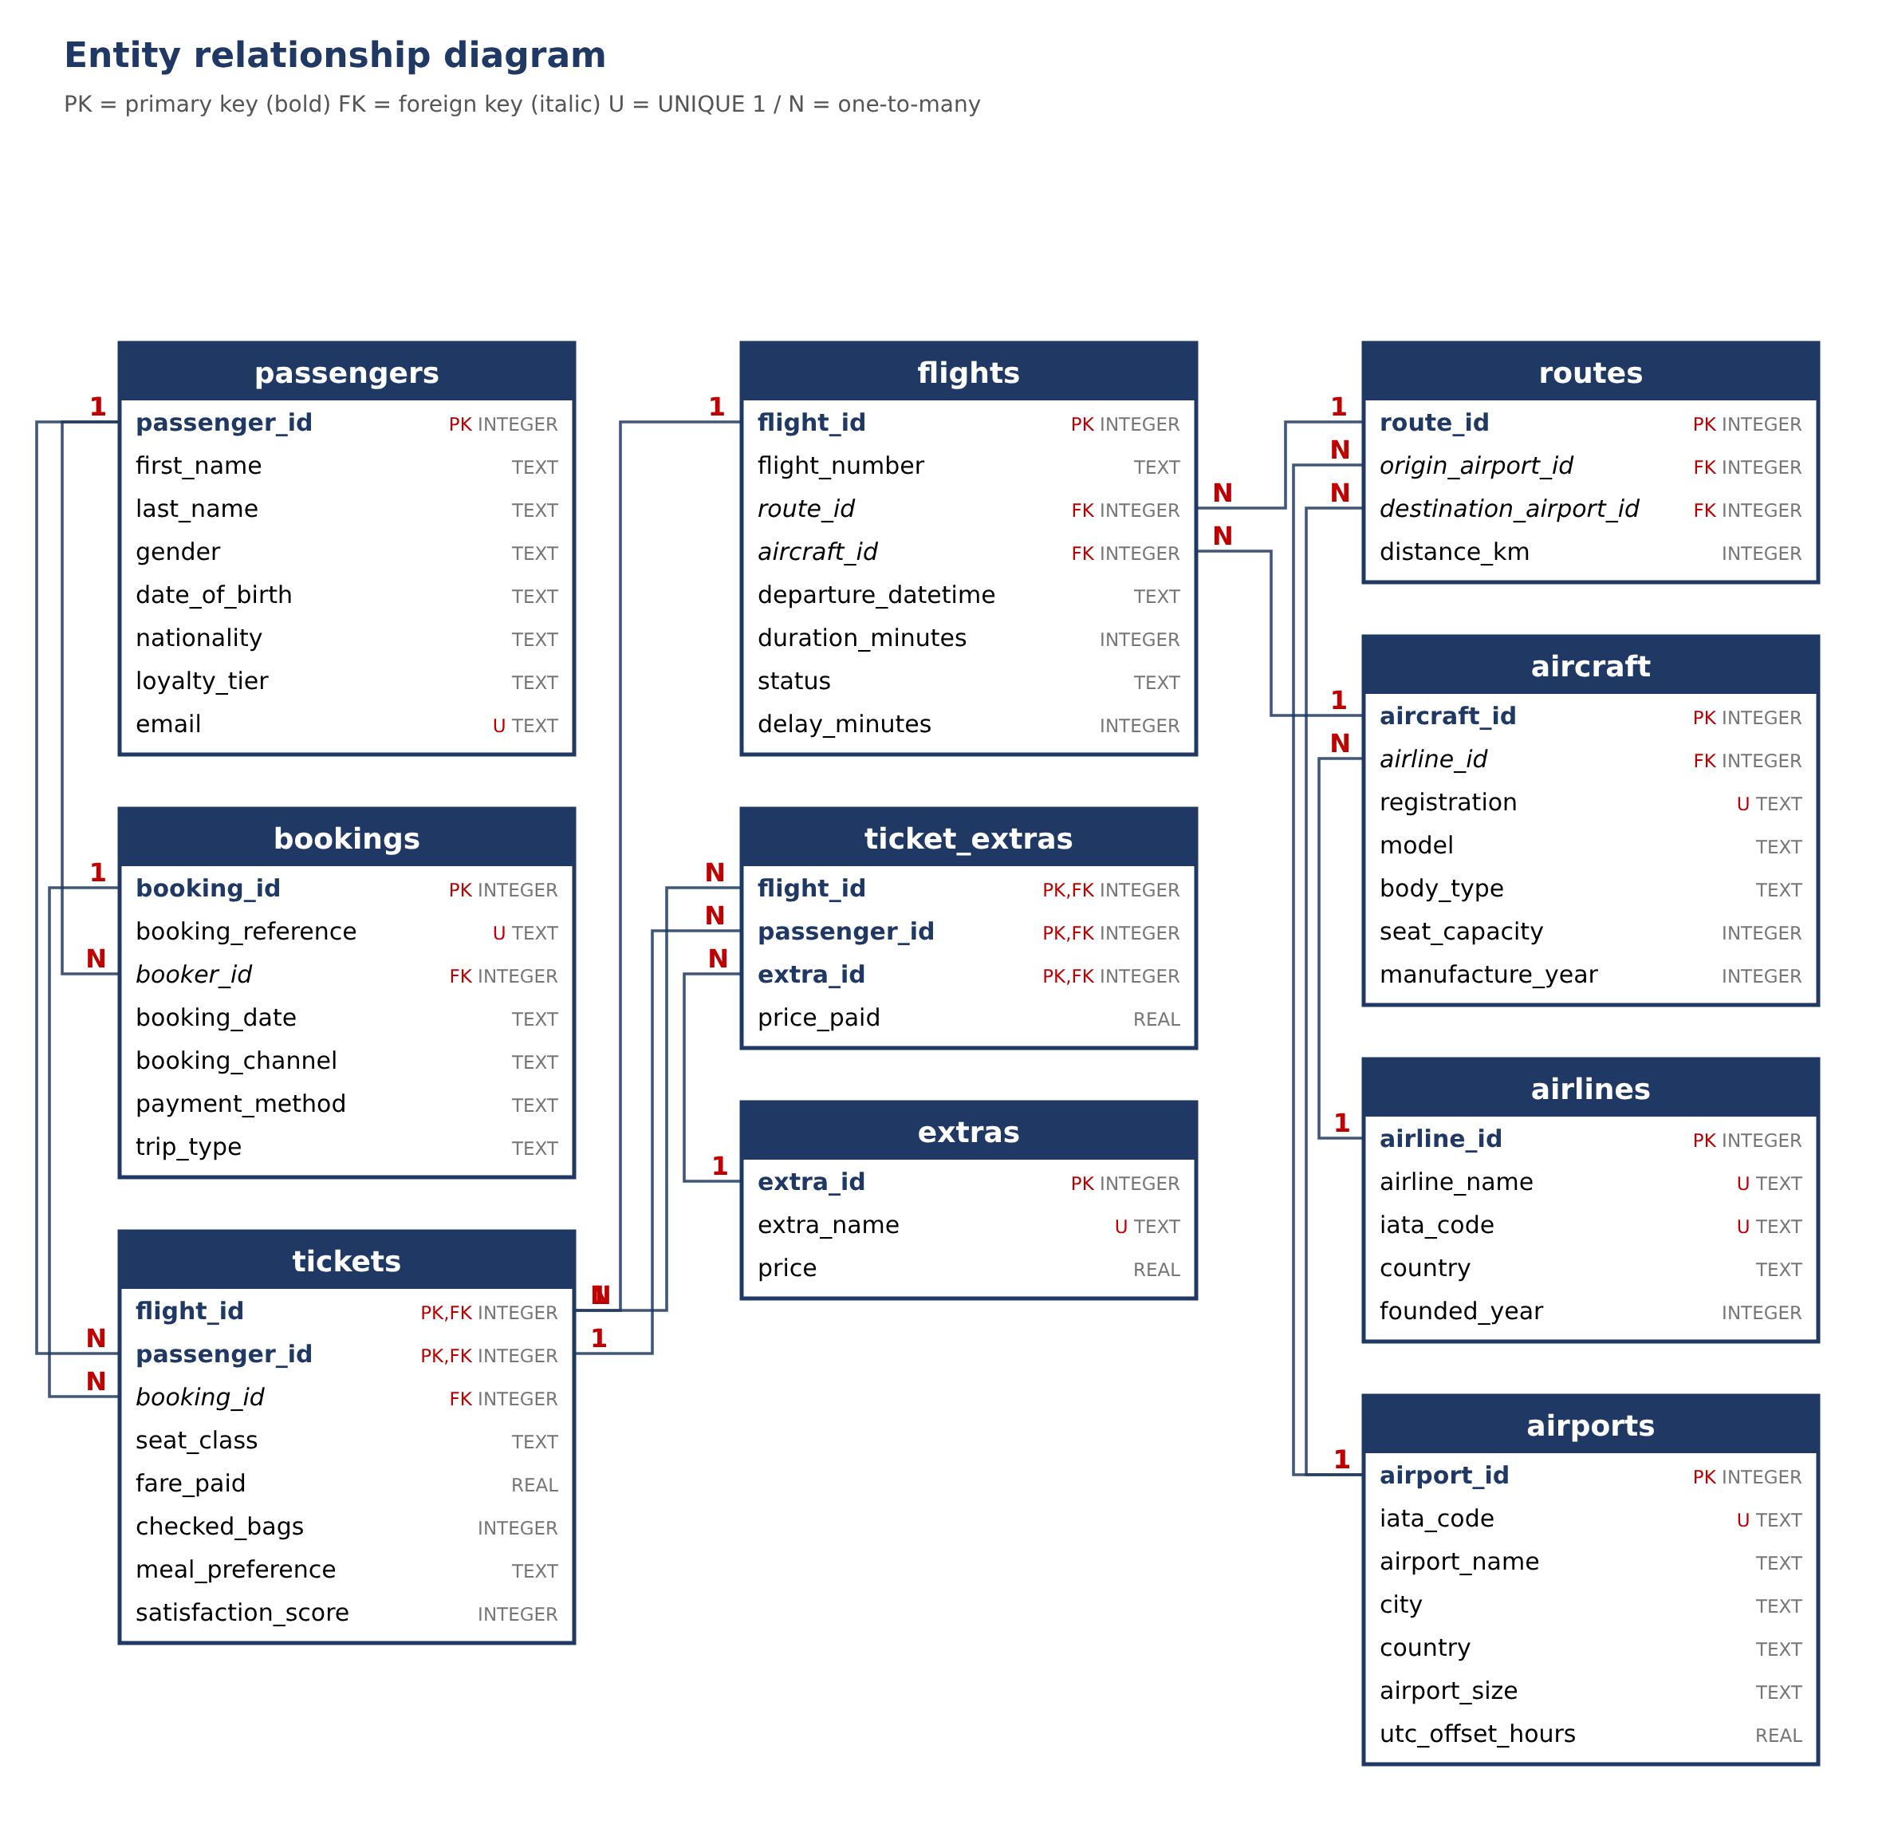
4. Justification for separate tables and constraints
Table 2: Tables, rows and reasons
Table | Rows | Reason for a separate table
airlines | 6 | Name, code, country and founding year stored once; aircraft refer to them.
airports | 20 | Code, city, country, size and UTC offset stored once; used by both ends of every route.
aircraft | 36 | Registration, model and capacity belong to the aircraft, not to each flight; one airline owns many aircraft.
routes | 60 | Origin, destination and distance stored once per directional pair (UNIQUE), shared by many flights.
flights | 4,000 | One dated run of a route on an aircraft, with duration, status and delay.
passengers | 4,000 | Personal details stored once; a person can fly and book many times. No address, phone or passport is kept.
bookings | 3,500 | One trip by a booker: reference, date, channel, payment and trip type, shared by all its tickets.
tickets | 9,381 | Resolves flights and passengers (many-to-many). Compound key (flight_id, passenger_id); holds class, fare, bags, meal, score.
extras | 8 | Service name and list price stored once, so a price change is made in one place.
ticket_extras | 14,285 | A ticket can have several extras. Compound key (flight_id, passenger_id, extra_id); holds price_paid.

Constraints. SQLite enforces foreign keys only when PRAGMA foreign_keys = ON is set (SQLite, n.d.a); the script sets it on the first line. Every table has a primary key and required fields are NOT NULL. UNIQUE constraints cover airline_name, the IATA codes, aircraft registration, (origin, destination) on routes, passenger email, booking_reference and extra_name; a passenger also cannot hold two tickets for the same flight because of the compound key. CHECK constraints limit value lists (airport size, status, gender, loyalty tier, booking channel, payment method, trip type, seat class, meal) and ranges (distance, capacity, delay, fare above zero, bags 0 to 3, satisfaction 1 to 5). Two row-level rules link columns: origin and destination must differ, and only an Arrived flight may have a delay. NULLs are used only where a value does not apply: delay_minutes (flights that have not arrived) and satisfaction_score (no reply or no completed flight). 8 indexes speed up the common joins (flights by route and date, tickets by booking, and the other foreign keys). The separation follows the relational model (Codd, 1970).
5. Ethical and data privacy discussion
Synthetic data. No real airline, passenger or booking is represented, so there is no consent or re-identification issue; names are assembled from lists, emails use the reserved example.com domain, and any match with a real person is a coincidence. The airports and aircraft models are real names, but the flights, fares and delays are simulated, so the data must not be used as evidence about any real airline's punctuality or prices.
The design is realistic on purpose. A real copy would hold personal data under the UK GDPR and the Data Protection Act 2018 (legislation.gov.uk, 2018): names, birth dates, travel history and payment method together reveal where people were and with whom, so it would need a lawful basis, strict access control, secure storage, retention limits and pseudonymised identifiers for analysis. The schema limits exposure by storing no address, phone number, passport number or card details, and by keeping only the payment method type.
Re-identification and fairness. A combination of nationality, birth date, gender and flight could single out a passenger, so published results would be aggregated and small groups removed. A model trained on data like this (for example dynamic pricing or upgrade offers) could treat passengers unfairly by age, nationality or loyalty tier, and satisfaction scores depend on delays that passengers do not control, so any use would need review by a person. Limits of realism. The distributions are my assumptions, not airline statistics: there are no connecting itineraries, seat numbers, refunds, no-shows, weather or crew data, fares follow one formula, and most bookings sit on a single flight. The database demonstrates technique and does not reflect any real airline.
6. Code
The whole database is built by Flight_management_system_script.sql (about 608 lines, supplied with this report), with comments where a design decision needs explaining. Running it in SQLite creates Flight_management_system.db and finishes with the integrity and foreign-key checks. Example finding: tickets on flights delayed over 120 minutes have a much lower average satisfaction score (2.33) than those on time (3.71), found by grouping the tickets table by delay band.
GitHub repository: https://github.com/Emm-001/SQL-db
7. Evidence: first rows of each table, opened in VS Code
Figures 2 to 11 are screenshots of Flight_management_system.db opened in Visual Studio Code with the SQLite Viewer extension, showing the first rows of each table; the row count appears at the top of each view.
Figure 2: tickets (9,381 rows)  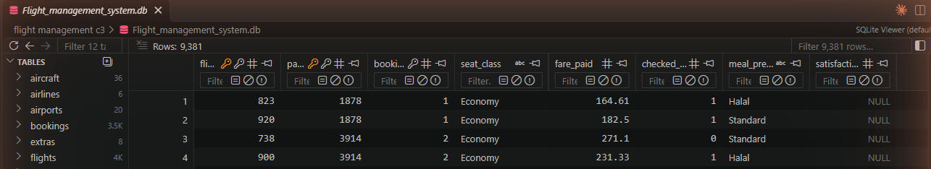 | Figure 3: ticket_extras (14,285 rows)  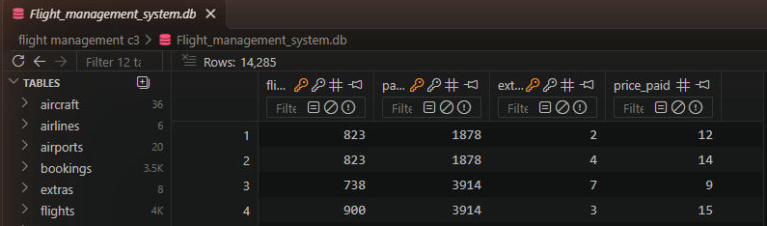
Figure 4: flights (4,000 rows)  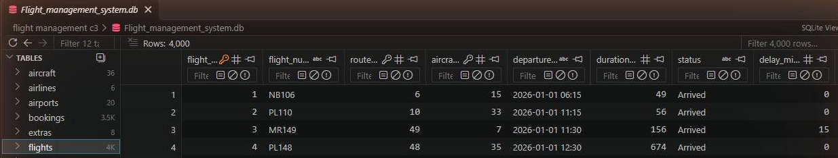 | Figure 5: passengers (4,000 rows)  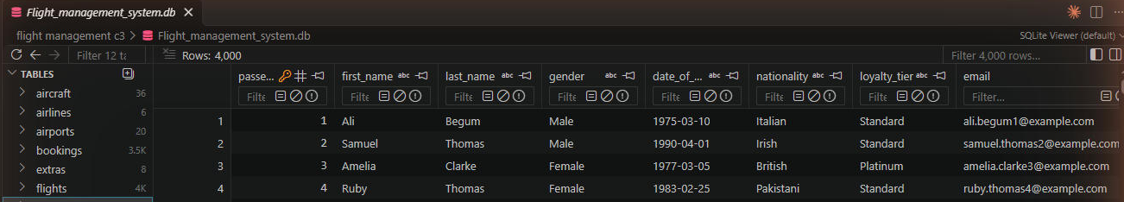
Figure 6: bookings (3,500 rows)  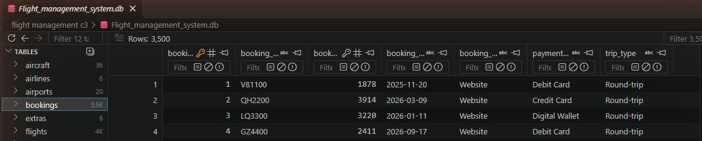 | Figure 7: routes (60 rows)  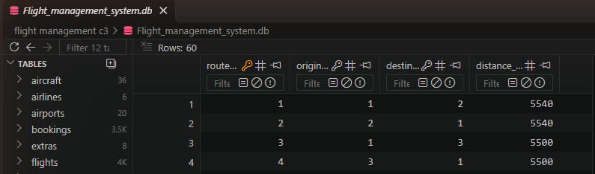
Figure 8: aircraft (36 rows)  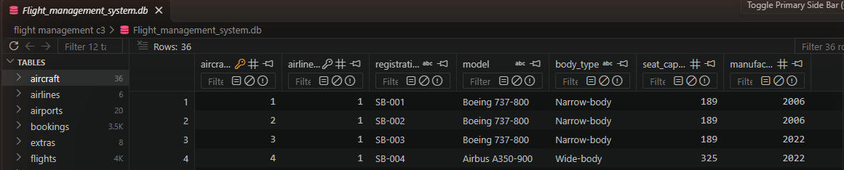 | Figure 9: airports (20 rows)  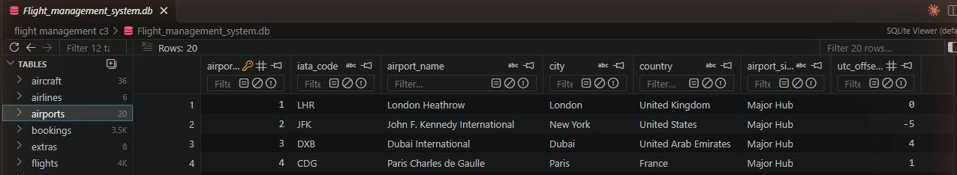
Figure 10: airlines (6 rows)  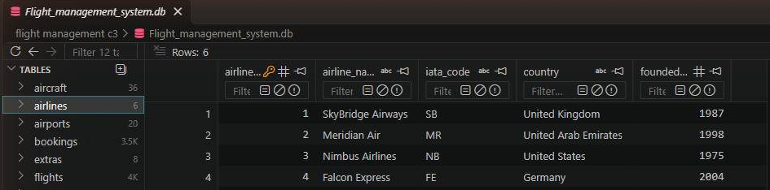 | Figure 11: extras (8 rows)  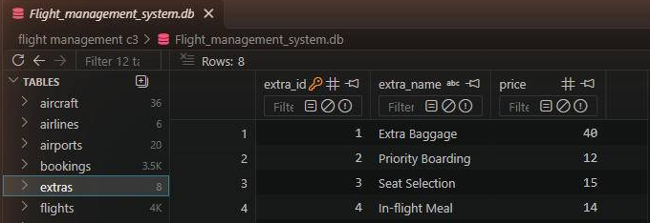
References
Codd, E.F. (1970) 'A relational model of data for large shared data banks', Communications of the ACM, 13(6), pp. 377-387.
Eastlake, D. and Panitz, A. (1999) RFC 2606: Reserved top level DNS names. Internet Engineering Task Force. Available at: https://www.rfc-editor.org/rfc/rfc2606 (Accessed: 5 November 2026).
legislation.gov.uk (2018) Data Protection Act 2018. Available at: https://www.legislation.gov.uk/ukpga/2018/12/contents (Accessed: 5 November 2026).
SQLite (n.d.a) SQLite foreign key support. Available at: https://www.sqlite.org/foreignkeys.html (Accessed: 5 November 2026).
SQLite (n.d.b) Built-in scalar SQL functions: random(). Available at: https://www.sqlite.org/lang_corefunc.html (Accessed: 5 November 2026).
Stevens, S.S. (1946) 'On the theory of scales of measurement', Science, 103(2684), pp. 677-680.

