Association Rule Learning
Groceries Dataset — Market Basket Analysis
Emmanuel Manzi
September 2026

Question 1: Understand the Data
a. The Groceries dataset contains 9,835 transactions.
b. The dataset includes 169 different grocery items.
c. The 10 most frequently purchased items are shown below, ranked by the number of transactions in which they appear.
Item | Count | Support
whole milk | 2513 | 0.2555
other vegetables | 1903 | 0.1935
rolls/buns | 1809 | 0.1839
soda | 1715 | 0.1744
yogurt | 1372 | 0.1395
bottled water | 1087 | 0.1105
root vegetables | 1072 | 0.1090
tropical fruit | 1032 | 0.1049
shopping bags | 969 | 0.0985
sausage | 924 | 0.0940

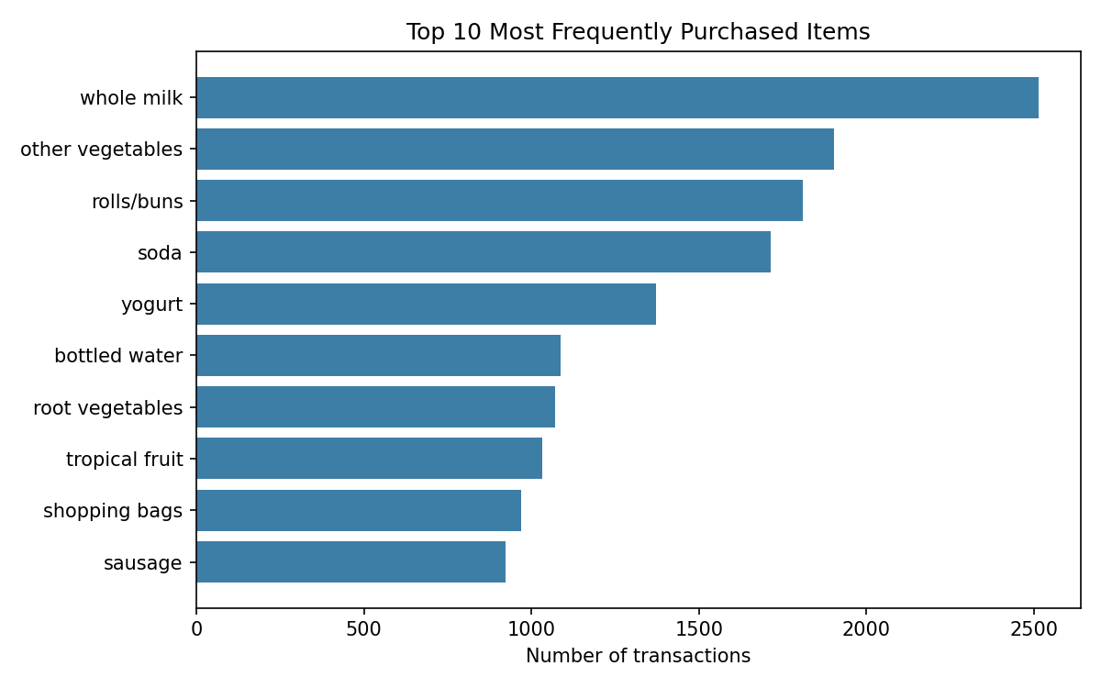

Question 2: Frequent Itemsets
a-b. Using the Apriori algorithm with a minimum support threshold of 1%, the following frequent itemsets of two or more products were identified (top 15 shown, sorted by support):
Itemset | Support
other vegetables, whole milk | 0.0748
rolls/buns, whole milk | 0.0566
whole milk, yogurt | 0.0560
root vegetables, whole milk | 0.0489
other vegetables, root vegetables | 0.0474
other vegetables, yogurt | 0.0434
other vegetables, rolls/buns | 0.0426
tropical fruit, whole milk | 0.0423
soda, whole milk | 0.0401
rolls/buns, soda | 0.0383
other vegetables, tropical fruit | 0.0359
rolls/buns, yogurt | 0.0344
bottled water, whole milk | 0.0344
pastry, whole milk | 0.0332
other vegetables, soda | 0.0327

c. Highest-support itemset
{other vegetables, whole milk} has the highest support (0.0748), meaning it appears together in about 7.5% of all transactions.

d. Interpretation of support
Support measures how frequently an itemset occurs across all transactions. A higher support value indicates that a larger proportion of customers buy that combination of items, so these are the combinations most worth acting on because they affect many baskets. Low-support itemsets, even if interesting, only apply to a small number of customers.

Question 3: Association Rules
Rules were generated from the frequent itemsets using a minimum confidence threshold of 0.2, producing 231 rules in total. The top 10 rules (ranked by lift) are shown below.
Antecedent | Consequent | Support | Confidence | Lift
citrus fruit, other vegetables | root vegetables | 0.0104 | 0.3592 | 3.2950
other vegetables, yogurt | whipped/sour cream | 0.0102 | 0.2342 | 3.2671
other vegetables, tropical fruit | root vegetables | 0.0123 | 0.3428 | 3.1448
beef | root vegetables | 0.0174 | 0.3314 | 3.0404
citrus fruit, root vegetables | other vegetables | 0.0104 | 0.5862 | 3.0296
root vegetables, tropical fruit | other vegetables | 0.0123 | 0.5845 | 3.0210
other vegetables, whole milk | root vegetables | 0.0232 | 0.3098 | 2.8421
curd, whole milk | yogurt | 0.0101 | 0.3852 | 2.7614
other vegetables, yogurt | root vegetables | 0.0129 | 0.2974 | 2.7287
other vegetables, yogurt | tropical fruit | 0.0123 | 0.2834 | 2.7005

Question 4: Understanding the Measures
Three rules from the table above are explained in detail:

Rule 1: {citrus fruit, other vegetables} → {root vegetables}
- Support (1.04%): This combination of all three items together appears in about 1 out of every 100 transactions.
- Confidence (35.9%): Of the customers who buy citrus fruit and other vegetables, about 36% also buy root vegetables.
- Lift (3.30): Customers who buy citrus fruit and other vegetables are about 3.3 times more likely to also buy root vegetables than a random customer — a strong positive association.

Rule 2: {citrus fruit, root vegetables} → {other vegetables}
- Support (1.04%): This itemset appears in about 1% of all transactions.
- Confidence (58.6%): Nearly 6 in 10 customers who buy citrus fruit and root vegetables also buy other vegetables — the highest confidence among the generated rules.
- Lift (3.03): Buying citrus fruit and root vegetables together makes a customer about 3 times more likely to also buy other vegetables than average.

Rule 3: {other vegetables} → {whole milk}
- Support (7.48%): This is the most common pairing in the dataset — nearly 7.5% of all transactions include both items.
- Confidence (38.7%): Almost 39% of customers who buy other vegetables also buy whole milk.
- Lift (1.51): Buying other vegetables makes a customer about 1.5 times more likely to buy whole milk than average — a moderate, still meaningful, positive association.

Question 5: Find Interesting Rules
Criterion | Antecedent | Consequent | Support | Confidence | Lift
Highest confidence | citrus fruit, root vegetables | other vegetables | 0.0104 | 0.5862 | 3.0296
Highest lift | citrus fruit, other vegetables | root vegetables | 0.0104 | 0.3592 | 3.2950
Highest support | other vegetables | whole milk | 0.0748 | 0.3868 | 1.5136
d. These are not the same rule. The highest-support rule ({other vegetables} → {whole milk}) simply reflects that both items are purchased very often overall, regardless of whether one causes purchase of the other — its lift (1.51) is comparatively modest. The highest-confidence and highest-lift rules both involve citrus fruit, root vegetables, and other vegetables together, and describe a narrower but statistically stronger relationship: these items co-occur far more than chance would predict, even though fewer customers buy them. In short, support reflects popularity, while confidence and lift reflect the strength of the relationship between specific items.

Question 6: Interpret a Rule
Rule: {citrus fruit, root vegetables} → {other vegetables}
In simple language: customers who purchase citrus fruit and root vegetables also tend to purchase other vegetables. This makes intuitive sense — these are all items from the same part of the store (fresh produce), so a customer stocking up on fresh produce for the week tends to pick up several types of vegetables and fruit at once.
This is a strong association. The confidence of 58.6% means the rule holds for well over half of the relevant customers, and the lift of 3.03 shows that buying these two items together makes a customer three times more likely than average to also buy other vegetables. Both measures point in the same direction, confirming the relationship is meaningful rather than coincidental.

Question 7: Business Application

a. Products to place close together
Root vegetables and other vegetables could be placed close to each other, since they show a high lift (2.84–3.02 across several rules) and are already part of the same fresh-produce shopping trip.

b. Possible product bundle
A "Fresh Produce Basket" bundle of citrus fruit, root vegetables, and other vegetables could be promoted together, since all three appear together far more often than chance would predict.

c. Recommendation engine example
When a customer adds root vegetables and citrus fruit to their online cart or self-checkout basket, the system could automatically suggest other vegetables ("customers who bought this also bought..."), since 58.6% of similar customers went on to buy it.

Question 8: Understanding Association

a. Does association imply causation?
No. An association rule only shows that two items are statistically likely to appear in the same transaction — it does not prove that buying one product causes a customer to buy the other. The relationship could instead be explained by a shared underlying cause, such as both items being needed for the same meal or recipe, seasonal shopping habits, or store layout, rather than one product influencing the purchase of the other.

b. High confidence but low lift
A rule can have high confidence but low lift when the consequent item is already very popular on its own. For example, if 90% of all transactions include whole milk regardless of what else is bought, then almost any antecedent will show high confidence for "→ whole milk" simply because most customers buy milk anyway — not because the antecedent actually drives that purchase. Lift corrects for this by comparing confidence to the item's baseline frequency.

c. Lift greater than 1
A lift value greater than 1 indicates that the antecedent and consequent occur together more often than would be expected if they were purchased independently — that is, there is a positive association between the items. A lift of exactly 1 indicates no association (independence), and a lift below 1 indicates the items are purchased together less often than expected (a negative association).

Appendix: Top 10 Rules by Lift (Chart)
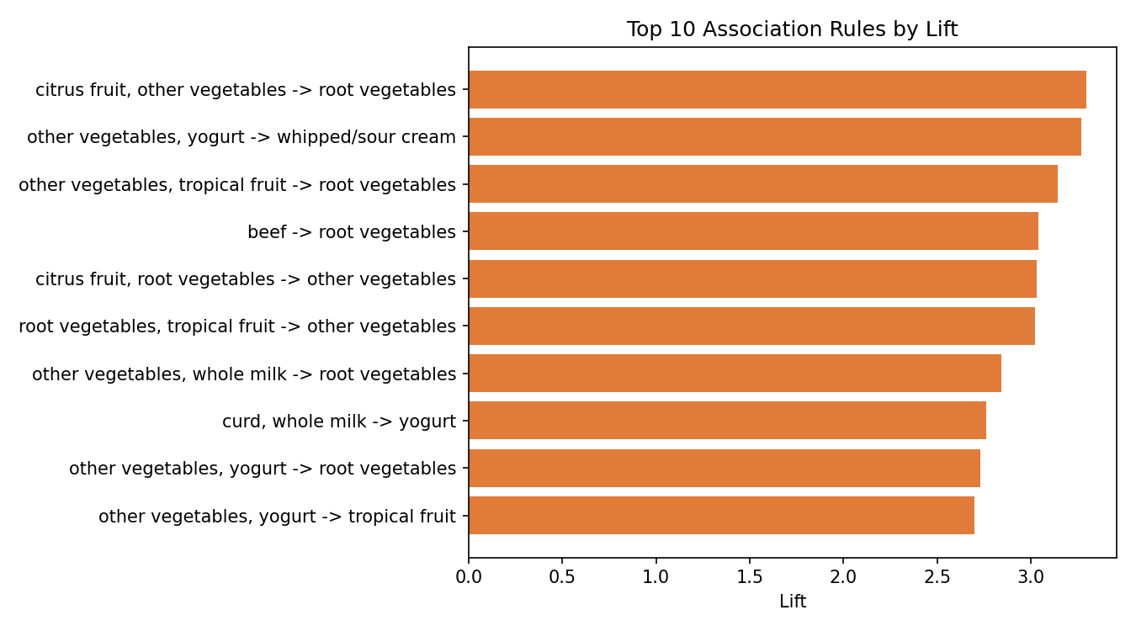

Methodology & Code
Analysis was performed in Python using pandas, mlxtend (Apriori algorithm and association_rules), and matplotlib. Frequent itemsets were mined with a minimum support of 1%, and association rules were generated with a minimum confidence of 20%. The complete, commented analysis script is submitted alongside this report (analysis_final.py).

