PaleoMapper
by Emma Havens, David Walsh, and Christopher Scotese
Version: 2026/03

Table of Contents
- Introduction
  - Why PaleoMapper?
  - Who developed PaleoMapper?
  - How was PaleoMapper coded?
- Program Structure
  - GUI Quickguide
  - Input Files
    - Plate Model
    - Geographic files
    - Raster files
    - Symbol format files (User data)
    - Project file
  - Other User Selections
    - Reconstruction Time
      - Generating a single map vs. animation
    - Hold a Continent Fixed
    - Output Options
      - Outputting to the Screen
      - Outputting to File
- Advanced Topics
  - Creating and using your own symbol format file
  - Understanding project files
  - Color options
- Tutorials
  - Making a Devonian (400Ma) Map with Fossil Reef Localities

Introduction

Why PaleoMapper?
Current paleogeographic map-making software (e.g., GPlates) often requires computational knowledge and has a steep learning curve associated with the application. This software comes with many powerful features, such as data construction and manipulation, that complicates basic map generation. Users without coding skills, those that are not knowledgeable about plate tectonic reconstructions, or those that do not need to generate maps frequently experience a high barrier when attempting to create paleogeographic maps.
PaleoMapper is a simple Python-based map-making application that provides users with a quick way to generate paleogeographic maps and animations. Users can easily upload user-defined data and choose from a variety of map settings in order to generate figures for publications and presentations. In-depth knowledge of computer science and plate tectonic reconstructions is not required to run PaleoMapper. The map settings are highly customizable. PaleoMapper comes loaded with all of the data necessary for map generation, such as a global plate model and coastline and country boundary data, though other files can added from a library of digital geographic data.

Who Developed PaleoMapper?
PaleoMapper was developed by Emma Havens and based on the plate tectonic mapping programs written by Chris Scotese (Scotese et al., 1975) and David Walsh (Walsh and Scotese, 1993).
Christopher Scotese first wrote the algorithms to read and process a global plate model and rotate points in FORTRAN. The project was then passed onto David Walsh, who updated the algorithms to run in python and built it into a command line interface called PlateTracker. PlateTracker prompted the user for file names, reconstruction time, map options, and output options, and then plotted a map to screen or saved it as a .dat. It was later picked up by Emma Havens, who turned it into a GUI and added all remaining functionality: animation, project files, increased color, output, input, and projection options, raster readability, etc.

How was PaleoMapper coded?
PaleoMapper was coded in Python 3.10.13. The GUI was built using PySide6, a Python binding of Qt. Some GUI elements were constructed using Deep Seek RL2. Maps are generated using Matplotlib and Cartopy.

Program Structure

GUI Quickguide:

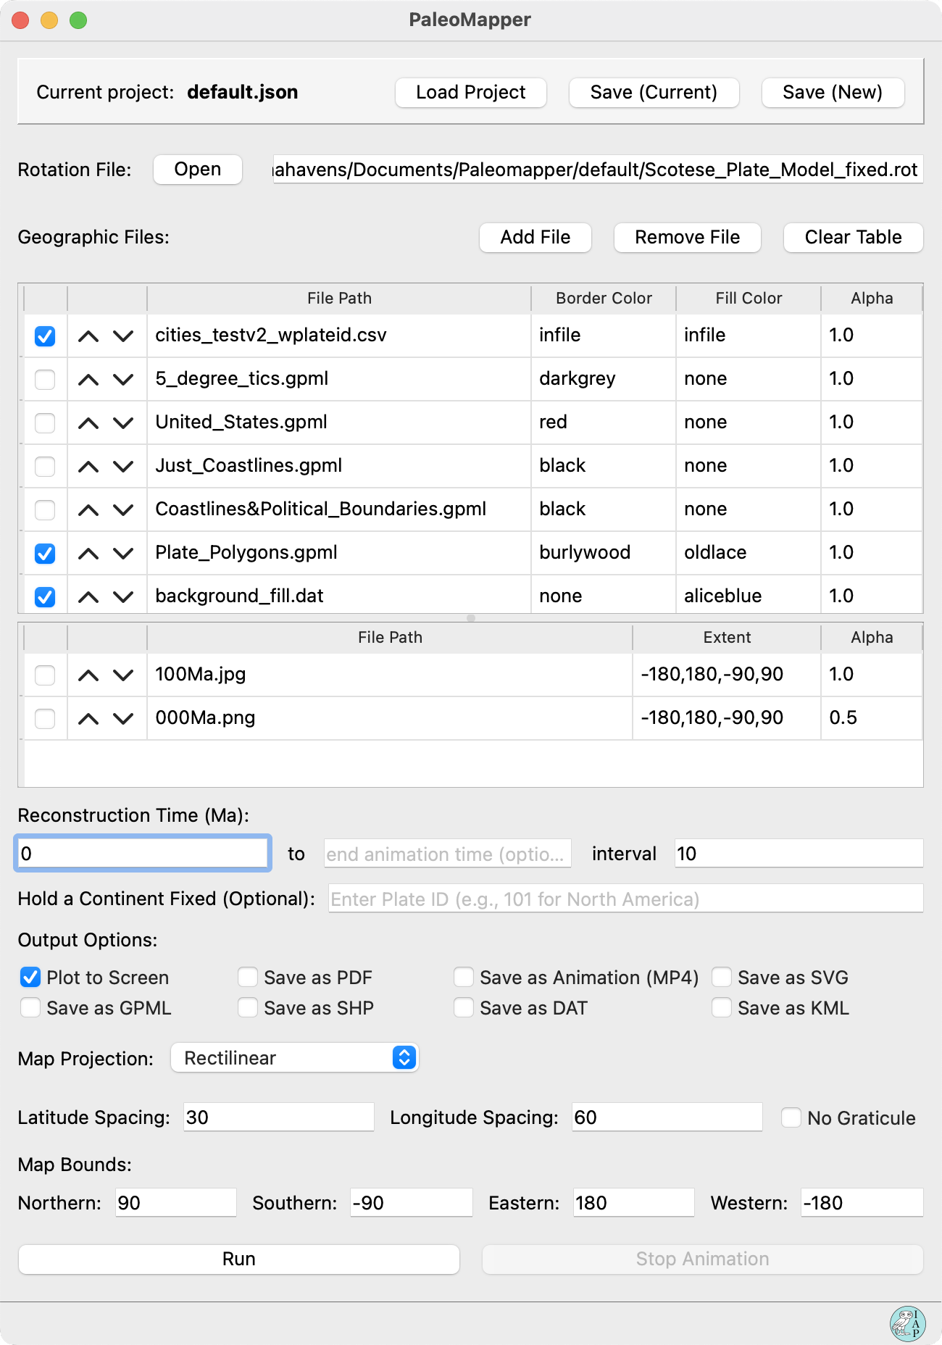
Project Controls
Raster Table
Time Input
Output Options
Map Options and Output Filenames
Status Bar
Geographic Table
Rotation File

Project Controls
The current open project is displayed in bold. Loading in a new project will automatically remove all currently loaded files and load all files specified in the new project, including all specified parameters (Border and Fill Color, Alpha, etc.). Saving (Current) a project will update the currently opened project with any changes you have made, including adding and removing files and updating parameters. Saving (New) a project will create a new project in the location you specify and does not affect the project you modified to build it, if you did so.

Rotation File
A rotation (.rot) file is critical to building a map reconstruction. PaleoMapper will not run if a rotation file is not given.

Geographic Table
The geographic table accepts the following file types: .gpml, .csv, .shp, .dat. Files are added or removed from the table with the buttons directly above it. The table can be resized by clicking and dragging the space between the geographic and raster tables. The files are displayed in ‘plotting order,’ meaning files shown at the bottom of the stack will be plotted at the bottom of the map and vice versa. Files can be moved within the table by toggling the up/down arrows. Files will only be read and plotted by PaleoMapper if they are checked. Color and opacity information can be specified in the following columns. Opacity ranges from 0-1. Always ensure your cursor is not active in a table cell before clicking ‘Run’ or the value will not be properly read and enacted. Read more about what you can do with color in (III. Advanced Topics—Color Options).

Raster Table
The raster table accepts the following file types: .png, .jpg, .jpeg. Files are added or removed from the table with the buttons directly above the geographic table (and are automatically sorted into the raster table.) Files in the raster table are displayed in plotting order and will always be plotted underneath files in the geographic table. The check box and up/down arrows function the same as in the geographic table. If the raster is not a global raster, enter the extent in the following pattern: left,right,bottom,top.

Time Input
A time is required for PaleoMapper to run. If only the first box is filled, then a single map will be generated at the time specified. To generate an animation, a start time, an end time and a time interval are required.

Output Options
On default, PaleoMapper will output the map with the specified layers and the specified map parameters to the screen. The map can be saved as either a .pdf, .mp4, or a .svg. The reconstructed files can also be saved as a .gpml, .shp, .dat, or .kml. It is possible to deselect ‘Plot to Screen,’ in which case the map/data will be saved without displaying. This may be preferable if you are plotting a very complex map that takes PaleoMapper a long time to draw.

Map Options and Output Filenames
Based on what output options you selected, different map options and output filename fields will appear. If you selected an option that will generate a map, you will be able to select a map projection and enter graticule information. Depending on the map projection, you may also be able to select map boundary extent, central latitude, or displayed hemisphere. If you selected an option that saves a file, you will be able to enter a filename. The file will always save to the same folder that your project file is in.

Status Bar
The status bar runs along the bottom of the application window and displays the IAP logo on the right. It will display messages when you load or save projects to let you know they were successful. When running, it will display a progress bar. For very complicated maps, PaleoMapper may take a long time to run. The program is still working if the progress bar is displayed, even if it appears stuck.

Input Files

Plate model

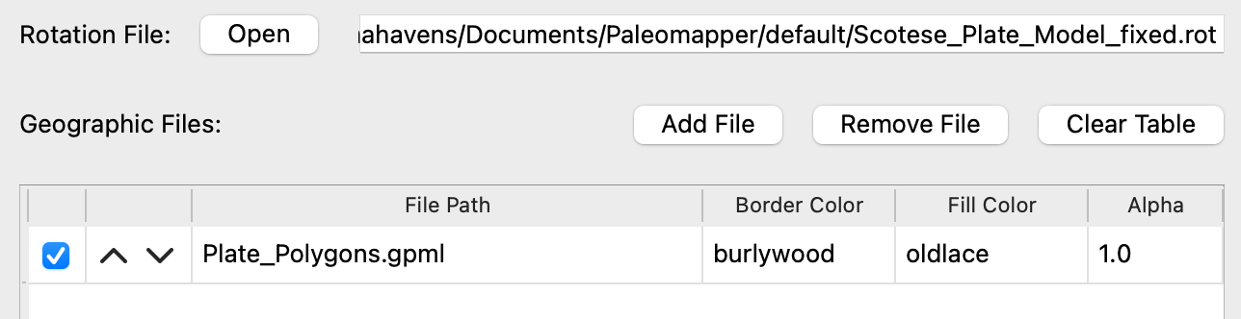
A global plate model refers to a rotation (.rot) and a plate polygon (.gpml or .dat) file. A plate polygon file defines plate geometry and identifies them with a Plate ID. A rotation file specifies how objects with a given Plate ID move through time. A rotation file is necessary for PaleoMapper to run, and whatever files PaleoMapper is reconstructing must correspond to that rotation file (use the same Plate ID naming scheme). While a plate model refers to just the rotation and plate polygon file, that means that whatever other files you want to reconstruct (ex. Coastlines, Country borders, user data) must have matching Plate IDs as well. It also means that a plate polygon file is not necessary for PaleoMapper to run—PaleoMapper needs to be given at least one geographic file to reconstruct, but it cannot tell the difference between what is and is not a plate polygon file.
For learning how assign Plate IDs to your input data, see (III. Advanced Topics—Creating and using your own symbol format file.)

Geographic files

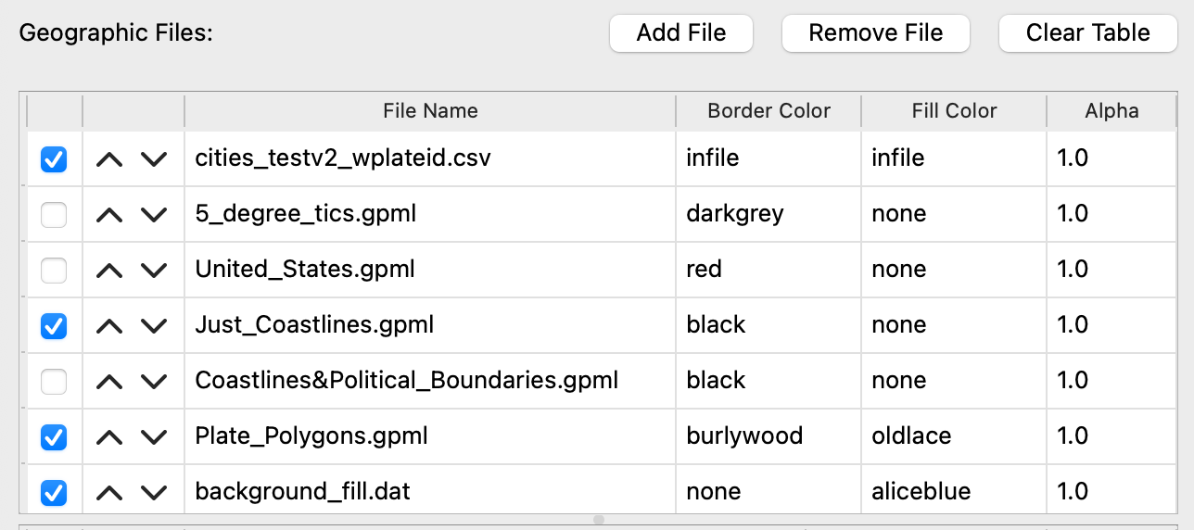
Geographic files (.gpml, .csv, .shp, .dat ) are automatically sorted into the geographic table when entered into the program. The table has the following columns:
- Check box: PaleoMapper will only read and reconstruct files that are checked.
- Up/Down arrows: Files are shown in plotting order (files at the bottom of the table are plotted first and appear underneath other layers.) Plotting order can be adjusted by moving files with the arrows.
- Title: Displays the name of the file, but never the file path.
- Border Color: The color that will be used when drawing the lines defined in the file.
- Fill Color: The color that will be used when filling in polygons defined in the file. Not all files define their shapes using polygons, and the color fill will not work properly in this case. Even shapes that appear closed when drawn may not be properly defined polygons.
- Alpha: The desired opacity of the layer, defined on the closed interval 0-1. An alpha of 0 is invisible, and an alpha of 1 is fully visible.
All geographic files that display in the table are considered loaded for the purpose of projects, but PaleoMapper only reads and reconstructs the files that are checked.

Raster files

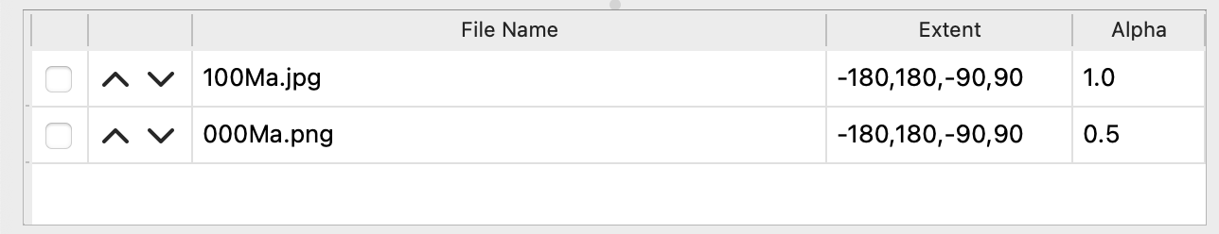
Raster files (.png, .jpg, .jpeg ) are automatically sorted into the raster table when entered into the program. The table has the following columns:
- Check box: PaleoMapper will only read and reconstruct files that are checked.
- Up/Down arrows: Files are shown in plotting order (files at the bottom of the table are plotted first and appear underneath other layers.) Plotting order can be adjusted by moving files with the arrows.
- Title: Displays the name of the file, but never the file path.
- Extent: The edges of the raster defined by latitude/longitude. The extent should be entered like so: left,right,bottom,top
- Alpha: The desired opacity of the layer, defined on the closed interval 0-1. An alpha of 0 is invisible, and an alpha of 1 is fully visible.
Since raster files are not geographic files, they are never reconstructed and will always be plotted as-is, regardless of the time entered.

Symbol format files (User data)
Symbol format files are .csv files that are designed to be read in by PaleoMapper. They hold the information necessary to place reconstructable data points on maps. Symbol format files must have the following fields in the following order:
- URN: An identification number unique to the entry.
- Label: A string of characters (any letters, numbers, or special characters) to identify the entry.
- Plate ID: The Plate ID corresponding to the ID of the entry’s location. If a value is given, it should match the Plate Model being used by PaleoMapper. If no value is given, PaleoMapper will assign a Plate ID (see III. Advanced Topics—Creating and using your own symbol format file.)
- Latitude: The latitude of the entry.
- Longitude: The longitude of the entry.
- Symbol: The desired plotting shape. There are many possible shape keywords (see III. Advanced Topics—Creating and using your own symbol format file), and if a keyword in unrecognized, PaleoMapper will plot the text entered into the field.
- Size: The size of the plotted shape. A square with size 1 is equivalent to 1˚. Numbers do not have to be integers.
- Azimuth: The rotation applied to the plotted shape in degrees. An azimuth of 0 will apply no rotation.
- Start Time: The earliest possible time the entry should appear on the map in millions of years.
- End Time: The latest possible time the entry should appear on the map in millions of years.
- Border Color: The desired color for the outline of the plotted shape. See III. Advanced Topics—Color options.
- Fill Color: The desired color for the interior of the plotted shape. Not all symbols will have a valid interior. See III. Advanced Topics— Creating and using your own symbol format file to see what symbols shouldn’t be filled and III. Advanced Topics—Color options to see valid keywords for this field.
Below is an example that would place a labeled point on Chicago, USA.
URN | Label | Plate ID |  | Lat | Long | Symbol |  | Size |  | Azimuth | Start | End | Border Color | Fill Color
1 | Chicago |  | 101 | 44.00 | -87.99 |  | label |  | 1 | 0 | 4500 | 0 | black | black
2 | Chicago |  | 101 | 42.00 | -87.99 |  | circle |  | 1 | 0 | 4500 | 0 | blue | red

Project file
Project files help you stay organized in PaleoMapper by storing the settings of the geographic and raster tables. Unlike project files in many other programs, the project file is not storing your data inside of it—it is just a list of settings and relative file paths inside of a .json file. This keeps the project very transparent to you and can prevent large or numerous projects from taking up space on your computer, if organized correctly.
When you save a new project file, either making a new one or updating an existing one, you must select a location to put the project file on your computer. Then, PaleoMapper will make copies of all of the currently loaded geographic, raster, and rotation files and save them to the same folder as the project file, if they are not already there. If you have many projects reusing the same files, keeping them in the same place allows multiple projects to pull from the same file. File paths are stored relatively so that you can move and rename encapsulating folders without breaking any existing projects.
When loading a project, select the project file. The project file will always be expecting its necessary files to be stored in the same folder as itself. This will always be the case unless you have moved or deleted files yourself. If PaleoMapper cannot locate a file, then it will skip that file and load what it can.

Other User Selections

Reconstruction time
A reconstruction time must be entered for PaleoMapper to run. Time is measured in Myr. All geographic files will be reconstructed to their paleocoordinates, according to the rotations specified in the plate model.
In order to generate an animation instead of a single map, enter an end time and an interval, as well; the interval must divide evenly into the range. The range is allowed to be either backwards or forwards through time (ex. Start = 0, End = 40 and Start = 40, End = 0 are both acceptable), but the interval should always be a positive number.
When creating an animation to screen, each frame will show up as it is created. Oftentimes, this will be slow. To view the animation at speed, save it as an .mp4.

Hold a continent fixed
By entering a Plate ID into the Hold a Continent Fixed field, you can anchor that plate in its present day coordinates. All other plates will then move relative to the fixed plate, rather than a static reference frame. The images below demonstrate the concept best; the map on the left shows plate polygons and country borders reconstructed to 300Ma with a static reference frame, and the map on the right shows the same reconstruction, this time with plate 701 (African craton) held fixed.

Output options

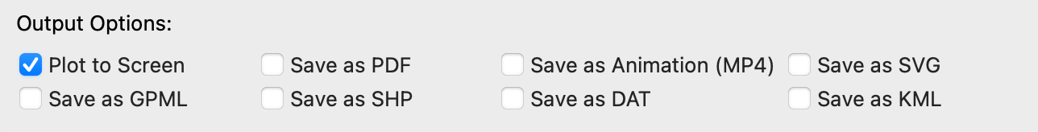
PaleoMapper, by default, will display your map via an interactive window. Oftentimes, you will want to save the reconstructed map or data for later reference or use. The following output options are supported: .pdf, .mp4, .svg, .gpml, .shp, .dat, .kml.
The top row of output options (Plot to Screen, .pdf, .mp4, .svg) are all map output options, though the map will only display if the Plot to Screen option is checked. Otherwise, both .pdf and .svg will save the map as high quality vector graphics. If you want to save an animation rather than a static map, you must save it as an .mp4. The .mp4 is assembled from .pngs and will be lower quality than the vector graphic options. If .pdf or .svg are selected as output options for an animation, then each individual frame will be saved as part of a series.
The bottom row of output options (.gpml, .shp, .dat, .kml) will reconstruct all of the selected files and save it to a single file, rather than displaying it as a map. This is useful if you want to export to other programs with tools for data modification. For example, symbol format files were designed to be easy to view and manipulate data, but are unique to PaleoMapper. You will lose the ease and flexibility of a .csv file, but an exported symbol format file will retain symbol and text shapes and Plate IDs.
Exported .gpml, .dat. and .shp files can also be read back in by PaleoMapper. .gmpl and .shp files will retain all shapes, .dat will retain all shapes and colors, and none will retain opacity. This can be a useful functionality to perform manipulations with time. None of the exported files retain the fact that they are reconstructions—features are reconstructed and then written out as-is with the time ranges they were originally assigned, but they don’t keep any information about what reconstruction time they were written out, as all of the file formats assume they only hold present-day coordinates. Be cautious, as it can be easy to make mistakes here. All automatic time ranges will be wrong, and you should never reconstruct a reconstruction, as it will draw the wrong rotation data out of the rotation file. On the left is a map reconstructed and exported at 300Ma, then imported and displayed at 0Ma. On the right is the same exported map, but erroneously reconstructed to 300Ma again.
It may seem like a hassle, but it can allow you to do some pretty neat things. Below is a time-sequence of North America. Each instance was separately reconstructed and exported, then they were all loaded and plotted at 0Ma.

Advanced Topics

Creating and using your own symbol format file
Although PaleoMapper will accept any file with a .csv extension, it will crash unless the file is organized in a specific way. In order for a .csv to be a symbol format file, it must have the following fields with the listed properties in this order:
- URN: The unique record number of the data point. This is expected to be an integer number. As opposed to what the name implies, the numbers do not have to be unique—this is because you may want to have multiple symbols to represent one data point, such as a circle and a label.
- Label: The description of the data point. This can have any characters and be as long as desired. This is purely to help the reader identify the data point, and potentially be used as symbol text if so desired.
- Plate ID: The Plate ID that corresponds to the location of the point specified by the latitude and longitude fields. This is expected to be an integer number. Read more about this field below.
- Latitude: The latitude of the data point. This can be either an integer or a decimal number.
- Longitude: The longitude of the data point. This can be either an integer or a decimal number.
- Symbol: The shape that should be used to represent the data point. The list of built-in symbols is as follows: urn, label, circle, dot, triangle, square, plus, cross, storm, asterisk, diamond, star, dextral, sinistral, arrow01, arrow02, arrow03, arrow04, arrow05, arrow06, subduction, normal, conglomerate, sand, sandwmud, mud, mudwls, lswmud, limestone. If the contents of the symbol field are not recognized as one of these built in options, PaleoMapper will instead plot the contents of the symbol field as a text string. See a picture of the built-in options below.
- Size: The size of the data point symbol. This can be either an integer or decimal number. A size of 1 corresponds to ~1˚ of latitude.
- Azimuth: The rotation applied to the data point symbol. This can be either an integer or decimal number. This is unrelated to the translational rotation applied to the data point for reconstructions, and instead rotates the symbol around its center. An azimuth of 0 applies no rotation, an azimuth of 180 turns the symbol upside-down, etc.
- Start Time: The earliest time the data point should appear in reconstructions. This can be either an integer or a decimal number. The symbol will not be plotted for reconstruction ages older than the data point’s start time.
- End Time: The latest time the data point should appear in reconstructions. This can be either an integer or a decimal number. The symbol will not be plotted for reconstruction ages younger than the data point’s end time.
- Border Color: The color of the lines or outline of the symbol. This should be one of the options specified in III. Advanced Topics—Color Options.
- Fill Color: The color of the interior of the symbol. This should be one of the options specified in III. Advanced Topics—Color Options.
The symbol file is expected to have exactly one header row of column labels. They do not need to read exactly as specified above—PaleoMapper does not read your header row. Make sure you provide a header row, or your first row of data will silently disappear.
The figure below displays all built-in symbol options. Symbols that can be filled are filled with light blue and are listed as follows: urn, label, circle, triangle, square, plus, storm, diamond, star, arrow04, arrow05, arrow06, subduction. It is not recommended to give any other symbol a fill color.
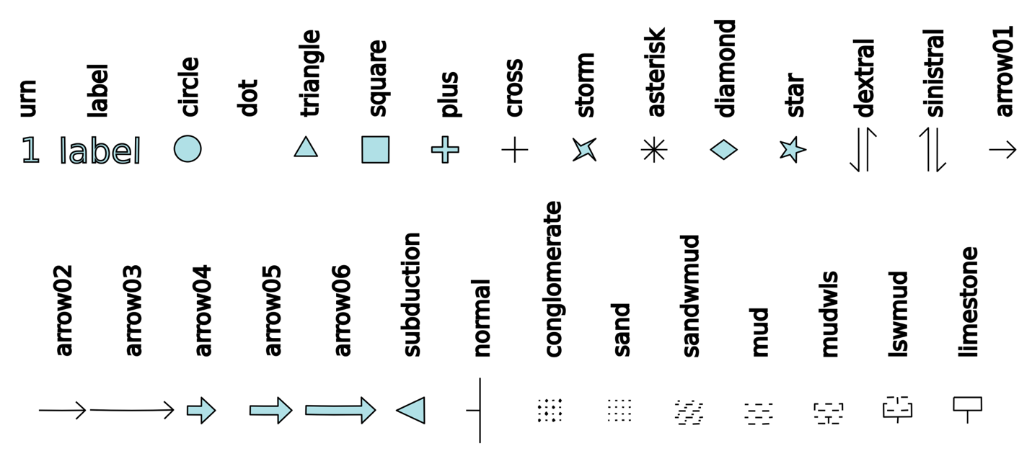
Note that dots do not actually appear when plotted. This is because it is truly a single point. You may want to use them to export your symbol format file and keep your data specified in exact coordinates, rather than the set of coordinates that will draw the symbol shape. Though again, you will likely not be able to see them through any visual software. If you want to plot dots on your map, just use very tiny circles.
You have likely identified already that Plate ID is a troublesome field to provide. PaleoMapper provides a workaround if you don’t already have Plate IDs for your data. Unlike all other fields, PaleoMapper will not throw an error if you provide a non-integer value for a data point’s Plate ID. It will instead assign it a Plate ID according to the plate polygon file specified in the Preferences window. (The Preferences window is found under the python tab of the application.) You may change this file if you wish, but it is preset to use the default plate polygon file, which coordinates with the default rotation file. You will only need to change this file if you are both using a different global plate model and loading a symbol format file that does not specify Plate IDs.
When PaleoMapper assigns Plate IDs, it checks each entry individually to see if it needs a Plate ID assigned. If you are only missing a few Plate IDs, it will not reassign data points that have a provided Plate ID. It also creates a new file titled ‘<name of your symbol format file>_wplateid.csv’. Since it can take a while for the program to assign Plate IDs, you may want to use that file moving forwards so that PaleoMapper doesn’t have to reassign Plate IDs each time you use the file. Assigning Plate IDs doesn’t change any other columns or modify any other data.
Note that in order to trigger Plate ID assignment, you must provide a non-integer value in the field, such as ‘N/A’ or leaving it blank. If you put in 0, it will read that as a valid Plate ID and likely assign it a rotation of 0 (as in, the data point will not move when reconstructed). This is sometimes desired behavior, but it is a separate matter from Plate ID assignment.
Assigning a Plate ID of 0 will only result in a rotation of 0 if the rotation file in use doesn’t define any rotations for Plate 0—for most rotation files, this is the case. If you are not changing the rotation file, this will always be the case. Assigning a rotation of zero is most useful when you want to prevent symbols from having a distorted azimuthal rotation. Although the azimuth of a data point applies a rotation around the center of the symbol, the translational rotation of reconstruction can also result in a rotation that changes the direction of symbol. For example, most of the text symbols will not be well-aligned for reading at 300Ma after getting reconstructed. If you want to ensure your text at 300Ma is perfectly left-right aligned, you will have to identify the locations you want them to appear, enter that as their latitude and longitude, and assign them a Plate ID of 0 so they don’t move around. On the left is a map where the labels have a Plate ID of 0 and their paleocoordinates already given. On the right, the labels are reconstructed like normal.

