(Weight Limit 30KGS)

This toy is unsuitable for children under 3 years.

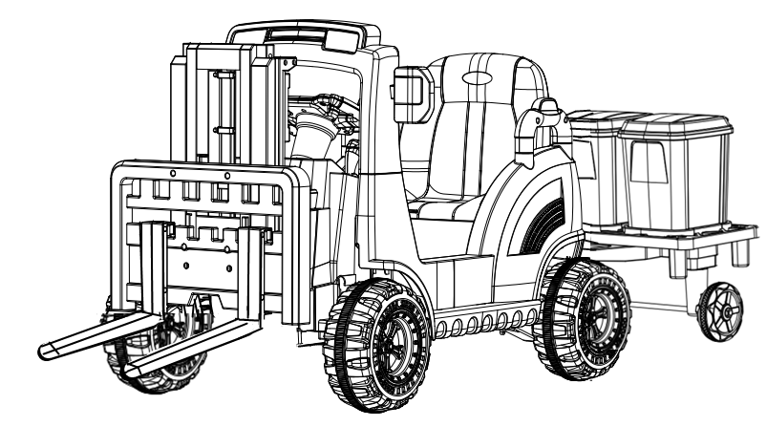

IMPORTED AND MADE FOR ATAA CARS
ATAA INTERACTIVE SL
CIF B73966277
WWW.ATAACARS.COM

12 Volt RC Ride-On Car
Owners Manual With Assembly Instructions

WARNING: ASSEMBLY SHOULDBE DONE BY ADULTS


WARNING！
•To reduce the risk of injury, adult supervision is required. Never use it in roadways, around motor vehicles，steep inclines or steps，swimming pools or other water bodies. Always wear shoes and helmets.
•Limited to one person.
•TO PREVENT FIRE AND ELECTRIC SHOCK:
•Only use batteries and chargers provided or specified by the manufacturer. Using the wrong type of batteries or chargers could cause a fire or explosion.
•DO NOT use the batteries or chargers on any other product.Or overheating,fire or explosion could occur.
•NEVER modify the circuit system. Alterations could cause a shock,fire or explosion.
•DO NOT pour any type of liquid on the batteries or other components.
Explosive gases are produced during charging.
•DO NOT charge near heat or flammable materials. Charge in a well-ventilated area ONLY.Charge in a dry area ONLY.
•DO NOT open the batteries. Batteries contain lead and other toxic and corrosive materials
•DO NOT open the chargers. Exposed wiring and circuitry may cause electric shock
•ONLY ADULTS can handle or charge the batteries. NEVER allow child to handle or charge the batteries. Batteries are heavy and contain lead acid (electrolyte)
•DO NOT drop the batteries.Otherwise permanent damage or other serious injury to the batteries would occur.
•Before charging, check the wear and damage of the battery,charger and the connectors.
•DO NOT charge the battery if any damage to parts has occurred. Please contact the dealer or manufacture to replace the parts ONLY.
•DO NOT allow the battery to drain completely; charge the battery after each use or at least once a month if not used regularly.
•DO NOT charge battery upside down.
•Always make sure that the battery is fixed with the bracket.Otherwise,battery can fall out and even injure a child if the vehicle tips over. Risk of fire. Do not bypass.
•If a battery leaks, avoid it from contacting with the leaking acid and put the damaged battery into a plastic bag.Refer to information in “Disposal of Battery ”for proper disposal.
•If acid comes in contact with skin or eyes, rinse with cool water for at least 15 minutes and call for a doctor.
•If mistakenly take a large number of acid,take a large amount of water,milk of magnesia or egg-white immediately. Call a physician.

Specification instruction

Name | Specification
Battery | 12V4.5AH*1
Motor | 12V*2
Applicable age | 3-7 years old
Maximum load | 30KG
Charge time | Charge 8-12 hours
Charger | 12V500mA
Speed | 2-4 km/h

※Above parameters are selected for customers, the specific parameters is based on the actual parameter.

WARNING: The toy is to be assembled by an adult.
In unassembled state contain potentially hazardous sharp points,sharp edges and small part,so please keep out of baby s reach.

WARNING: To reduce the risk of injury,adult supervision is required.
Never use in roadways,near motor vehicles,on or near steep inclines or steps,swimming pools or other bodies of water,always wear shoes,and never allow more than 1 rider.

Parts List
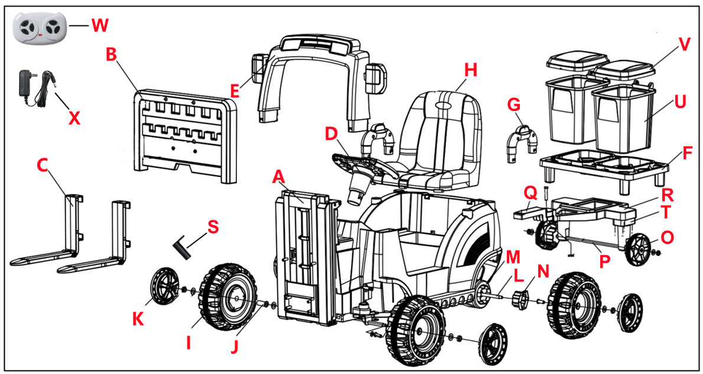

Parts List
  Car body  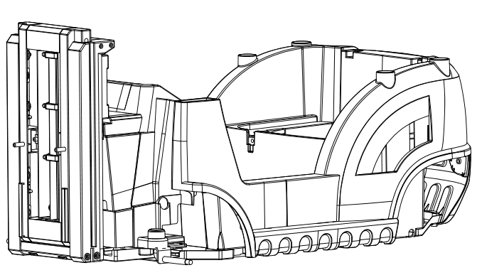  1PC |   Forklift lift table  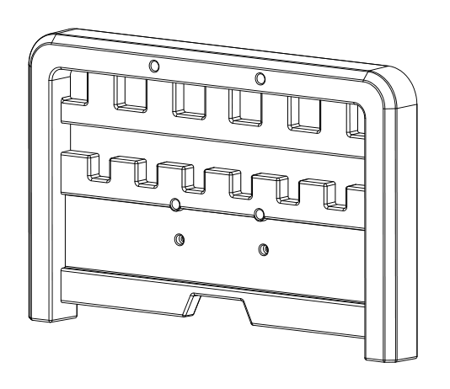  1PC |   Forklift arm  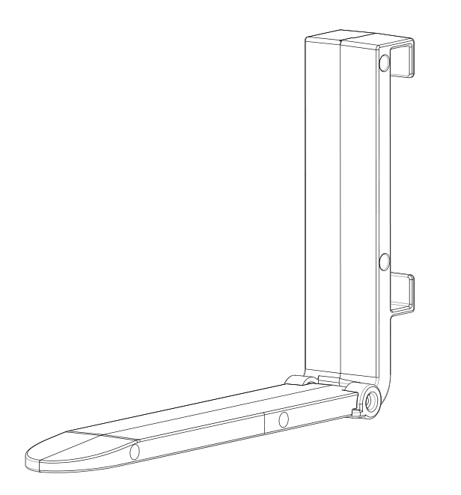  2PCS
  Steering wheel  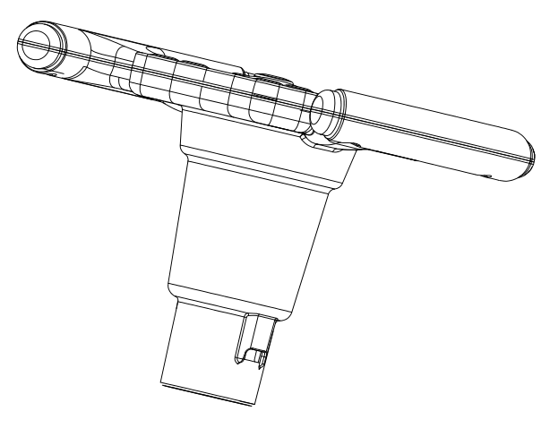  1PC |   Front windscreen  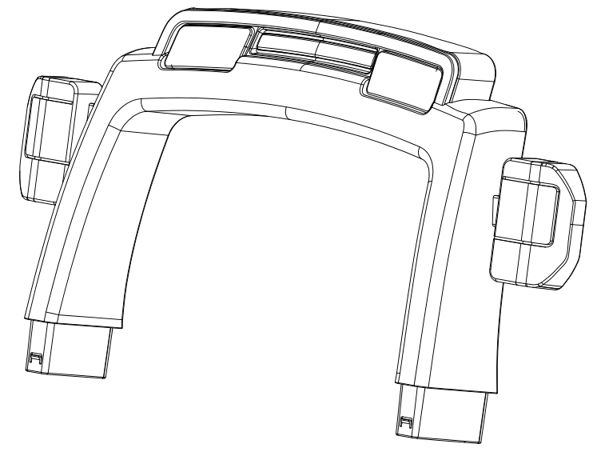  frame  1PC |   Pallet  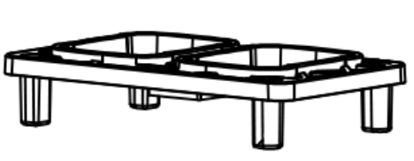  1PC
  Side armrest  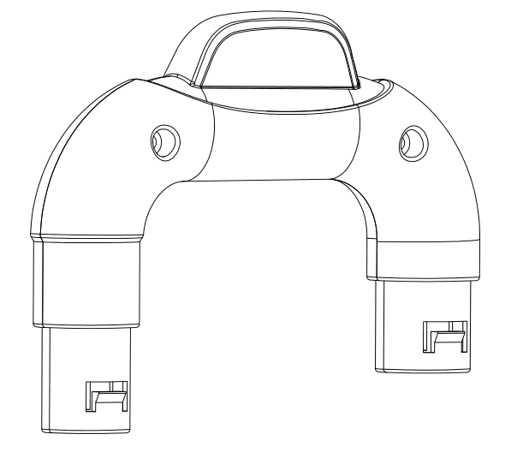  2PCS |   Seat  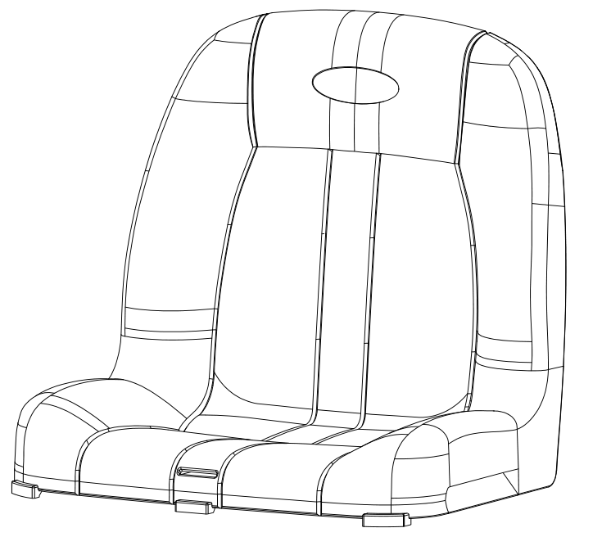  1PC |   Wheel  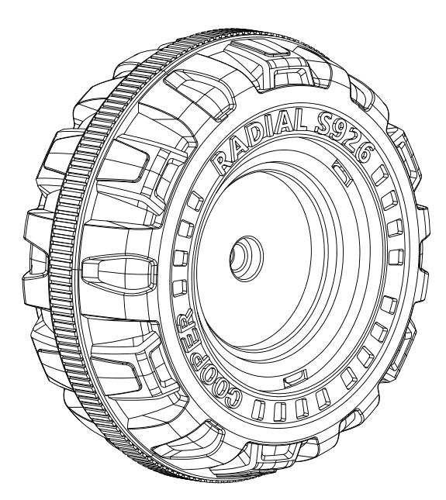  4PCS
  Bushing  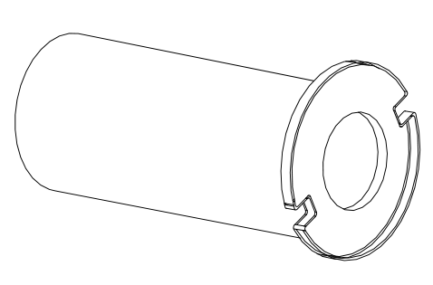  4PCS |   Wheel Cap  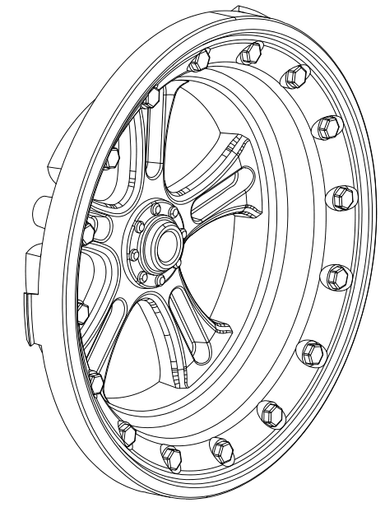  4PCS |   Rear Axle (50cm）  （2pcs nuts）    1PC
  Drive motor  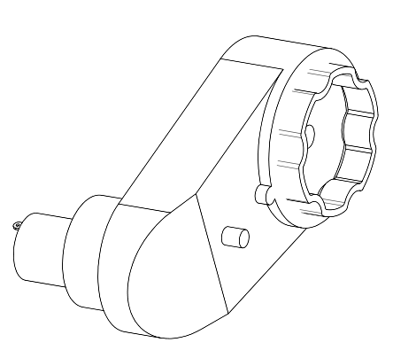  2PCS |   Driven connector  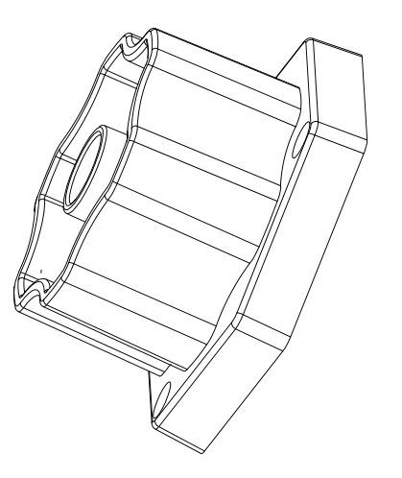  2PCS |   Tractor wheel  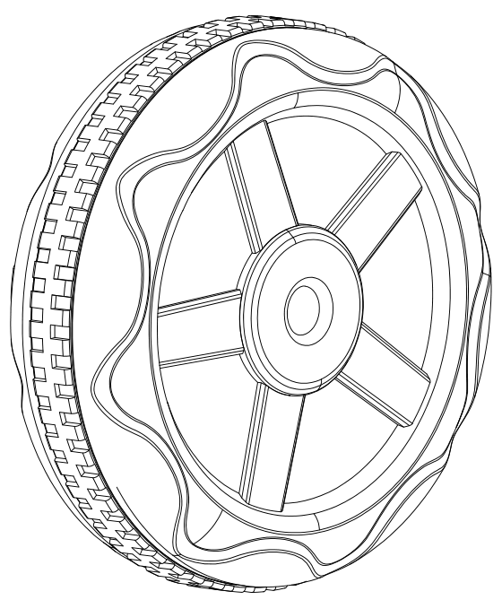  2PCS
  Tractor axle（47cm）  （2pcs nuts）  1PC |   Tractor connection  (1pc screw and nut)  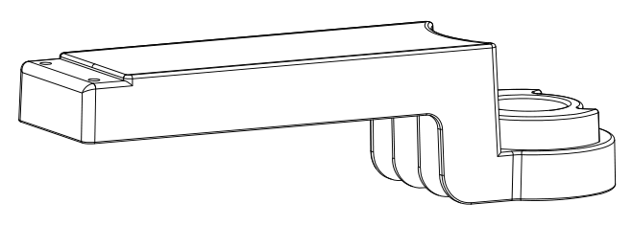  1PC |   Tractor  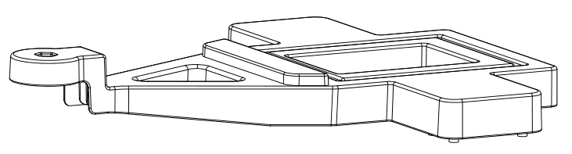  1PC
  Wrench    2PCS |   Tractor wheel  Connection  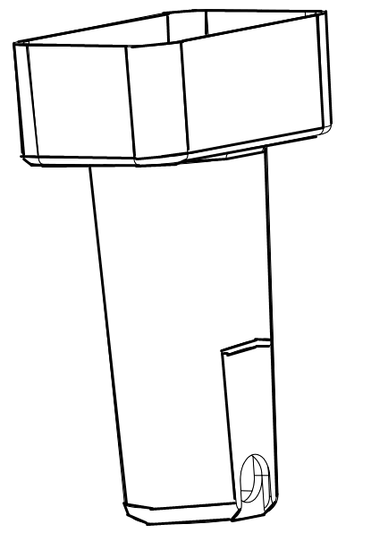  2PCS |   Rubbish bin  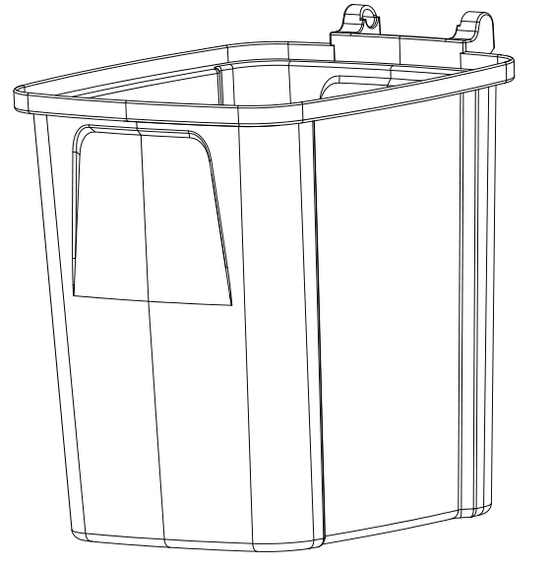  2PCS
  Bin lid  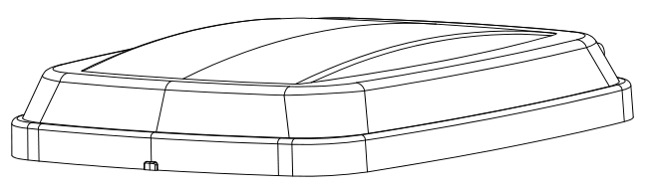  2PCS |   Remote control  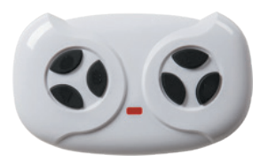  1PC |   Charger  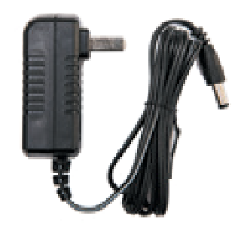  1PC
Parts Packages
No. | Name | QTY | Use
 | 4*12mm flat head screws | 8 | Installation of forklift lift table (part B)*6pcs  Installation of seat (part H)*2pcs
 | 4*16mm flat head screws | 2 | Installation of front windscreen frame（part E)*2pcs
 | 4*12mm round head screws | 14 | Installation of driven connector（part N)*6pcs  Installation of tractor wheel connection（part T)*8pcs
 | 4*10mm round head screws（Black） | 4 | Installation of gear switch*4pcs
 | M10 Washer | 10 | Installation of front wheels（part I)*4pcs, rear wheels（part I) *2pcs,tractor wheels（part O) *4pcs
 | 4*35mm flat head screw | 2 | Installation of tractor connection（part Q)*2pcs
Connect the motor wiring and power cord
1.Flip the car onto its wheels, Within the seat,plug the connectors for the left and right drive motors into the designated terminals on the circuit board.
2.Insert the connector from the battery into the designated terminal on the circuit board.
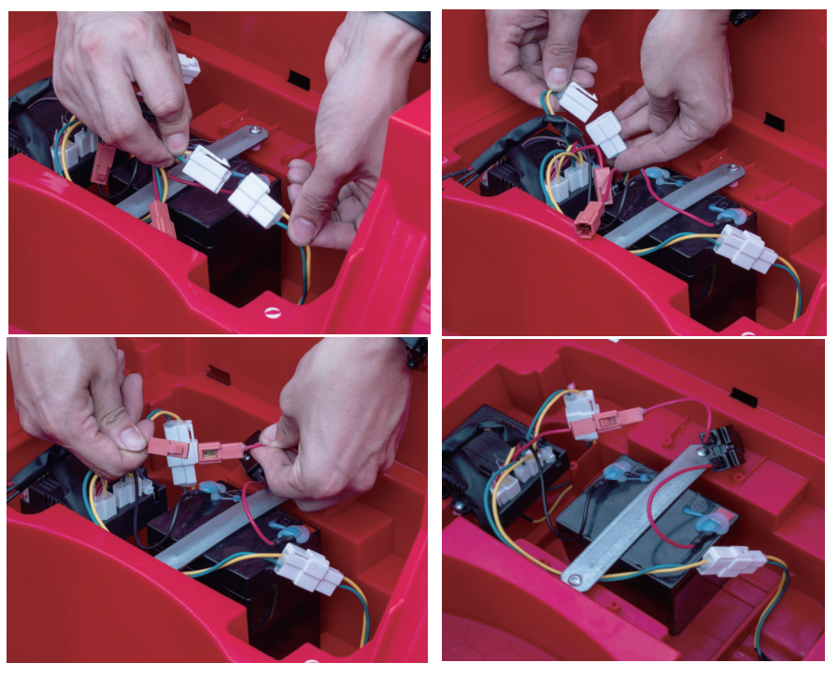
NOTE:Make sure the connector is oriented correctly to fit into the terminal.

Install front wheel
1.Flip vehicle over and lay it on a level surface. Remove the nuts(2pcs) from the front axle.
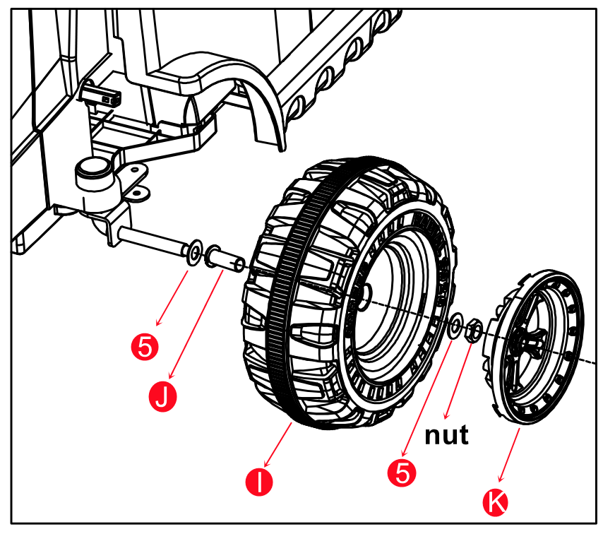
2. Insert the washer, bushing, wheel and washer in turn through the front axle (bushing aligned with the inside of the wheel) and secure with the nut. Finally snap on the wheel cap.

Install rear wheel
1.Remove the nuts(2pcs) from the rear axle.
2.Passing the rear axle through the body,Make sure rear axle is positioned evenly on each side. Install the drive motors "L" and "R" on the left and right side of the rear axle respectively.
3.Place a bushing on the inside of the wheel .Align the wheel driven connector with the screw hole of wheel,use 3pcs M4*12mm round head screws to fix.(total installed two wheels according to these steps)
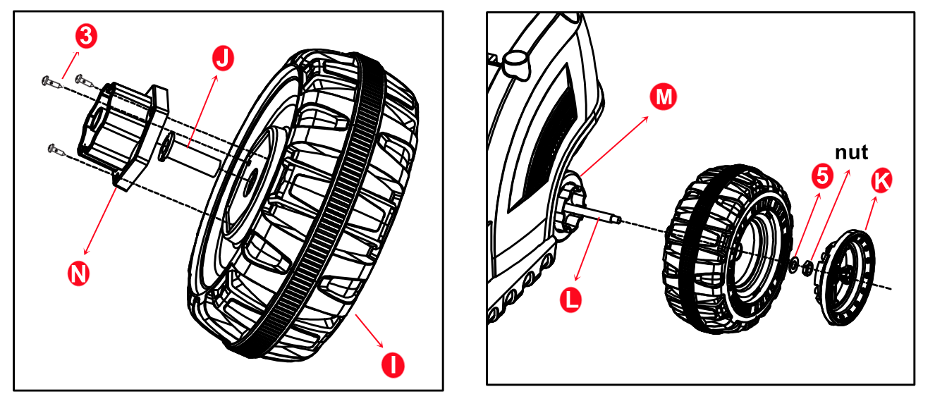
4.Slide a wheel with driven connector onto the rear axle , place a M12 washer and finally fix it with a nut. Snap on a wheel cap. Repeat on the other side. NOTE:Use two plastic wrenches(one on each side) and rotate in opposite directions to tighten nuts.

Install Side armrest
1.Insert the 2pcs side armrests into the car body.
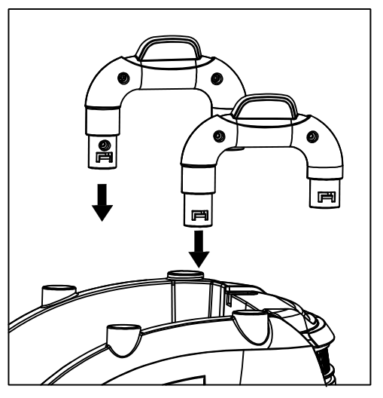

Install tractor connection
1.Insert the tractor connection into the rear of the car, at the bottom of the seat, and secure it with 2pcs 4*35mm flat head screws.
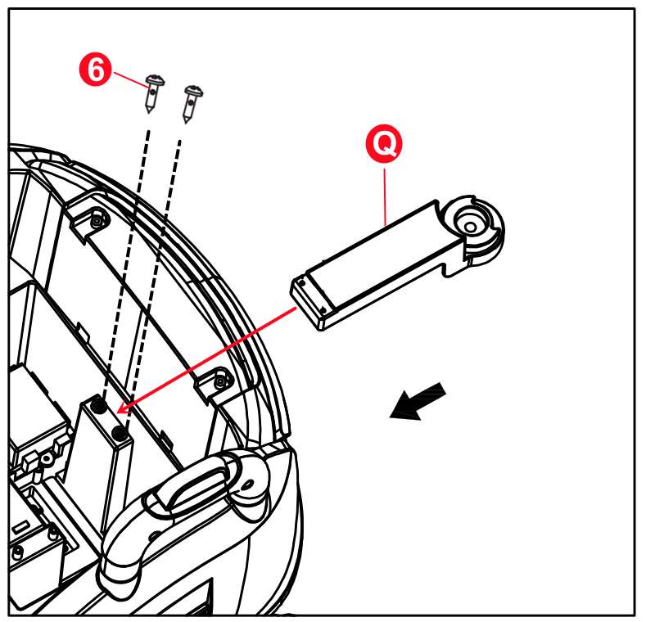

Install tractor
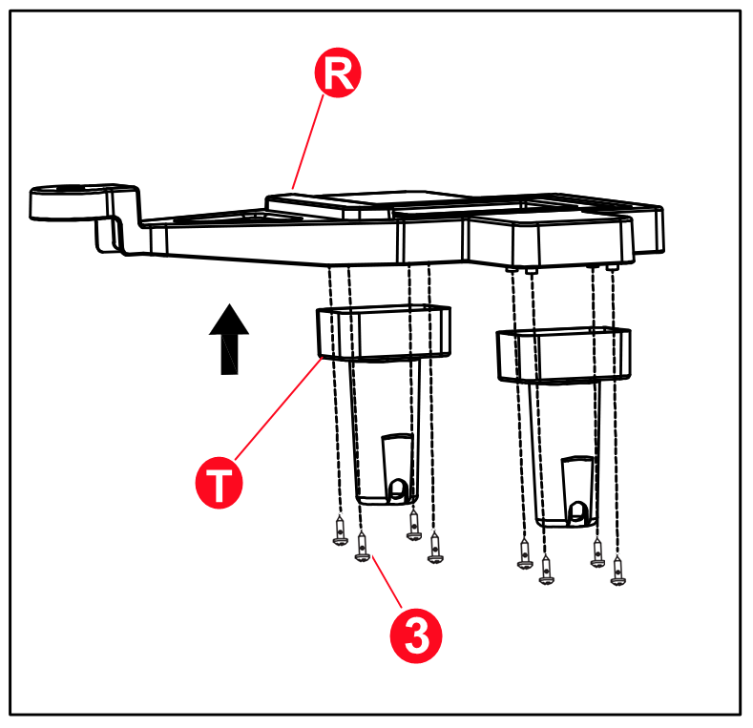
1.Attach the tractor wheel connection to the tractor with 8pcs 4*12 round head screws.

2.Remove the nuts(2pcs) from the tractor axle (47cm).
3.Passing the tractor axle through the tractor wheel connection.
4.Put M10 washer, tractor wheel, M10 washer on the tractor axle.finally fix it with a nut. Repeat on the other side.
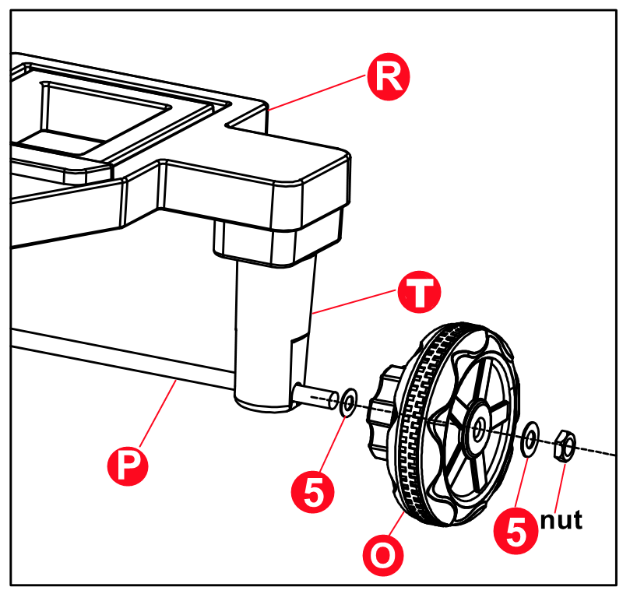

5.Remove the M5 screw and nut from the tractor connection.
6.Place the front end of the tractor over the tractor connection and secure it with the M5 screw and nut.
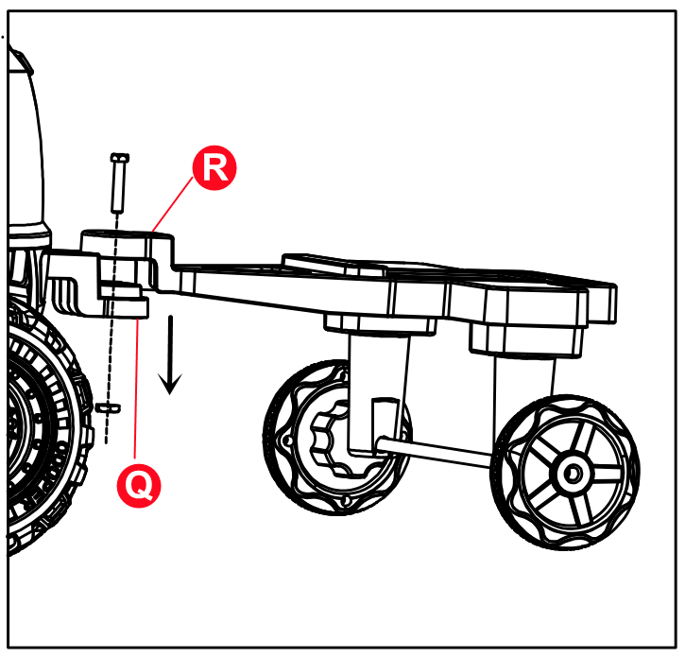

Install seat
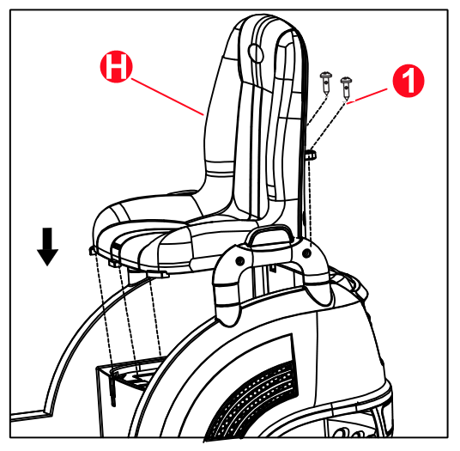
1.Snap the seat into the car body and secure it with 2pcs 4*12 flat head screws.

Installation of gear switches
1.First check if the gear switch connection cable is connected,the left and right side gear switches are fixed with 2pcs black 4*10 round head screws respectively.
Note:The gear switch is oriented as shown in the picture.
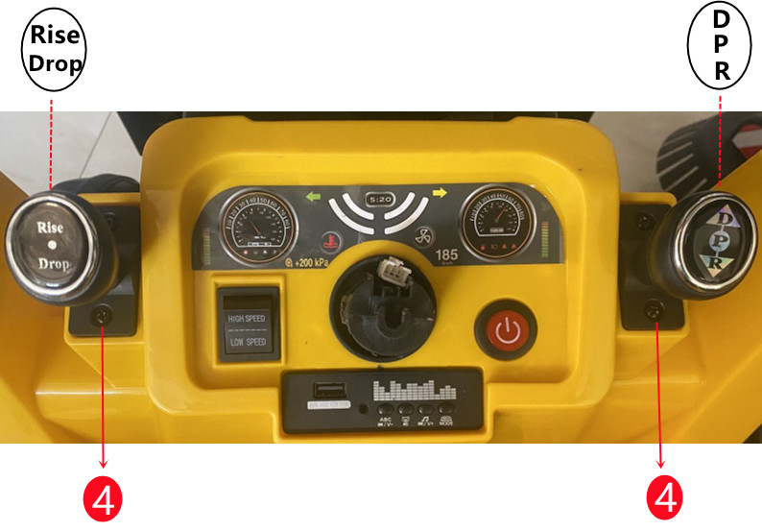

Install steering wheel
1.Flip the car onto its wheels, .Push into steering wheel after SM terminal on steering wheel is aligned and inserted well with SM terminal of body.
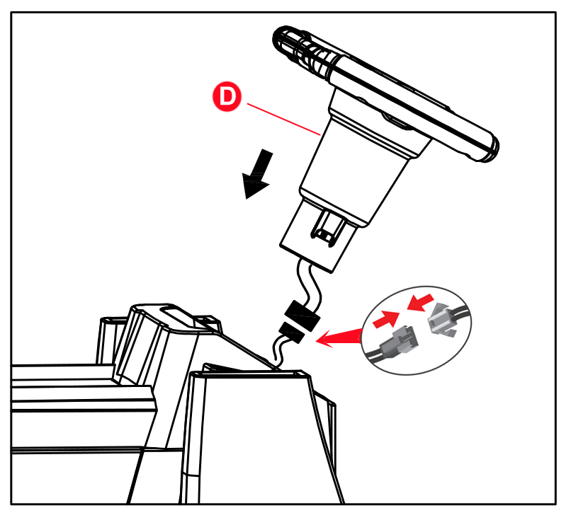
2.Then align the steering wheel then insert it into car and hook it well, don’t fiercely beat the key of steering wheel during assemble process. (please note that the wire can’t be seized during installation)

Install front windscreen frame
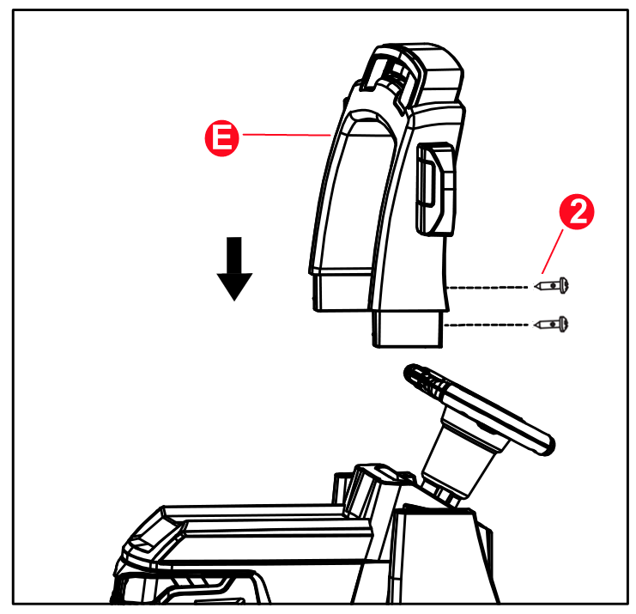
1.Insert the front windscreen frame into the car body and secure it with 2pcs 4*16 flat head screws.

Install forklift lift table and forklift arm
1.Attach the forklift lift table to the car body with 6pcs 4*12mm flat head screws.
2.The forklift arm is snapped in through the middle of the forklift lift table and can be moved to either side to change the distance between the two arms.

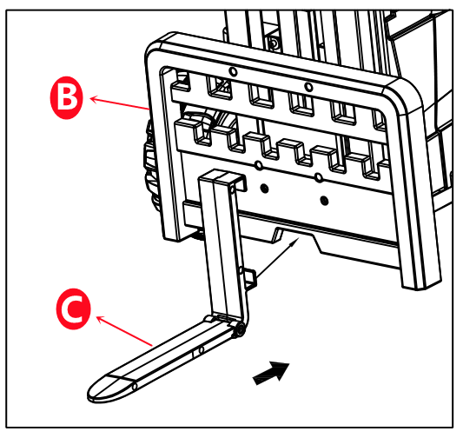
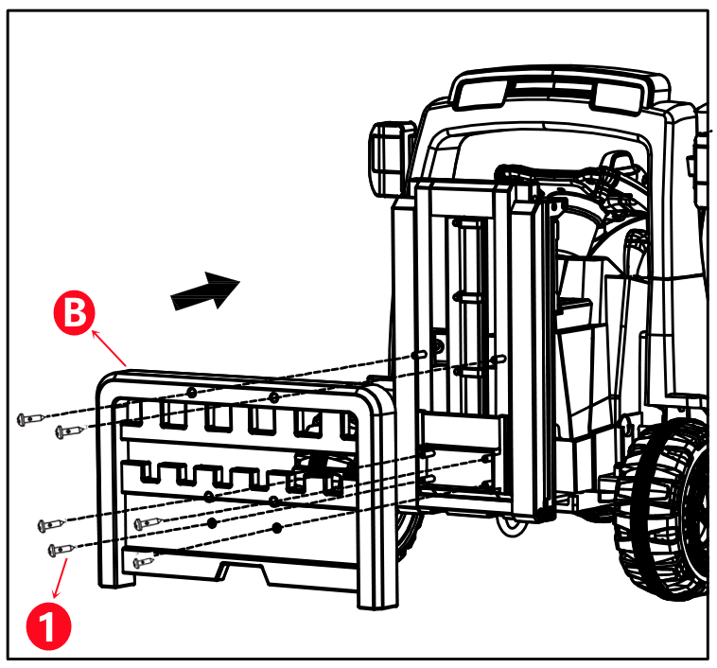

Install rubbish bin
1.Snap the bin lid into the rubbish bin.
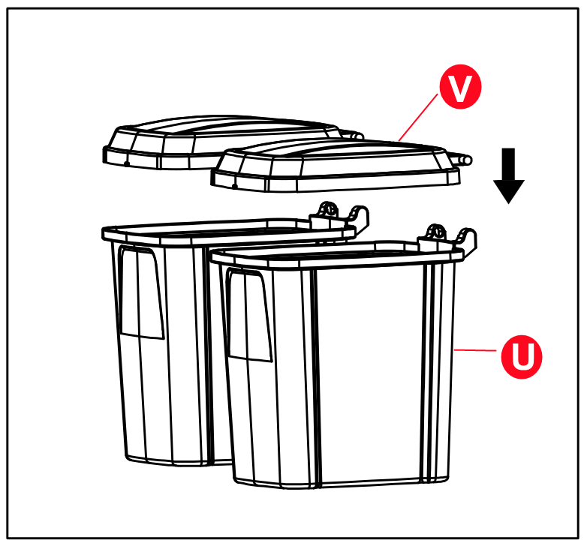

2.Place the pallet on the tractor and then place the rubbish bin on the pallet.

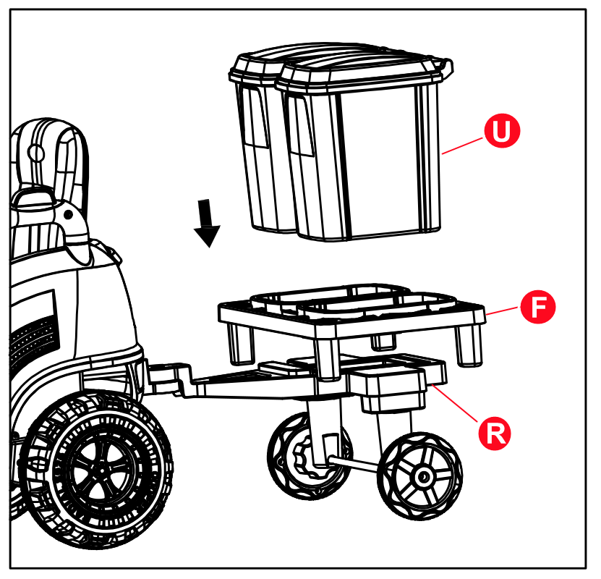

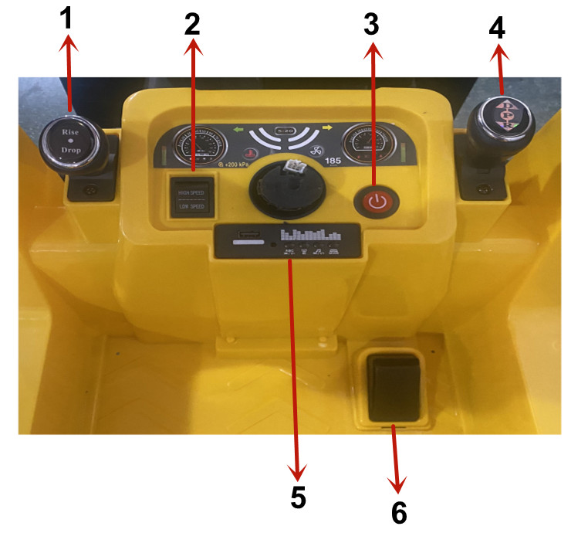
Function

- Forklift arm lift switch (Rise/Drop)
- High and low speed switch
- Start switch
- Forward/stop/reverse switch（D/P/R）
- MP3 player
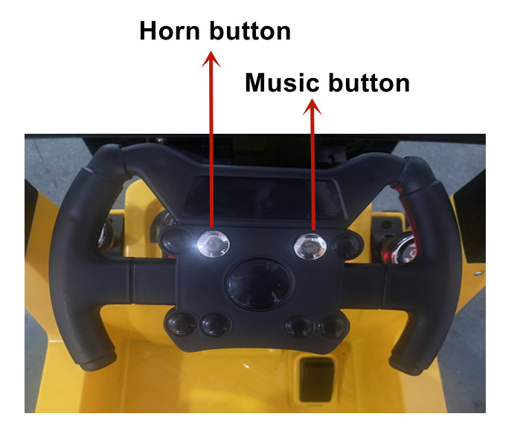
- Foot switch

Remote Control Function and Instructions

① Install battery:open the battery cover which is in the remote control, install two pieces of AAA (1.5V)(#7)dry batteries, pay attention to the polarity of battery before installing. Put on the battery cover and use screws to fix(Please follow the steps above to replace the battery. Only adults can replace it.) Please don’t mix the new and old batteries or different batteries. Please take away the exhausted batteries from the toys in time.)

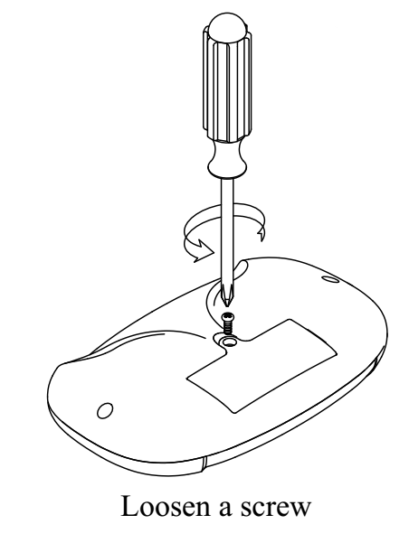

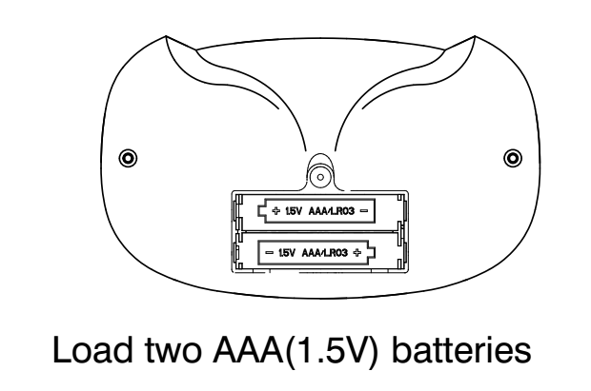

② use method:
a. use for the first time needs to match code this product has storage function.Replace battery or restart don’t need to match code.
b. Press “▲”&“▼”keys for 3 seconds at the same time to start match code, The first LED flickers.
c. Turn the car body power on now, The first LED lit up, Match code Succeeds
d. Press Remoter for 10 seconds if it doesn’t run it will be stand by, Press any key wake it up.
e. Keys caption:“▲” Forward,“▼”Back,“◀” Left,“▶” Right,“S”Speed,“P” Brake.Press“S”key to accelerate(1 LED lit up is low speed, 2 LED lit up is medium speed,3 LED lit up is high speed). Back a car is only low speed Press“P”key hold the brake, All LED flicker.

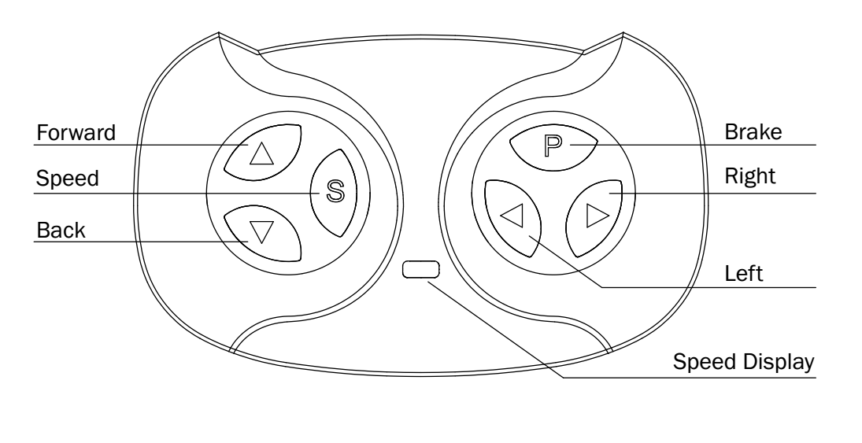

WARNING!
1.Not for children under 3 years old. Small parts. Choking hazard.
2.The remote controller only can be used with adult’s guidance.
3.Load two AAA(1.5V )batteries according to the diagram.
4.Non-rechargeable batteries are not to be recharged.
5.Different types of batteries or new and used batteries are not to be mixed.
6.Batteries are to be inserted with the correct polarity.
7.Exhausted batteries are to be removed from the toy.
8.The supply terminals are not to be short-circuited.
9.Should take away the exhausted batteries from the toys, and handle well, prevent played by children and caused harm.
10.The packaging must be retained since it contains important information.

Charging steps are as follows
Step1:The charging hole is under the under the seat.
Step2: Put the charger plug into the plug hole.
Step3: Connect the charger to the power socket.
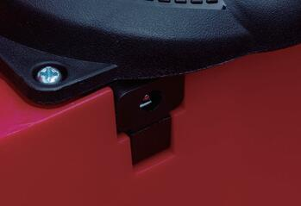
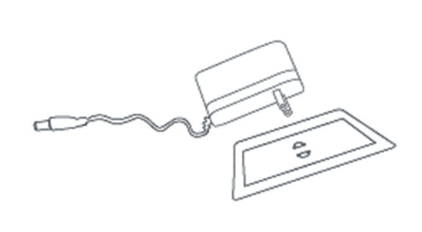

Warning: Car must be charged by adults only. Car is useless during charging.
Warning

To make your baby safety driving, you must pay attention on the below warnings:

1.Assemble and adjustment of products must be done by adult, please make children far away from the motion parts.
2. Small parts in it, which is not suitable to be used by the children under 3 years old!
3. Must correctly use the life belt when children sits. Don’t close to fire!
4. The children must use this product under the guidance of adults, and the guardian can’t leave during the using process!
5. Don’t allow the children stand or play on the foot pedal(or in the electric car).
6.charging the storage battery must be done by adults. Please charge at first before use this product!
7. To avoid to hurt children, please make the package materials like plastic bag far away from the children! Asphyxiation hazard!
8. Strictly forbidden to use any accessories which are not provided by manufacturer.
9. Don’t use charges as joys.
10. The maximum load of this car is 30KG, can’t overload.
11. The suitable age scope of this car:3-7 years old.
12. The toy can’t connect to too many power supplier which exceeds the recommend numbers.
13. The toy(complete car) can’t be operated during charging.

Notices for charging
1. When use the electric car for the first time,the user must guarantee the positive and negative pole of power supply have already correctly connected(the storage battery installed in the engine plate at the front of car,pay attention to different positive/negative poles when connects, needs red to red, black to black). Must guarantee that storage battery is charged for 8 hours, otherwise, it will perpetually damage the storage battery which can’t recover.
2.Plug the DC plug of charger into the charge hole at first, then plug the charger into power outlet.
3. Must charge in time after using about one hour each time, the normal charge time is from 8 to 12 hours, and charge time for every time can not exceed 20 hours.
4.During the charging process, it is normal for the charger temperature to be lower than 60℃, and normal for the storage battery temperature to be lower than 45℃.
- If there is stagnant water in the connect/plug part ,it can’t charge, otherwise it maybe cause short circuit.
6.This electric car must use the charger and storage battery configured with this car to avoid to damage the charge and storage battery or electric circuit.
7. charge at least once a month . if don’t use the electric car for a long time, please plug out the connect/plug part of storage battery.

Maintenance
1.To guarantee that your baby will not be hurt unexpectedly, please frequently check and maintain this car.
2.Check if package assemblies are complete before assembling, contact us immediately if there is a lack.
3 check whether has screws loosen or parts damaged on a regular basis.
4.Please frequently check whether it is intact when each part is installed or used
5.When disassembling, please operate according to the operating specification carefully to avoid to cause unnecessary damage.
6.Please check product and the charger used on a regular basis, check whether wire, plug, outer shell and other parts are damaged and you should stop use if find damage, till it is repaired well.
7.Please do cleaning for this product at a regular time, fill lubricating oil into rotating parts. Be careful not to damage the electric elements, don’t use water to wash, use dry cloth to wipe.

Use notices

1.Please check whether all parts are installed on position, tightly connect before use.
2.Can’t use in the dangerous area like streets, roads, slopes and ditches, etc.
3.Please don’t used it on smooth ground,for example marbles, ground tiles, etc.
4.Don’t shift forward/backward switches when the electric car is running. Please note that don’t allow children to stand on the seat.
5.Don’t change the circuit and additional electrical devices of this car.
6.The remote controller and electric car can’t be used in rain or water, don’t pour the water or other liquid on the car or other places to make it soaking and make it far away from the fire source to avoid to cause circuit damaged.
7.Electrical car stops running when it touches hinder, please run after leaving the hinders.
8.Don’t use in room to avoid to crack up the furniture even though make the children tumble.
9.When the quantity of electricity of battery of remote controller is not enough, it will occur that the complete car can only remote forward, can’t remote left/right direction, shortens remote distance and shakes, please renewal battery in time.
10.Please shut off the power supply switch when don’t use it, please plug out the connect/plug parts of storage battery.
11.This product limits to one people, can’t be overloaded, the maximum load is 30kg.

Note: the product picture, functional and introduce in this specification only for reference, project to the physical entity.

