Task #1

Create a risk matrix for testing on a project (see given project description below)

Insurance company from USA builds a risk-assessment system for analytics team. Epam helps Team composition: 1 PM (B3 onsite), 1 BA (A2 onsite), 1 Key Dev (D3), 5 Devs (D1), 1 QA (L2), 1DQE (L1). Estimated project deadline is Mar 1, 2021 and is related to org changes in the customer Analytics team.

**Homework.**

|  |  |  |  |  |  |
| --- | --- | --- | --- | --- | --- |
| Risk Probability | Catastropic A | Hazardous B | Major C | Minor D | Negligible E |
| Frequent 5 | 5A | 5B | 5C | 5D | 5E |
| Occasional 4 | 4A | 4B | 4C | 4D | 4E |
| Remote 3 | 3A | 3B | 3C | 3D | 3E |
| Improbable 2 | 2A | 2B | 2C | 2D | 2E |
| Extremely improbabe 1 | 1A | 1B | 1C | 1D | 1E |

Risks:

1. Time
   1. Schedule Delays – 4B (low seniority pyramid, D1, L1)
   2. Force Majeure – 2C (Belarusian team, political issues)
   3. Changes – 4C (Mar 1, 2021???)
   4. Geography timezones – 2D
2. People
   1. Shortage – 5C (6 Dev VS 1QA and 1DQE, DevOPS is missing)
   2. Labor Strike – 1E
   3. Skills Deficiency – 3B (low seniority pyramid, 5 Devs (D1), 1DQE (L1))
   4. Vacations, ills (covid-19) – 2A (1QA, 1DQE, 1BA)
   5. Org changes in the customer Analytics team – 2B
3. Costs
   1. Escalation – 2C (Mar 1, 2021???)
   2. Estimations Errors – 3C
4. Deliverables
   1. Component Issues – 2C
   2. Unproven Design – 2B
   3. CI/CD – 4B (DevOPS is missing)
   4. Permission – 2B
   5. License – 2B
   6. Environments – 3C (DevOPS is missing)
5. Quality
   1. Performance – 3D
   2. Unclear Requirements – 3B
   3. Production Data vs Test Dataset – 4D

Task #2

You have issue tracker log / export file. “bond_issue_log.zip”

Please create metrics answering these questions:

1. What is the least reliable component of the system?
2. Is the situation improving over timeline?
3. What weeks were the most dynamic in testing/development?
4. What weeks were the most silent?
5. Suggest a threshold for bug quantity per week (take into consideration their severity)

**Homework.**

1. Module C

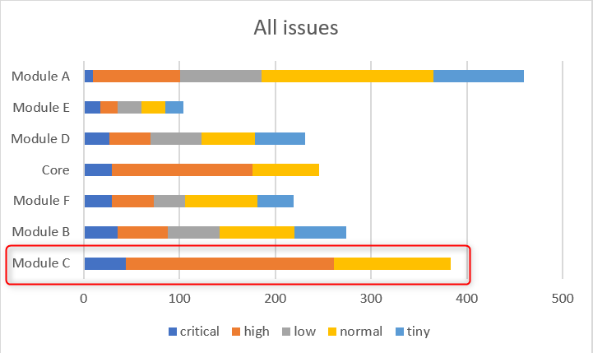 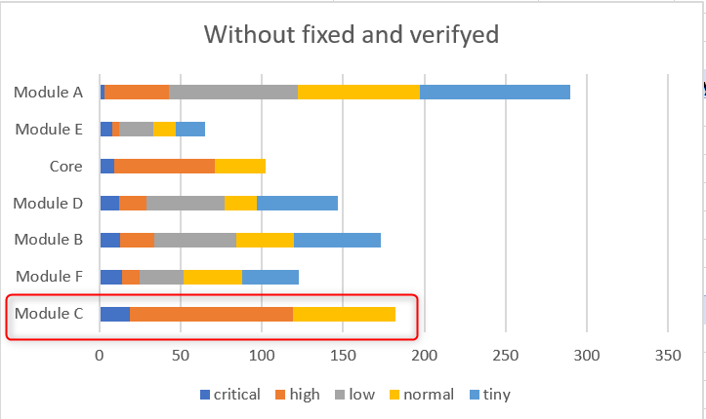

1. Not

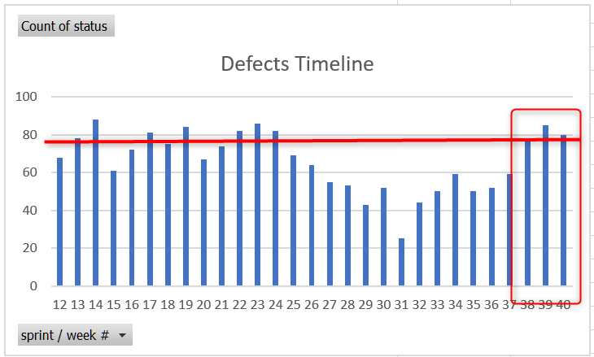

1. 16-th week

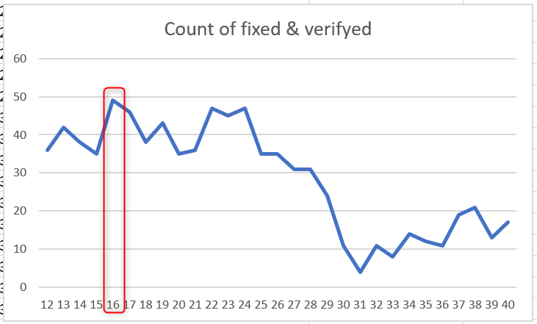

1. 31-th week

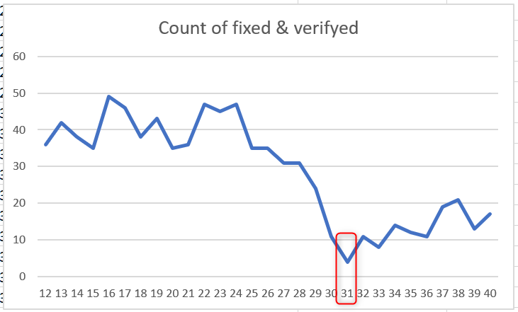

1. Using Average

