Sweden, Norway, Finland and Denmark waterway data
- Data for line-waterways (rivers), polygon-waterways (lakes) have been combined separately from different sources to form a continuous coverage for the whole area.
- On the borders to Sweden there have been some minor alterations to remove overlap and slightly different data geometries.
- For lines-waterways for Norway and Sweden, there are different rankings that can be used to exclude the smaller entries. This is not true for Finland and Denmark though. There is an updated “reduced” version included still.
- For polygon-waterways there are no rankings, but it has been possible to add a field to calculate the area of each entry. A selection of the smallest polygons can be done and then deleted. There is an updated “reduced” version included.
Line-waterways
This is how the original data layers look like:
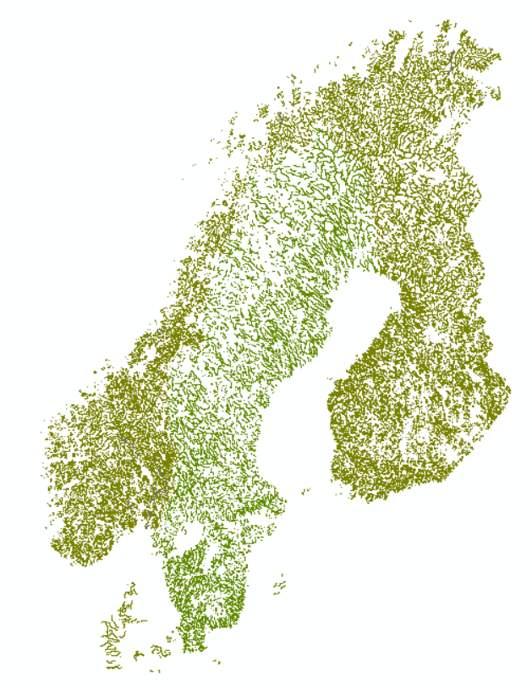
Sources:
Sweden data: https://www.lantmateriet.se/sv/Kartor-och-geografisk-information/oppna-data/?faq=d3f4
Finland data:
Norway data:
Denmark data:
Border Finland/Sweden line-waterways:
- Use the shapefile ”se_rivers_line_cut” and ”fi_water_line”. Select by location, lines in the Swedish file that intersects with the finish lines (24 features selected):

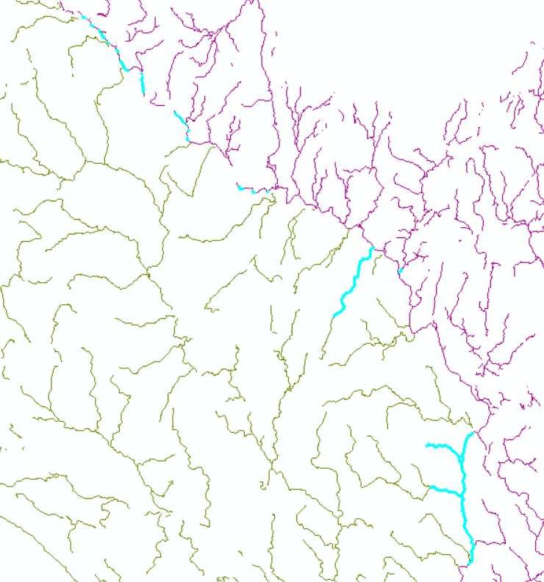
- From these selected features, take away lines in the Swedish filet that overlaps with the finish file. For lines that shall remain, make sure that the geometries line up where they intersect the finish lines.
Fixing of geometries
  - Start an edit session for ”se_rivers_line_cut”.
  - Select the specific feature. Move the line endpoint to the finish line it should intersect (snaps to the line).
Example FID 6412 (left before, right after):

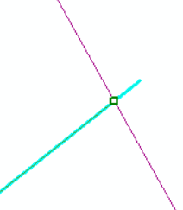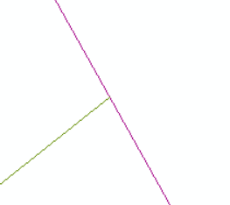
Same procedure for FID 5624 and FID 229.

- The remaining 21 features intersecting the Finland lines are representing the same features as in the finish file. Remove the 21 Swedish ones.

- Sweden/Finland ready to be merged into one line-shapefile for all countries.

Border Sweden/Norway line-waterways:
- The file ”se_rivers_line_cut” are altered in the section as well. Norway’s data is in the file ”no_alv_linje”. Selection of all the Sweden-lines that intersect the Norwegian. Only three. Very good overlap for one of the lines and could keep as is:

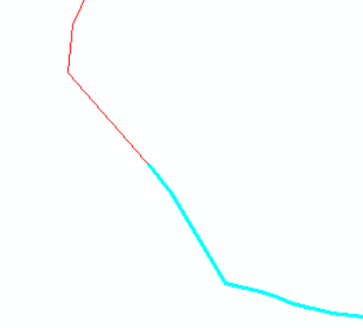
- The other two features to review are shown below. Keep the small crossing polygon, change edges on the other line to connect to the Norwegian one (very close in proximity and must be connected). Left is before, right is after:
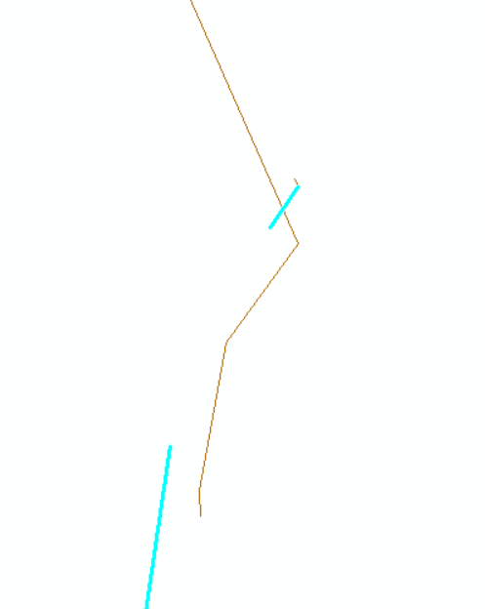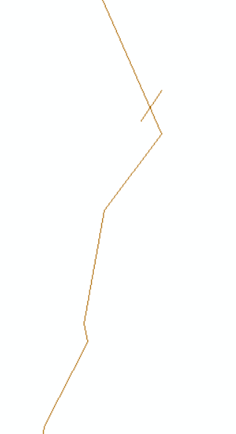
- Sweden/Norway ready to be merged.
Denmark
- No intersecting borders. Keep the features the way they area.
Merge into one shapefile:
- Add a field called ”land” in each of the four ”ready to go” shapefiles. Fill each row in with the country name. This will make it easy to make selections for specific countries later.
- Tool ”merge” in ArcMap 10.6. Keeping all the fields from the different countries. These are just blank for the countries that do not share the same field-title. Keep because can be used for selections later (see example later in this text).
- Final output is ” scandinavian_waters_lines” (find in drive).
Taking away smaller rivers for an additional shapefile.
- Possible for only Sweden and Norway because they have fields called ”KATEGORI” and ”vannBredde”. Can consider calculate and use the length of each line segment for Denmark and Finland but it may exclude important waterways that are short and wide.
- For Sweden, size specified by size 1-5 (”Vattendrag storleksklass, X”). Five is the largest:
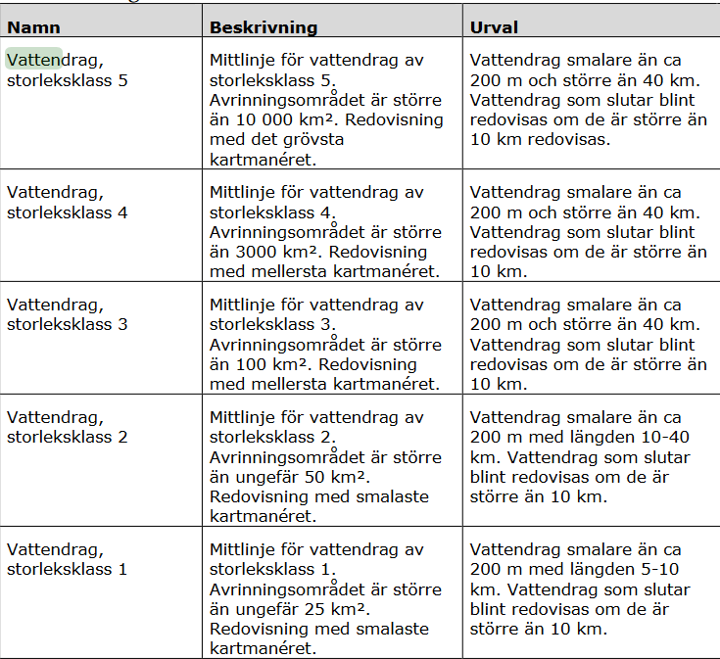
https://www.lantmateriet.se/globalassets/kartor-och-geografisk-information/kartor/sv1mshmi.pdf
page 25. Downloaded 2019-05-27.
- For Norway, size specified by size 3-5 (vannBredde X)
- Want to export all the lines from Denmark and Finland as well for the final export of this reduced lines shapefile. Select by attribute in ” fi_se_de_no_water_lines”:

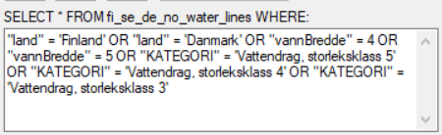

- Selection over Sweden and Norway looks like this:
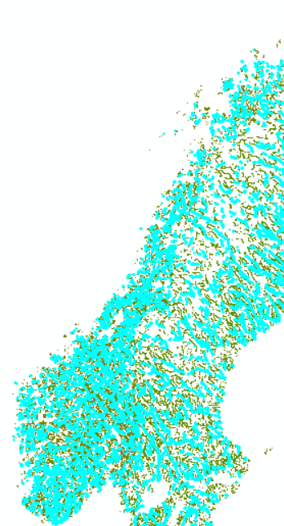
For Sweden 2208/6453 lines are selected.
For Norway 3709/9027 lines are selected.

- Export of whole selection exported into uploaded file ” scandinavian_waters_lines_reduced”:
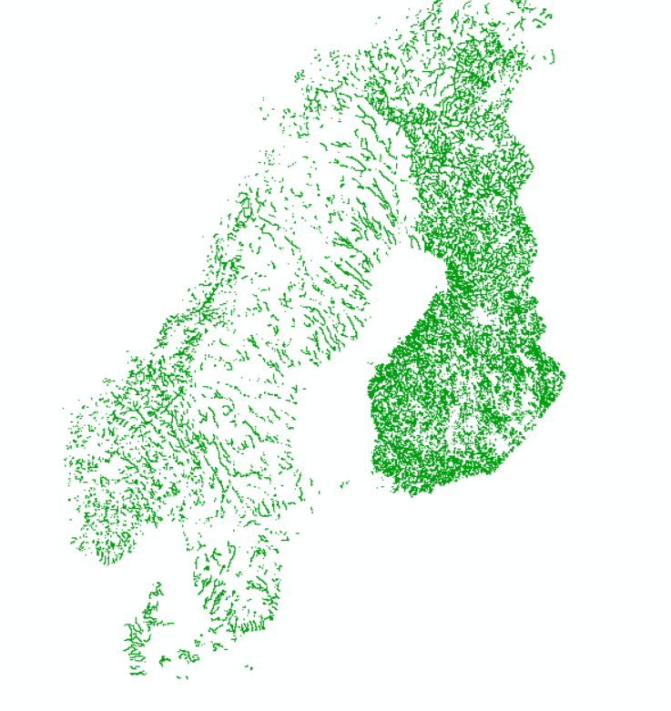
- For more zoomed out maps, could make similar selection, export and simplify the polygons. Consider using length of line segment for Finland (and Denmark).

Polygon-waterways
Border Sweden/Finland.
- The Swedish lakes in ”se_lakes_polygon” extends beyond the finish borders. Used the Swedish border polygon (from previously uploaded landscape file) to select all the lake polygons that overlaps with Sweden (select by location). Exported selection is called ”se_lakes_polygon_cut”.
- Select by location to select polygons in Finland that overlaps with the new Swedish layer. Very few selected. Overlapped with Swedish and were removed.
- Ready to merge se_lakes_polygon_cut and fi_water_polygon to common shapefile.

Border Sweden/Norway.
- Use ” se_lakes_polygon_cut” and ” no_insjo”AND ” no_alv_polygon” (only 27 features).
- Select by location: Norwegian polygons that intersect with the Swedish polygons. Norwegian polygons were cut at the Swedish border. Removed these and kept instead the Swedish polygons that extended beyond the border.
- No intersection between ”se_lakes_polygon_cut” and ” ” no_alv_polygon”.
- Ready to merge to common shapefile.

Merge into one shapefile:
- Add a field called ”land” in each of the four ”ready to go” shapefiles. Fill each row in with the country name. This will make it easy to make selections for specific countries later.
- Tool ”merge” in ArcMap 10.6. Keeping all the fields from the different countries. These are just blank for the countries that do not share the same field-title. Keep because can be used for selections later.
- Once file is merged, add additional field called ”area”. Use ”calculate geometry” to get the area in km2 for each of the features. Can be used to select for only bigger polygons (see example later)
- Final output is ”scandinavian_waters_polygons” (find in drive):
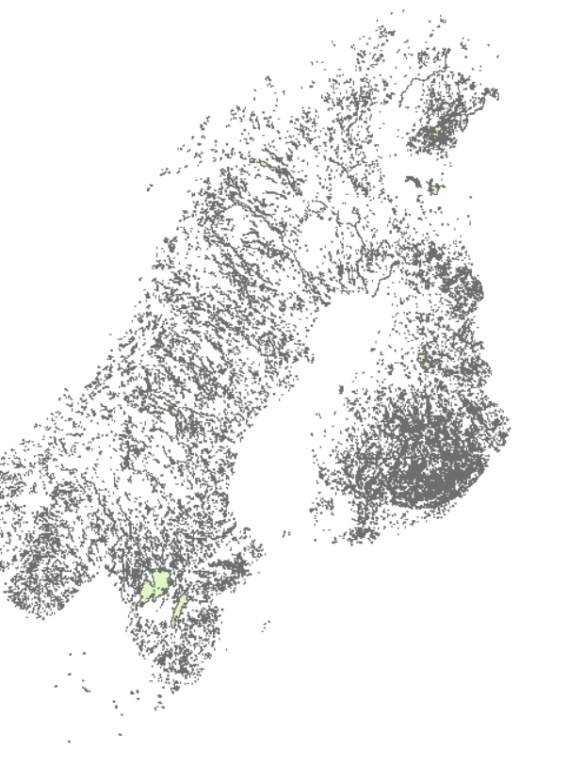

Taking away smaller lakes for an additional shapefile:
- Use the new area field to make selections (select by attribute).
- Test selection of polygons with minimum area of 1 km2. Would remove 15/14822 polygons.
- Test with minimum 2 km2. Would remove 1490/14822 polygons.
- Test with minimum 3km2. Would remove 3174/14822:
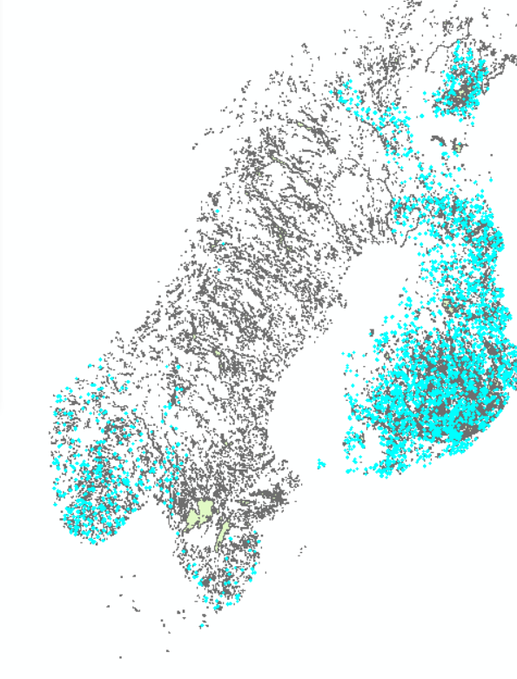
- Can come back and remove. For now, only the complete shapefile.
- Will also be possible to come back and simplify the polygons for more zoomed out maps.

