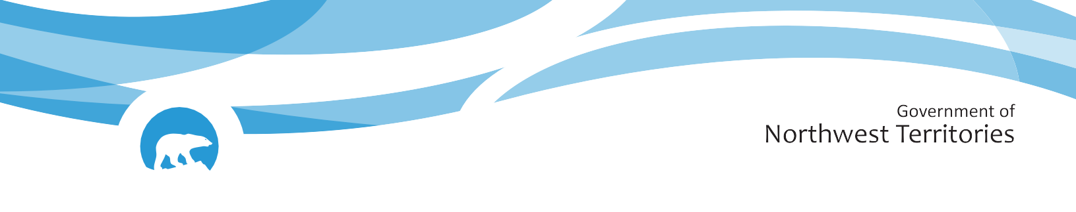
NWT break up reports will be published routinely as break up unfolds. These reports will focus on regions with active snowmelt and ice break up. The geographic focus of the report will shift as conditions change. Additional information about basin conditions can be found in the ECC Snow Survey Bulletin and Spring Water Outlook, available here. If you have any photos or information about break up in your community, feel free to reach out to us: nwtwaters@gov.nt.ca.

