Final Year Project
Interim Report



Emma Myo Nyunt
22351647

Department of Computer Science and Information Systems
Faculty of Science and Engineering
University of Limerick

Submitted to the University of Limerick for the degree of
Bsc. in Computer Systems academic year 2026

1. Supervisor: Dr. Lilian Motti Ader

University of Limerick
Ireland

AI Declaration
I herewith declare that I have used artificial intelligence to produce my project and/or report in the following ways:
- AI assistance was used to help structure this interim report, including formatting and organisation.
- AI tools may be used in future phases to assist with design mockup creation, feature ideas, and planning documentation.
- All AI-generated content has been reviewed, edited, and verified by me to ensure accuracy and alignment with the project’s objectives.
I further declare that I have discussed this use of artificial intelligence with my supervisor and received permission to use it.

Acknowledgments

I want to thank my supervisor, Dr. Lilian Motti Ader, for all of her help and guidance throughout this project so far. Her expertise in human-computer interaction and interaction design has really helped me think through design decisions, and she’s been great at answering my queries whenever I have needed the help.

Contents
1 Introduction 5
1.1 Project Overview 5
1.2 Problem Statement 5
1.3 Goals and Deliverables 6
2 Background and Literature Review 7
2.1 Web App Usability and User-Centred Design 7
2.2 Storage and Privacy 7
2.3 Emotional Models in Digital Interfaces 8
2.4 Related Web Apps and Design Approaches 9
3 Methodology 10
3.1 Design Approach 10
3.2 Technology Choices 10
3.3 Planned Features and Requirements 10
3.4 User Studies Methodology 11
3.5 Ethical Considerations 11
3.6 Timeline, Constraints, and Risk Management 11
4 Conclusions 12
4.1 Progress Summary 12
4.2 Challenges and Learning 12
4.3 Next Steps 12
5 Appendices 13
6 References 17

Introduction

Project Overview
MoodGarden is a mental-health tracking web application aimed at students and young adults who want a private, accessible way to reflect on their wellbeing. The app will allow users to track mood, stress, sleep, appetite, and journal entries, while also providing visualisations to help them identify patterns over time. Unlike many existing apps, MoodGarden will be free, web-based, and will not require account creation. All data will be stored locally on the user’s device.
A key feature of the project is the use of the arousal–valence model of emotion, which represents emotions along two dimensions rather than as single labels. This allows users to select up to two emotions per entry, reflecting the reality that people often feel mixed emotions.

Problem Statement
Young adults frequently experience stress and anxiety. Between assignments, exams, part‑time work, and trying to maintain some kind of social life, it’s easy to feel overwhelmed. Even though mental‑health issues are common among students, getting support isn’t always straightforward. Therapy can be expensive, waiting lists are long, and many digital tools that claim to help come with their own barriers.
When I started looking into existing mental‑health apps, I tried several of them myself. What stood out immediately was how limited they felt. Most of them asked to pick a single emotion, as if I had to choose between being “happy” or “anxious” when in reality I might feel both at once, or something more complicated. On top of that, many apps require subscriptions, only work on mobile, or store sensitive data in the cloud. A lot of these tools aren’t designed with young adults’ actual needs or realities in mind.
All of this highlighted a clear opportunity to design something better — a tool that is free and accessible, respects privacy, captures emotions in a more nuanced way, and genuinely supports the way young adults experience their day‑to‑day lives. MoodGarden aims to fill this gap by offering a simple, private, and emotionally expressive space that works across devices without accounts, subscriptions, or oversimplified mood labels.

Goals and Deliverables
- A fully functioning web application built with React, TypeScript, and Tailwind CSS
- Design mockups (sketches) that I'll use for user testing
- A GitHub repository code and documentation
- A dashboard with visualisations
- Results from the user studies showing what people thought of the designs
- Final Written Report

Background and Literature Review
Before starting the design work for MoodGarden, I looked at how other researchers and developers have approached building web applications, especially ones that involve user input, emotional data, or daily tracking. Even though my project is centred on mental-health tracking, the most useful research at this stage came from studies on usability, user-centred design, and how digital tools represent emotions in a way that feels intuitive to users.

Web App Usability and User-Centred Design
One of the first things I learned from the literature is that usability can make or break a web application. Palmer’s early work (2002) showed that people judge a site within seconds based on how easy it is to navigate and how quickly it responds. Even though that study is over twenty years old, the core idea still holds true today: if an app feels slow, cluttered, or confusing, people simply won’t use it.
More recent reviews, like Omonigho (2024), emphasise the importance of involving users early in the design process. Instead of guessing what people want, user-centred design encourages developers to test ideas with real users and adapt based on their feedback. This approach really resonated with me, especially because MoodGarden is aimed at students. I don’t want to build something based purely on my own assumptions — I want to understand how other students think, what they find intuitive, and what might confuse them. That’s why user testing and co-design are such central parts of my methodology.

Storage and Privacy
Because privacy is such a big part of this project, I also looked into research on client-side storage. Several studies compare cookies, localStorage, and other browser-based storage options, and many of them highlight that localStorage is a practical choice for lightweight applications that don’t need complex databases (Ekpobimi et al., 2024). It offers more space than cookies, works well with structured data, and — most importantly — keeps everything on the user’s device.
This aligns perfectly with what I want MoodGarden to be: a tool that doesn’t require accounts, doesn’t upload anything to a server, and gives users full control over their own data. Even outside mental-health contexts, people are becoming more aware of how apps collect and use their information. Designing MoodGarden around local-only storage helps build trust and removes a lot of the barriers that come with cloud-based systems.

Emotional Models in Digital Interfaces
Although most web-development research isn’t about emotions, I did come across work that explores how digital tools represent affect. Russell’s arousal–valence model (1980) stood out because it offers a simple but powerful way to map emotions along two dimensions: pleasantness and energy. Instead of forcing people to pick a single label, the model acknowledges that emotions can be mixed, layered, or somewhere in between.
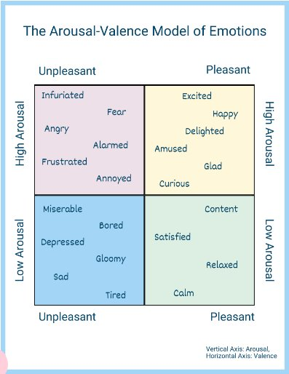
Other studies, like Barrett et al. (2001), show that helping users identify emotions more precisely can support better self-reflection. Even though these studies weren’t about mood-tracking apps specifically, they helped me understand why a dimensional model might feel more natural than a list of isolated labels. This directly influenced my decision to let users select up to two emotions per entry and to group emotions by colour to make the interface easier to understand.

Related Web Apps and Design Approaches
I also explored how other developers and researchers approached building apps that involve emotional input or daily tracking. Some recent work looks at how emotional information can improve user interfaces. For example, Drungilas et al. (2024) created a framework for using emotion recognition during usability testing, showing that emotional cues can help designers create clearer and more responsive interfaces. Even though MoodGarden doesn’t use emotion recognition, the idea that emotions can guide design decisions was helpful.
Broader reviews in affective computing, such as Kapase and Uke (2025), highlight that dimensional models of emotion are becoming more common in digital systems because they help software interpret user states more accurately. These studies aren’t about mental-health apps specifically, but they show that emotion-aware design is becoming more mainstream. This reassured me that using the arousal–valence model in a web app isn’t too abstract or unusual — it’s actually part of a growing trend in human-computer interaction.

Methodology

Design Approach
This project follows an iterative, user-centred design approach, beginning with research and requirements gathering before moving into design, testing, and development. I started by reviewing existing relevant web applications and studies to understand the landscape and identify gaps. From there, I created low-fidelity mockups to explore layout ideas and feature flows. These early designs will be tested with students to gather feedback on clarity, usability, and overall appeal. Based on this feedback, I will refine the designs into high-fidelity prototypes before beginning the development phase. The final stage will involve evaluating the working application with users to see how well it supports emotional reflection and daily tracking.

Technology Choices
For the technical side, I chose tools that I’m comfortable with but that also support a smooth development process. React and TypeScript form the core of the application because they make it easier to build modular components and catch errors early. Vite provides a fast and lightweight development environment, which is especially helpful when iterating quickly. Tailwind CSS allows me to build a consistent visual style without writing large amounts of custom CSS.
For visualisations, I plan to use Recharts, which integrates well with React and supports the kinds of charts I need for mood trends and insights. date-fns will help with formatting and manipulating dates, and React Context will manage global state like theme settings and pet preferences. All user data will be stored in localStorage, which supports the privacy-first approach that is central to the project

Planned Features and Requirements
MoodGarden will include several core features: mood tracking using the arousal–valence model, stress and sleep tracking, appetite tracking, journaling, and a dashboard that brings everything together. The mood-tracking feature is the heart of the app, allowing users to select up to two emotions per entry and add notes if they want. The other trackers provide additional context, helping users understand how different aspects of their life might influence their mood.
The anonymous pet-based onboarding system is a small but important detail. Instead of creating an account, users simply choose a pet and give it a name. This creates a sense of personalisation without collecting any personal information. It also keeps the app light and approachable, which is important for something that deals with emotions.

User Studies Methodology
The user-testing process is divided into three phases. The first phase focuses on early mockups. I’ll show participants the initial designs and ask them to talk through what they see, what they understand, and what feels unclear. This will help me identify usability issues before investing time in high-fidelity designs.
The second phase is a co-design workshop. Instead of just reacting to my ideas, participants will help shape the interface by suggesting improvements, alternatives, or discussing how they would prefer to track their emotions. This collaborative approach helps ensure that the app reflects real user needs.
The final phase involves testing the working application over one to two weeks. This will give me insight into how people use the app in their daily lives, whether they find it helpful, and what might encourage or discourage long-term engagement.

Ethical Considerations
Ethical considerations have been central to the project from the beginning, and all user-testing sessions will follow strict guidelines around informed consent, voluntary participation, and anonymity. Clear disclaimers will also be included to remind users that the app is not a clinical tool, and any “medical” advice will be provided from the general HSE mental health tips website which is already available to the general public.

Timeline, Constraints, and Risk Management
The project timeline is structured around the academic year. The research, and initial design work are already complete. The next few months will focus on user testing and refining the designs, followed by the development phase in spring. The final evaluation and report writing will take place toward the end of the semester.
There are a few constraints to keep in mind. Time is the biggest one — balancing design, development, and testing within the academic calendar is challenging. Another constraint is ensuring that the emotional model is intuitive for users who may not be familiar with psychological frameworks. To manage these risks, I plan to use clear visual cues, simple interactions, and iterative testing to refine the experience.

Conclusions

Progress Summary
Overall, the project has progressed steadily and is on track with the planned timeline. I’ve completed the initial research, explored existing applications, and reviewed relevant literature on usability, emotional models, and web-app design. These steps have helped shape a clearer understanding of what MoodGarden needs to achieve and how it can best support students in reflecting on their emotions

Challenges and Learning
The process hasn’t been without challenges. The ethics application took longer than expected, but it ultimately strengthened the project by forcing me to think carefully about privacy, data handling, and participant wellbeing. Researching emotional models also pushed me to think more deeply about how to translate psychological theory into a simple, approachable interface. These challenges have been valuable learning experiences and have helped refine the direction of the project.

Next Steps
Looking ahead, the next steps involve conducting the first round of user testing, gathering feedback, and refining the designs based on what participants find intuitive or confusing. Once the designs are validated, I will move into the development phase and begin building the application using the planned technology stack. After the app is functional, I will run a final evaluation to understand how people use it over time and whether it genuinely helps them reflect on their emotional patterns. The insights from this evaluation will feed into the final report and presentation.

Appendices
Low-Fidelity Home Page Mock-Up Design:
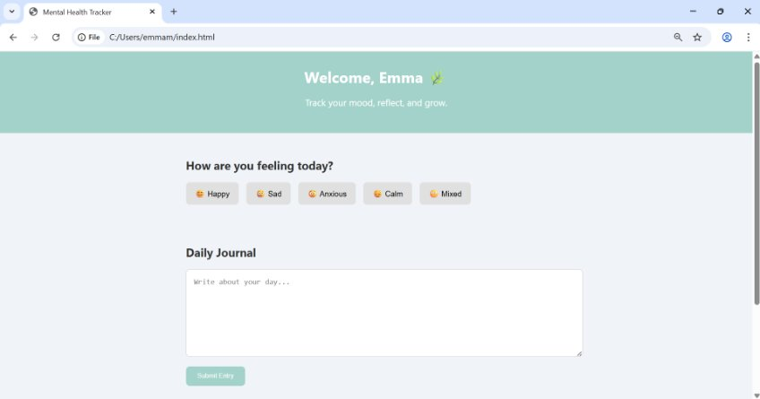
High-Fidelity Mock-Up Designs:
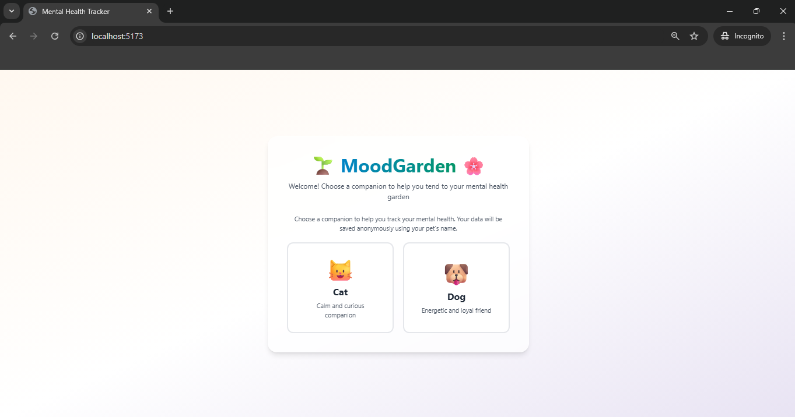
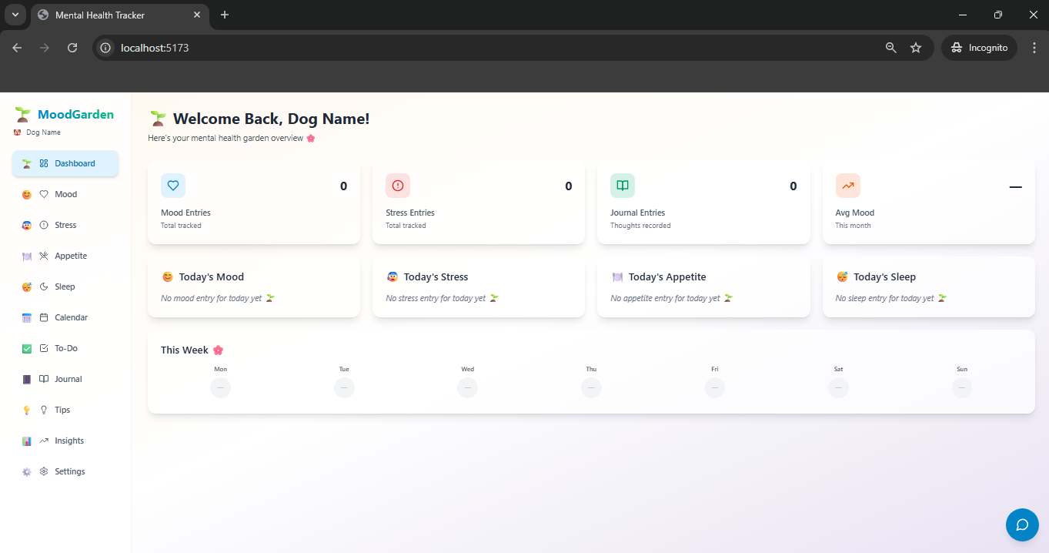
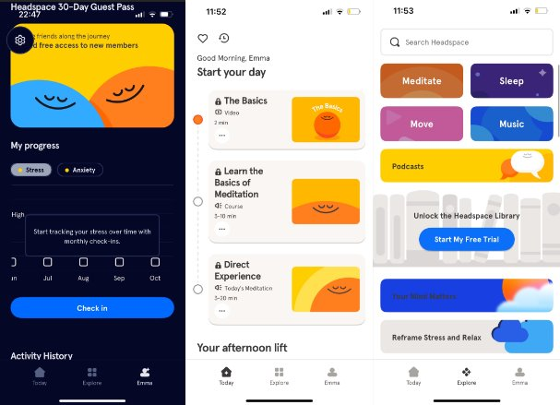
Headspace – mostly contained audio and video features:
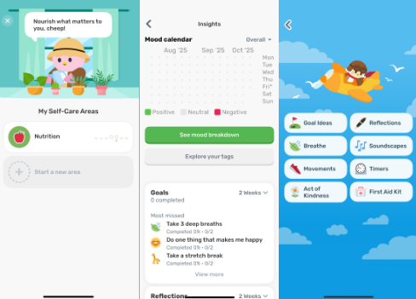
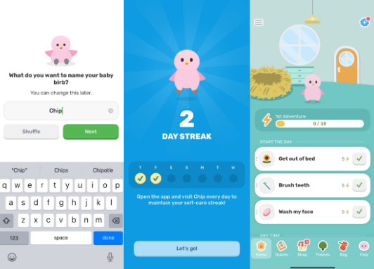
Finch – this is where I got the idea for choosing a pet and naming it, the chart visualisations, and as well as the appetite tracker. I like the features a lot, as well as how interactive and fun it is for the user to access the app. A pet you can name and take care of, really good for anonymity:
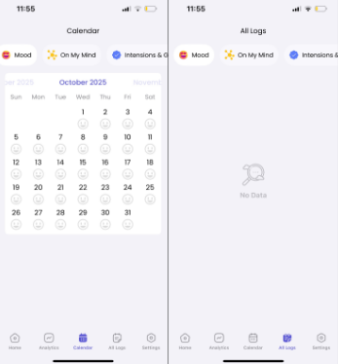
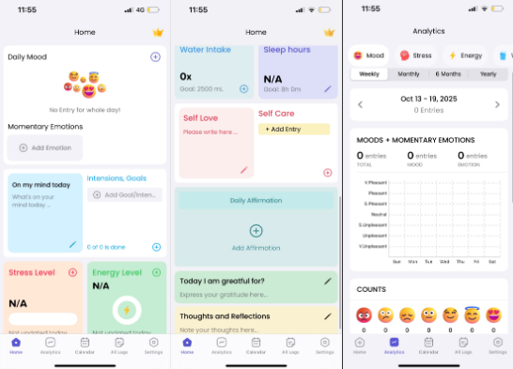
Mental Health Journal – I really like the features on this app, as well as the layout because it is designed and separated by boxes. It’s nice and compact. The boxes are like sticky notes, and scattered like a diary, giving it a personal affect. It also allows you to filter through different features through the calendar:

References
Barrett, L. F., Gross, J., Christensen, T. C., & Benvenuto, M. (2001). Knowing what you're feeling and knowing what to do about it: Mapping the relation between emotion differentiation and emotion regulation. Cognition & Emotion.
Drungilas, V., et al. (2024). Emotion Recognition in Usability Testing: A Framework for Improving Web Application UI Design. Applied Sciences.
Ekpobimi, O., et al. (2024). Comparative Analysis of Client-Side Storage Mechanisms for Web Applications. Journal of Web Engineering.
Kapase, S. & Uke, N. (2025). A Comprehensive Review in Affective Computing: An Exploration of Artificial Intelligence in Unimodal and Multimodal Emotion Recognition Systems. International Journal of Speech Technology.
Omonigho, M. (2024). A Critical Review of Web Application Usability and User-Centred Design. International Journal of Computer Applications.
Palmer, J. (2002). Web site usability, design, and performance metrics. Information Systems Research.
Russell, J. A. (1980). A circumplex model of affect. Journal of Personality and Social Psychology.

