Emmanuella G. Nyamekye

Prototype for WalletBank

Marvel App Link: <https://marvelapp.com/prototype/842b83j/screen/89716582>

## Changes:

Page 1 Home Page/Main Page:  
- Moved the expenses and the income buttons upwards.  
- Changed the color of the card.  
- Changed the font sizes and font family to a more slim and cleaner font (Calibri).

Page 2 Transaction details Page:  
New page that connects Page 1 to Page 3.

Page 3 Category Page:  
- Added the app navigation on the bottom.  
- Resized the icons to a smaller size.  
- Changed the font sizes and font family to a more slim and cleaner font (Calibri).

## Site Map:

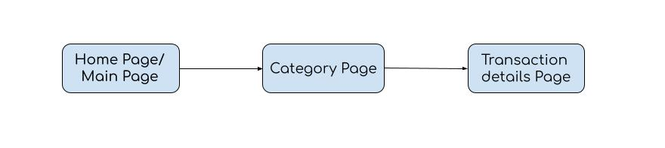

## User flow:

