# **Walletbank** [Marvelapp Link](https://marvelapp.com/prototype/842b83j/screen/90056258)

Emmanuella Gyamfuua Nyamekye

User testing, personas & scenarios

### Introduction:

Walletbank is an app where users can do every task they would normally do in cash. From paying rent and splitting the bill to tracking and budgeting with Walletbank you can do it all. With this app, cash will be a thing of the past.

### Personas:

|  |  |
| --- | --- |
| Persona A - Suzi   * Early twenties * Student * Just got her second credit card * Goes out and travels a lot with friends * Opened in trying the latest app especially if recommended from friends |  |
| Persona B – Paolo   * Late forties * Trader * Owns multiple cards * Has a minimalistic lifestyle * Likes to track every penny he spends |  |
| Persona C – Marco   * Mid thirties * Waiter * Has only one credit card that he uses for everything * Not good with money * What is to save up for a motorcycle |  |
| Persona D – Angela   * Late Fifties * Nurse * Distrusting of banks * Has owned the same two credit cards for the last 30 years * Prefers cash but is annoyed at the withdrawal fees at ATM |  |

### Scenario:

1. Suzi is organizing a trip to the Maldives with two friends.  
   At the travel agency they discover that if they pay for the flights all at once with one credit card, they will have a discount of 15%. One of her friends kindly pays for the flights.  
   The following day Suzi wants to transfer the money that she owns but unfortunately, they do not use the same credit card company so Suzi will be forced to pay a fee of 5% of the price of the money transfer.
2. Marco has finally found the motorcycle of his dreams but does not have enough money to pay for it.  
   He has been trying to save for the last 2 months but he always goes over budget.

### User Testing Analysis:

|  |  |  |  |  |  |  |  |  |  |  |  |  |  |
| --- | --- | --- | --- | --- | --- | --- | --- | --- | --- | --- | --- | --- | --- |
| **Averages**   |  |  | | --- | --- | | GUI  Element | Scale  (1-5) | | Interface | 4.9 | | Color | 5 | | Text | 4.8 | | Navigation | 4.74 | | Usability | 4.96 | | **Interface**: Elements needed to be align better.  **Color:** The users appreciated the colors scheme of the app.  **Text:** Only one user out of five would have preferred a different font from the one used.  **Navigation:** In general the navigation was well liked by almost all the users but one of them made me notice that two buttons did the same thing.  **Usability**: The users found my app easy to use. |

### General Questions Feedback:

Almost all the users immediately understood what the app was for and how to use it.

I gave the users a task to complete: From the Main page go to the category page of the € 400 expense and back. Did you successfully complete the task?. They were all able to complete it successfully.

The most liked parts of the app were:  
- The category page  
- The colors  
- The main page because you can immediately see your expenses

All the users wrote that they would use the app especially for the budgeting section.

### User Suggestions:

Additional settings/ features:

* pay insurance or a top-up for mobile phones

Text:

* Change font

Colors: N/A

### Changes made after Feedback:

* Aligned properly the elements that were not symmetrical.
* The font remained the same because the majority of the users did not have an issue with the font. They found it clear and readable.
* I was not able to add pay insurance or a top-up for mobile phones feature because of time. The app already has a lot of elements but I do agree that adding these new feature would make the app more complete.

### Site Map:

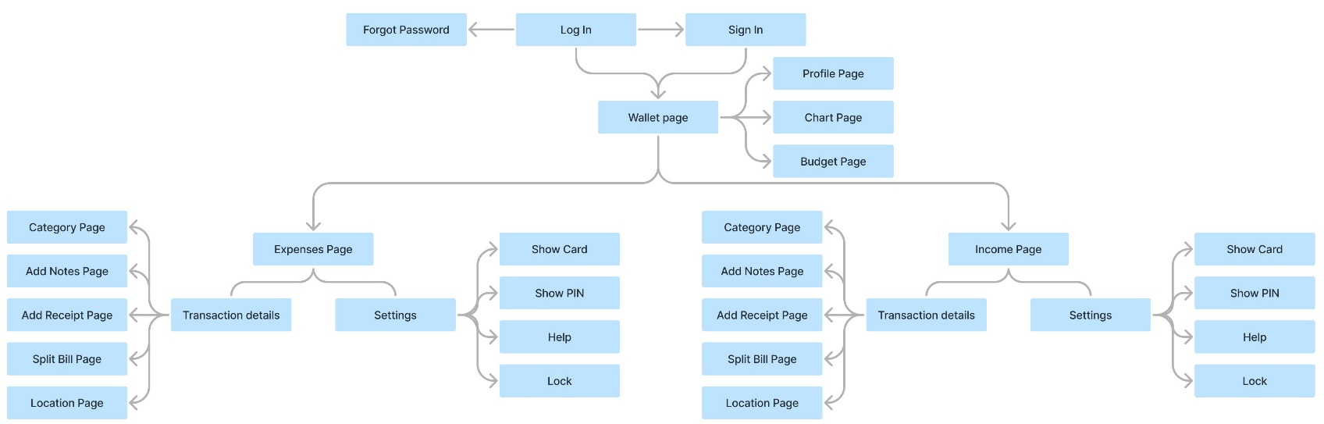

### User Flow:

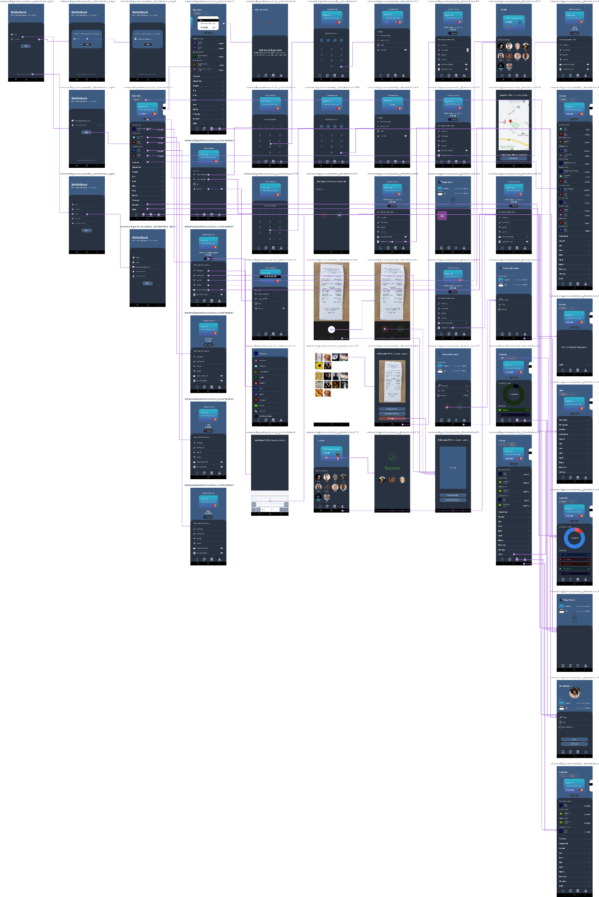

### Appendices:

**USER INTERFACES : USER TESTING FORM**

|  |  |  |
| --- | --- | --- |
| Graphical User Interface Element: | Scale (1-5): | Comments: |
| Interface |  |  |
| Color |  |  |
| Text |  |  |
| Navigation |  |  |
| Usability |  |  |

|  |  |
| --- | --- |
| General Questions: | Answers: |
| At first glance, what is the purpose of this App? |  |
| From the Main page go to the category page of the € 400 expense and back. Did you successfully complete the task? |  |
| What parts of the web/mobile app did you like the most? Why? |  |
| What parts of the web/mobile app did you use the least? Why? |  |
| Would you use this app? Why or why not? |  |
| Are there any unnecessary features? |  |

|  |  |
| --- | --- |
| Suggestions: | Answers: |
| Additional settings/ features: |  |
| Text: |  |
| Colors: |  |