Class diagram

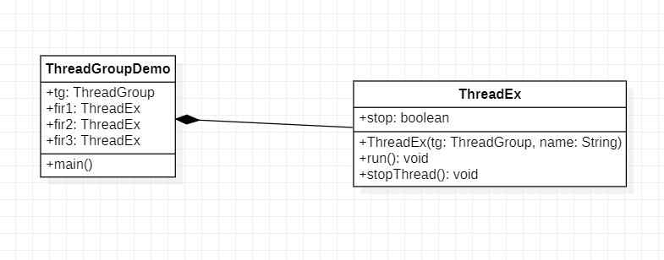

State machine diagram

Sequence diagram

