/*
QUESTION 1:
Analyze the total profit each month of each year based on unit USD; Note: Profit of one products = unit_price - unit_cost
*/

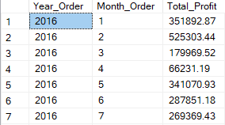

/*
QUESTION 2:
Write a SQL query to see customer demographics meaning with format table
Age_Group, Gender, Country, State, Count_Customer
With Age_Group is
0-17, 18-25, 26,35, 36-45, 46-55, 56+
*/
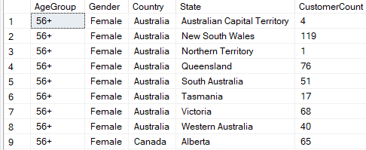

/*
QUESTION 3:
Write a SQL query to determine the months where the month-over-month growth in cumulative profit is significant (at least 10%).
Based on unit USD
*/

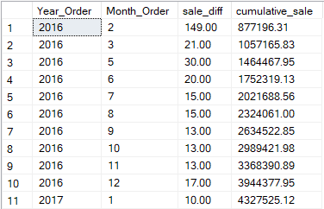

/*
QUESTION 4:
Write a SQL query to find pairs of different Subcategories that are purchased together in the same order.
Only include unique pairs (e.g., "Desktops" and "Movie DVD", not both "Desktops"-"Movie DVD" and "Movie DVD"-"Desktops").

Display the following columns:
SubCategory_1
SubCategory_2
Count_Pair (number of times the two subcategories appear together in an order)
Rank_Pair (ranking based on highest Count_Pair)

Sort the result by Count_Pair in descending order.
*/
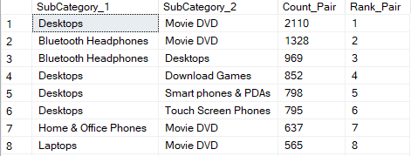

/*
QUESTION 5:
Create report of the top 2 selling products in each country,
category, product name and ranking them accordingly.
*/

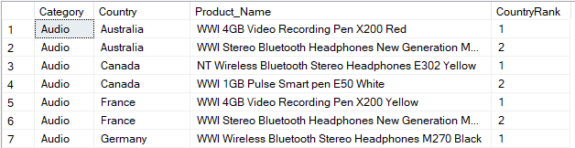

QUESTION 6:
Write a query to analyze the profitability efficiency of each store by calculating:

The total profit in local currency (TotalProfitLocalCurrency)
The profit per square meter (ProfitPerSquareMeter)
A ranking of stores based on ProfitPerSquareMeter in descending order

The final output should include:
StoreKey, Country, State, Square_Meters, TotalProfitLocalCurrency, ProfitPerSquareMeter, and Ranking.
*/
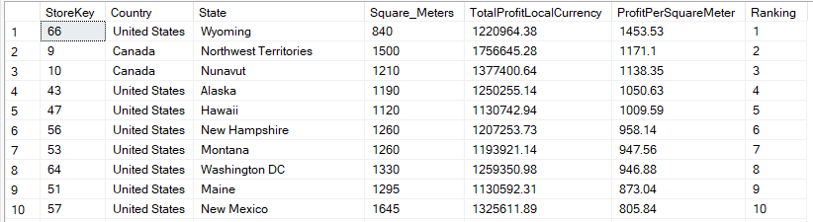

/*
QUESTION 7:
Same as QUESTION 5 output
Analyze the total sales in local currency per product by country and category
and ranking top 2 each product name of each category within each country
*/
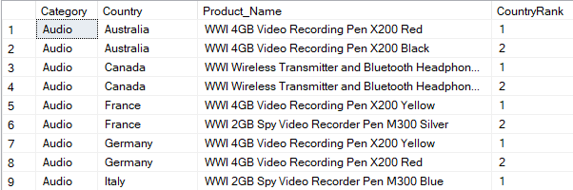

/*
QUESTION 8: Check total quantity make by each day of each customer
Write the query to calculate total quantity of each customer make in one day
*/
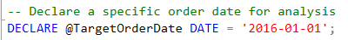
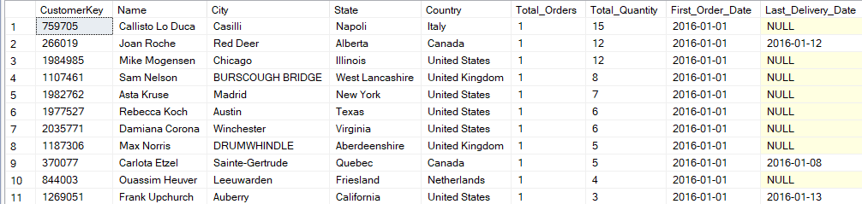

/*
QUESTION 9: Write the query to calculate total order make by each country for each year
Format table
Country, Year 1, Year 2, Year 3,...
*/
